Site: OWS M, Norwegian Sea (Updated September 2007)
Position: 66°N 2°E-
Categories:
- operating
- Weather Ship Station and hydrographic station
- oceanography, meteorology, biogeochemical

Short description:
- 1 station
- Variables measured:
- temperature, salinity, and (since 1953) oxygen weekly at standard depths to 2200 meters
- temperature and salinity at standard depths down to 1000 meters 3 or 4 times a week
- an autonomous air-sea delta pCO2 system was added by the Bjerknes Centre for Climate Research in 2005. This operates continuously.
- an autonomous air-sea flux package “AutoFlux” was added by the National Oceanography Centre, Southampton, UK in September 2007, for direct measurement of the fluxes of CO2, momentum, sensible heat and latent heat. This operates continuously.
- A directional wave radar was also added by the National Oceanography Centre in September 2006. This operates continuously, as does the ship’s existing ship-borne wave recorder.
- Start date of the timeseries: 1 October 1948
- service interval: This program has been running continuously since 1 October 1948 to this very day only hampered by occasionally extreme weather.

Scientific rationale:
Having performed daily oceanographic measurements in the deep Norwegian Sea since 1 October 1948, Ocean Weather Ship Station (OWS) M, at 66°N, 02°E, can present the longest existing homogeneous time series from the deep ocean. Station M is operating above the eastern margin of the Norwegian Sea deep basin where a branch of the Atlantic current is entering the area, Figure 1. The location proved to be strategic both for studying the Atlantic inflow, and the Norwegian Sea Deep Water, figure 2. The Norwegian Meteorological Institute operates the OWS M. Geophysical Institute, University of Bergen, is responsible for the hydrographic program.

Groups / P.I.s /labs /countries involved / responsible:
Svein Østerhus, Bjerknes Centre for Climate Research and Geophysical Institute, University of Bergen, Norway. E-mail: svein.osterhus@gfi.uib.no
For the National Oceanography Centre systems, contact Margaret Yelland, Email: mjy@noc.soton.ac.uk

Status:
The OWS M will continue its operation for the years to comes. In addition to standard hydrography observations programs for the hydrographic, biological and geochemical program exist. It is proposed that Polarfront should be equipped with an Acoustic Doppler Current Profiler (ADCP). Twenty-four ADCP’s and XBT’s sections a year across the Norwegian Atlantic Current will be invaluable for monitoring the influx of Atlantic water to the Arctic. The long term funding for OWS is not secured.

Technology:
The method of obtaining temperature and salinity observations (Nansen bottles with reversing thermometers) has not changed significantly either so the time series are indeed homogeneous. Although this method is robust it is time consuming and does not meet the today standard therefore a new Sea Bird MicroCat CTD instrument for temperature and salinity measurements is used as a supplement to the old Nansen bottles.

Data policy:
- realtime data: The standard meteorological (including SST) data is transmitted real-time to GTS and can also be downloaded from www.met.no.
- delayed mode data: The hydrographical data is public and delayed data can be obtained from www.gfi.uib.no. Daily data from the National Oceanography Centre systems can be viewed at http://www.noc.soton.ac.uk/ooc/CRUISES/HiWASE/OBS/data_intro.php

Data management:
Water samples and hydrographical data are sent monthly to Geophysical Institute for analyses and banking. Plans for real-time data processing exist but depend on external funding.

Societal value / Users / customers:
The hydrographical data are used mainly for fishery managements and climate research.

Role in the integrated global observing system:
Proved strategic location both to study variations in the Atlantic water flowing northward to the Arctic, and changes in the intermediate and deep water in the Nordic Seas.

Contact Person:
- for enquiry about addition of instrumentation or sensors to the site or for possible ancillary measurements during cruises to the site: post@gfi.uib.no
- for information about the site or data : ngfso@uib.no

Links / Web-sites:
Project information and data can be found on www.gfi.uib.no/forskning/
Information about the National Oceanography Centre contribution can be found at http://www.noc.soton.ac.uk/ooc/CRUISES/HiWASE/index.php

compiled/ updated by: Svein Østerhus (April 2005)

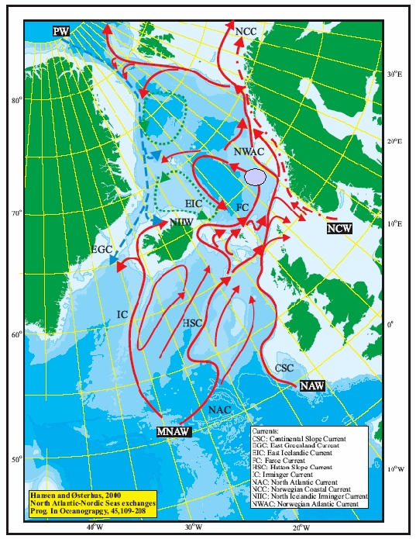 | Figure 1:  The main current system (schematic) in the Nordic Seas with the position of the weather ship station M.
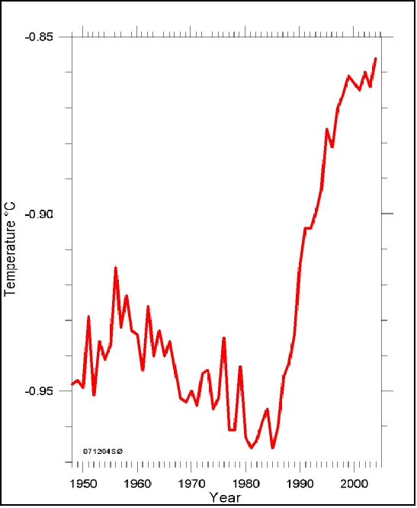 | Figure 2:  Time series (1948-2004) of salinity anomalies (0-2000m, below) and the temperature at 2000 m (left) at the weather ship station M.  