Site: Porcupine Abyssal Plain (PAP)
Position: 49°N 16.5°W (central site)
study area covering 48.4° to 49.4°N and 16.0° to 17.0°W
Categories: physical, biogeochemical, biological, upper ocean and benthic; observatory

Short description:
- 4 moorings
- Variables measured : CTD over top 1000m, and at about 35m depth sensor package with fluorescence, backscatter, PCO2, Nitrate. Downward particle flux at 3000m and 4700m depth. Water currents over top 300m and at 3000m
- Start date of the timeseries, service interval: Upper ocean October 2002, benthic studies since 1989; at least once per year

Scientific rationale:
Biogeochemistry and biology:
The biological pump is responsible for the uptake of about 50% of global anthropogenic carbon sequestration. There is however considerable uncertainly about the absolute uptake rates, their temporal and spatial variability and the changes that are most likely to occur in response to climatic shifts. Because of the strong interdependence of different aspects of the oceanic system (meteorology, ocean physics, biology etc) significant advances in understanding are impossible without integrated cross-disciplinary observations.
During the past decade the intention has been to observe changes in rate and state variables within the entire water column and benthos for a wide range of biogeochemically significant features in the centre of the Porcupine Abyssal Plain (49N 16.5W). The site appears to satisfy many of the conditions for simplicity, it lies well away from regions where physical gradients are strong and is in the middle of one of the biogeochemical provinces. The seabed is very flat over large areas (4800m depth) and there is no evidence of significant advective supply of material. Below the upper mixed layer currents are in general northerly and of low velocity. The uptake of CO₂ from the atmosphere is relatively high which is relevant to issues of global climate change. The depth of winter mixing is large and variable (300-800m) and this facilitates research into the effects of the most important driving force on upper ocean biogeochemistry: nutrient supply. There is a substantial data base from previous programs on which to build: It is about 350Km to the northeast of the site of the JGOFS North Atlantic Bloom Experiment in 1989 is at the northern boundary of the current French POMME program. Ships of opportunity contribute significantly with frequent transects by the Continuous Plankton Recorder since 1949 and currently PCO₂ transects under the EU program CAVASOO.

Groups / P.I.s /labs /countries involved / responsible:
SOC (UK)(Biogeochemistry, biology, physics and benthic biology), Aberdeen University (UK) (Benthic biology), IFM-GEOMAR (Germany) (Biogeochemistry and physics), Bremen University (Germany)( Biogeochemistry),

Status:
- operating
- time horizon / long-term plans: Continuing for at least 5 years and expanding in terms of measurements and interest groups. Expectation to have full meteorological buoy within 5 years.
- funding status, source of funding
PAP is one of the EU ANIMATE sites funded by EU FP6 projects (MERSEA and Carboocean) and is a focus for two additional core strategic programs at SOC. Funding is assured for most aspects of the in situ time series observations for the next three to five years (satellite observations, CTD, PCO₂, nutrients, fluorescence, deep ocean particle flux) and the expectation is that during this period an increasing number of research groups will take advantage of this observational infrastructure.

Technology:
- moored and ship-based sensors
- real-time telemetry: only currently of CTD but expected to cover various other sensors in the next few years
- SST measurements from research ships and sensor package at 35m depth.
- Profile measurements from research ships and from 2005 using the McLane Moored profiler over top 1000m.

Data policy:
- real-time data: public for all data.
- delayed mode data: public for all data

Data management:
- Satellite data collection system: SeaWIFFS, Modis and AVHRR
- Real-time data processing and distribution system: Currently real-time data is processed and an accumulated file is placed daily on an ftp site. When, as is planned, the data are incorporated in systems such as Coriolis the data will be re-encoded and distributed in GTS format.
- Metadata scheme: Protocols are in place to aid the collection of metadata by the data manager. Metadata are currently included in readme files and in NetCDF structures. Where appropriate BODC data dictionary definitions are used.
- The ANIMATE ethos has always been to engage in the creation and embrace any pre-existing standards. This will continue under the auspices of MERSEA and CarboOceans.

Societal value / Users / customers:
If intelligent decisions are to be made about anthropogenic influences on climate change, it is essential that our rudimentary understanding of oceanic biogeochemistry be improved. At present the intention is not to provide operational data for short term forecasting or disaster mitigation but is to enhance fundamental understanding of system structure and function.

Role in the integrated global observing system:
PAP provides a direct comparator with the BATS and HOT sites in its objective and it is hoped that the data coverage will increase over the next 5 years to the levels obtained at these other sites. As part of ANIMATE it is closely linked with observatories in the Irminger Basin and off the Canary Islands.
Contact Person: R.Lampitt

Links / Web-sites:
- for Project information: http://www.soc.soton.ac.uk/GDD/pap/
http://www.soc.soton.ac.uk/animate/
- for data access : http://www.soc.soton.ac.uk/animate/

Compiled/ updated by: Richard Lampitt, March 2005
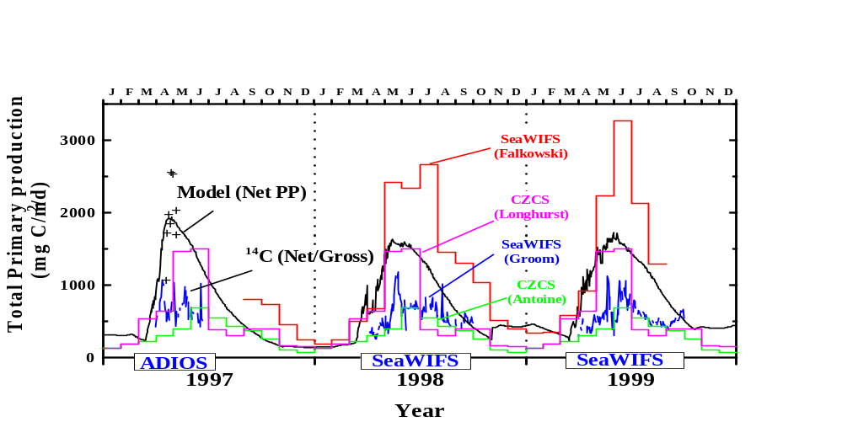
Figure 1
Seasonal changes in total primary production at PAP as determined by satellite (CZCS climatology and SeaWHIFS time specific), by a 7-compartment biogeochemical model driven by NCEP meteorology and by in situ measurement (crosses).

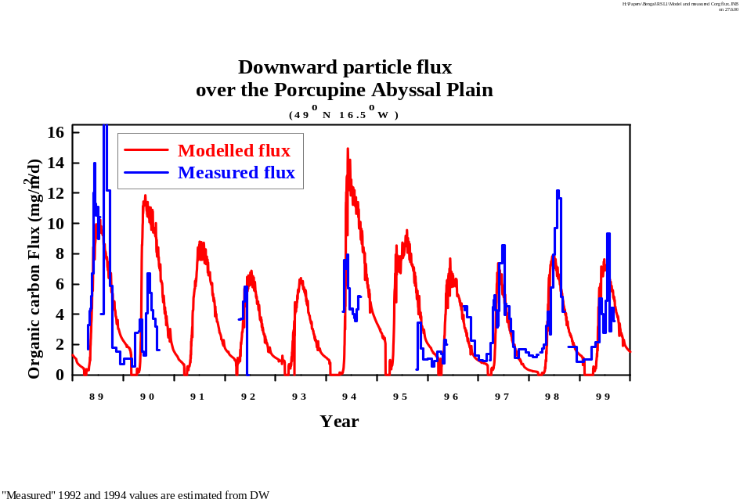
Figure 2
Downward flux of organic carbon at 3000m depth as measured by sediment trap and as described by the biogeochemical model.
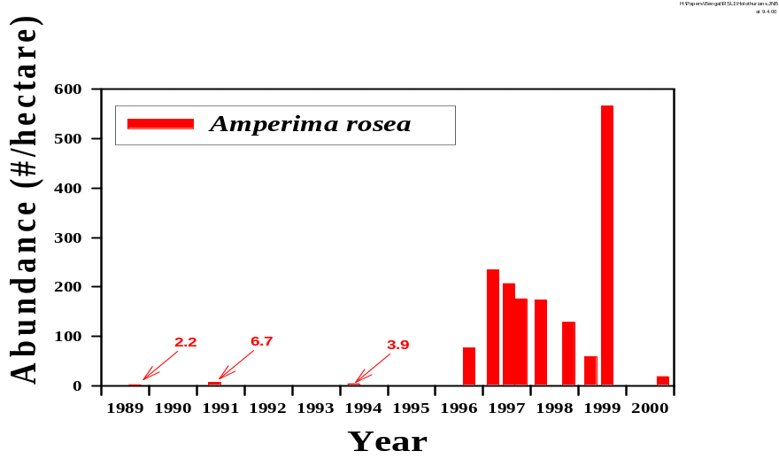 Figure 3
The regime shift in the benthic biota as best represented by the abundance of the holothurian Amperima rosea. This particular species is normally rare but the population over the entire Abyssal Plain exploded between 1994 and 1996. Although not apparently related to the bulk supply of organic carbon from above, this probably reflects qualitative changes in the particulate supply and the ecological changes that have occurred over the last decade in the surface waters of the North Atlantic.
Compiled by

