Site: PIRATA Time Series Sites
Position: 10 º S 10 º W, 0 º N 20 º W and 15 º N 38 º W
Categories:
- recommended
- Air-Sea flux reference 10°S 10°W & 15°N 38°W
- Observatory 0°N 23°W

Safety distance for ship operations:
Two nautical miles. See http://www.pmel.noaa.gov/tao/proj_over/taobuoy.html
Short description:
Three sites are recommended at 10°S, 10°W; 0°, 23°W; and 15°N, 38°W. These sites were initiated in 1997-98 during the pilot phase of the PIRATA program. They are serviced yearly by French and Brazilian research vessels.
The proposed time series locations are in key climatic regimes in the tropical Atlantic, namely in the cold tongue of the central equatorial Atlantic (0°, 23°W) where mean SST is relatively low and variability related to Atlantic warm events is high; and regions north and south of the equator where variations related to the interhemispheric SST gradient mode are large. At the equatorial site, ocean dynamics is important in generating SST anomalies and surface heat fluxes tend to damp those anomalies while at the off-equatorial sites, SST is primarily controlled by air-sea heat fluxes.
All three mooring sites presently measure winds, air temperature, relative humidity, rainfall, shortwave radiation, sea surface temperature, ocean temperatures to 500 m (10 depths), sea surface salinity, and salinity at 20 m, 40 m, and 120 m. Enhancements to this basic measurement suite (long wave radiation, barometric pressure, mixed layer velocity, higher vertical resolution temperature and salinity) would make the moorings fully flux capable.
All data are collected and stored internally at 10-minute sample rates except for rainfall (1 minute), shortwave radiation (2 minutes).

Scientific rationale:
In order to improve our understanding and ability to predict regional climate variability in the tropical Atlantic, it is necessary to quantify to the extent possible the relative magnitudes of processes affecting the evolution of SST in this region on seasonal to decadal time scales. The phenomena of principal interest include equatorial Atlantic warm events (analogous to Pacific El Ninos), and the development of interhemispheric SST gradients. These phenomena significantly affect rainfall over west Africa and northeastern South America. In the north tropical Atlantic, SST variations are known to affect tropical storm and hurricane development in the main development region (MDR) located between 10°-20°N. This region is also subject to significant but poorly understood influences from the Pacific associated with ENSO, and from the North Atlantic associated with the NAO.
Moreover, the North Atlantic has been shown overall to be a strong sink of CO₂ from the atmosphere. In order to establish the magnitude of the air-sea fluxes, as well as their variability on seasonal and interannual and most likely longer time scales, measurements are required at some key locations at the scale of the basin. In the budget of CO2 air-sea fluxes, the equatorial and tropical Atlantic act as a source for the atmosphere owing to the warm water regime of these regions, which may be subject to net warming of surface waters and become then a more significant source of CO₂ for the atmosphere.

Groups / P.I.s /labs /countries involved / responsible:
The PIRATA array is a joint French (IRD, Meteo-France), Brazilian (DHN, INPE) and US (NOAA) collaboration.

Status:
PIRATA will be maintained through the end of 2005 via a memorandum of understanding signed by the agencies involved. A major international review of the program will take place in late 2005 to assess its value for climate research and forecasting. It is expected that this review will recommend that PIRATA be sustained as a permanent component of the Global Ocean Observing System (GOOS) and the Global Climate Observing System (GCOS).

Technology:
The basic technology is used is the ATLAS mooring which measures meteorological and physical oceanographic data to depths of 500 m (see http://www.pmel.noaa.gov/tao/proj_over/mooring.shtml). There is also an upward looking subsurface ADCP mooring deployed at 0°, 23°W. All ATLAS data are transmitted to shore via Service Argos.
Logistic support is provided by ships that routinely service the PIRATA array.

Data policy: All data (real-time and delayed mode) are freely available without restriction.

Data management:
Data are transmitted from buoy to shore via Service Argos. Most data are put on the Global Telecommunications System (GTS). Data are freely available on the World Wide Web without restriction in near-real time (delay of one day) and in delayed mode after moorings are recovered and data are post-processed (See http://www.pmel.noaa.gov/pirata/ ).

Societal value / Users / customers:
PIRATA data are valuable for climate analyses, forecasts, and assessments. Users include the research community, the weather and climate forecasting communities, and the global change community.

Role in the integrated global observing system:
The PIRATA array is a central component of an emerging tropical Atlantic Ocean climate observing system and a pre-operational contribution to GOOS and GCOS. As noted above, it is expected that PIRATA will become a permanent part of GOOS and GCOS following evaluation by the international climate community in late 2005.

Contact Person:
Michael J. McPhaden, NOAA/PMEL (michael.j.mcphaden@noaa.gov)

Links / Web-sites:
- for Project information: http://www.brest.ird.fr/pirata/piratafr.html
- for data access: http://www.pmel.noaa.gov/pirata/

Compiled/ updated by: Michael J. McPhaden (March 2002, revised February 2005)

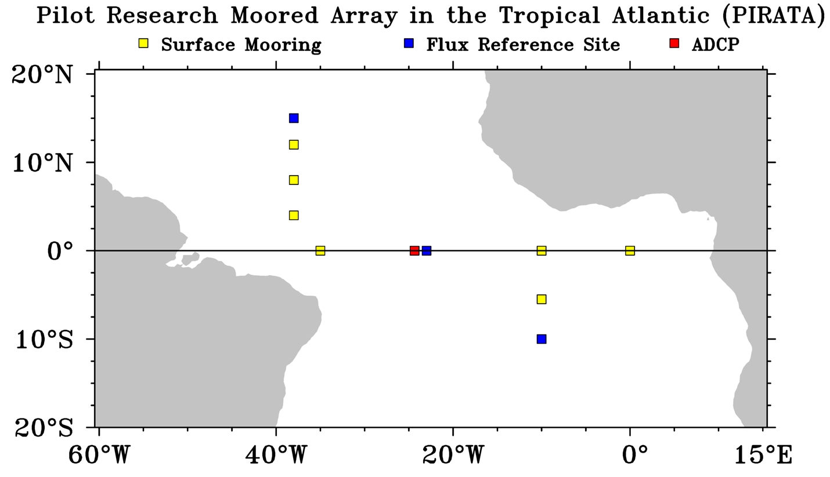 |  | Figure 1  Schematic of the PIRATA array. Proposed OceanSites stations are shown in blue. The site at 0°, 23°W is intended as both a flux reference site and an observatory.
Figure 2  Example of daily moored time series from the PIRATA site at 15°N, 38°W. | 