Site: RAPID - Monitoring the Atlantic Meridional Overturning Circulation at 26°N (AMOC @ 26N)
Position: 26.5N 76.9W - 27.9N 13.4W
Categories: operating; transport, physical

Short description:
Mooring | Latitude (°N) | Longitude (°W) | Corrected Water Depth (m) | Deployment Date
ADCP East | 27.9005 | 13.3935 | 436 | 27/02/2004
EBH5 | 27.8567 | 13.5207 | 1015 | 27/02/2004
EBH4 | 27.8322 | 13.7886 | 1510 | 27/02/2004
EBH3 | 27.6224 | 14.2054 | 2005 | 27/02/2004
EBH2 | 27.4880 | 14.6846 | 2510 | 27/02/2004
EBH1 | 27.2760 | 15.4166 | 3012 | 27/02/2004
EB3 | 26.9961 | 16.2306 | 3515 | 28/02/2004
EB2 | 26.8917 | 16.2339 | 3532 | 28/02/2004
EB1 | 24.5239 | 23.4488 | 5000 | 01/03/2004
MAR3 | 24.4998 | 41.2153 | 5200 | 05/03/2004
MAR4 | 24.5019 | 41.3012 | 4730 | 05/03/2004
MAR1 | 24.4914 | 50.2604 | 4760 | 07/03/2004
MAR2 | 24.4760 | 50.5704 | 5050 | 07/03/2004
BJE (RSMAS) | 26.4945 | 71.9712 | 5295 | 21/03/2004
WB4 | 26.4907 | 76.0433* | 4790 | 23/03/2004
BJB (RSMAS) | 26.4992 | 76.4945 | 4846 | 24/03/2004
WBH2 | 26.5003 | 76.5992 | 4800 | 25/03/2004
WBH1 | 26.5003 | 76.6984 | 4287 | 25/03/2004
WB2 | 26.5153 | 76.7410* | 3898 | 26/03/2004
WB1 | 26.5027 | 76.8138 | 1382 | 27/03/2004
BJA (RSMAS) | 26.5087 | 76.8410 | 1003 | 26/03/2004
ADCP West | 26.5391 | 76.8810 | 395 | 20/03/2004
- Mooring locations and deployment dates for mooring array March 2004 to May 2005:

- Start date of the timeseries, service interval: March 2004, Some parts of the array will be serviced bi-annualy, others annually.

Scientific rationale:
To establish a pre-operational prototype system to continuously observe the strength and structure of the Atlantic meridional overturning circulation (MOC). The MOC is commonly defined as the zonally integrated meridional flow, as a function of latitude and depth. While parts of the MOC are wind-driven, the basin-scale Atlantic MOC is largely buoyancy-forced. Hence, observing the Atlantic MOC is the fundamental observational requirement of a programme aiming to assess the role of the Atlantic thermohaline circulation (THC) in rapid climate change.

Groups / P.I.s /labs /countries involved / responsible:
PI: Jochem Marotzke, Max-Planck-Institut für Meteorologie, Hamburg
CoI: Dr Stuart Cunningham Southampton Oceanography Centre;
Professor Harry Bryden Southampton Oceanography Centre
Collaborators: Professor Bill Johns and Dr Lisa Beal, Division of Meteorology and Physical Oceanography, Rosenstiel School of Marine and Atmospheric Scienses, Miami; Dr Molly O’Neill Barringer, Physical Oceanography Division, Atlantic Oceanographic and Meteorological Laboratory, Oceanic and Atmospheric Research Facilities of the National Oceanic and Atmospheric Administration, Miami. Collaborators Professor Detlef Stammer, Physical Oceanography Research Division, Scripps Institution of Oceanography; Dr Gregorio Parrilla, Instituto Espanol de Oceanografia, Madrid, Spain; Dr Pedro Joaquín Vélez Belchi Instituto Español de Oceanografia - Centro Oceanográfico de Canaria, Dr Chris Hughes, Proudman Oceanographic Laboratory, NERC, UK.

Status:
This project is funded from November 2002. The first mooring array was deployed in March 2004 and will serviced annually (or bi-annually) by this programme until 2008. We are actively seeking funds to continue these observations after 2008.

Technology:
- moored sensors (MMP, BPR, CM, CTD, ADCP)
- real-time telemetry: Two western boundary and one eastern boundary full depth moorings will have telemetry. Telemetry systems were deployed last year but failed within 8 weeks of deployments. A new design of telemetry system will be deployed in the western boundary in May 2005 and in the eastern boundary in October 2005.
- Profile measurements: We propose to monitor continuously full-depth density profiles at and near the eastern and western boundaries, using conventional full-depth mooring at each end with fixed-depth CTDs and new McLane Mooring Profilers. Bottom pressure sensors will be deployed on landers close to the eastern and western boundaries and on either side of the mid-Atlantic Ridge. The BPR measurements will be continuous over two years with duplicate BPRs being deployed every year, giving a continuous record with year long overlaps between instruments. To test the boundary array, two transoceanic sections would be required to obtain MOC estimates toward the beginning and the end of the deployment period, using an independent approach. The SOC James Rennell Division completed a 26.5°N cruise as part of its Core Programme in 2004 ; we expect a second cruise to take place in 2008.
The presence of the Mid-Atlantic Ridge (MAR) complicates the endpoint monitoring of the MOC, because a pressure drop may exist across the ridge. Below the ridge crest, the sub-basins to the east and west therefore have to be monitored separately.
In addition to the full-depth sampling, we propose to instrument the sloping shelfbreak topography, from the deep water to shallow depths, with CTDs, bottom pressure recorders (BPR), and current meters (CM), to obtain continuous observations at fixed depths. This would provide an alternative vertical sampling strategy, and also help solve the bottom triangle problem.
- In summary, our design is based on the strategy that even the complete loss of any one mooring would not jeopardise the project as a whole.

Data policy:
- real-time data: Two principal profiling moorings at the western and eastern boundary will have real time telemetry.
Raw telemetered data (either T/S from 21 fixed depths every hour or twice weekly T/S profiles at 2dbar resolution) from the two principal moorings will be available in real time via the internet
- delayed mode data: public once processed

Data management:
Data collected within the RAPID programme will comply with NERC's policy on data management. The main objective of this policy is to ensure that the data will contribute to a key NERC resource, which will continue to be exploited both scientifically and commercially long after the formal end of the programme. The management of the data collected within the RAPID programme will be the responsibility of the relevant NERC designated data centres.
Mooring data will be publicly available from two years after mooring recovery and managed by the British Oceanographic Data Centre (http://www.bodc.ac.uk/).

Societal value / Users / customers:
Dissemination of research results to the user community.
Appropriate use of partnership and technology transfer schemes.
Development of collaboration and participation of government/industry in scientific research.

Role in the integrated global observing system:
Interannual to decadal property variability
Direct observation of ocean currents.
Continuous basin scale transports of mass and heat.

Contact Person:
Darren Rayner, Southampton Oceanography Centre, Empress Dock, Southampton, SO14 3ZH.
Email: dr400@soc.soton.ac.uk

Links / Web-sites for Project information: http://www.soc.soton.ac.uk/rapidmoc/

compiled/ updated by: Stuart Cunningham, January 2005

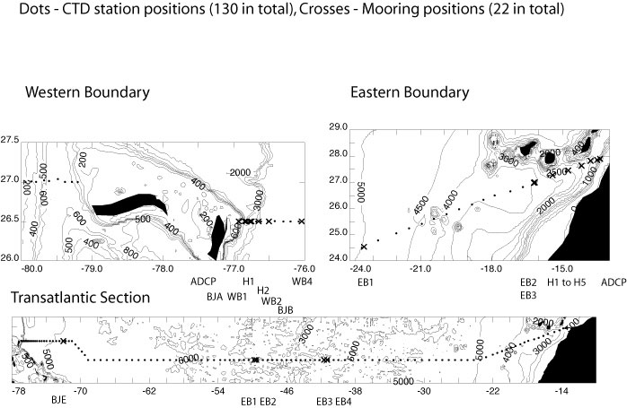 |  | Figure 1:  Monitoring the Atlantic Meridional Overturning Circulation at 26°N, between 14°W and 80°W. Mooring sites are marked by crosses, CTD stations by dots.
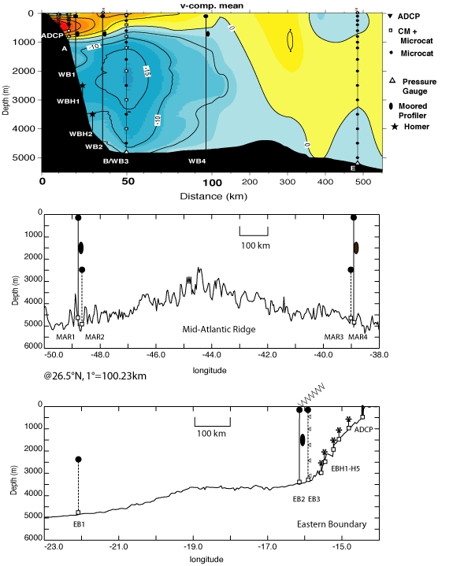  Figure 2: Cross sections of the 26.5°N section showing the mooring locations and instrument distributions. | Western array at 26.5°N:  WB2 with a profiling MMP, a BPR, CM at top and bottom and, crucially, telemetry  WB3 backup, conventional mooring, with 14 CTD and 6 CM instead of the MMP  WB1 similar to WB2, but without telemetry  WBH1, WBH2 with 5 SeaBird CTDs  WB4 similar to WB2, but without telemetry, placed at outer edge of the DWBC core, obtain thermal-wind shear estimates across the strong current  upward-looking ADCP in 500m water depth, to capture the shallow Antilles current  MAR array at 26.5N:  MAR1 and MAR4 similar to WB2, with a profiling MMP and a BPR but without telemetry  MAR2 and MAR3, backup moorings, equipped with 10 CTDs each  Eastern array at 26.6N:  EB2 counterpart to WB2, with a profiling MMP, a BPR, CM at the top and bottom, and telemetry  EB3 backup, conventional mooring, with 10 CTD and 5 CM instead of the MMP  EB1 similar to MAR3, and serves to cover thermal-wind shear at depths greater than the bottom of EB2  EBH1 to EBH5, CTD moorings plus BPR, to obtain density profiles near the sloping bottom, over 400 vertical metres and to minimise leakage due to the potential of incurring a significant bottom triangle error owing to the more gently sloping topography, compared to the western boundary  upward-looking ADCP in 500m deep water, to capture shallow boundary currents.

