Site: SE Greenland (ASOF-West)
Position: 63-63.5N, 35-37W
Categories: Transport, physical
Figure 1 Measurment area of ASOF – W:
shelf array (red), slope array (blue)
Short description:
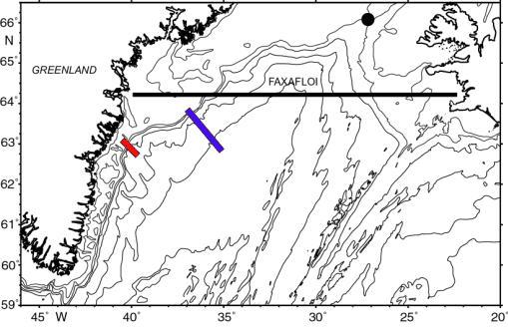
- 4 moorings plus 1 shelf mooring and ADCP:
F2 - 05 63° 35.48' N 36° 38.90' W
UK1 - 05 63° 29.07' N 36° 18.10' W
G1 - 05 63° 21.99' N 36° 04.20' W
UK2 - 05 63° 16.94' N 35° 52.24' W
G2 - 05 63° 07.19' N 35° 32.50' W
ADCP - 20 63° 01.12' N 40° 31.50' W
TUBE - 21 63° 00.27' N 40° 32.74' W

- Variables measured: Currents, T and S
- Start date of the timeseries, service interval:1987, every one to two years, last turnaround in summer 2005

Scientific rationale:
- Monitoring the net transport and phase of the freshwater flux on the SE Greenland shelf.
- Monitoring the core of the Denmark Strait Overflow, found at depths between 1000 and 2500m in a layer up to 300m from the bottom.

Groups / P.I.s /labs /countries responsible / involved:
B. Dickson (CEFAS, UK), J. Meincke (IfM-Hamburg, Germany) and B. Rudels (FMR, Finland)

Status:
- operating till 2006 under ASOF-EC(W) project (EU funded)
- planned to continue but funding not secured yet

Technology:
- moorings with current meters (Aanderaa RCM, RDI ADCP workhorse) and T and S sensors (Microcats SBE)
- The 2 TUBE-moorings have a deflectable top that protects the moored equipment being snagged and destroyed by passing ice. The near-surface buoyancy and instrument packages are enclosed in 45m-long, rigid, freely-flooding, PE plastic shells, designed by IFM Hamburg to deflect on impact with deep ice floes, then return to the vertical.

Data policy:
recent collected data are under the EC data policy and also will be subjected to the recently released CLIVAR data policy: http://www.clivar.org/data/data_policy.htm

Data management:
ASOF is forming a data management task team and the details of the ASOF data management will be defined this year. The general idea is to follow the CLIVAR data management.

Societal value / Users / customers:

Role in the integrated global observing system: Monitoring MOC

Contact Person:
- for enquiry about addition of instrumentation or sensors to the site or for possible ancillary measurements during cruises to the site: Bob Dickson (r.r.dickson@cefas.co.uk)
- for information about the site or data : Jens Meincke (meincke@ifm-hamburg.de)

Links / Web-sites for Project information:
http://www.ifm.uni-hamburg.de/%7ewwwro/ASOF/index.html

Compiled by: Roberta Boscolo; March 2005
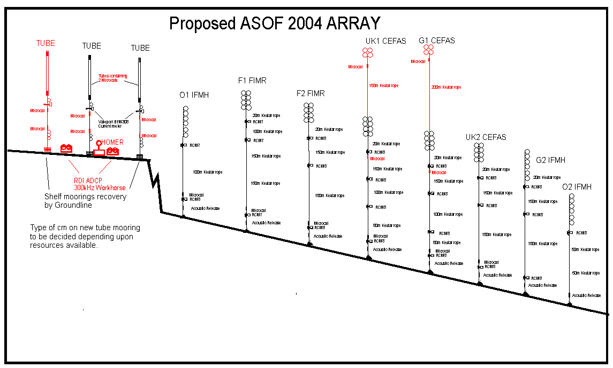
Figure 2 The SE Greenland freshwater and dense overflow array.

