Site: Station W
Position: 39°N 69°W
Categories: operating; Observatory, Transport; physical, biogeochemical

Short description:
- 5 moorings:
Mooring # | lat | lon | water depth | instrument types
0 | 39º 44.3’ N | 69º 48.8’ W | 1800 m | BPR
1 | 39º 36.1’ N | 69º 43.0’ W | 2238 m | MP & BPR &VACM
2 | 39º 13.0’ N | 69º 26.7’ W | 2752 m | VACMs & BPR
3 | 38º 50.7’ N | 69º 11.3’ W | 3248 m | MP & BPR
4 | 38º 25.5’ N | 68º 54.2’ W | 3686 m | VACMs & BPR &UADCP
5 | 38º 04.4’ N | 68º 39.8’ W | 4110 m | MP & BPR
- Variables measured :
MP (Moored Profiler): pressure, temperature, conductivity, velocity
nominally 50 meters – bottom; burst sampling
Mooring #5 1000 meters - bottom
VACM (current meters): velocity / various depths
T/C (Seacat ): temperature, conductivity / various depths
BPR(bottom pressure): pressure
UADCP (upward looking ADCP): velocity
Shipboard transect: CTD (full water column): conductivity, temperature, oxygen, pressure
Bottle samples: CFCs, salinity, oxygen, I129
LADCP, ADCP : velocity
- Start date of the timeseries: Full array of instruments installed April 2004
- service interval: annual Spring turnaround of MP, 2-year turnaround for VACMs, twice yearly shipboard measurements

Scientific rationale:
Station W is designed to be a long-term moored array which, combined with other observing system components, will quantify the time dependent roles of several mechanisms that directly influence the deep limb of the Atlantic meridional overturning circulation. These include deep western boundary current transport variability, advection of property anomalies, and the propagation of topographic Rossby waves and boundary waves. The combination of moored and shipboard observations will clarify the deep ocean response to variability in high-latitude air-sea exchanges and, ultimately, the ocean's role in global climate variability through changes in its transports of heat and freshwater.

Groups / P.I.s /labs /countries involved / responsible:
WHOI, USA (Toole, Curry, Joyce, Pickart)
LDEO, Columbia University, USA (Smethie)
Collaboration with UK RAPID (Hughes, Williams, Marshall)

Status:
- Operating: started 2002 (1 MMP) with grant from Vetlesen Foundation
- presently funded for 5 years (2003 – 2008) by National Science Foundation
- will seek continuation past 2008

Technology:
- 3 moorings are instrumented with MacLane/WHOI Moored Profilers (MP) to acquire autonomous full water column p,t,s and velocity profiles
- 2 moorings consist of VACMs, T/C recorders and 1-upward looking ADCP
- Twice yearly shipboard hydrographic transects along the array including CTD, LADCP, ADCP and discrete depth sampling for salinity, oxygen, CFCs, and I129.

Data policy: All data are web-distributed in delayed mode.

Data management:
Metadata scheme : MP data: gridded arrays (Matlab)
CTD, Bottle data: WOCE and HydroBase formats
VACM: ascii text
LADCP: TBA
SADCP: TBA

Societal value / Users / customers:

Role in the integrated global observing system:
Time series measurements of DWBC velocities and property distributions will aid in quantifying the response of the Atlantic MOC's deep limb to high latitude climate variability.

Contact Person for enquiry about addition of instrumentation or sensors to the site and for possible ancillary measurements during cruises to the site: John Toole (jtoole@whoi.edu )

Links / Web-sites:
When website officially goes online: http://www.whoi.edu/science/PO/StationW

Compiled / updated by: Ruth Curry, March 2005
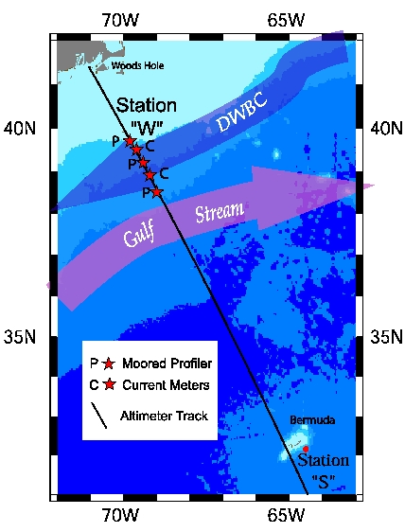 | Figure 1 (left)  Map depicting location of Station W moored array relative to the Gulf Stream and DWBC, regional bathymetry and altimeter ground track.  Figure 2 (bottom)  Mean sections of water properties and velocity along the Station W measurement line based on 8 previous occupations of the trackline between 1994-2001. The location of the slope array is diagrammed in each panel.
