Site :Vema Channel
Position: 31° S 39° W
Categories: Physical Observatory

Safety distance for ship operations: Not necessary
Short description:
- Two subsurface moorings in the Antarctic Bottom Water level:
Vema-East 31° 15.28'S 39° 18.96'W
Vema-West 31° 15.60'S 39° 27.19'W
- Variables measured : temperature at 3200, 3500, 4000, 4300, 4500 m; salinity at 3200, 4000, 4300, 4500 m; current-direction and -speed at 3200, 3700, 4000, 4300, 4500 m.
- Start date of the timeseries, service interval: December 2003, serviced every 1-2 years

Scientific rationale:
The formation and northward spreading of Antarctic Bottom Water (AABW) represents an important part of the cold water branch of the global thermohaline circulation (THC). In the South Atlantic, the narrow (ca. 30 km) Vema Channel (Fig. 1) allows for about 60% of its northward volume transport from the Argentine into the Brazil Basin thus partly compensating for the southward transport of North Atlantic Deep Water (NADW).

The suggested "Vema Observatory" aims at monitoring the the variability of the AABW branch in the THC of the Atlantic, both in water mass characteristics and flow strength. Using available close-to-bottom CTD data on the channel’s sill, it is obvious that the AABW temperature increased significantly by 0.06 K between 1973 and 2002 and since then stays high (Fig. 2). The causes for this increase and its implication on the heat balance are still unknown. However, the increase in temperature highlights that also deep and bottom water flows as the cold branches of the THZ may significantly contribute to the total heat balance.

The narrow and well-defined passage of the Vema Channel provides a topographically excellent choke point to observe the AABW characteristics and flow. Also, the site is located not too far from regular passages of research ships to and from Antarctica for biannual morring services.

Groups / P.I.s /labs /countries involved / responsible:
IFM-GEOMAR, Kiel , Germany, Thomas J. Mueller (tmueller@ifm-geomar.de)
IFM-GEOMAR, Kiel , Germany, Walter Zenk
Shirshov Institute, Moscow, Russia, Eugene Morozov
WHOI, Woods Hole, MA, USA, Nelson Hogg, John Toole

Status:
- Operational since December 2003 until late 2006;
- time horizon / long-term plans: as significant fluctuations in temperature on a decadal scale are obvious, continued observations is needed well into the next decade for monitoring and understanding
- funding status, source of funding: in Germany, the Vema Channel monitoring moorings are project funded from 2003-2006 as part of the national CLIVAR observational program. From late 2006 on, funding is uncertain; other groups are welcome to take over.

Technology:
- dep sea near bottom moored sensors: Microcat (SBE37), Aanderaa Current Meter (RCM8 and RCM11), MTD- Logger; no data telemetry
- Profile measurements: deep CTD casts on the occasion of mooring services.

Data policy:
- delayed mode data: public six months after data acqusition / mooring recovery; use of data for publication in co-operation with the principal investigator only.

Data management:
- Metadata scheme (collection, distribution mean, format): IFM-GEOMAR formats and cruise reports
- Possibilities of evolution to comply with a more general JCOMM GTS scheme (incl. Metadata): presently difficult

Societal value / User / customers:
Analysts of ocean climate forecasts and assimilation models.

Role in the integrated global observing system:
Branch of the world-wide thermohaline circulation and its fluctuations with global impact on climate changes.

Contact Person:
- for enquiry about addition of instrumentation or sensors to the site: Thomas J. Müller, IFM-GEOMAR, Kiel, Germany, tmueller@ifm-geomar.de.
- for possible ancillary measurements during cruises to the site: Thomas J. Müller, IFM-GEOMAR, Kiel, Germany, tmueller@ifm-geomar.de.

Links / Web-sites:
- for project information : to be established
- for data access (if public) : to be established

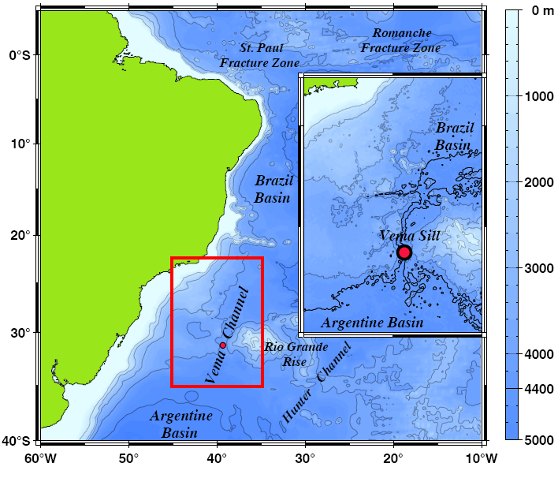
Figure 1: The Vema-Channel connects the Argentine and Brazil basins.
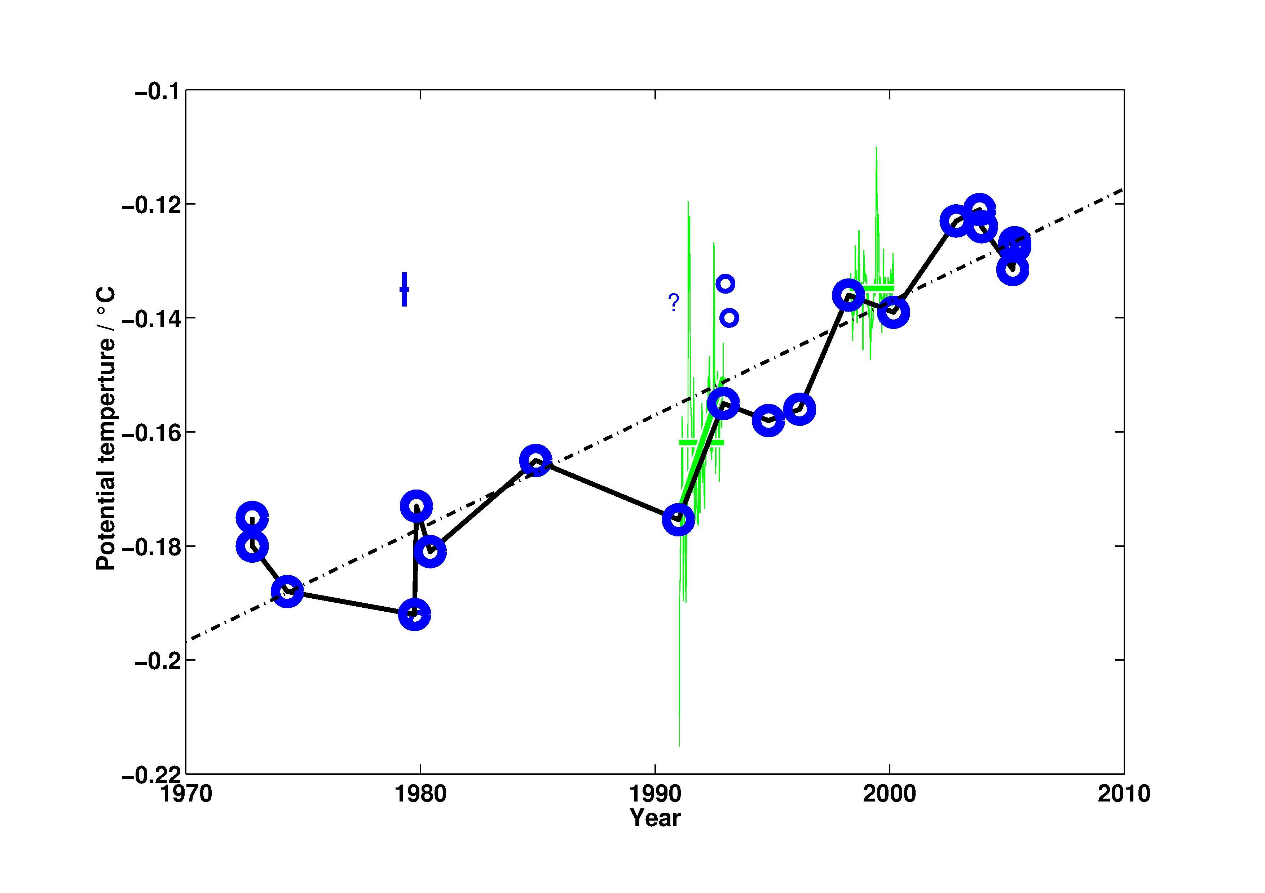

Fig 2: Bottom temperature at the Vema Channel sill 1973 to 2005; CTD casts (circles); overall trend (dashed line); moored instruments (green, weekly subsamples) with averages during WOCE (1991-1993) and pre-CLIVAR (1998-2000)

Compiled by: Thomas J. Mueller, W. Zenk (Feb. 2006)

Selected references:
- Hogg, N. and W. Zenk (1997): Long-period changes in the bottom water flowing through Vema Channel. J. Geophys. Res., 102 (C7) 15,639-15,646.
- Zenk, W., E. Morozov, A. Sokov and T.J. Müller (2003): Vema Channel: Antarctic bottom water temperatures continue to rise. CLIVAR Exchanges, 26, 24-26.
- Zenk, W. und U. Neumann* (in the press): Cruise Report, FS POLARSTERN, Cruise ANTXXII/5, Berichte zur Polar- und Meeresforschung, Alfred-Wegener Institut für Polar- und Meeresforschung.

