Site: Indian Ocean Moored Buoy Array
Position: Eight sites are recommended in various regions of the tropical and subtropical Indian Ocean as described below.

Categories: Observatory and air-sea flux reference sites with physical, meteorological, biogeochemical measurements.

Safety distance for ship operations: 2 nautical miles. See http://www.pmel.noaa.gov/tao/proj_over/taobuoy.html

Short description:
A total of eight sites are recommended within the framework of the CLIVAR/GOOS Indian Ocean moored buoy array (Fig. 1). Two sites are recommended along the equator (55°E and 80.5°E), one site in the Arabian Sea (15°N, 65°E), one site in the Bay of Bengal (15°N, 89°E), one site along the thermocline ridge centered south of the equator (8°S, 67°E), one site in the southwestern basin (16°S, 55°E), one site in the region offshore of the Java upwelling zone (5°S, 95°E), and one site in the subduction zone of the southeastern subtropical Indian Ocean (25°S, 97°E).

Scientific rationale:
The sites have been chosen on the basis of their location in regions of strong ocean-atmosphere interactions. In addition, several of the sites are located in regions where currently available flux products are widely divergent in terms of their net mean values of air-sea heat exchange. The data from these sites will be used for describing new phenomena, for diagnostic studies, for model validation, and for satellite validation. They will also be valuable in helping us to understand and resolve the biases between the various heat flux products. Below is a brief site-by-site summary of salient features.

Arabian Sea (15°N, 65°E): Strong seasonally reversing monsoon winds, large seasonal variations in SST, high SSTs before the onset of the southwest monsoon, significant latent heat losses during the southwest monsoon. Current heat flux products have difficulties in producing the intensity of latent heat losses in the southwest monsoon season.

Bay of Bengal (15°N, 89°E): Large seasonal and intraseasonal variations in surface heat and fresh water fluxes, thin salinity stratified mixed layers, significant air-sea interactions associated with tropical cyclones and instraseasonal variability. Current heat flux products show large differences here and disagree on whether the region should gain heat from the atmosphere on annual mean basis (Fig. 2b).

Western Equatorial Indian Ocean (0°, 55°E): Located in the western SST index region for Indian Ocean Dipole Zonal Mode and a region of high net heat flux into the ocean (Fig. 2a). Current heat flux products show large differences here due to differences in net solar radiation (Fig. 2b).

Central Equatorial Indian Ocean (0°, 80.5°E): Strong semiannual wind forcing associated with the monsoon transition westerlies, significant intraseasonal variability associated with the Madden-Julian Oscillation. Current heat flux products show large differences here due largely to differences in net surface radiation (Fig. 2b). Various precipitation products also show large differences here.

Eastern Equatorial Indian Ocean (5°S, 95°E): Offshore of the Java coastal upwelling zone in the eastern SST index regions for the Indian Ocean Dipole Zonal Mode. Current heat flux products show large biases here and cannot agree on the sign of the annual mean net heat flux. This is also another region where precipitation products show large differences (Fig. 2b).

Thermocline Ridge (8°S, 67°E): Region of large seasonal and interannual variations in the thermocline ridge that are correlated with SST variations; and a region of large intraseasonal variations in SST. Current heat flux products show large differnces here and do not agree on the sign of the annual mean net heat flux (Fig. 2b).

Subduction Zone (25°S, 97°E): Located in the southeast subtropical Indian Ocean where mixed layer water masses are subducted into the subtropical pycnocline. This is also a region of large mean oceanic heat loss to the atmosphere (Fig. 2a).

Southwestern Indian Ocean (16°S, 55°E): Located in a region where variability in the thermocline ridge and SST are significantly correlated with tropical cyclone activity.

Groups / P.I.s /labs /countries involved / responsible:
P.I.s for the current operational sites at 5°S, 95°E and 0°, 80.5°E are Y. Kuroda of JAMSTEC and M. J. McPhaden of NOAA//PMEL, respectively. The site at 0°, 80.5°E represents a collaboration between NOAA/PMEL, the Indian National Institute of Oceanography (NIO), and the Indian Department of Ocean Development (DOD). Other sites are not yet occupied. It is anticipated that PMEL will maintain some of these sites as part of its contribution to the CLIVAR/GOOS moored buoy array as additional ship time and funding becomes available. Other countries, institutions, and P.I.s are welcome to participate in the establishment of these sites. NOAA/PMEL anticipates placing CO₂ sensors on all 8 moorings within the next five years. This work will likely be in collaboration with international partners. The lead P.I. for the pCO₂ systems is Christopher Sabine at PMEL.

Status:
Two sites are operational, one maintained by JAMSTEC with a TRITON mooring at 5°S, 95°E (initiated in October 2001) and one maintained by NOAA/PMEL, NIO, and DOD with an ATLAS/ADCP mooring combination at 0°, 80.5°E (initiated in October 2004). These sites are presently serviced at yearly intervals and will be maintained for the foreseeable future. The JAMSTEC site is described in detail in a separate submission by Y. Kuroda. Currently there are no CO₂ measurements on these moorings. We hope to begin installing CO₂ systems by 2007.

Technology:
The basic technology used at 0°, 80.5°E is the PMEL ATLAS mooring, which measures meteorological and physical oceanographic data to depths of 500 m (see http://www.pmel.noaa.gov/tao/proj_over/mooring.shtml). ATLAS moorings at flux reference sites measure surface winds, air temperature, relative humidity, rainfall, shortwave radiation, longwave radiation, and sea level pressure, ocean temperatures at a minimum of 13 depths between the surface and 500 m, ocean salinity at a minimum of 8 depths between the surface and 100 m, and ocean currents at 4 depths between 10 m and 200 m. All data are transmitted in real-time as daily averages and a few spot hourly values. Data are stored internally at 10-minute intervals, except for rainfall at 1 minute intervals, short and long wave radiation at 2 minute intervals, and surface air pressure at 1 hour intervals. Equatorial ATLAS moorings are deployed next to nearby (within about 10 km) subsurface ADCP moorings to provide hourly velocity measurements between depths of about 20-250 m with 8 m vertical resolution. The TRITON mooring used at 5°S, 95°E is functionally equivalent to an ATLAS mooring in most respects in terms of measurement suite and sampling schemes. The pCO₂ measurements will be LiCor based infrared detection systems mounted in the surface buoy with an equilibrator for surface water pCO₂ measurements. Surface ocean and atmospheric carbon measurements are made every 3 hours.

Data policy:

All data (real-time and delayed mode) are freely available without restriction.

Data management:
ATLAS and TRITON data are internally recorded and transmitted from buoy to shore in real-time via Service Argos. Service Argos places most real-time data on the Global Telecommunications System (GTS). ADCP data are internally recorded only. Data are freely available on the World Wide Web without restriction in near-real time (delay of one day for ATLAS and two days for TRITON) and in delayed mode after moorings are recovered and data are post-processed. Extensive metadata are available from TAO and TRITON web pages, from data reports, and from the data files themselves. Measurements of pCO₂ will be made every 3-hours and transmitted daily via Iridium to be posted to the WWW. Final calibrated data will be submitted to the Carbon Dioxide Information Analysis Center and made freely available within 6 months of recovery.

Societal value / Users / customers:
Data users include the research community, the weather and climate forecasting communities, the climate assessments community, policy makers, and the general public.

Role in the integrated global observing system:
The designated sites are an integral part of the CLIVAR/GOOS Indian Ocean observing system, which is a component of the Global Ocean Observing System (GOOS) and the Global Climate Observing System (GCOS). It is also a contribution to the Global Earth Observing System of Systems (GEOSS). The planned carbon observations are a key element of the U.S. Ocean Carbon and Climate Change Program (OCCC) as well as the international Integrated Marine Biogeochemistry and Ecosystem Research (IMBER) and Surface Ocean Lower Atmosphere (SOLAS) programs.

Contact Persons:
Michael J. McPhaden, NOAA/PMEL (michael.j.mcphaden@noaa.gov)
Yoshifumi Kuroda (kuroday@jamstec.go.jp)
Gary Meyers (gary.meyers@csiro.au)
Carbon contacts: Christopher L. Sabine (chris.sabine@noaa.gov) and Bronte Tilbrook (Bronte.Tilbrook@csiro.au)

Links / Web-sites:
Indian Ocean Observing System: http://www.clivar.org//
Data access: http://www.jamstec.go.jp/triton/data_deliv/ and http://www.pmel.noaa.gov/tao/disdel (site under development)

Compiled by:
Michael J. McPhaden (NOAA/PMEL) with input from Gary Meyers (WHOI), Lisan Yu (WHOI), Yoshifumi Kuroda (JAMSTEC), VSN Murty (NIO), Chris Sabine (NOAA/PMEL), Bronte Tillbrook (CSIRO).

June 2005

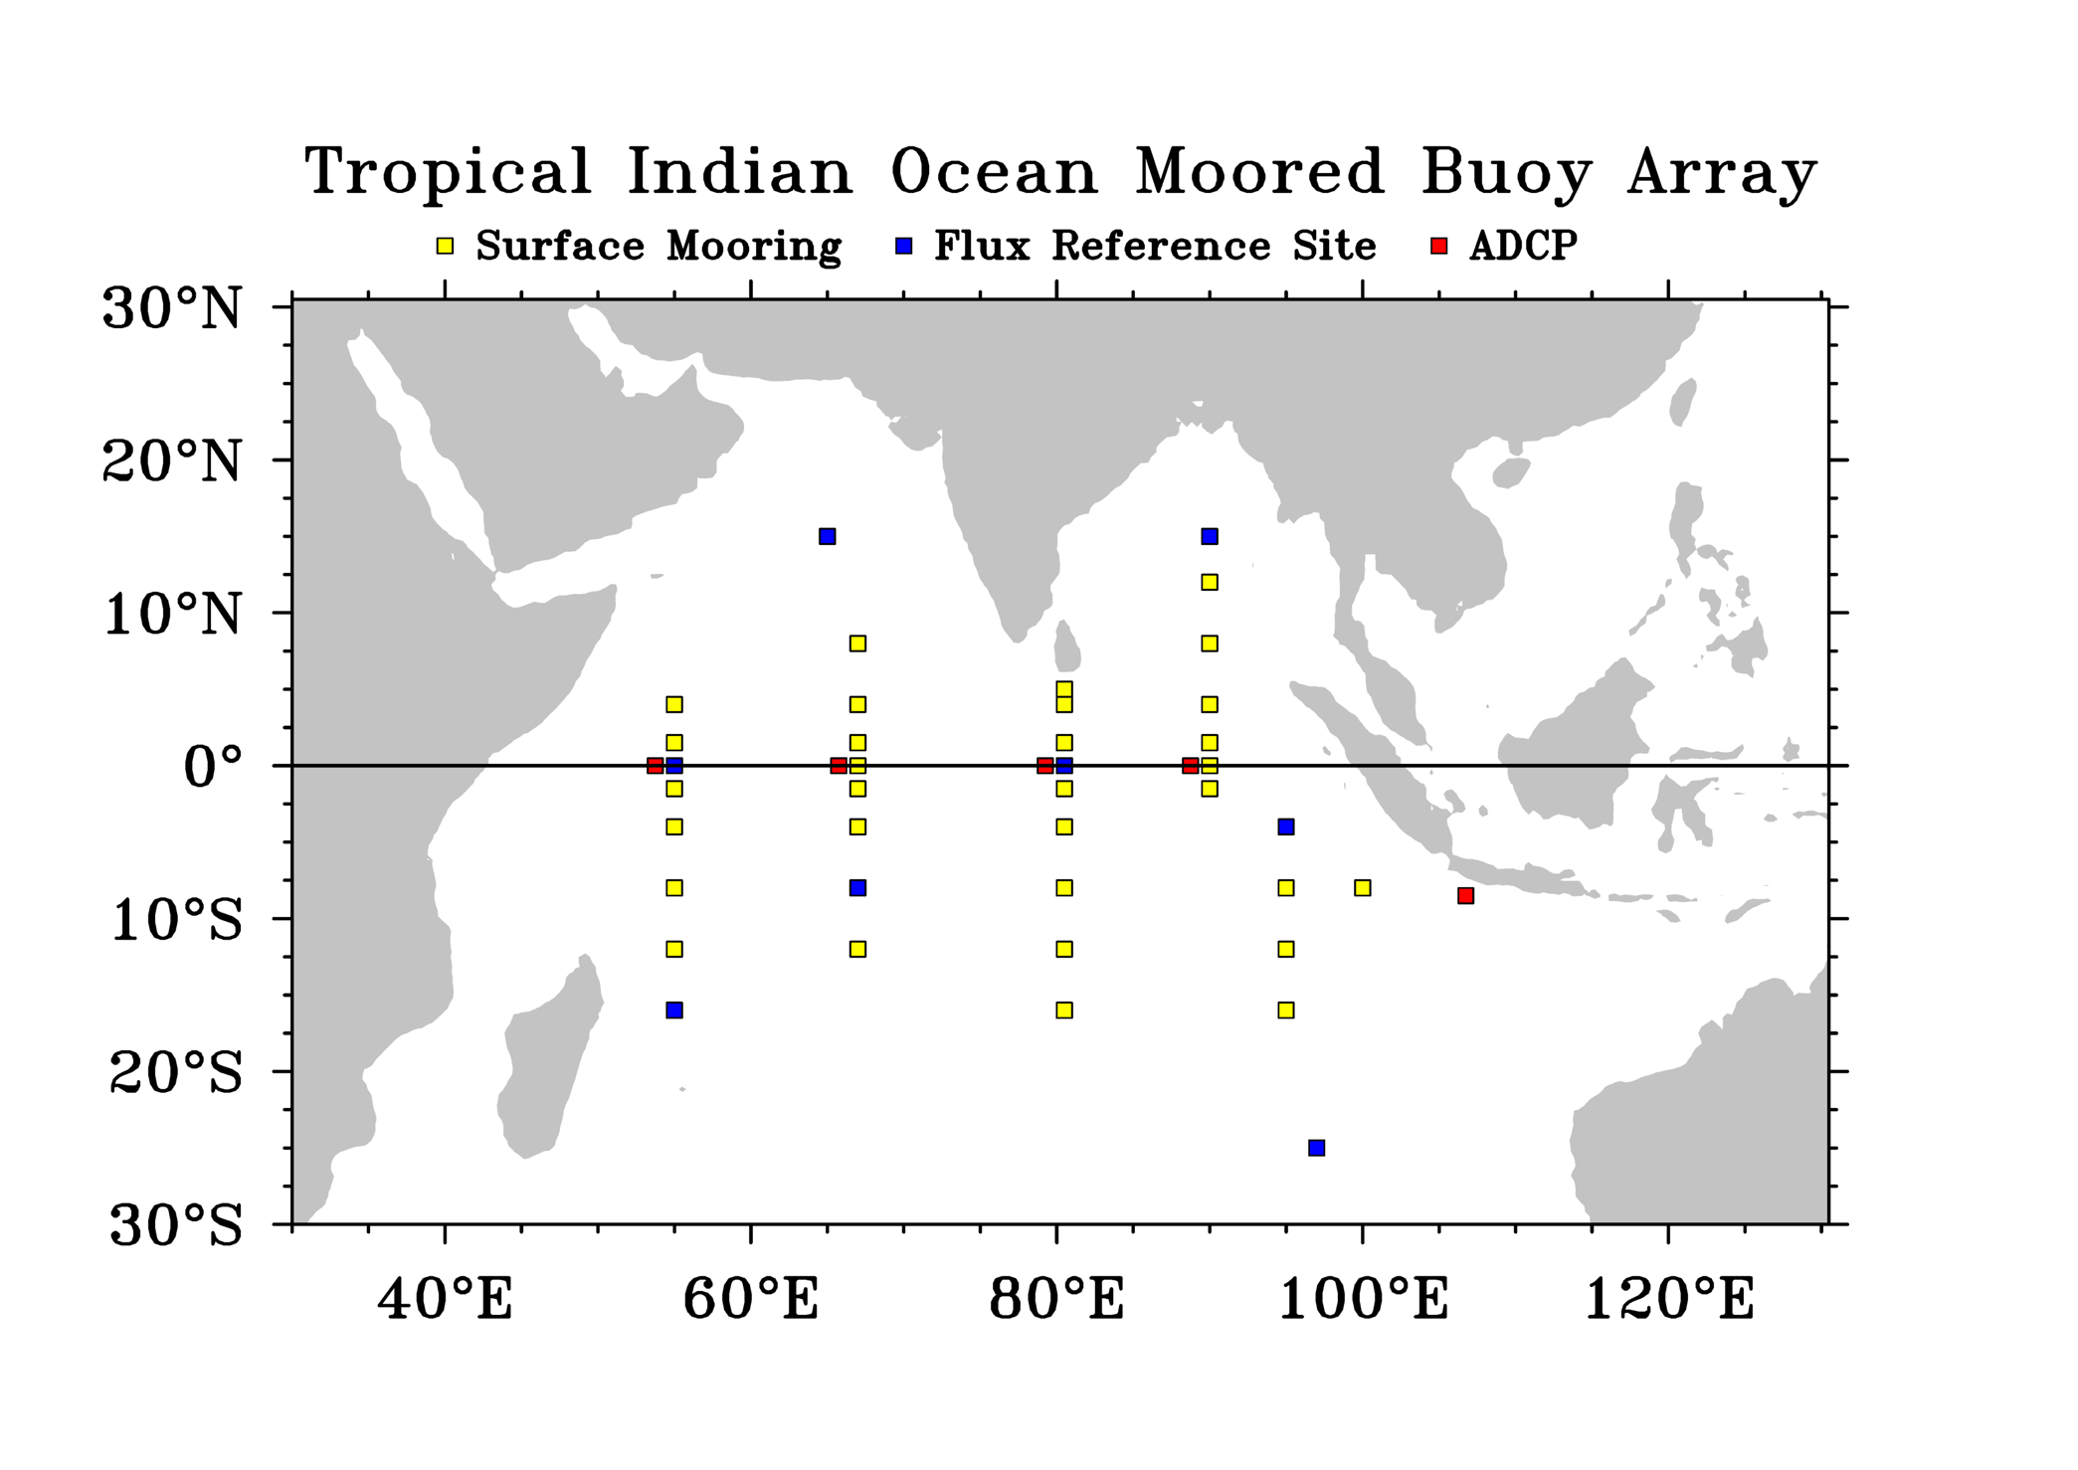
Figure 1: Draft plan for an Indian Ocean moored buoy array as part of a sustained and integrated ocean observing system.

(a) (b)
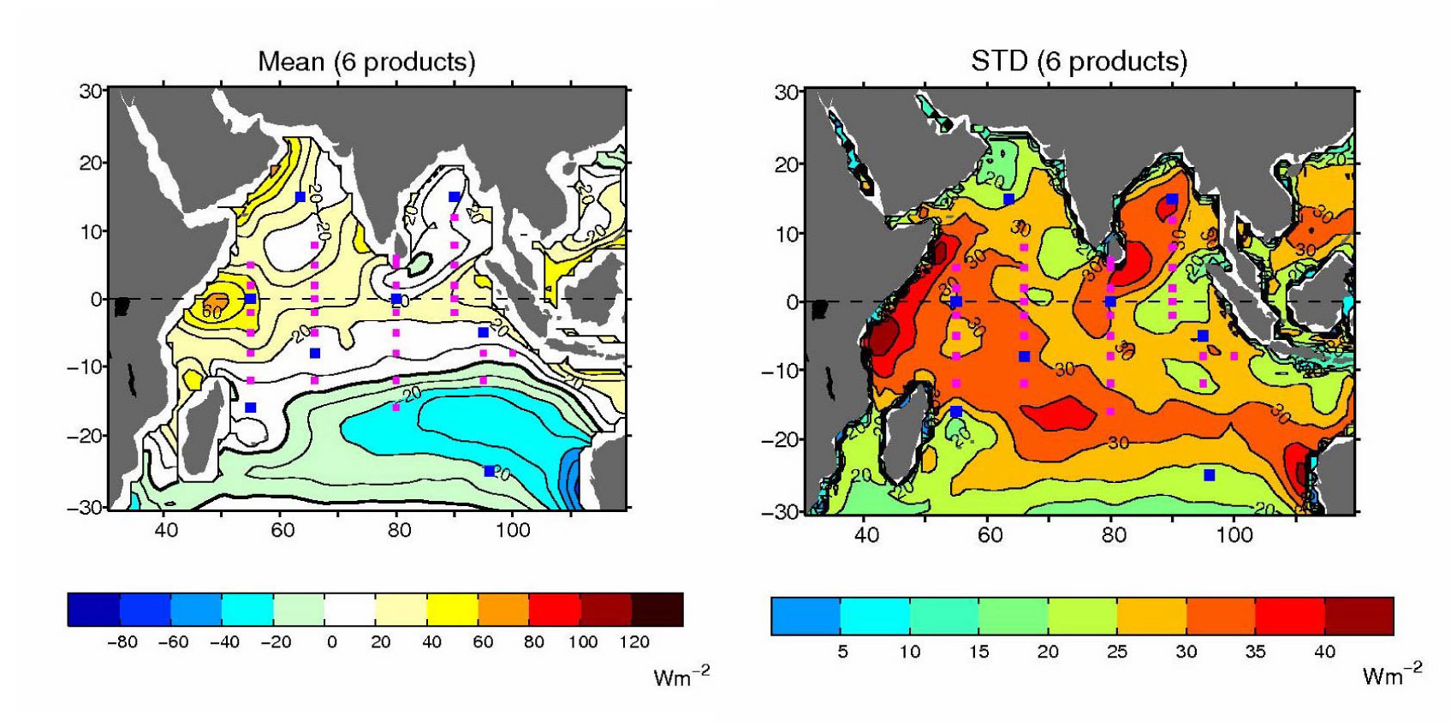
Figure 2: (a) Mean and (b) standard deviation of record length means from an ensemble of six surface heat flux products in the tropical Indian Ocean. The six products are OFA+ISSCP (WHOI), NCEP/NCAR reanalysis (NCEP1), NCEP/DOE reanalysis (NCEP2), ECMWF operational analysis, ECMWF reanalysis (ERA-40), and Southampton Oceanography Centre (SOC) analysis. (Courtesy of L. Yu, WHOI).

