Site: Long-term measurements of currents in the eastern equatorial Indian Ocean
Position: 0; 93 E, 83 E and 76/77 E
Categories: observatory, physical

Safety distance for ship operations: OOS (Ocean Observing System) moorings are of subsurface nature.
Short description:
- 3 current meter moorings
- Variables measured : Current speed, direction, temperature, salinity and pressure at each depth of RCMs. The sampling interval is 1 hour. The moorings deployed in 2004 keep upward looking ADCP at 100 m depth.
- Start date of the timeseries, service interval: February 2000 (One mooring at 93E in 2000, two current meter moorings at 83E and 93E in 2001 and 3 current meter moorings at 93E, 83E and 76E in 2002. In 2003, the location of 76E current meter mooring was shifted to 77E.), annual servicing

Scientific rationale:
The sparse measurements of currents in the eastern equatorial Indian Ocean (EEIO), particularly east of 80E, compared to the western and central equatorial regions prompted the beginning of time series current measurements on longer time scale in the EEIO, characterised with an eastern boundary off Sumatra. The current and temperature measurements are planned
- to understand the variability of currents in the entire water column in the EEIO on intraseasonal, seasonal, and interannual time scales,
- to document the differences in the variability of currents and dynamics in the eastern basin from that of in the western basin (from the information available from earlier experiments prior to 2000),
- to document the variability in the EEIO response to the wind forcing,
- to address the meridional overturning circulation in the EEIO, and
- to support the Indian Ocean modelling community with the in situ data to address the feed back, if any, of EEIO dynamics on the Indian monsoon.
To supplement the time series data, hydrographic surveys were also planned (and are being undertaken) to understand the upper ocean variability by collecting multi-disciplinary data in the EEIO.

Groups / P.I.s /labs /countries involved / responsible: National Institute of Oceanography, Goa, India

Status:
- operating
- time horizon / long-term plans: 6 years from 2000.
- funding status, source of funding: Department of Ocean Development (DOD), Government of India.

Technology:
Subsurface I-moorings; in each mooring, 6 RCMs were placed at six depths (see Table 1). In 2004 deployments, all the three moorings have an upward looking ADCP kept at 100 m depth. Also, Microcat CTDs were placed at 4000 m depth at 93E and 83E in 2002-2004. In 2004 deployment, the Microcat CTDs were placed at 200 m depth for obtaining high resolution temperature and salinity data.

Table 1: Mean depth [m] of RCMs in each deployment at each location

Station No. | 2000 | 2000-02 | 2002-03 | 2003-04 | 2004-05
EQCM 1  [Eq., 93E] | 135, 280, 487, 983, 1996, 3995 | 106, 264, 462, 966, 1969, 3968 | 64, 267, 469, 972, 1983, 3986 | 76, 365, 501, 996, 1981, 3991 | To be recovered
EQCM 2  [Eq., 83E] |  | No Data, 385, 590, 1072, 2081, 4095 | 140, 343, 545, 1047, 2049, 4052 | 139, 339, 534, No Data, 2022, 4000 | To be recovered
EQCM 3  [Eq., 76E] |  |  | 418, 621, 823, 1326, 2330, 4134 | ------ | ------
EQCM 3  [Eq., 77E] |  |  | ------ | 168, 389, 568, 1059, 2101, 4084 | To be recovered

Data policy: Delayed mode data. Policy for data distribution is to be formulated.

Data management:
- Metadata scheme: Copy of the data will be deposited with the Department of Indian National Center for Ocean Information System (INCOIS), Hyderabad, India.

Societal value / Users / customers:
Improvement the long-term predictive capability of the Indian Monsoon Rainfall is very essential for the agriculture-dependent people of India and neighbouring Asian countries. Understanding the dynamical role of the ocean in monsoon climate is the first step toward understanding predictability. Ultimately, improved intraseasonal, seasonal and longer term climate prediction is essential for mitigation of societal impacts, by smart management of agriculture, water resources, natural resources (e.g. fisheries) and many other impacted sectors.

Role in the integrated global observing system:
Towards understanding the role of the Indian Ocean, particularly the equatorial Indian Ocean which is not studied much compared to its counterparts such as the Equatorial Pacific and Atlantic, on the Asian monsoon climate over India, a sustainable Ocean Observing System (OOS) program was initiated in 2000 by the Government of India. One aspect of this OOS Program was the deployment of current meter moorings for measuring long-term time series currents and temperature data along the equator at 3 locations. The other programs were the deployment of surface drifters, occupation of XBT lines and surface moored buoys in the Bay of Bengal and the Arabian Sea. The OOS program would constitute the Plot program of the Indian Ocean - Global Ocean Observing System (IO-GOOS). However, continuation of the current meter moorings in the EEIO for a period of 3-5 years (beyond 2007) and simultaneous time series measurements from the moorings in the western and central equatorial Indian Ocean would form an integrated ocean observatory for an understanding the regional climate predictability.

Contact Person: Dr. V.S.N. Murty,
National Institute of Oceanography,
Dona Paula, Goa – 403 004
India.

Links / Web-sites:
- for Project information and data access:
http://www.nio.org/data_info/deep-sea_mooring/oos-deep-sea-currentmeter-moorings.htm

Compiled by : V.S.N. Murty, NIO, Goa (March 2005)

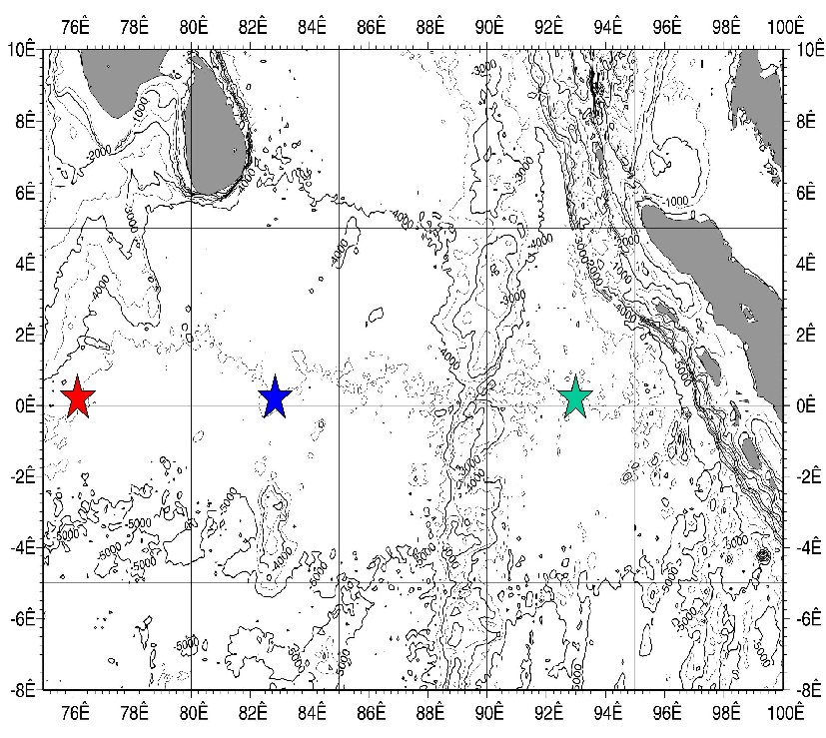

Figure 1:
The mooring locations are 93E, 83E and 76E. The latter mooring location was shifted to 77E in 2003.

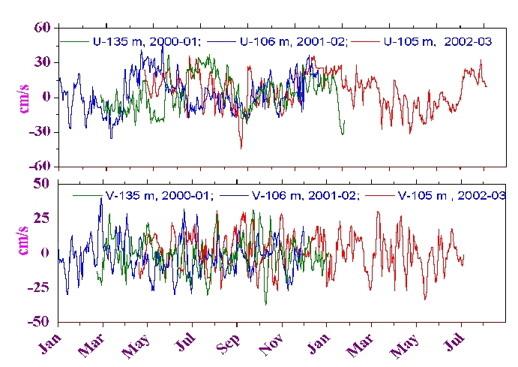

Figure 2:
Variation of U & V at 100 m depth (93°E) from 2000 to 2003
Zonal velocity shows low frequency variation- comprising the equatorial Jets and monsoon currents
Meridional velocity shows considerable intraseasonal variability – comprising of 10-20 day period (biweekly) and 20-30 day period oscillations.

