Site: Indian Ocean TRITON mooring
Position: 0°N 90°E & 5°S 95°E
Categories: Air-sea flux reference site and observatory with meteorological and physical measurements

Safety distance for ship operations: 2 miles same as for TAO moorings
Short description:
- Two TRITON buoys are deployed in the eastern tropical Indian Ocean. One TRITON buoy is located at 1.5S, 90E to determine the upper-layer variations associated with the zonal jets along the equator. Another buoy is deployed at 5S, 95E, to investigate the contribution of the surface heat flux and the ocean dynamics/thermodynamics to the SST variability in the eastern part of the DM. This location corresponds to the center of the area where the maximum SST anomaly appears during the peak period of the DM.
- Variables measured :
- surface meteorological sensors: wind vector, shortwave radiation, relative humidity, air temperature, atmospheric pressure, rain rate
- subsurface sensors:
  - temperature and conductivity (1.5, 25, 50, 75, 100, 125, 150, 200, 250, 300, 500, 750m)
  - pressure (300m, 750m)
  - current vector (10m)
- Sampling rate: every 10 min (except current meter of 20 min)
- Start date of the timeseries, service interval:
Indian Ocean: 1.5S 90E ; deployed in October 2001
5S 95E ; deployed in October 2001
(This site at 1.5S 90E has been maintained instead of 0,90E site because there is a possibility that extremely strong surface jet may make surface buoy sink.)
Subsurface ADCP mooring at 90E-0 was deployed in November 2000.
Service interval is once a year

Scientific rationale:
The major target is to elucidate the air-sea interaction and subsurface oceanic variability associated with Indian Ocean Dipole Mode. These buoys are also to contribute as part of the CLIVAR/GOOS basin wide Indian ocean mooring array from which data will be utilized in climate prediction models and enable to improve prediction skill.

Groups / P.I.s /labs /countries involved / responsible:
Dr. Yoshifumi Kuroda, IORGC of JAMSTEC
Dr. Yukio Masumoto, IORGC of JAMSTEC, University of Tokyo

Status:
- Operating
- The sites by present TRITON system will be maintained at least until 2008 by JAMSTEC as a pilot study and those will be plugged in the future Indian Ocean Mooring array.
- Funded by the Japanese Ministry of Education, Culture, Sports, Science, and Technology.

Technology:
- moored surface mooring
- real-time telemetry
- SST measurement: SBE 37-IM, Sea Bird Electronics, at 1.5 m depth on the cradle of surface float

Data policy:
- real-time data:
- wind vector, relative humidity, air temperature, atmospheric pressure (on GTS and web)
- temperature (1.5, 25, 50, 75, 100, 125, 150, 200, 250, 300, 500, 750m) (on GTS and web)
- shortwave radiation(to be appeared on web)
- current vector (10m) (to be appeared on web)
- delayed mode data: rain rate (because of large data quality variance)

Data management:
- Satellite data collection system : ARGOS
- Real-time data processing and distribution system : GTS through French ARGOS global processing center
- Metadata scheme : The real-time raw data are received via ARGOS center.After real-time QC, including visual inspection, hourly data of each sensor are merged as an ascii metadata with in site by site. When post-calibration of sensors has been done after 1-year mooring, we correct data applying calibration result and make hourly delayed metadata.
in the future, 10-minutes metadata will be distributed via our web site.

Societal value / Users / customers:
Monitoring ocean and atmosphere changes/ meteorological institutions/ researchers

Role in the integrated global observing system:
These buoys will contribute to the CLIVAR/GOOS Indian Ocean mooring array.

Contact Person: Yoshifumi Kuroda

Links / Web-sites:
- for Project information : http://www.jamstec.go.jp/jamstec/TRITON/index.html
- for data access :
The standard data from Indian TRITON buoys can be seen from TRITON home page.
http://www.jamstec.go.jp/jamstec/TRITON/real_time/html/index.html Choose 2S 90E, or 5S 95E.

compiled / updated by: Yoshifumi Kuroda (February 2005)

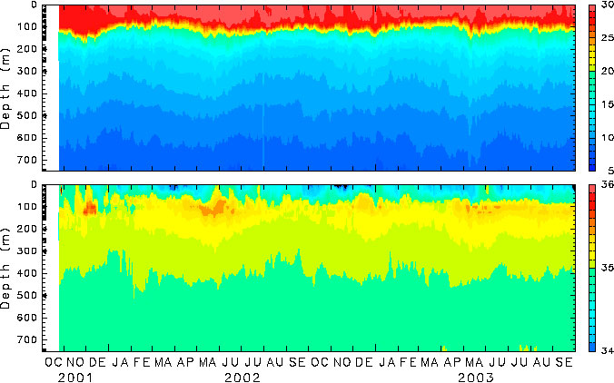
Figure 1 :
TRITON temperature (top) and salinity (bottom) timeseries at 1.5S-90E.
These indicate prominent semiannual signal of surface warm water accumulation and subsurface high salinity water intrusion originated in the Arabian Sea with large intraseasonal variation.
(provided by H.Hase)

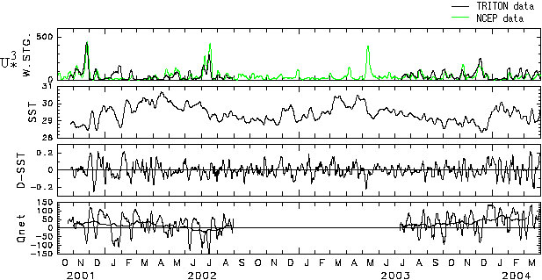

Figure 2: Response of SST (at 1.5m depth) to local heat flux and wind stirring at 1.5S90E TRITON dataThese figures indicate the wind stirring as the turbulent mixing effect, temperature variation at 1.5m depth, and its daily change, and net heat flux estimated from Clark and COARE formula using TRITON meteorological data.SST seems to be cooled corresponding with wind stirring as turbulent mixing effect.SST cdhanges seems to agree with local net heat flux variation on the intra-seasonal time scale. (provided by H.Hase)

