Site: LOCO Indian Ocean (Mozambique Channel)
Position: ~ 17°S , 40-43E
Categories: transport, physical

Short description:
- mooring array consisting of 7 moorings located across the shallowest section of the Mozambique Channel
- variables measured: currents, T, S
- start date of the timeseries, service interval: November 2003, serviced every 1.5 years

Scientific rationale:
A pilot-project with an array of current meter moorings in 2000-2001 showed that the meridional mass transport through the Mozambique Channel fluctuates remarkably regularly with values between 20 Sv northwards and 60 Sv southwards. The mean transport for this one year of observations was some 15 Sv southwards. The spatial structure of the current field suggested that during the periods with a strong southward flow a current jet separates from the African coast and forms a large anti-cyclonic eddy. These eddies migrate southward, interact with the Agulhas current and seem to initialize the meandering of the Agulhas current, thereby influence the formation of Agulhas rings. Thus the flow in Mozambique Channel is of importance not only for the tropical-subtropical transport in the Indian Ocean but also for the Indian-Atlantic ocean exchange.
At intermediate and deep levels against the African continental slope a northward flowing Mozambique Undercurrent was observed with a mean northward speed of 4.6 cms⁻¹ (1500 m) and 4.5 cms⁻¹ (2500 m). Hydrographic observations showed that the deepest flow consists of North Atlantic Deep Water. As part of the LOCO program a new array of moorings, with much more current meters, ADCP’s and T-S sensors, was deployed at the narrowest section in the Mozambique Channel in November 2003. These sub-surface moorings will be serviced each 1.5 years and the observations will continue till at least 2008. The observations will be used mainly to quantify the variability of the meridional mass and heat transport, to relate this variability to Indian Ocean (or El Nino) climate modes and to study the relation between this variability and the ‘downstream’ formation of Agulhas Rings.

Groups / P.I.s /labs /countries involved / responsible:
- Dr. H. Ridderinkhof, Royal NIOZ, PO Box 59, 1790AB Den Burg, the Netherlands; e-mail: rid@nioz.nl
- Prof. Dr. W.P.M. de Ruijter, IMAU, PO Box 80000, 3508 TA Utrecht, the Netherlands, W.P.M.deRuijter@phys.uu.nl

Status:
- operating
- A consortium of three Dutch institutions (Royal NIOZ, IMAU, KNMI) have obtained a large grant for investments in the Long-term Ocean Climate Observations (LOCO) programme. The program is embedded in the WCRP - CLIVAR programme and is funded by the Netherlands Organisation for Scientific Research (NWO).
- Presently funding is available for continuation of these observations till at least 2008.

Technology:
Moored sub-surface observations with ADCP’s, current meters and CTD sensors

Data policy:
No real time data will be available. The delayed mode data will become public once they have been processed.

Role in the integrated global observing system:
The observations will be used mainly to quantify the variability of the meridional mass and heat transport, to relate this variability to Indian Ocean (or El Nino) climate modes and to study the relation between this variability and the ‘downstream’ formation of Agulhas Rings.

Contact Persons: H. Ridderinkhof,

Links / Web-sites:
- for Project information: http://www.nioz.nl/projects/acsex
- for data access (if public): http://www.nioz.nl/dmg

Compiled /updated by: Herman Ridderinkhoff (February 2005)

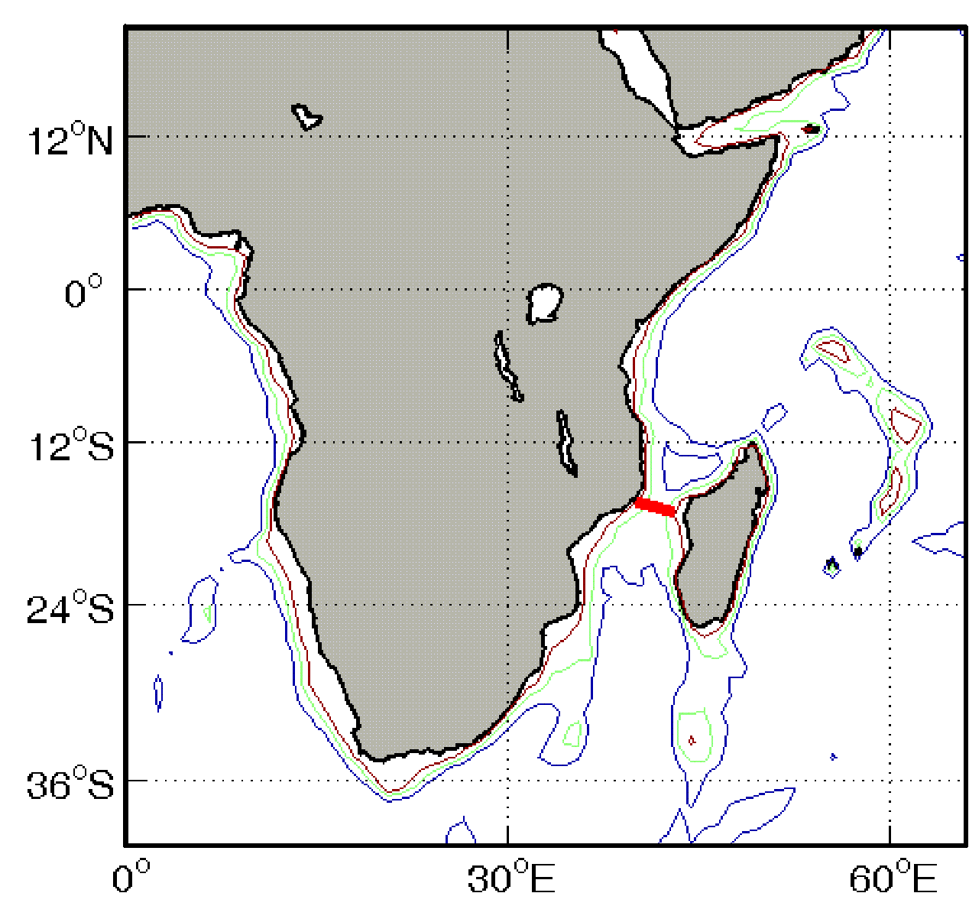

Figure 1:
The locations of the LOCO Indian Ocean Transport Array (red dots) against the geographic back-ground of the western Indian Ocean.
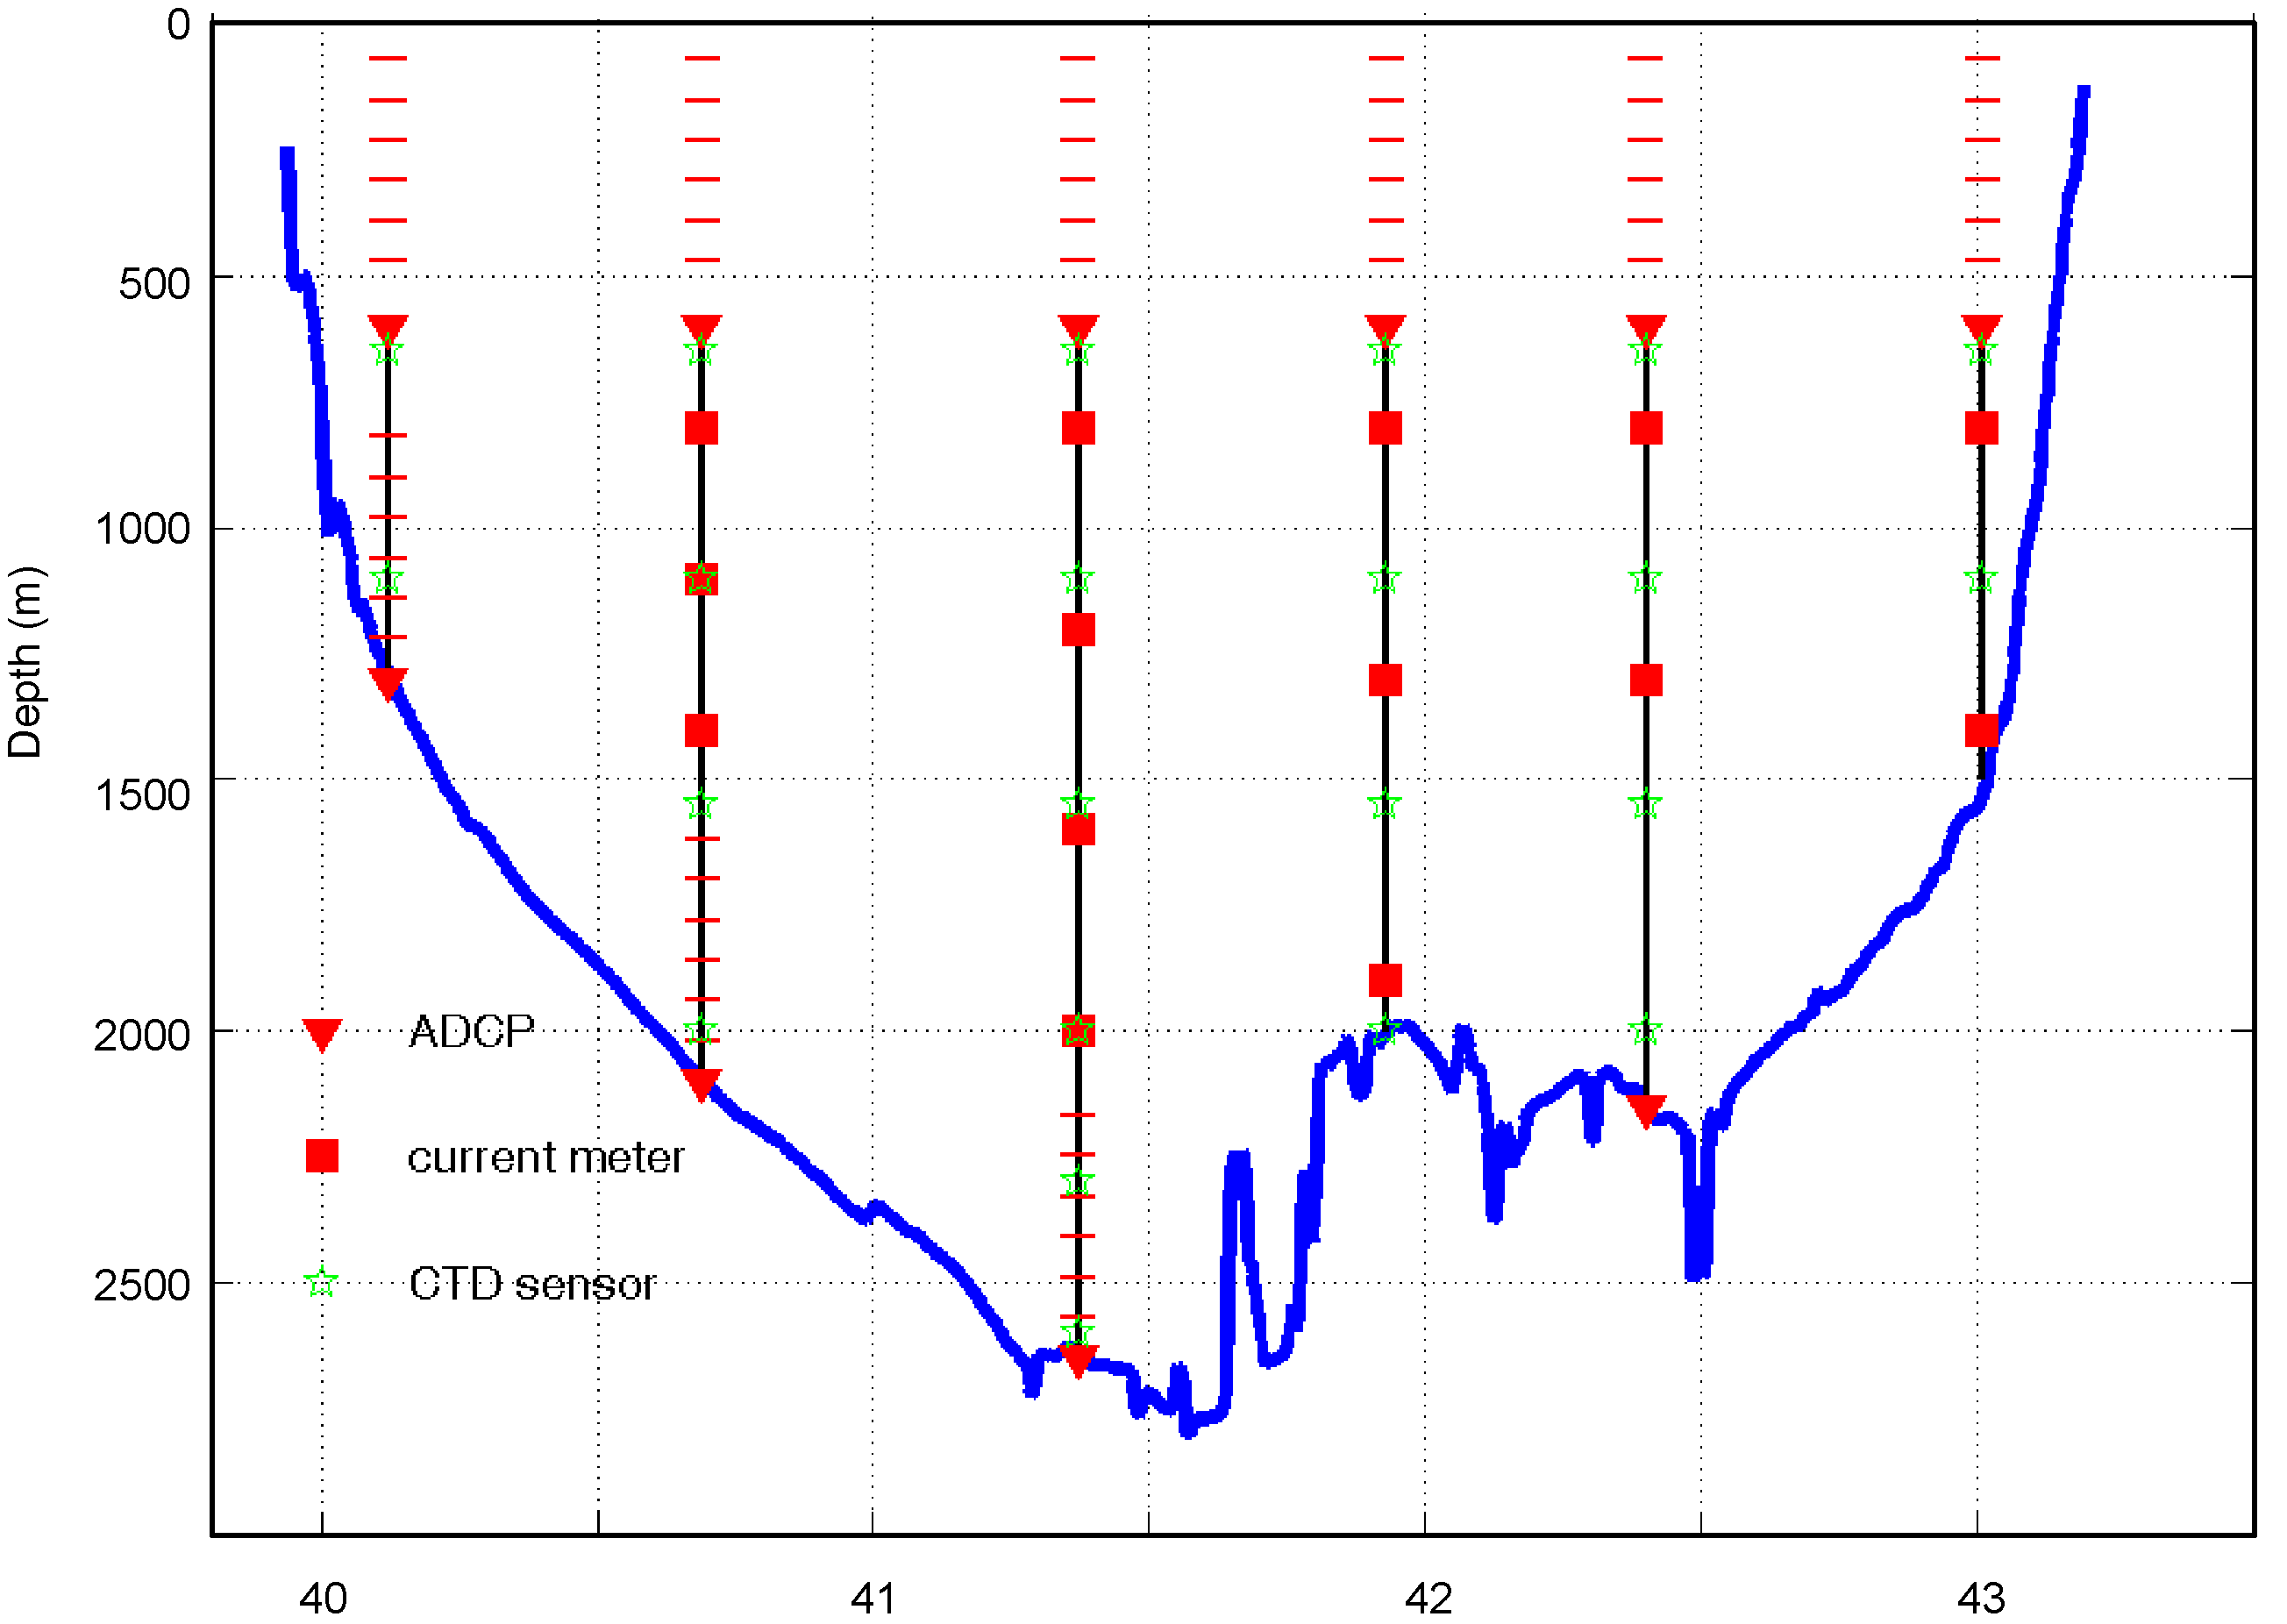

Figure 2:
The configuration of the LOCO mooring array in the Mozambique Channel.

