Site: HALE-ALOHA (H-A) mooring program
Position: 22° 45’N 158° 6’W (Nominal Position)
Categories: observatory: physical, meteorological, biogeochemical, ecological

Safety distance for ship operations: 5 nautical miles
Short description:
- 1 interdisciplinary autonomously sampling mooring
- Variables measured : generally summarized in Figure 1 and on the OPL website
- meteorological variables (solar insolation, spectral radiation, wind speed and direction, air and sea surface temperature, barometric pressure, relative humidity), horizontal currents (uplooking ADCP, 3m vertical bins), temperature, salinity, photosynthetic available radiation, spectral and hyperspectral inherent and apparent optical properties (IOPs and AOPs), and chlorophyll fluorescence
- most meteorological, physical, and optical measurements are made at intervals of about 5-15 min and discrete water sampling is done on roughly weekly intervals
- pCO2 measurements; surface ocean and atmospheric carbon measurements are made every 3 hours.
- Investigators using the H-A have also done measurements of macro- and micronutrients (water samplers), dissolved oxygen, carbon dioxide, and zooplankton using acoustic backscatter data
- Start date of the timeseries, service interval:
The new H-A mooring began in November 2004 and plans are in place for continued. H-A recoveries and redeployments are planned for 6 month intervals.

Scientific rationale:
The recent HALE-ALOHA (H-A) program was initiated in the fall 2004. The H-A mooring captures a broad dynamic range of oceanic variability (minutes to years), enabling new insights into high frequency and episodic phenomena while also providing long-term (climate-scale) and contextual, complementary information for other observations at the H-A/HOT/NOAA sites, for evaluation of undersampling/aliasing effects, and for developing and testing models. Some of the highlight results to date include studies of passages of Rossby waves, cold-core eddies and other mesoscale features have been used to estimate their roles in affecting new production, biogeochemical cycling, and carbon flux to the deep ocean.

The moored pCO2 program is designed to assess the short-term variability that cannot be accomplished with shipboard measurements. Obtaining long-term records of these high-resolution measurements allows a full integration of the short-term variability into the longer-term records obtained from the HOT program as well as other elements of the NOAA CO2 program. In particular, the moored pCO2 data will directly contribute to the production of regional CO2 flux maps and is being examined as a component of a new breed of data assimilation models that include estimates of carbon distributions and fluxes.

Groups / P.I.s /labs /countries involved / responsible:
Lead PI is Tommy Dickey (UCSB). Dave Karl (UH) has been a co-PI since the inception of the H-A mooring program. The H-A and/or H-A data has/have been used by about many investigators. Christopher Sabine (NOAA/PMEL) is the lead PI for the pCO2 measurements. Charlie Eriksen of UW is doing glider observations near the site.

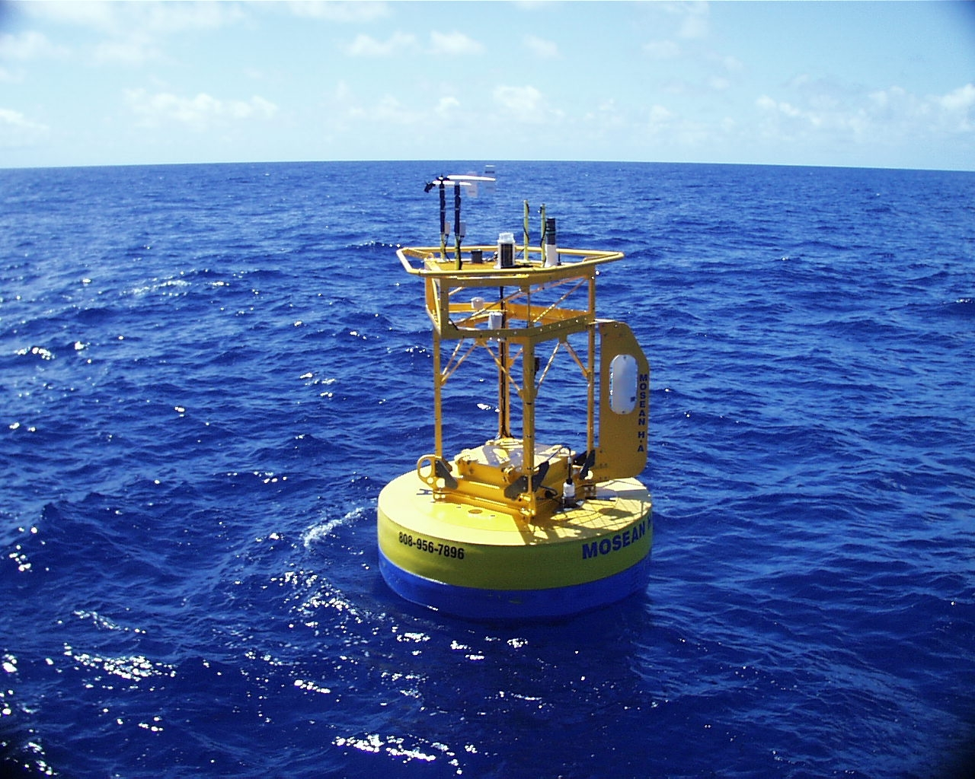
Status:
Figure 1
Photograph showing the HALE-ALOHA surface buoy.
- operational.
- Funding support has come from the National Ocean Partnership Program
- Funding cycle is 3-5 years per proposal and a renewal or new proposal directed is due in 2007-2008.
- Long-term support for the moored pCO2 measurements is provided by NOAA’s Office of Climate Observations

Technology:
The H-A uses autonomous sampling sensors and systems (see Figures 1 and 2). Meteorological and buoy position data are telemetered in near real-time.
New technologies for sensors and data telemetry are commonly tested from the H-A mooring.
The pCO2 measurements are LiCor based infrared detection systems mounted in the surface buoy with an equilibrator for surface water pCO2 measurements.

Data policy:
- real-time data: Meteorological and buoy position data are telemetered in near real-time.
- delayed mode data: Other data that must be retrieved from in situ systems at present are made available following recovery of the mooring and processing of data – typically within a few months at maximum.
- Data are freely available to the public.
- The 3-hour carbon measurements are transmitted daily via Iridium and posted to the WWW. Final calibrated data are submitted to the Carbon Dioxide Information Analysis Center and are freely available within 6 months of recovery.

Data management:
- Complementary satellite data and some imagery are included on the OPL website (www.opl.ucsb.edu).
- Subsets of H-A data are routinely collected and distributed in near real-time (e.g., meteorological data and position of the buoy). It is anticipated that real-time telemetry will be used for additional interdisciplinary variables in the future.
- Moored pCO2 data are posted daily to: http://www.pmel.noaa.gov/co2/moorings/hot/hot_main.htm
- Metadata scheme :
H-A investigators are participating in a pilot OceanSITES data management program (contact is Songnian Jiang, songnian.jiang@opl.ucsb.edu)

Societal value / Users / customers:
The H-A mooring is used for several purposes at present:
- Testing of oceanographic instrumentation
- Scientific studies
- Calibration and validation of satellite sensors
- Development and testing of interdisciplinary ocean models
Other users could include:
- Tsunami warning system in North Pacific Ocean
- Weather services (i.e., hurricane prediction and warning)

Role in the integrated global observing system:
H-A serves or can serve several global ocean observing system goals:
- Pilot mooring for testing of new ocean instrumentation
- Studies of air-sea interaction, upper ocean dynamics, biogeochemistry, upper ocean ecology, extreme and episodic events including hurricanes and eddies, climate change
- Calibration and validation of ocean satellites
- Data for use in data assimilation models and for formulating and testing of a variety of interdisciplinary ocean models

Contact Persons:
- Tommy D. Dickey or Derek Manov
[Ocean Physics Laboratory | University of California, Santa Barbara | 6487 Calle Real, Suite A |
Santa Barbara, CA 93117 | Phone: 805 893-7354 | FAX: 805 967-5704 ]
- Lead for carbon measurements: Christopher Sabine, NOAA/PMEL

Links / Web-sites:
- www.opl.ucsb.edu or contact Tommy Dickey
- carbon info: http://www.pmel.noaa.gov/co2/moorings/hot/hot_main.htm

compiled/ updated by: Tommy Dickey (January 2005) and Christopher Sabine (March 2005)

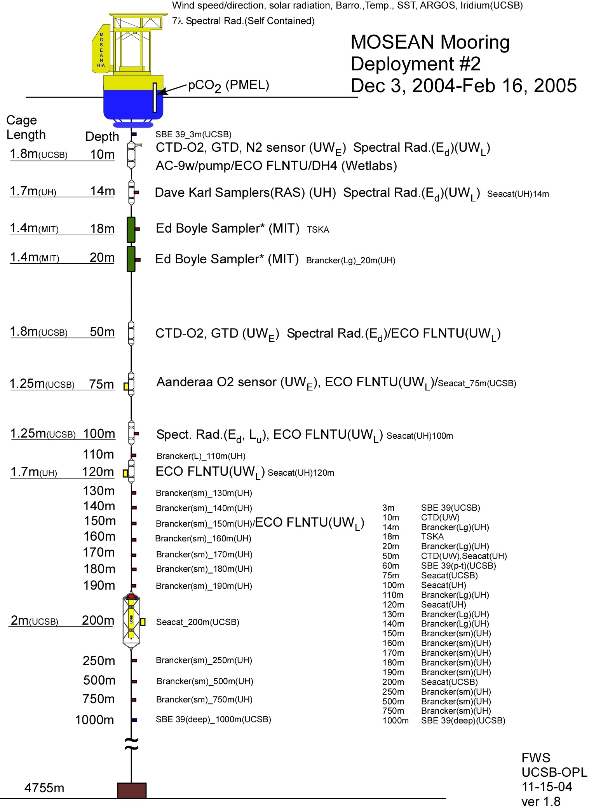

Figure 2 Mooring diagram for the HALE-ALOHA Mooring

