Site: Kuroshio Extension Observatory (KEO)
Position: 32.3°N 144.5°E
On southern side of the Kuroshio Extension, in the recirculation gyre.
Categories: Air-Sea Flux, Observatory; meteorological, physical, biogeochemical

Safety distance for ship operations: 6 km
Short description:
- 1 surface buoy with slackline mooring
- Variables measured :
- Surface: wind speed and direction (from a sonic anemometer), air temperature, relative humidity, rain, shortwave and longwave radiation, 1m sea surface temperature and salinity, barometric pressure*, air and sea surface water pCO2*, and O2*.
- Subsurface temperature at nominal depths of 5m, 10m, 15m*, 25m, 35m*, 50m, 75m, 100m, 125m*, 150m, 175m*, 200m, 225*, 250m*, 275m*, 300m, 325m*, 350m*, 375m*, 400m, 425m*, 450m*, 475m*, 500m
- Subsurface salinity at nominal depths 5m, 10m, 15m*, 25m, 35m*, 50m, 75m, 125m*, 150m, 200m, 275m*, 325m*, 400m, 475m*
- Subsurface ocean pressure (for remapping to nominal depths) at nominal depths 100m, 175m*, 250m*, 300m, 375m*, 425m*, 500m
- Ocean currents at: 5m*, 15m*, 35m*
- Ocean current profiles: 30m-230m**
- All physical measurements are recorded at least every 10 minutes. Biogeochemical measurements are recorded every 3 hours.
- Start date of the timeseries: 16th June 2004 (*Start June 2005, **planned)
- service interval: once per year

Scientific rationale:
As with other western boundary currents, the North Pacific's western boundary current has some of the largest air-sea fluxes found in the entire basin. It is one of the largest sinks of carbon in the North Pacific, has the characteristic maxima lobes of latent, sensible, and net surface heat loss, and is co-located with the Pacific storm track. The Kuroshio Extension (KE) current carries warm water at nearly 140 million cubic meters per second (140 Sv) eastward into the North Pacific. Wind driven Sverdrup transport accounts for about a third of this transport; the other 90 Sv is due to a tight recirculation gyre whose size varies on seasonal-decadal time scales. As cold dry air comes in contact with the warm KE and recirculation water, heat and moisture are extracted from the surface, resulting in deep convection (both in the atmosphere and ocean) and rainfall. Surface cooling and biological production lower the surface water CO2 concentrations driving a net uptake. In late winter, surface water in the KE recirculation region is subducted into the permanent thermocline, forming Subtropical Mode Water, and sequestering carbon. Large dust clouds blowing eastward off Asia are visible in satellite images and can be traced all the way across the Pacific. Macro- and micro-nutrients, including iron, from the dust clouds can affect biological production and therefore may play an important role in the North Pacific carbon cycle.

Groups / P.I.s /labs /countries involved / responsible:
Dr. Meghan Cronin NOAA / PMEL (lead)
Mr. Christian Meinig NOAA / PMEL (Lead Engineer)
Dr. Christopher Sabine NOAA / PMEL (Lead Carbon Scientist)

Status:
- operating
- time horizon / long-term plans: Long-term
- funded

Technology:
- Moored / autonomous sensors
- real-time telemetry: Daily-averages and spot measurements of all surface physical data and most subsurface data are available in near-realtime. Carbon has daily transmissions of 3-hour measurements.
- SST measurement: self-contained sensor attached to bridle at 1m below surface
- Profile measurements: Sensors are attached to slackline mooring (pressure sensors can be used to remap observations onto nominal depths).

Data policy:
- real-time data: All data are public
- delayed mode data: High-resolution data will be made public within 6 months of recovery

Data management:
- Satellite data collection system : Service Argos (physical data), Iridium (carbon data)
- Real-time data processing and distribution system : PMEL realtime processing, QA and web distribution. Starting June 2005, distribution via GTS (Service Argos) as well.
- Metadata scheme : see website
- Possibilities of evolution to comply with a more general JCOMM GTS scheme : Planned for the future.

Societal value / Users / customers:
Kuroshio Extension Observatory (KEO) users include the research community, weather and climate forecasting communities, and satellite and numerical weather prediction products assessments communities.

Role in the integrated global observing system:
The KEO mooring serves as an air-sea flux and carbon flux reference site and as an observatory for the Kuroshio Extension region of the northwest Pacific. KEO is supported by the NOAA Office of Climate Observations as an element of the Global Climate Observing System (GCOS). With the planned carbon observations, KEO would be a key element of the U.S. Ocean Carbon and Climate Change Program (OCCC), and internattional Integrated Marine Biogeochemistry and Ecosystem Research (IMBER) and Surface Ocean Lower Atmosphere (SOLAS) programs.

Contact Person:
- for enquiry about addition of instrumentation or sensors to the site or for possible ancillary measurements during cruises to the site:
Meghan Cronin (Meghan.F.Cronin@noaa.gov )
- for information about the site or data:
Meghan.F.Cronin@noaa.gov
Chris.Sabine@noaa.gov for carbon component

Links / Web-sites:
- for Project information : http://www.pmel.noaa.gov/keo/
- for data access : http://www.pmel.noaa.gov/keo/data.html
- for information on carbon system : http://www.pmel.noaa.gov/co2/moorings/

compiled by: Meghan Cronin (March 2005 )

Figure 1: KEO site (square) shown in relation to the NCEP-2 climatological JFM latent heat flux (shaded) and mean sea surface height from Teague et al. (1990) (contours). Latent heat flux contour intervals are 20 Watts per meter squared. Sea surface height contour intervals are 10 centimeters. The sea surface height contours can be interpreted as surface geostrophic streamlines of flow.
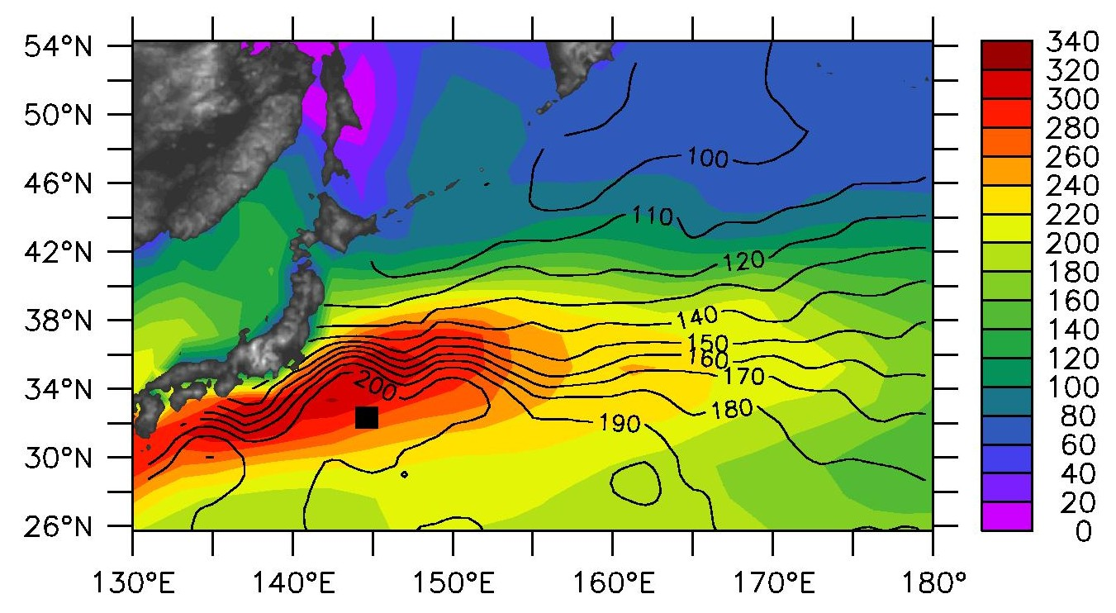
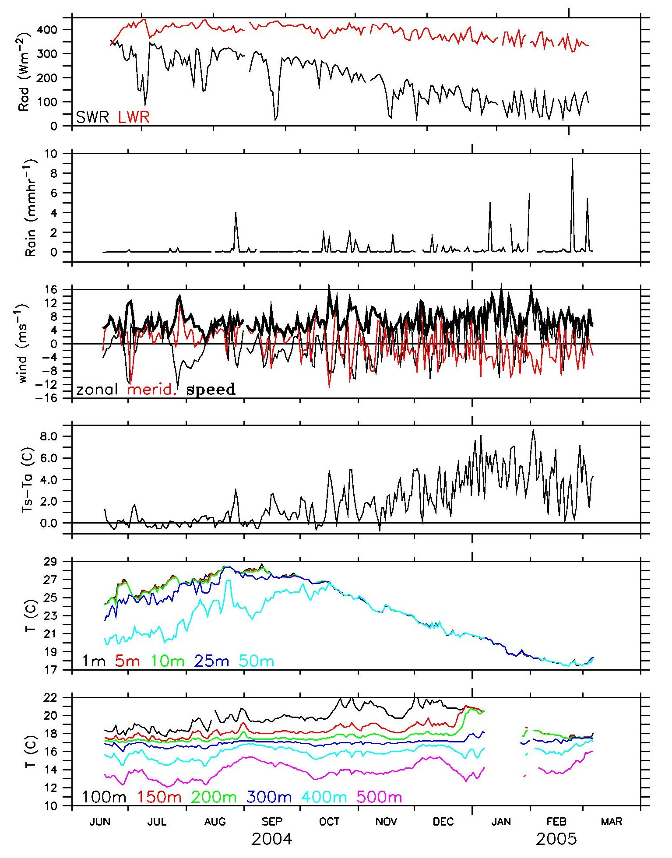

Figure 2: KEO telemetered daily-averaged time series (relative humidity and salinity data not shown). Top panel shows downwelling solar (black) and longwave (red) radiation. Second panel shows rain rate. Third panel shows wind speed (thick black), and zonal (thin black) and meridional (thin red) components. Fourth panel shows sea minus air temperature difference in degrees Celsius. Bottom two panels show surface and subsurface temperature, with nominal depths listed. Units are listed on figure.

