Site: California Current Biogeochemical Moorings
Position: M1: 36°45’N 122°01’W;
M2: 36°42’N 122°23’W
(in California Current System)
Categories: Physical, meteorological (including air-sea flux) and biochemical measurements.

Safety distance for ship operations: 2 nautical miles
Short description:
- 2 moorings
- variables measured:
- surface winds, air temperature, relative humidity, barometric pressure, ocean temperature and salinity from the surface to 300 0r 500 m (11 depths), ocean current profiles to 400 m, sea surface nitrate, delta pCO2 between atmosphere and sea surface, surface fluorescence and backscatter, and radiance and irradiance at surface and 10 m
- all data transmitted in real-time
- M1 also has shortwave and long wave radiation sensors making this mooring fully flux capable.
- maintained by MBARI since 1989

Scientific rationale:
Ecosystem productivity and the biogeochemical cycling of elements in the California upwelling regions is regulated by physical processes that vary on daily to multidecadal time scales. Concurrent measurements of physics, chemistry and biology allow an estimate of changes in biological and chemical fluxes associated with the physical variability and for the development of predictive models. Satellite validation and algorithm development are also a goal.

Groups / P.I.s /labs /countries involved / responsible:
MBARI maintains the California Current System moorings.

Status:
MBARI, with funding from the David and Lucile Packard Foundation, maintains moorings M1 and M2. Support from NASA has been used for bio-optical measurements.

Technology:
Instrument controllers developed at MBARI are used to collect and transmit instrument data.

Data policy:
Core data (real-time and delayed mode) are freely available without restriction. Core data are proven physical (T,S, u, v) and meteorological (windspeed and direction, air temperature, relative humidity, barometric pressure) measurements. Experimental biological and chemical measurements are available after quality control.

Data management:
Mooring data are internally recorded and transmitted from buoy to shore via free-wave radio in real-time. Data and metadata are available from the MBARI Shore Side Data System (http://ssdspub.mbari.org:8080/access/siamRawDataStep1.jsp).

Contact Persons: Francisco Chavez (chfr@mbari.org)

Links / Web-sites: http://www.mbari.org/oasis/index.html

Compiled by: Francisco Chavez (April 2005)
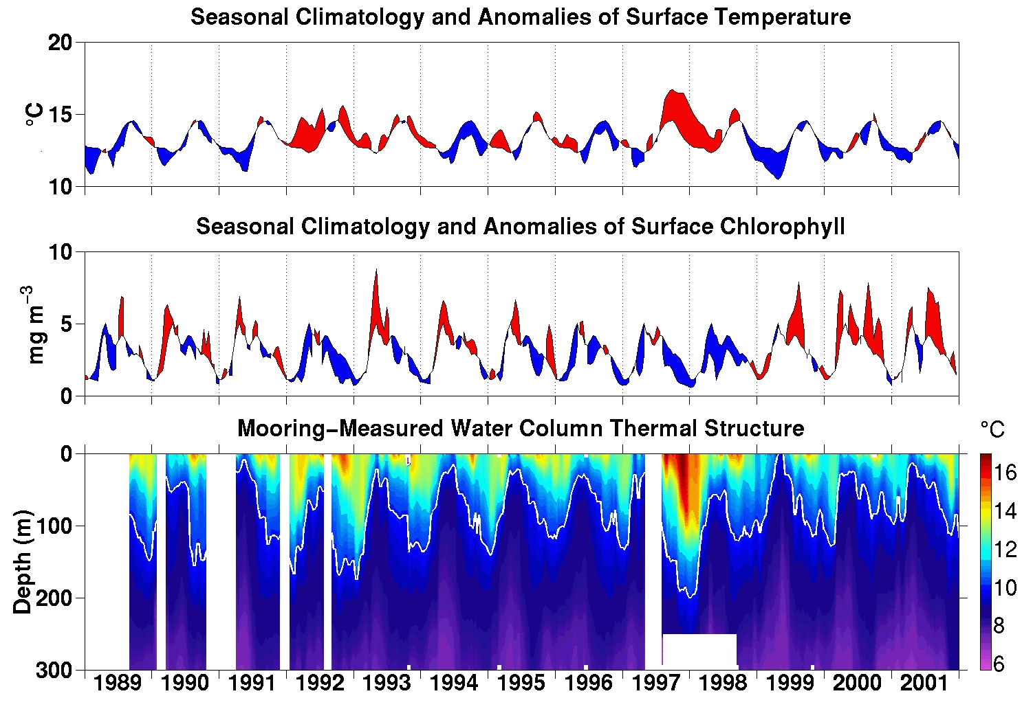
Figure 1: Time series of surface temperature (top), surface chlorophyll (middle) and thermal structure off Monterey Bay, California.

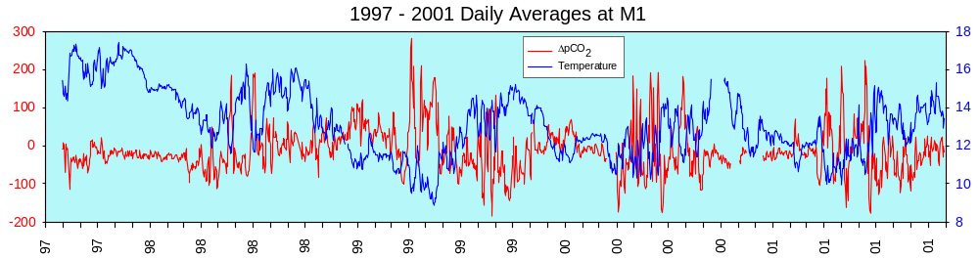
Figure 2: Time series of surface temperature and delta pCO2 from a mooring off Monterey Bay, California.

