Site: Equatorial Pacific Biogeochemical Moorings
Position: EP1 at 0° 155°W; EP2 at 2°S 170°W (two TAO sites in the equatorial Pacific)
Categories: Physical, meteorological and biochemical measurements.

Safety distance for ship operations: Two nautical miles.
Short description:
The TAO equatorial moorings are augmented with pCO2 sensors, fluorometer and backscatter sensors and radiance and irradiance sensors at the surface and 20 m.

Scientific rationale:
Ecosystem productivity and the biogeochemical cycling of elements in the Equatorial Pacific upwelling regions is regulated by physical processes that vary on daily to multidecadal time scales. Concurrent measurements of physics, chemistry and biology allow an estimate of changes in biological and chemical fluxes associated with the physical variability and for the development of predictive models. Satellite validation and algorithm development are also a goal.

Groups / P.I.s /labs /countries involved / responsible:
MBARI collaborates with NOAA/PMEL on the TAO moorings. TAO contacts are Mike McPhaden and Chris Sabine.

Status:
The TAO/TRITON moorings in this study are supported primarily by NOAA. Support from NASA has been used for bio-optical measurements.

Technology:
Instrument controllers developed at MBARI are used to collect and transmit instrument data.

Data policy:
Core data (real-time and delayed mode) are freely available without restriction. Core data are proven physical (T,S, u, v) and meteorological (windspeed and direction, air temperature, relative humidity, barometric pressure) measurements. Experimental biological and chemical measurements are available after quality control.

Data management:
Mooring data are internally recorded and transmitted from buoy to shore via Orbcomm in real-time. Data and metadata are available from the MBARI Shore Side Data System (http://ssdspub.mbari.org:8080/access/siamRawDataStep1.jsp).

Contact Persons: Francisco Chavez (chfr@mbari.org)

Links / Web-sites: http://www.mbari.org/bog/Projects/EQPAC/Default.htm

Compiled by: Francisco Chavez (April 2005)

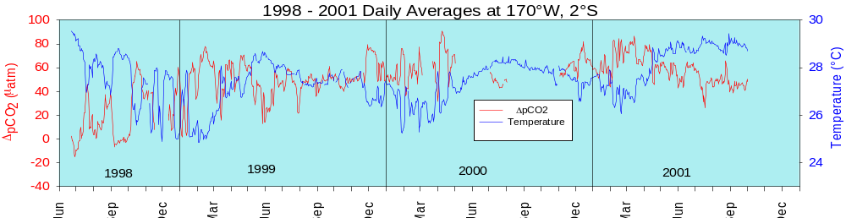
Figure 1:
Time series of delta pCO2 and temperature from a mooring in the equatorial Pacific at 2 S, 170 W.

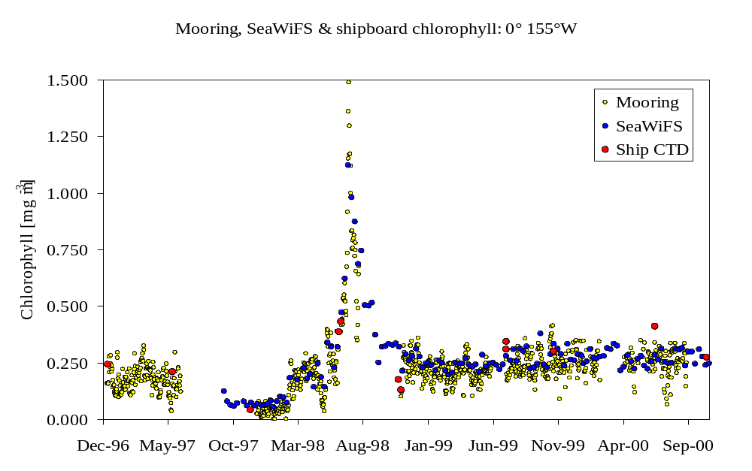

Figure 2:
Comparison of moored, satellite and in situ estimates of chlorophyll from 0, 155 W in the equatorial Pacific

