Site: High Latitude Time-series Ocean Observatories (HiLaTS)
Positions: K-1 51°N 165°E, K-2 47°N 160°E, K-3 39°N 169°E
( http://jpac.whoi.edu/hilats/strategy/stations.html )
Categories: Observatory; biogeochemical, physical and climatological
The biological pump operating in the Northwestern Pacific and it link with the world ocean. Biogeochemistry, primary production, circulation dynamics, hydrography and paleoceanography.

Safety distance for ship operations: 5 n. miles around any HiLaTS moorings
Two highly sophisticated mooring systems (PO and BGC mooring), are moored at each station. The mooring apex depth is often only 30 to 50 m from the surface. Particularly moored profilers are operated along a PO mooring. No over the board deployment is allowed within the diameter of 5 n. miles around any HiLaTS moorings.
Short description:
- Three array points (K1: 50N 161E, K2: 47N 160E, K3: 39N 169E)
- Variables measured: Entire water column. Continuously for one year, March to March.
- Start date of the time series, service interval: mooring systems were deployed in September 2001, annual service in March

Scientific rationale:
The North Pacific Time-Series Observational Study initiated in 2001 as a one of research programs at Mutsu Institute for Oceanography (MIO <http://jpac.whoi.edu/hilats/mio/index.html >), Japan Marine Science and Technology Center (JAMSTEC) on board R/V Mirai (GW 8,675 tons, <http://www.jamstec.go.jp/jamstec-e/ships/mirai1.html >). This program is also a joint program with Woods Hole Oceanographic Institution (WHOI). A physical oceanography (PO) mooring system for primary physical oceanography support moored profiler (Fig.1 a). A biogeochemical (BGC) mooring system has time-series sediment traps (every week or bi-week increments), autonomous 14C incubator to access primary production (SID)(50-times a year), automated optical various auto-sampler and autonomous incubation system for the measurement of productivity (SID) (Fig.1 b) and time series phyto-, zooplankton collectors. MIO is pursuing to deploy MEX sediment trap array in order to understand the mesopelagic organic C fluxes and remineralization. <http://jpac.whoi.edu/hilats/strategy/mex.html >. These new mooring engineering has been established systems stand up from 5.5 km deep-sea floor to the surface euphotic zone. Three mooring sites were selected taking into account for the flat topography and stability in oceanography in the Western Pacific Sub-arctic Gyre. Precision acoustic and in situ altimeter bottom survey on these 3 stations has completed since 2002. HiLaTS stations are visited at least a few times a year by other JAMSTEC research vessels including R/V Natsushima for hydrographic, nutrients, ocean optics, primary productivity and thorium isotope chemistry by using CTD-rosette sampler and depth series large volume pump array and contentious surface water sampling systems in order to build up the understanding of time-series variability as well as test new hypothesis and instrumentation.

Groups / P.I.s /labs /countries involved / responsible:
Makio Honda (Mutsu Institute for Oceanography; e-mail: hondam@jamstec.go.jp),
Susumu Honjo (Woods Hole Oceanographic Institution; e-mail: shonjo@whoi.edu)

Status:
- Stations are operating since September 2001: 18-months hiatus to improve the mooring security from October 03 to March 05. Reopened station (K-2) on March 05.
- Time horizon : Decadal operation
- Funding status, source of funding: JAMSTEC and other competitive public funding

Technology:
Seven major sensor-sampler platforms. Autonomous, time-series, full-water column and multi-sensor approach. Refer http://jpac.whoi.edu/hilats for detail.

Data policy:
- real-time data: open to qualified public after cruise report as same as JGOFS protocols.

Data management:
- Satellite data collection via NASDAC
- Real-time data processing and distribution system: Working on GTS encoding & distribution
- Metadata scheme: will comply when the temperate is shown
- Possibilities of evolution to comply with a more general JCOMM GTS scheme: Same as above

Societal value / Users / customers: Refer http://jpac.whoi.edu/hilats

Role in the integrated global observing system:
HiLaTS will be the key program to understand the biological pump, biogeochemical cycles and the fate of atmospheric CO₂ that is removed to the oceanic interior that is operated in Westerlies Domain of the world ocean.

Links / Web-sites:
- for Project information: http://jpac.whoi.edu/hilats
- for data access : http://usjgofs.whoi.edu/mzweb/data/Honjo/sed_traps.html

compiled/ updated by: Susumu Honjo (March 2005)
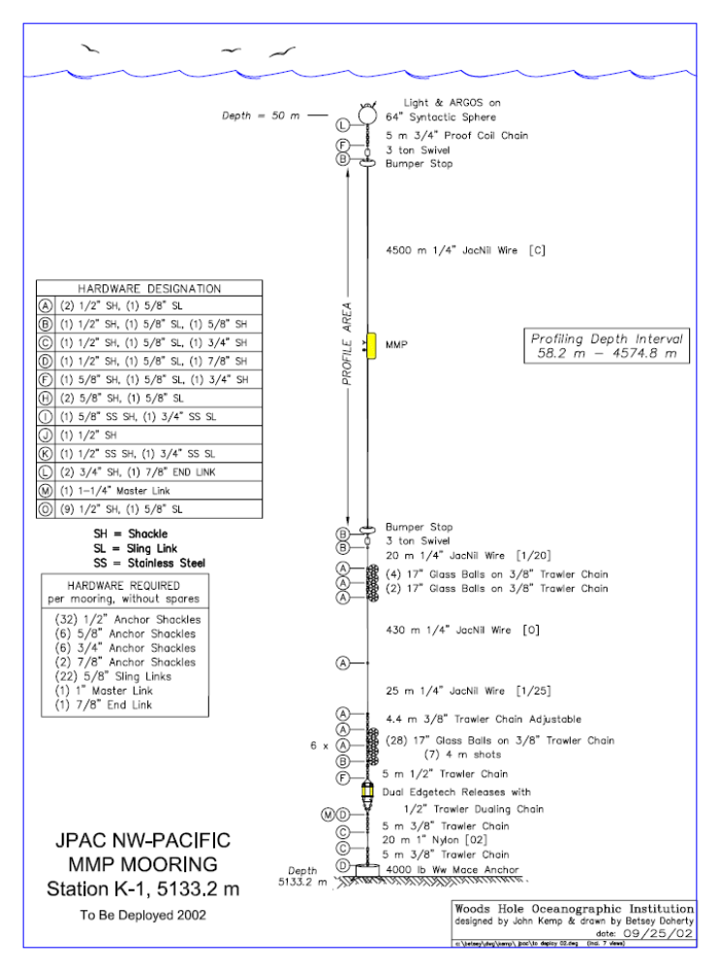
Figure 1: mooring system for physical oceanography
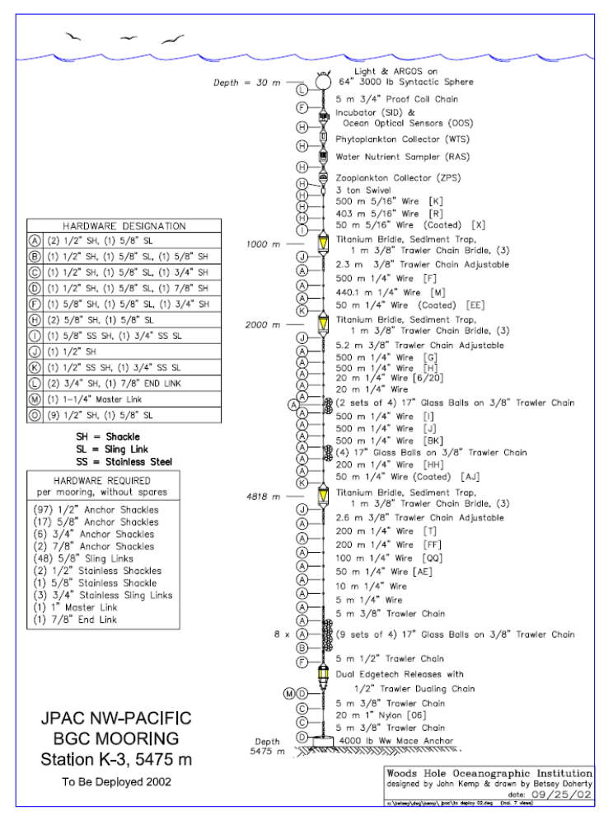
Figure 2: mooring system for biogeochemistry

