Site: Ocean Station Papa
Position: 50°N 145°W
Categories:
- air-sea gas exchange mooring (S. Vagle), sediment traps (C, N, Si transport, C.S. Wong)
- physical (H. Freeland, IOS), biogeochemical (F. Whitney, L. Miller, IOS) biological (D. Mackas, zooplankton; university researchers, phytoplankton)

Safety distance for ship operations: no surface mooring at present, no ship concerns.
Short description:
- Number of stations / moorings:
A survey line of 26 stations extends from the coast to Station Papa.
Moorings for gas exchange and particle fluxes are near St Papa.
- Variables measured : T, S, oxygen, nutrients, DIC from surface to bottom (~4200m). Zooplankton tows collected from 150 m to surface.
- Start date of the timeseries, service interval:
The first measurements at Station Papa began in 1949, conducted by the US Weather Service but including mechanical BT casts. This was taken over by Canadian weatherships in 1950 and at that time oceanographic observations ceased. Oceanography resumed in July 1952. The mechanical BT was abandoned in July 1956 and it is at that time that the high quality oceanographic time series begins at Station Papa itself. In 1959 sampling began along the cruise track between the Juan de Fuca Strait and Station Papa, and at that time the Line-P observations began. The weathership program was terminated in June 1981 but sampling has continued to the present day, typically at 3 times annually, using Canadian research vessels.
air-sea gas exchange mooring since 2002, sediment traps since 1983

Scientific rationale:
Ocean Station Papa, also known as Station P, is in the Gulf of Alaska at 50°N and 145°W. Line-P is a sequence of oceanographic stations that starts near the mouth of the Juan de Fuca Strait and extends into the Gulf of Alaska ending at Station P.
The Line-P and Station-P programs are used to monitor the state of the ocean environment. We complete three surveys per year typically in May/June, Aug./Sept. and Feb. of each fiscal year. The rationale is to observe the state of the ocean including macro-nutrient distributions:
- After the major winter storms have completed deep mixing and resupply of nutrients to the upper ocean.
- Near the peak of the spring primary production period (May/June trip).
- A late summer survey to observe what happened following the summer productive period.

Groups / P.I.s /labs /countries involved / responsible:
The execution of Line-P surveys primarily belongs to the Fisheries and Oceans Canada, Pacific Region. However, it has also been the test bed for much detailed biological research carried out under programs such as SUPER, JGOFS and SOLAS.
Station P is a standard monitoring location for other programs. The Japanese research cruises conducted on the Oshoru Maru sample along 145W to Station Papa each summer. Howard Freeland (FreelandHj@dfo-mpo.gc.ca) is the lead scientist for physical property sampling.
Frank Whitney (WhitneyF@dfo-mpo.gc.ca) is the lead scientist for chemical property sampling. In addition, Dave Mackas continues a zooplankton time series, Lisa Miller measures DIC, C.S. Wong carries out particle flux studies and Svein Vagle maintains a gas exchange mooring.

Status:
- operating
- time horizon / long-term plans: continue our monitoring program at 2 or 3 times annually.
- funding is not guaranteed at present, however this program is considered core to our ocean monitoring efforts.

Technology:
- Argo profilers deployed in region (Freeland), gas analyzers and T sensors moored in upper 120 m, continuous T, S and pCO₂ (Wong) on most surveys.
- SST measurement : Seabird thermosalinography and GPS
- Profile measurements : Rosette sampling with SBE CTD.

Data policy:
- real-time data: Argo T and S data are available near real time
- delayed mode data: verified data is posted on a web site (http://www-sci.pac.dfo-mpo.gc.ca/osap/data/linep/linepselectdata_e.htm) , and includes CTD casts and water properties (oxygen and nutrients).
- All data are public available.

Data management:
Data is archived about annually with MEDS (Marine Environmental Data Service (http://www.meds-sdmm.dfo-mpo.gc.ca/meds/Home_e.htm) in Ottawa. If Station Papa becomes part of GEO, we expect to have adequate funding to improve data formatting and accessibility.

Societal value / Users / customers:
The sampling strategy has proven invaluable for understanding variations in the open ocean ecosystem that ultimately feed the salmon stocks migrating from the open ocean to land. Thus major customers are fisheries managers in Canada.

Role in the integrated global observing system:
We intend to participate by continuing Line P surveys 2 to 3 times annually and posting data on our web site. These cruises will ensure that the NE Pacific stays populated with Argo profilers, and that moorings (funding dependant) can continue at Station Papa.

Contact Person:
- for enquiry about addition of instrumentation or sensors to the site or for possible ancillary measurements during cruises to the site: Marie Robert (robertM@pac.dfo-mpo.gc.ca)
- for information about the site or data : Marie Robert, Line P program coordinator (robertM@pac.dfo-mpo.gc.ca); Joe Linguanti, data manager (LinguantiJ@pac.dfo-mpo.gc.ca)

Links / Web-sites:
- for Project information : http://www-sci.pac.dfo-mpo.gc.ca/osap/projects/linepdata/default_e.htm or Marie Robert (tel 250 363-6612)
- for data access :
http://www-sci.pac.dfo-mpo.gc.ca/osap/data/linep/linepselectdata_e.htm or through MEDS (http://www.meds-sdmm.dfo-mpo.gc.ca/meds/Home_e.htm).
Argo data is available from http://www.argo.ucsd.edu/

Compiled/ updated by: Howard Freeland (2002) , Frank Whitney (January 2005)

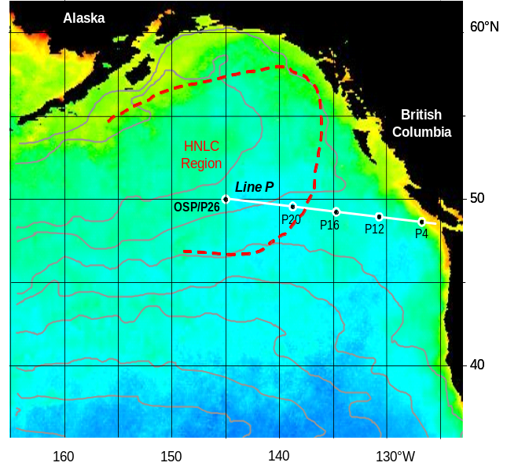 | 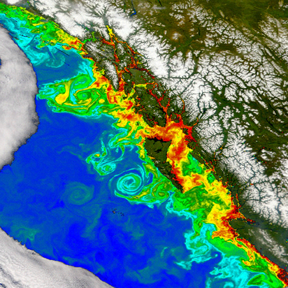
Figure 1  Map of the NE Pacific Ocean showing SeaWiFS summer chlorophyll distribution (blue is low, orange/red is high), temperature contours (unlabelled, decreasing to the north), the approximate position of the High Nutrient-Low Chlorophyll (HNLC) boundary in summer (dashed red line) and location of the stations sampled for water properties along Line P. Ocean Station Papa (OSP) is also designated as station P26, the terminal station of Line P. | Figure 2  SeaWiFS chlorophyll image from July 2002, showing the formation of mesoscale eddies off the west coast of North America. These eddies create patchiness in the adjacent ocean by transporting coastal water, nutrients and organisms westward. Their influence has been observed at Station Papa.

