Site: SEATS in South China Sea
Position: 18.25 ºN, 115.5 ºE
Categories: observatory: physical and biogeochemical

Short description:
- 1 mooring operating (TAIWAN)
- Variables measured : Water temperatures at standard depths (as TAO configuration for western Pacific). Fluorometers were added since November 2004.
- Start date of the timeseries, service interval: The timeseries in this site started in 1997. Mooring is refurbished every 6 months. Four cruises, at least, are scheduled per year to perform the biogeochemical measurements near the mooring site.

Scientific rationale:
The SEATS mooring station is very close to the previous mooring station SCS1 during the South China Sea Monsoon Experiment (SCSMEX) began in 1997 for which Prof. T. Y. Tang at National Taiwan University was responsible. The South East Asia Time-series Study (SEATS) program supported by the National Center for Ocean Research (NCOR) of Taiwan is now responsible for the mooring at 18°15’N, 115°30’E since October 2000. Since vandalism is always a serious problem in the South China Sea, only measurements below sea surface are conducted. Water temperatures of the upper 500 m are recorded as continuous as possible while current velocity and salinity are conducted sporadically. The Objectives of the SEATS mooring is:
- to understand the variations of thermal structure in the SCS, especially the oceanic response to the atmospheric forces such as monsoon and typhoons,
- to investigate the oceanic variations which related to long-time events, such as the El Niño, decadal variation, or even global warming, and
- to better understand biogeochemical processes in the SCS.

Groups / P.I.s /labs /countries involved / responsible:
The National Center for Ocean Research (NCOR) of Taiwan is now responsible for the mooring.

Status:
- operating
- funding status, source of funding: NCOR has a stable fund to maintain the mooring as long as the SEATS program is conducting.

Technology:
- moored sensors
- SST measurements: 1-m water temperature. Self-contained temperature loggers.
- Profile measurements: ADCP, sporadic

Data policy:
The data archive of SEATS mooring observation is being compiled and could be available through NCOR (http://www.ncor.ntu.edu.tw). Due to the problem of vandalism, real-time data transmission is not possible.

Data management:

Societal value / Users / customers:

Role in the integrated global observing system:

Contact Person:
Y. YANG (yy@ncor.ntu.edu.tw) or C. M. Tseng (cmtseng@ncor.ntu.edu.tw, Program Manager of SEATS).

Compiled by: Y. YANG (3rd March, 2005)

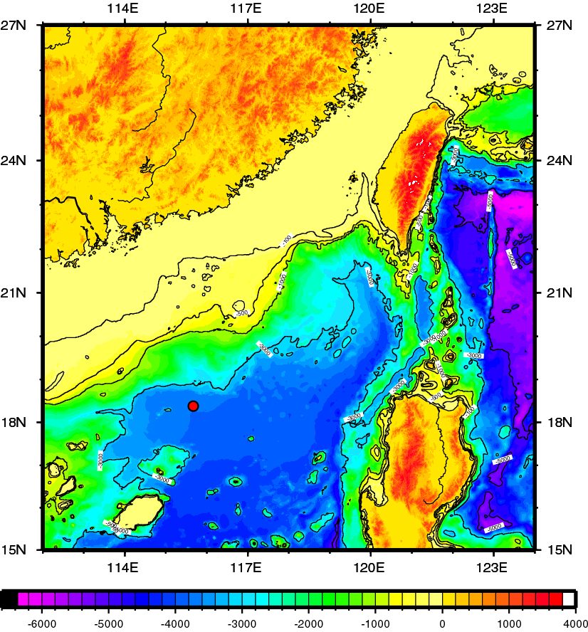

Figure 1: SEATS mooring location (red dot)

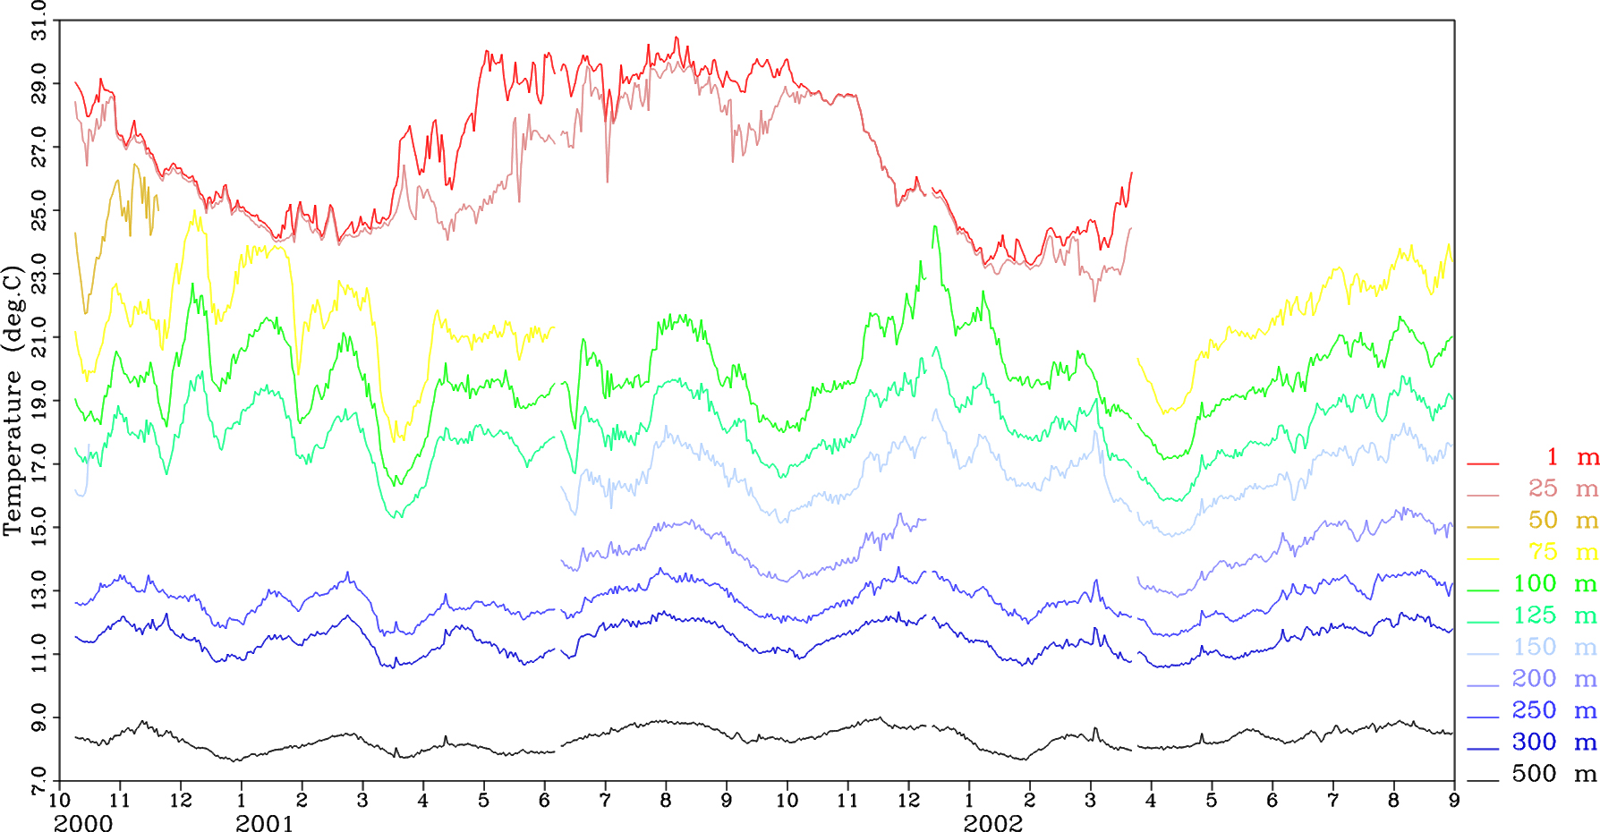

Figure 2 Part of time-series measurements of water temperature.

