Site: Stratus Ocean Reference Station
Position: 20ºS 85ºW
Categories:
- Air-Sea Flux reference site
- observatory: meteorological and physical

Safety distance for ship operations: 10 nautical miles
Short description:
- One surface mooring
- Variables measured:
- Surface meteorology (wind speed and direction, air temperature, sea surface temperature, sea surface salinity, relative humidity, incoming shortwave and longwave radiation, barometric pressure, and precipitation) measured every minute
- Temperature, salinity, velocity at fixed depths to 450 m, internally recorded at 5 to 15 minute intervals
- First deployed October 2000; serviced roughly every 12 months

Scientific rationale:
Obtain high quality surface meteorological and air-sea flux time series under the stratus cloud deck. Use these data, which are withheld from use in initializing global atmospheric models, to examine the performance of these models and to work with modeling centers, remote sensors, and those developing improved air-sea flux fields to develop improved surface meteorological and air-sea flux fields. The high quality surface mooring data identify bias and other errors in the model and satellite fields.

Use the surface forcing data together with the records of upper ocean variability to examine atmosphere-ocean coupling under the stratus deck, possible feedbacks between cool SSTs and the presence of stratus, and the processes that govern evolution of SST. These processes are both local and remote, as Rossby waves excited by coastal trapped waves which can be generated by equatorial waves associated with ENSO appear to play a role in offshore transport of cool water..

Groups / P.I.s /labs /countries involved / responsible:
The Stratus Ocean Reference Station is maintained by Dr. Robert Weller and the Upper Ocean Processes Group of the Woods Hole Oceanographic Institution, Woods Hole, MA, USA with support from the NOAA Climate Observation Program. Collaborative work on the annual cruises is done by the Chilean Navy Hydrographic and Oceanographic Service (SHOA).

Status:
- The site is operational.
- Support is planned for the foreseeable future as one of the global array of Ocean Reference Stations.

Technology:
- Surface mooring.
- Telemetry of hourly averaged surface meteorology via Service Argos.
- Internally recording SST by floating SBE 39, a few cm deep; telemetered SST data comes from 1 m depth.
- Oceanographic instruments are internally recording point instruments and one Doppler profiling current meter.

Data policy:
- Real-time data: hourly surface meteorology available in near real time via website (http://uop.whoi.edu/projects/Stratus/stratusdata.htm)
- Delayed mode data: Internally recorded surface meteorology, computed air-sea fluxes, and internally recorded oceanographic variables available via website after post-deployment calibration and quality control procedures

Data management:
- Satellite data collection system: Service ARGOS, plan transition to Iridium
- Real-time data processing and distribution system: Meteorology withheld from GTS to ensure value as independent data set; available in ascii format via website
- Metadata scheme : netCDF

Societal value / Users / customers:
- Serves as a benchmark or reference station for motivating/validating improvements to numerical weather prediction and climate models and remote sensing products and for anchoring new, more accurate regional and global fields of air-sea fluxes.
- Improves understanding of air-sea coupling and the processes that govern the evolution of SST in the stratus cloud deck region, which is of critical importance to climate.

Role in the integrated global observing system:
Occupies one of the classic problem areas for atmospheric models – the stratus deck region- and provides benchmark time series for improving/validating atmsopheric models, for ground-truthing remotes sensing products, and for anchoring air-sea flux fields.

Links / Web-sites:
- for Project information : http://uop.whoi.edu/projects/Stratus/
- for data access : http://uop.whoi.edu/projects/Stratus/stratusdata.htm

Compiled/updated by: Robert A. Weller (February 2005)

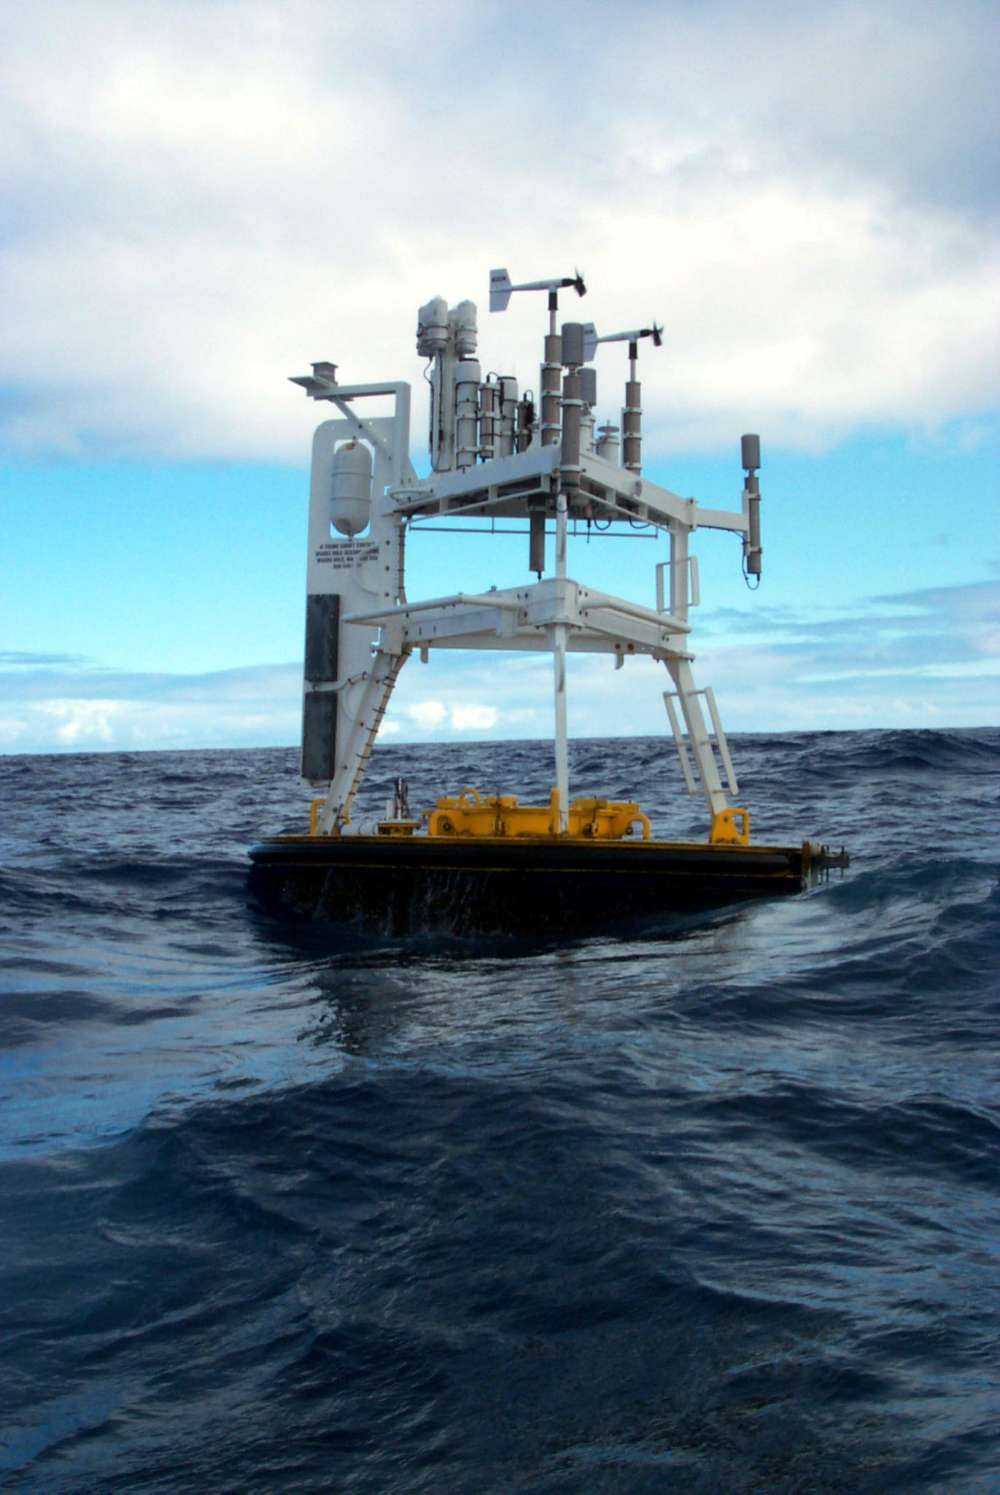
Figure 1 (left):
Surface buoy deployed at the Stratus Ocean Reference Station. Two redundant meteorological systems are used

Figure 2 (bottom): Comparison of monthly values of the four components of heat flux (from top: sensible, latent, new longwave, and net shortwave) from the buoy (IMET), models (ECMWF, NCEP1, NCEP2), and climatologies (NCAR, SOC).
