Site: TAO/TRITON moorings
Position: Four sites are recommended on the equator at 110°W, 140°W, 170°W, 165°E.
Categories:
Observatory and air-sea flux reference site with physical, meteorological, biogeochemical measurements.

Safety distance for ship operations: Two nautical miles. See http://www.pmel.noaa.gov/tao/proj_over/taobuoy.html
Short description:
- Four sites are recommended on the equator at 110°W, 140°W, 170°W, 165°E. PMEL ATLAS moorings are presently deployed at all four sites. The sites were initiated in January 1979 (110°W), April 1983 (140°W), May 1988 (170°W) and January 1986 (165°E). They are serviced at 6 month intervals by the NOAA ship Ka’imimoana and, at 110°W, by a combination of the Ka’imimoana and NOAA Ship Ron Brown.
- ATLAS moorings at the four recommended sites routinely measure surface winds, air temperature, relative humidity, sea surface temperature, ocean temperatures to 500 m (10 depths), sea surface salinity, and ocean currents at 4-5 selected depth between 10 m and 200 m. All data are stored internally at 10-minute intervals and transmitted in real-time as daily averages and a few spot hourly values. Each ATLAS mooring is deployed next to a nearby (within about 10 km) subsurface ADCP mooring providing hourly velocity measurements between depths of about 20-250 m with 8 m vertical resolution.
- Enhancements to the basic ATLAS measurement suite with proven technologies for rainfall, shortwave radiation, long wave radiation, and barometric pressure, plus the addition of higher vertical resolution temperature and salinity measurements below the surface, would make the moorings fully flux capable.
- Surface water and atmospheric pCO₂ measurements are being made or are planned for all four sites. The first pCO₂ system was deployed at 140°W in May 2004. A second system is planned for 170°W in June 2005, with other sites to follow in the near future.

Scientific rationale:
In order to improve our understanding and ability to predict El Nino and La Nina, it is necessary to quantify to the extent possible the relative magnitudes of processes affecting the evolution of SST in the tropical Pacific on interannual time scales. The proposed time series locations span key climatic regimes in the equatorial Pacific, namely the equatorial cold tongue (110°W, 140°W), the western Pacific warm pool (165°E), and the transition zone between these two regimes (170°W). The two cold tongue sites are distinctly different in their large-scale background conditions (e.g. depth of thermocline, strength of Undercurrent, mean surface heat fluxes, background vertical mixing).

Upwelling in the equatorial Pacific leads to enhanced productivity and degassing of CO₂ across a region ranging from the coast of South America to past the International Date Line. The vast area affected makes this region a significant contributor to global biogeochemical cycles. The El Niño-La Niña cycle results in significant interannual variability in CO₂ fluxes that are still not fully understood. The pCO₂ measurements in these key locations will allow a better characterization of the seasonal and interannual variability in CO₂ fluxes in this region.

The data from these sites can be used for describing new phenomena, and for diagnostic studies, model validation and development, climate forecast initialization, and satellite validation.

Groups / P.I.s /labs /countries involved / responsible:
PMEL ATLAS moorings are deployed between 95°W and 165°E, JAMSTEC TRITON moorings at and west of 156°E. P.I. for the 110°W-165°E sites is Michael McPhaden. The lead P.I. for the pCO₂ systems is Christopher Sabine.

Status:
- TAO/TRITON is presently supported primarily by NOAA in the U.S. and by JAMSTEC in Japan. The array will be maintained for the foreseeable future.
- The four sites can be immediately upgraded to flux reference sites using existing technologies as described above. All additional measurements would be transmitted in real-time as daily averages. Data would also be internally recorded at 10 minute intervals, except for rainfall at 1 minute intervals, short and long wave radiation at 2 minute intervals, and barometric pressure at 1 hour intervals.
- PCO₂ measurements are currently being made at the 140°W site and will be starting at 170°W in 2005 with support from NOAA’s Office of Climate Observations. Funding for PCO₂ measurements is pending for the remaining two sites.
- Logistic support is provided by ships that routinely service the TAO/TRITON array.

Technology:
The basic technology is used is the ATLAS mooring which measures meteorological and physical oceanographic data to depths of 500 m (see http://www.pmel.noaa.gov/tao/proj_over/mooring.shtml). There are also upward looking subsurface ADCP moorings deployed nearby each of the four sites. These moorings are equipped with 150 kHz RDI ADCPs. The pCO₂ measurements are LiCor based infrared detection systems mounted in the surface buoy with an equilibrator for surface water pCO₂ measurements. Surface ocean and atmospheric carbon measurements are made every 3 hours.

Data policy: All data (real-time and delayed mode) are freely available without restriction.

Data management:
ATLAS data are internally recorded and transmitted from buoy to shore via Service Argos in real-time. Service Argos places most real-time data on the Global Telecommunications System (GTS). ADCP data are internally recorded only. Data are freely available on the World Wide Web without restriction in near-real time (delay of one day) and in delayed mode after moorings are recovered and data are post-processed (See http://www.pmel.noaa.gov/tao/). Extensive metadata are available from TAO web pages, data reports, and from the data files themselves.

The 3-hour carbon measurements are transmitted daily via Iridium and posted to the WWW. Final calibrated data are submitted to the Carbon Dioxide Information Analysis Center and are freely available within 6 months of recovery.

Societal value / Users / customers:
The TAO/TRITON array is part of the ENSO Observing System for improved detection, understanding and prediction of ENSO warm and cold events. ENSO is the most pronounced year-to-year fluctuation on the planet, with impacts measured in the billions of dollars and thousands of lives worldwide. It is predictable with significant skill at lead times of 6-9 months. TAO/TRITON data users include the research community, the weather and climate forecasting communities, the climate assessments community, policy makers, and the general public.

Role in the integrated global observing system:
TAO/TRITON is a component of the ENSO Observing System, which in turn is an initial contribution to the Global Ocean Observing System (GOOS) and the Global Climate Observing System (GCOS). It is also a contribution to the Global Earth Observing System of Systems (GEOSS). The existing and planned carbon observations are a key element of the U.S. Ocean Carbon and Climate Change Program (OCCC) as well as the international Integrated Marine Biogeochemistry and Ecosystem Research (IMBER) and Surface Ocean Lower Atmosphere (SOLAS) programs.

Contact Persons:
TAO Project Director: Michael J. McPhaden, NOAA/PMEL (michael.j.mcphaden@noaa.gov)
TAO Operations and Data: H. Paul Freitag (Paul.Freitag@noaa.gov )
Carbon contact: Christopher L. Sabine (chris.sabine@noaa.gov )

Links / Web-sites:
TAO Project information: www.pmel.noaa.gov/tao/
TAO data access: http://www.pmel.noaa.gov/tao/data_deliv/deliv.html
Carbon information: http://www.pmel.noaa.gov/co2/moorings/

Compiled / updated by: Michael J. McPhaden (March 2005)

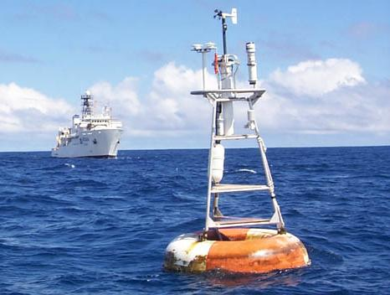

Figure 1: An ATLAS mooring instrumented for surface flux measurements during the four year (1999-2003) Eastern Pacific Investigation of Climate Processes (EPIC) along the 95°W. The NOAA ship Ka’imimoana is in the background.

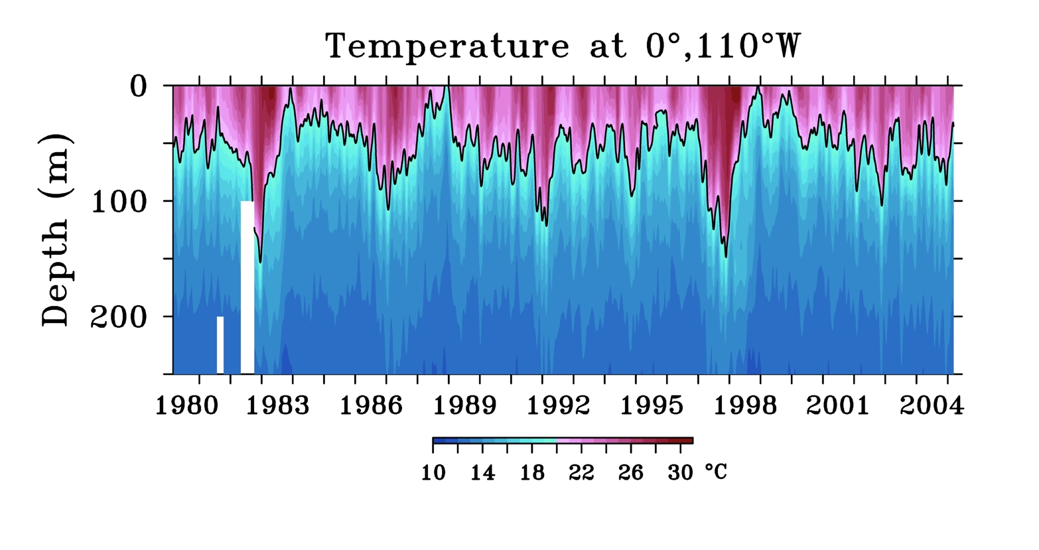 | Figure 2: Temperatures (top) and zonal velocities (bottom) for the 25-year period 1980-2005 at 0°, 110°W. Velocity data from ADCP moorings are internally recorded only, so data from late 2004 onwards are not yet available.
