Site: PMEL pCO₂ on TAO/TRITON mooring at 0°, 125°W
Position: 0°, 125°W
Categories: operating; observatory; biogeochemical measurements.

Safety distance for ship operations:
Two nautical miles. See http://www.pmel.noaa.gov/tao/proj_over/taobuoy.html
Short description:
- In addition to the four proposed observatory sites on the equator at 110°W, 140°W, 170°W, and 165°E, PMEL has deployed a surface pCO₂ system on the equator at 125°W to better characterize the seasonal and interannual variability in carbon fluxes in the Equatorial Pacific.
- Variables measured:
- winds, air temperature, relative humidity, rainfall, shortwave radiation, sea surface temperature, ocean temperatures to 500 m (10 depths), and sea surface salinity
- all data collected and stored internally at 10-minute sample rates except for rainfall (1 minute), shortwave radiation (2 minutes)
- data also transmitted in real-time as daily averages and a few spot hourly values
- Surface water and atmospheric pCO₂ measurements are being made every 3 hours at this site.
- The first pCO₂ system was deployed at 140°W in May 2004

Scientific rationale:
Upwelling in the equatorial Pacific leads to enhanced productivity and degassing of CO₂ across a region ranging from the coast of South America to past the International Date Line. The vast area affected makes this region a significant contributor to global biogeochemical cycles. The El Niño-La Niña cycle results in significant interannual variability in CO₂ fluxes that are still not fully understood. The pCO₂ measurements in several key locations will allow a better characterization of the seasonal and interannual variability in CO₂ fluxes in this region.

Groups / P.I.s /labs /countries involved / responsible:
PMEL ATLAS moorings are deployed between 95°W and 165°E, JAMSTEC TRITON moorings at and west of 156°E. P.I. for the 125°W site is Michael McPhaden. The lead P.I. for the pCO₂ systems is Christopher Sabine.

Status:
TAO/TRITON is presently funded primarily by NOAA in the U.S. and by JAMSTEC in Japan. PCO₂ measurements are funded by NOAA’s Office of Climate Observations. The array will be maintained for the foreseeable future.

Technology:
The basic technology is used is the ATLAS mooring which measures meteorological and physical oceanographic data to depths of 500 m (see http://www.pmel.noaa.gov/tao/proj_over/mooring.shtml). The pCO₂ measurements are LiCor based infrared detection systems mounted in the surface buoy with an equilibrator for surface water pCO₂ measurements. Surface ocean and atmospheric carbon measurements are made every 3 hours.

Data policy:
All data (real-time and delayed mode) are freely available without restriction.

Data management:
ATLAS data are internally recorded and transmitted from buoy to shore via Service Argos in real-time. Service Argos places most real-time data on the Global Telecommunications System (GTS). Data are freely available on the World Wide Web without restriction in near-real time (delay of one day) and in delayed mode after moorings are recovered and data are post-processed (See http://www.pmel.noaa.gov/tao/). Extensive metadata are available from TAO web pages, data reports, and from the data files themselves. The 3-hour carbon measurements are transmitted daily via Iridium and posted to the WWW. Final calibrated data are submitted to the Carbon Dioxide Information Analysis Center and are freely available within 6 months of recovery.

Societal value / Users / customers:
The TAO/TRITON array is part of the ENSO Observing System for improved detection, understanding and prediction of ENSO warm and cold events. TAO/TRITON and carbon data users include the research community, the weather and climate forecasting communities, the climate assessments community, policy makers, and the general public.

Role in the integrated global observing system:
TAO/TRITON is a component of the ENSO Observing System, which in turn is an initial contribution to the Global Ocean Observing System (GOOS) and the Global Climate Observing System (GCOS). It is also a contribution to the Global Earth Observing System of Systems (GEOSS). The existing and planned carbon observations are a key element of the U.S. Ocean Carbon and Climate Change Program (OCCC) as well as the international Integrated Marine Biogeochemistry and Ecosystem Research (IMBER) and Surface Ocean Lower Atmosphere (SOLAS) programs.

Contact Persons:
TAO contacts: Michael J. McPhaden, NOAA/PMEL (michael.j.mcphaden@noaa.gov),
H. Paul Freitag (Paul.Freitag@noaa.gov )
Carbon contact: Christopher L. Sabine (chris.sabine@noaa.gov )

Links / Web-sites:
TAO information : www.pmel.noaa.gov/tao/
TAO data access : http://www.pmel.noaa.gov/tao/data_deliv/deliv.html
Carbon information: http://www.pmel.noaa.gov/co2/moorings/

Compiled by: Christopher L. Sabine (March 2005)

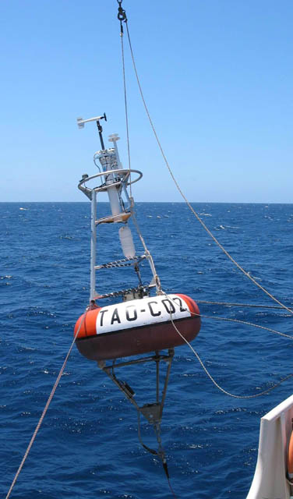
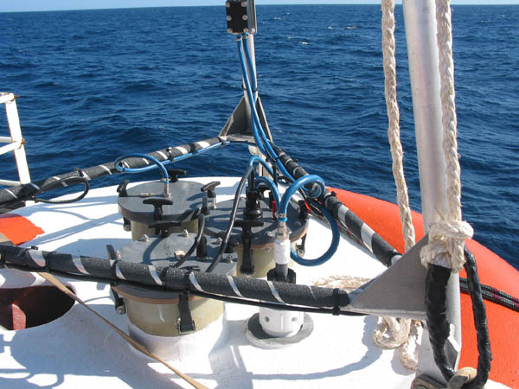

Figure 2:
A close up of CO₂ system mounted in ATLAS buoy.

Figure 1: Deployment of TAO-CO2 mooring at 125°W.

