Site: TRITON super reference site in the western Pacific warm pool
Position: 0°N 156°E
Categories:
- Air-Sea Flux reference site (at present)
- observatory: meteorology and physical (at present), biogeochemical (add the function in future)

Safety distance for ship operations: 2 miles same as for TAO moorings
Short description:
- One of the 16 TRITON sites in the western Pacific.
- Variables measured :
- surface meteorological sensors: wind vector, shortwave radiation, relative humidity, air temperature, atmospheric pressure, rain rate
- subsurface sensors:
temperature and conductivity (1.5, 25, 50, 75, 100, 125, 150, 200, 250, 300, 500, 750m)
pressure (300m, 750m)
current vector (10m)
- Sampling rate: every 10 min (except current meter of 20 min)
- Start date of the timeseries, service interval: 17 March 1998, once per year

Scientific rationale:
The scientific objectives are to elucidate the processes of heat and fresh water flux in the center of western Pacific warm water pool. It is consists of ENSO monitoring TAO/TRITON array.
In future, the buoy at this site will be used for high precision measurement of SST to validate the satellite products.
It will be also utilized for measuring partial pressure timeseries of CO2 in the water for a study of carbon flux.

Groups / P.I.s /labs /countries involved / responsible:
JAMSTEC/Yoshifumi Kuroda/ Japan/ Group Leader
JAMSTEC/ Kentaro Ando/ Japan/ Heat flux
JAMSTEC/Masaki Katsumata/ Japan/ Fresh water flux
JAMSTEC/Syuich Watanabe/ Japan/ CO2 (Plan)
Tohoku University/ Hiroshi Kawamura/ Japan/ Varidation of high resolution satellite SST product (Plan)

Status:
- Operating
- The site to be maintained at least until 2009 under the IORGC,JAMSTEC 5-year implementation plan.
- Funded by the Japanese Ministry of Education, Culture, Sports, Science, and Technology.

Technology:
- surface mooring
- real-time telemetry
- SST measurements: SBE 37-IM, Sea Bird Electronics, at 1.5 m depth on the cradle of surface float

Data policy:
- real-time data:
- wind vector, relative humidity, air temperature, atmospheric pressure (on GTS and web)
- temperature (1.5, 25, 50, 75, 100, 125, 150, 200, 250, 300, 500, 750m) (on GTS and web)
- shortwave radiation(to be appeared on web)
- current vector (10m) (to be appeared on web)
- delayed mode data: rain rate (because of large data quality variance)

Data management:
- Satellite data collection system :ARGOS
- Real-time data processing and distribution system : GTS through French ARGOS global processing center
- Metadata scheme :
The real-time raw data are received via ARGOS center.
After real-time QC, including visual inspection, hourly data of each sensor are merged as an ascii metadata with in site by site.
When post-calibration of sensors has been done after 1-year mooring, we correct data applying calibration result and make hourly delayed metadata.
in the future, 10-minutes metadata will be distributed via our web site.

Societal value / Users / customers:
Monitoring ocean and atmosphere changes/ meteorological institutions/ researchers

Role in the integrated global observing system: Part of ENSO observing system

Contact Person: Yoshifumi Kuroda

Links / Web-sites:
- for Project information : http://www.jamstec.go.jp/jamstec/TRITON/index.html
- for data access :
The standard data from Indian TRITON buoys can be seen from TRITON home page. http://www.jamstec.go.jp/jamstec/TRITON/real_time/html/index.html
Choose 0,156E.

Compiled by: Yoshifumi Kuroda (February 2005)

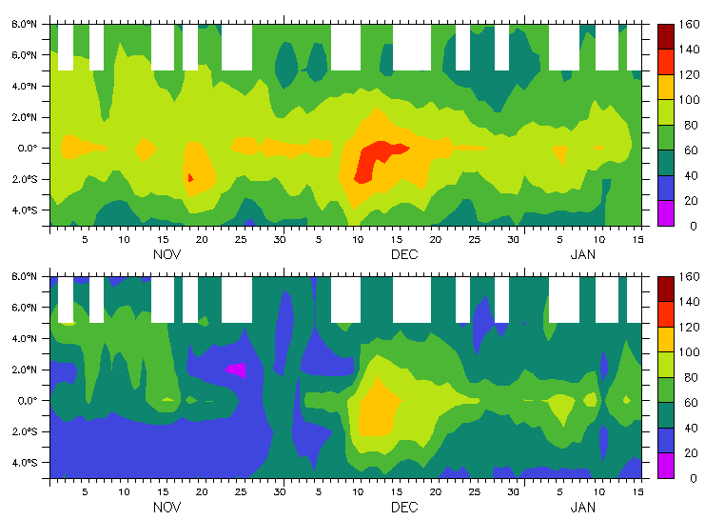

Figure Time-latitude plots of isothermal layer (upper) and mixed layer (lower) depths obtained from the temperature and salinity data of 156E TRITON. This is an example of how the ocean responds to a westerly wind burst. The isothermal layer and mixed layer depths deepened remarkably near the equator in December 2001 associated with one of the major westerly wind bursts prior to the 2002/2003 ENSO.
(provided by K.Ando)

