Site: New Zealand Ocean Time Series
Position: 41.5 S 178.5 E and 46.67 S 178.5 E
Categories: Observatory for physical, meteorological, biogeochemical measurements, CO2, particle flux, chlorophyll

Safety distance for ship operations: 10 n miles
Short description:
- 2 moorings: subtropical waters 41.5 S 178.5E;
subantarctic waters 46.6S 178.5 E
- Variables measured :
- 40 m depth (irradiance (10 minute mean), chlorophyll fluorescence (10 minute mean), temperature (hourly) , salinity (hourly) , CO2 (ten minute mean);
- 120 m depth current speed and direction (10 minute mean), temperature (hourly) , salinity (hourly);
- 250 m depth current speed and direction (10 minute mean), temperature (hourly) , salinity (hourly);
- 1500 m depth downward particle flux (mass flux, POC, PIC, opal, PON) every 5 days, current speed and direction (10 minute mean), temperature (hourly) , salinity (hourly).
- Start date of the timeseries, service interval:
The moorings have been deployed since October 2000. They are serviced every 4 months. During each servicing voyage, additional data are also collected (underway nutrients, deep CTD casts etc)

Scientific rationale:
The location of the subtropical convergence east of New Zealand provides the opportunity to obtain detailed time-series data in each of two distinct waters masses - subtropical and subantarctic waters. In particular, these water masses exhibit different biological signals, with subtropical waters characterised by a classical spring and autumn phytoplankton bloom, whereas subantarctic waters are perennially High Nitrate Low Chlorophyll due to low dissolved iron concentrations.
Our 2 identical moorings were designed to examine the degree of coupling between pelagic and deep water events in each of these water masses. We can assess if this coupling is stronger in the more productive subtropical waters relative to the subantarctic water mass. The latter, comprises a 10 degree N-S circumpolar ring and thus represents around 50% of the ice-free waters of the Southern Ocean. Thus, the data from the subantarctic water mooring will be of particular interest to the Southern Ocean biogeochemical community.

Groups / P.I.s /labs /countries involved / responsible:
Ocean Ecosystems group at NIWA (NZ) runs the moorings with Scott Nodder responsible for the deepwater traps, Philip Boyd for the bio-optical instruments, and Kim Currie for the SAMI pCO2 sensor. We have close links with other NIWA groups working on Ocean Colour. We have links with other S. ocean mooring groups from Australia (Tom Trull, Bronte Tilbrook) and elsewhere (Tommy Dickey).

Status:
- operating
- long-term plans
- funding status, source of funding: New Zealand

Technology:
- deep-moored sensors
- data downloaded every 4 months
- SST measurements: Seabird MICROCAT

Data policy:
- delayed mode data: not public at present – data dissemination via publications (Nodder et al. in review at JGR-Oceans)

Data management: internal at present – to be discussed later in 2005

Societal value / Users / customers:
Through assessment of the annual cycles of phytoplankton stocks and export of carbon to depth we are able to provide data to other New Zealand end-users on seasonal and interannual variability of these properties that will determine the carry capacity of local waters, and their ability to sequester carbon. We also have links with other groups with moorings in S. Ocean waters (CSIRO) and can thus compare our findings at various sites in subantarctic waters.

Role in the integrated global observing system:

Contact Person: Scott Nodder/ Philip Boyd (s.nodder@niwa.co.nz, p.boyd@niwa.co.nz )

Links / Web-sites: none at present

Compiled / updated by: Philip Boyd (March 2005)
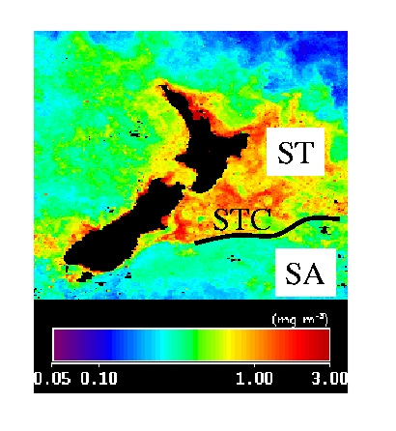

Figure 1: ST Spring bloom October 2000 SeaWiFs
The waters East of New Zealand are a natural laboratory to study Subantarctic (SA) and Suptropical (ST) waters. The SA Ring comprises 50 % of the open Southern Ocean.
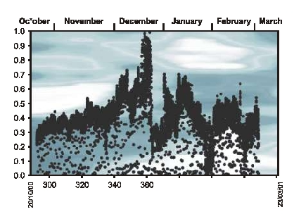
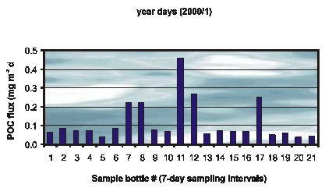
Figure 2: Time-series data from the Subantarctic mooring in late 2000 / early 2001 from 40 m subsurface (bio-optical instrument) and 1500 m (deep-moored sediment trap).

