Site: Rothera Time Series (RaTS)
Position: 67S, 68W (Marguerite Bay)
Categories: physical, biogeochemical, biological

Safety distance for ship operations:
There is no restriction on shipping (other than ice and water depth), but any work should be coordinated with the BAS base at Rothera.
Short description:
- 1 repeat CTD station, plus associated sampling for biogeochemical/biological variables
- Variables measured :
- CTD (temperature, conductivity, depth) profiling to ~450m
- Photosynthetically-active radiation profiled to ~450m
- Fluorescence profiled to ~450m
- Oxygen Isotopes sampled at 15m
- Chlorophyll sampled at 15m
- Nutrients sampled at 15m
- Other biological parameters sampled at 15m
- Start date of the timeseries, service interval: Started late 1997; repeat measurements ~weekly, subject to ice. (Profiling through hole cut in ice in winter).

Scientific rationale:
Antarctica as a whole is unusual in having a very deep continental shelf with relatively little freshwater or sediment input from rivers. It is, however, highly influenced by oceanographic processes associated with both surface ice and continental shelf ice. The Antarctic coastal marine system exhibits a marked seasonality, and also variability on a range of scales from interannual to Milankovitch. The RaTS site is towards the southern end of the Antarctic Peninsula, a region which has seen among the highest rates of regional climatic warming of the past 50 years. As the time series continues, we will be able to investigate the role of oceanographic variability on a range of timescales and its influence on the Antarctic marine ecosystem.
We have already discerned the impact of ENSO variability on the physical ocean system, and are currently tracking its progression through the associated biogeochemical and ecological system.

Groups / P.I.s /labs /countries involved / responsible:
Andrew Clarke (BAS, UK) for biogeochemistry and biology
Mike Meredith (BAS, UK) for physics

Status:
- Ongoing
- funding provided to the British Antarctic Survey by the UK Natural Environment Research Council as part of BAS's Long-Term Monitoring and Survey remit (LTMS)

Technology:
CTD and Niskin bottle sampling from small boat in Antarctic summer. When ice-covered, the sampling site is measured by cutting a hole through the ice, and conducting sledge-based profiling and sampling.

Data policy:
delayed mode data: public (available on request)

Data management:
At present, profile data relayed to UK by satellite (email). Some discrete samples analysed on base at Rothera Research Station; others returned to UK annually for laboratory analysis.

Contact Person:
Mike Meredith (physics, CTD, oxygen isotopes)
Andrew Clarke (biology, biogeochemistry)

Links / Web-sites:
- for Project information : some brief description on http://www.soc.soton.ac.uk/JRD/HYDRO/drake/rats.php
- a more up-to-date website is being developed.

compiled / updated by: Mike Meredith (December 2004) ???????
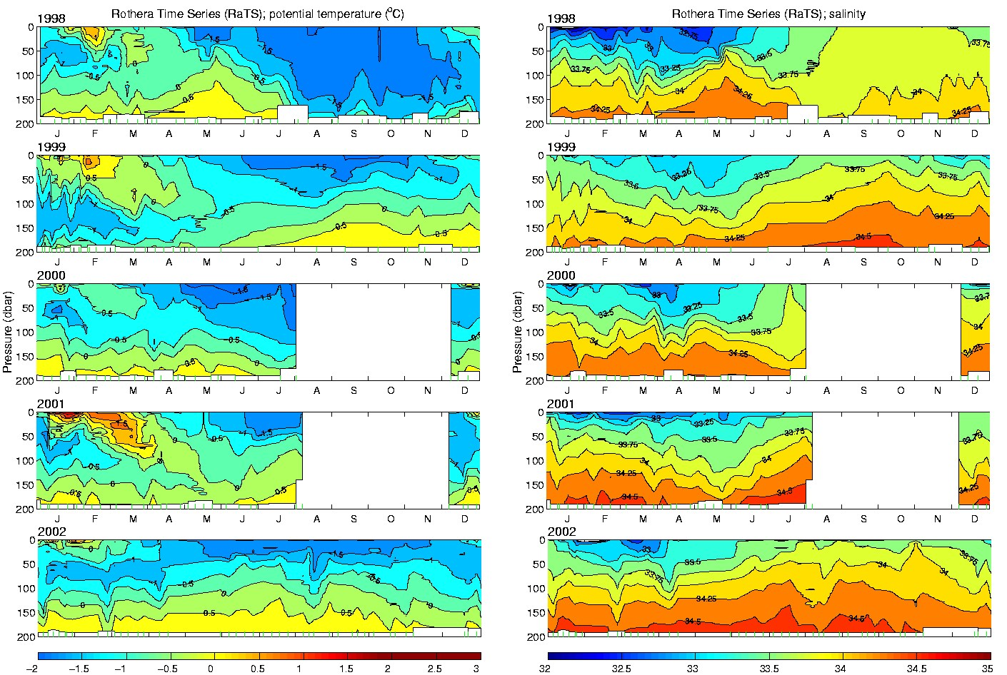

Figure: Temporal progression of the upper-layer temperature (left) and salinity (right) at the RaTS site, for the period 1998-2002. Note, in particular, the very deep homogeneous layer in austral winter of 1998, caused by the ENSO event that was then decaying.

