Site: Weddell Sea/Greenwich Meridian
Position: 54° 30’S 0° to 69°24’S 0°
Categories: operating; Observatory, Transport; physical, sea ice

Safety distance for ship operations: subsurface moorings 2 nm from each mooring
Short description:
- 9 moorings (positions see table 1)
- Variables measured: currents, T, S, p, sea ice (for details see table 1)
- Start date of the time series, service interval: First deployment 1996. Last redeployment in 2005.
The available mooring technology allows two year mooring periods. The required ship time is provided by AWI with the icebreaking research vessel “Polarstern.”

Scientific rationale:
On the Greenwich Meridian water masses enter the formation areas of bottom water from the east, newly formed bottom water fills the basin from the west and Maud Rise represents a topographic feature which has the potential to induce the formation of a large polynya with consequent deep water formation in the open ocean. Therefore the Greenwich Meridian is a key area where the status of the Weddell Sea as a water mass formation area can be monitored

The measurements consist of large scale hydrographic sections with a repeat cycle between 2 and 4 years and moored instruments to avoid effects of alising. The observed parameters are used to estimate water mass properties and transports are temperature, salinity, CO₂, CFCs, currents and ice thickness. The moored observing system is maintained in the Weddell Sea Convection Control (WECCON) project since 1996 with minor modifications. Current meter moorings were exchanged in 1998, 1999, 2001, 2003 and 2005. A redeployment is planned for the austral summer 2007/2008. The moorings are equipped with current meters, temperature and conductivity sensors and some with bottom pressure recorders (Tab.1). The mooring work occurs in cooperation with the University Bergen, Norway. Additional to the moorings, vertically profiling floats are deployed in the context of the ARGO programme. The moorings carry sound sources for RAFOS location of the floats. Upward looking sonars in 150 m depth are installed on 4 moorings in the framework of WCRP’s Antarctic Sea-Ice Thickness Project (AnSITP) to determine the sea ice transports (http://www.awi-bremerhaven.de/Research/IntCoop/Oce /ansitp/index.html). In 1996, 1998, 1999, 2001, 2003. 2005 hydrographic surveys were carried out along the Greenwich Meridian with a CTD-probe (Conductivity/Temperature/Depth) combined with a rosette water sampler). A repeat of this transect is planned for 2007/2008. XBTs are deployed north of the CTD transect. The continuation is envisaged.
To monitor the ACC transports a series of PIES is deployed In a final state 8 PIES will be located along a Jason track from the northern end of the mooring line toward South Africa.

Groups / P.I.s /labs /countries involved / responsible:
Eberhard Fahrbach and Olaf Boebel (Alfred-Wegener-Institut für Polar- und Meeresforschung)

Status:
- operating
- time horizon / long-term plans: funding assured until 2007/2008
- funding status, source of funding: The project is part of the Southern Ocean research project of the Alfred-Wegener-Institut für Polar- und Meeresforschung within the framework of the MARCOPOLI Programme of the Helmholtz-Gemeinschaft Deutscher Forschungszentren and a contribution to the German Atlantik project funded by BMBF.

Technology:
- moored sensors see Tab. 1
- SST measurements: only during CTD transects.
- Profile measurements: In the moorings only point measurements in different levels see Tab. 1.

Data policy:
- delayed mode data: available after recovery, processing and evaluation

Data management:
- Metadata scheme : See AWI data bank and CLIVAR data system
- Possibilities of evolution to comply with a more general JCOMM GTS scheme: Installation of profilers to allow quasi real time data transfer according technical feasibility and funding.

Societal value / Users / customers: Science

Role in the integrated global observing system:
The moorings provide data to monitor the status of a significant water mass formation area. However, they are very much influenced be the local conditions. Therefore, repeat hydrography and XBT launches have to cover a larger area to extend the observations over different water mass regimes. The repeat sequence of 2 to 4 years includes a large risk by aliasing and can not replace the moored instruments.

Contact Person: Gerd Rohardt: grohardt@awi-bremerhaven.de

Links / Web-sites:
- for Project information:
Eberhard Fahrbach (efahrbach@awi-bremerhaven.de) for more detail see:http://www.awi-bremerhaven.de/Research/IntCoop/Oce/weccon/index.html
- for data access : http://www.awi-bremerhaven.de/OZE/index.html

Compiled / updated by : Eberhard Fahrbach (April 2005)
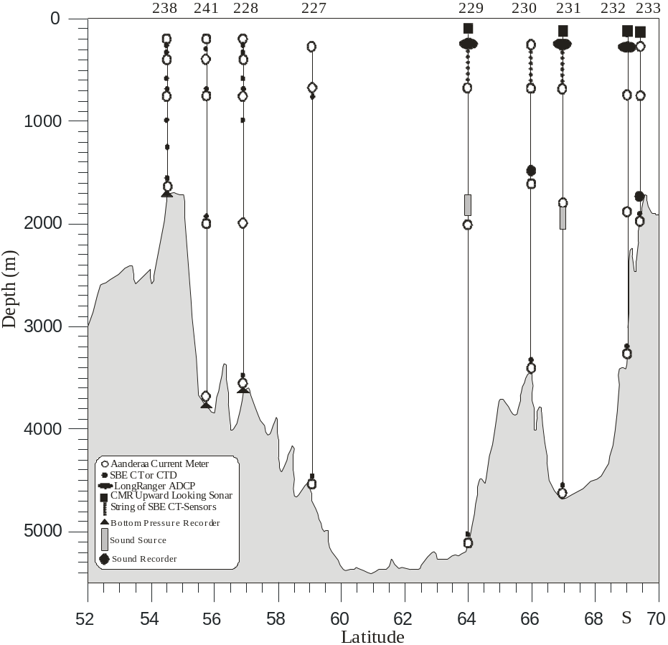

Figure
Moorings deployed in January/February 2005 along the Greenwich Meridian.

Table 1
Mooring | Latitude  Longitude | Water Depth (m) | Date  Time | Type | SN | Depth  (m)
AWI233-7 | 69° 23.60’ S | 1950 | 17.02.2005 | ULS | 46 | 150
 | 00° 04.29’ W |  | 21:06 | AVTP | 11890 | 202
 |  |  |  | RCM11 | 100 | 699
 |  |  |  | SR | W402 | 1700
 |  |  |  | SBE37PuP35 | 3810 | 1903
 |  |  |  | RCM 11 | 146 | 1904
AWI232-7 | 68° 59.75’ S | 3370 | 17.02.2005 | ULS | 47 | 151
 | 00° 00.11’ W |  | 12:43 | ADCP | 5373 | 375
 |  |  |  | AVTPC | 10927 | 752
 |  |  |  | AVT | 9186 | 1808
 |  |  |  | SBE37 | 230 | 3313
 |  |  |  | AVT | 6854 | 3314
AWI231-6 | 66° 30.66’ S | 4540 | 09.02.2005 | ULS | 56 | 151
 | 00° 01.91’ W |  | 15:47 | SBE37PuP3 | 1237 | 200
 |  |  |  | SBE37 | 216 | 300
 |  |  |  | ADCP | 3813 | 353
 |  |  |  | SBE37 | 224 | 400
 |  |  |  | SBE37 | 227 | 500
 |  |  |  | SBE37 | 229 | 600
 |  |  |  | SBE37P3 | 242 | 700
 |  |  |  | AVTPC | 10928 | 700
 |  |  |  | AVT | 9391 | 1802
 |  |  |  | SQ | W2-2 | 1900
 |  |  |  | SBE37 | 231 | 4493
 |  |  |  | AVT | 9180 | 4494
AWI230-5 | 66° 00.66’ S | 3450 | 08.02.2005 | AVTPC | 9204 | 194
 | 00° 11.28’ E |  | 21:00 | SBE37P3 | 243 | 200
 |  |  |  | SBE37 | 233 | 300
 |  |  |  | SBE37 | 232 | 400
 |  |  |  | SBE37 | 235 | 500
 |  |  |  | SBE37 | 236 | 600
 |  |  |  | SBE37PuP35 | 2721 | 700
 |  |  |  | AVTP | 9214 | 700
 |  |  |  | SR | A401 | 1550
 |  |  |  | AVTP | 9998 | 1590
 |  |  |  | SBE37 | 238 | 3400
 |  |  |  | RCM 11 | 25 | 3400
AWI229-6 | 63° 57.16’ S | 5200 | 07.02.2005 | ULS | 57 | 147
 | 00° 00.37’ W |  | 15:58 | SBE37PuP3 | 1236 | 200
 |  |  |  | SBE37 | 240 | 300
 |  |  |  | ADCP | 0825 | 380
 |  |  |  | SBE37Pu | 435 | 400
 |  |  |  | SBE37Pu | 436 | 500
 |  |  |  | SBE37Pu | 438 | 600
 |  |  |  | SBE37P3 | 248 | 700
 |  |  |  | AVT | 9769 | 700
 |  |  |  | SQ | W1-2 | 1814
 |  |  |  | AVT | 9188 | 2002
 |  |  |  | SBE37 | 439 | 5153
 |  |  |  | AVT | 9770 | 5154
AWI227-9 | 59° 04.11’ S | 4627 | 04.02.2005 | AVTP | 10003 | 231
 | 00° 04.92’ E |  | 18:39 | AVTPC | 10926 | 723
 |  |  |  | SBE37PuP10 | 1234 | 724
 |  |  |  | AVT | 11937 | 2019
 |  |  |  | SBE37Pu | 1603 | 4581
 |  |  |  | AVT | 9767 | 4582
AWI228-7 | 56° 57.56’ S | 3700 | 03.02.2005 | AVTP | 9763 | 191
 | 00° 01.07’ E |  | 16:03 | SBE37PuP3 | 1232 | 197
 |  |  |  | SBE37 | 441 | 247
 |  |  |  | SBE37 | 442 | 297
 |  |  |  | SBE37PuP3 | 1233 | 347
 |  |  |  | AVTP | 10539 | 401
 |  |  |  | SBE37 | 447 | 403
 |  |  |  | SBE37P3 | 247 | 582
 |  |  |  | AVTP | 8037 | 747
 |  |  |  | SBE37PuP3 | 1230 | 749
 |  |  |  | SBE37 | 444 | 998
 |  |  |  | SBE37 | 440 | 1247
 |  |  |  | RCM 11 | 214 | 2003
 |  |  |  | RCM 11 | 26 | 3654
 |  |  |  | SBE37Pu | 1607 | 3656
 |  |  |  | SBE26 | 257 | 3700
AWI241-1 | 55° 31.94’ S | 3810 | 02.02.2005 | AVTPC | 9200 | 212
 | 00° 00.05’ W |  | 15 :37 | SBE37P3 | 246 | 317
 |  |  |  | AVTP | 9785 | 424
 |  |  |  | AVT | 10532 | 770
 |  |  |  | SBE16P3 | 245 | 772
 |  |  |  | RCM 11 | 216 | 2017
 |  |  |  | SBE37 | 269 | 2000
 |  |  |  | RCM 11 | 219 | 3744
 |  |  |  | SBE26 | 228 | 3810
AWI238-5 | 54° 30.76’ S | 1700 | 01.02.2005 | AVTP | 10541 | 201
 | 00° 01.39’ E |  |  | SBE16PuP3 | 1235 | 208
 |  |  |  | SBE37P3 | 244 | 257
 |  |  |  | SBE37 | 218 | 306
 |  |  |  | SBE37PuP35 | 2719 | 356
 |  |  |  | AVTP | 9211 | 402
 |  |  |  | SBE37PuP35 | 2720 | 403
 |  |  |  | SBE37 | 225 | 573
 |  |  |  | AVTP | 7727 | 748
 |  |  |  | SBE37PuP35 | 2722 | 750
 |  |  |  | SBE37PuP35 | 2723 | 1000
 |  |  |  | SBE37 | 437 | 1250
 |  |  |  | RCM 11 | 215 | 1644
 |  |  |  | SBE37PuP35 | 3811 | 1646
 |  |  |  | SBE26 | 227 | 1700

Abbreviations:
ADCP RD-Instruments, Self Contained Acoustic Doppler Current Profiler
AVTCP Aanderaa Current Meter with Temperature-, Conductivity-, and Pressure Sensor
AVTP Aanderaa Current Meter with Temperature- and Pressure Sensor
AVT Aanderaa Current Meter with Temperature Sensor
RCM 11 Aanderaa Doppler Current Meter
SBE16P# SeaBird Electronics intern recording CTD measuresTemperature, Conductivity, and Pressure, Type: Seacat; P# indicates the Depth Rating, e.g. P1 up to 1000psi or P3 up to 3000psi
ULS Upward Looking Sonar; Christian Michelsen Research Inc.
SBE26 SeaBird Electronics to measure the Bottom Pressure
SBE37 SeaBird Electronics, Type: MicroCat, to measure Temperature and Conductivity
SBE37Pu SeaBird Electronics, Type: MicroCat, to measure Temperature and Conductivity including external Pump
SBE37PuP# SeaBird Electronics, Type: MicroCat, to measure Temperature and Conductivity including external Pump and Pressure Sensor; P# indicates the Depth Rating, e.g. P3 up to 3000psi or P7 up to 7000psi and P35 for 3500 dbar
SQ Sound Source for SOFAR-Floats
SR Sound Recorder

