Site: Weddell Sea (Northwestern Station)
Position: ~62°S 44°W – 64°S 42°W
Categories: operating; transport; physical, bottom water

Safety distance for ship operations: 2 km
Short description:
- 3 moorings maintained since 1999, with CTD/tracer stations occupied at and between the mooring sites when logistically feasible.
- Variables measured :
Moorings: temperature, salinity, water velocities from the bottom to 500 m above bottom at approximately 100 m intervals. Sampling rates vary from 7.5 to 30 minutes.
CTD/tracer: to within 10 m of the bottom at most stations. Water samples collected for analysis of CFC, transient tracers
- Start date of the timeseries, service interval:
Moorings first deployed 1999; serviced at intervals dictated by available vessel time and local conditions [2000, 2001, 2005]

Scientific rationale:
The abyssal ocean is filled with cold, dense water that obtains it characteristics on the Antarctic continental shelf and by mixing while sinking along the slope. Recent estimates of water mass formation rates using CFC inventories suggest that a total of 8 Sv of Antarctic Bottom Water (AABW) are formed [Orsi et al. 1999]. The Weddell Sea Gyre transports about 5 Sv of Deep and Bottom water and thus contributes as much as 50% to the formation of AABW [e.g. Gordon et al. 2001, Fahrbach et al. 1994, 1995, Meredith et al. 2001]. Streams of relatively low salinity Weddell Sea Deep Water with temperature between 0° and -0.7°C are found along the outer rim of the Weddell Sea with varying degree of oxygen saturation (Figure 1) [Gordon et al. 2001]. Between 1989 and 1998 Fahrbach et al. [2001] deployed a current meter array east of Joinville Island which allowed for the first glimpse at interannual variability in temperature, thickness and transport of the WSBW formed in the Weddell gyre region. Starting in April 1999 LDEO/WHOI continued the time series at a down stream location south of the South Orkney Islands with a small mooring array (Figure 2) [Visbeck et al. 2001]. This location is easier to maintain since the sea ice covered season is shorter on average.

Groups / P.I.s /labs /countries involved / responsible:
The main effort is supported by LDEO (A. Gordon, W. Smethie, P. Schlosser). One mooring has been instrumented by WHOI (Toole). Some of the hydrographic work has been carried out in collaboration with a joint German/Brazilian program (Garcia, Hellmer). Funding has been received by NOAA, and the field work was made possible by arrangement with the NSF Office of Polar Programs.

Status:
- operational since 1999
- Funding has been provided by NOAA through 2005, with plans to continue funding the mooring efforts for several years more.

Technology:
The ongoing program has two elements: A repeat hydrographic section across the northwestern Weddell gyre outflow including observations of trace elements (CFCs and Tritium/Helium) and an array of three moorings. Two of them are equipped with nominally two current meters, two TS recorder and several T recorders covering a 500m thick layer above the sea floor. The third mooring consists of a profiling CTD and current meter package which is capable of obtaining a 1000m long profile every other day. All moorings have internal recording only and it is not feasible to add telemetry due to heavy sea ice.

Data policy:
- delayed mode data: The mooring and CTD data are available to the public in delayed mode, to allow for preliminary processing of the data prior to public release. All available data can be accessed from the project web site.

Data management: Under development.

Societal value / Users / customers:
The site is perfect to document changes in rates and types of bottom waters formed in the Weddell Sea. Even subtle changes in the climate system would be detectable and at some point can be compared with climate model solution. Note, however, that this is a region of the world where climate model simulations are quite inadequate. At this point assessments of the state of the global climate systems, such as the IPCC process are our customers.

Role in the integrated global observing system:
The global observing system is very thin in the Southern Hemisphere. Seasonal sea ice cover and its rather high latitude limit the amount of information that can be gained by space based measurements. Thus sites like this one contribute crucial and unique information that will be hard to get any other way.

Contact Person:
- for enquiry about addition of instrumentation or sensors to the site or for possible ancillary measurements during cruises to the site: Prof Arnold Gordon (agordon@ldeo.columbia.edu)
- for information about the site or data : Bruce Huber (bhuber@ldeo.columbia.edu)

Links / Web-sites:
- for Project information : http://www.ldeo.columbia.edu/res/div/ocp/projects/corc.shtml
- for data access : http://www.ldeo.columbia.edu/res/div/ocp/projects/corc.shtml

compiled/ updated by: Bruce Huber (April 205)

Figure 1:
Potential temperature section south of the South Orkney Islands with the location of the mooring array superimposed. Inset: Bathymetric map of the Weddel Sea Gyre indicating the position of several streams of newly formed Weddell Sea Bottom Water [Gordon et al. 2001] and the CORC/ARCHES repeat section and mooring array
[reproduced from Visbeck et al, 2001].
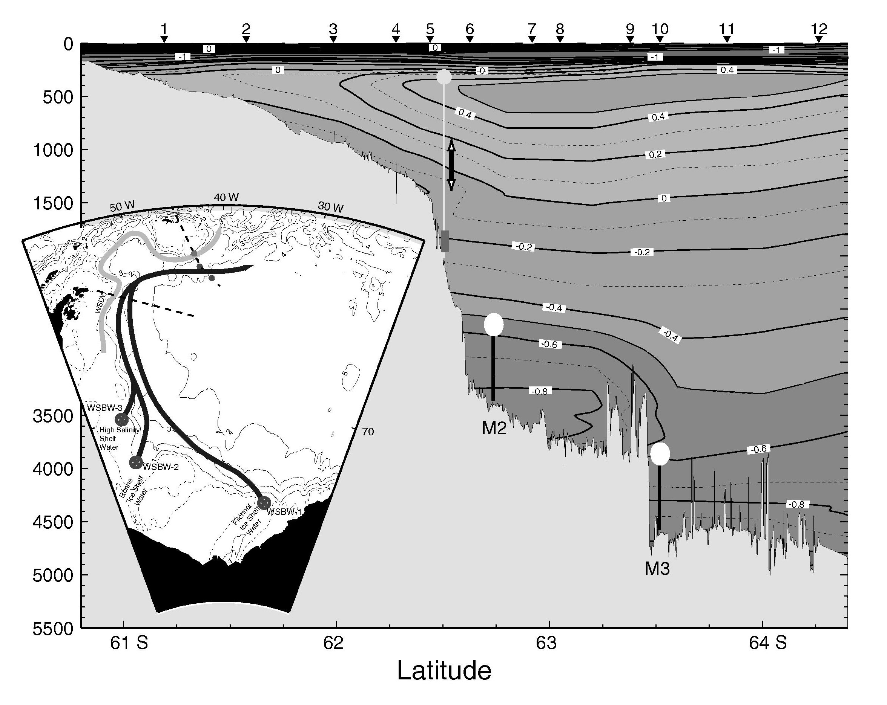
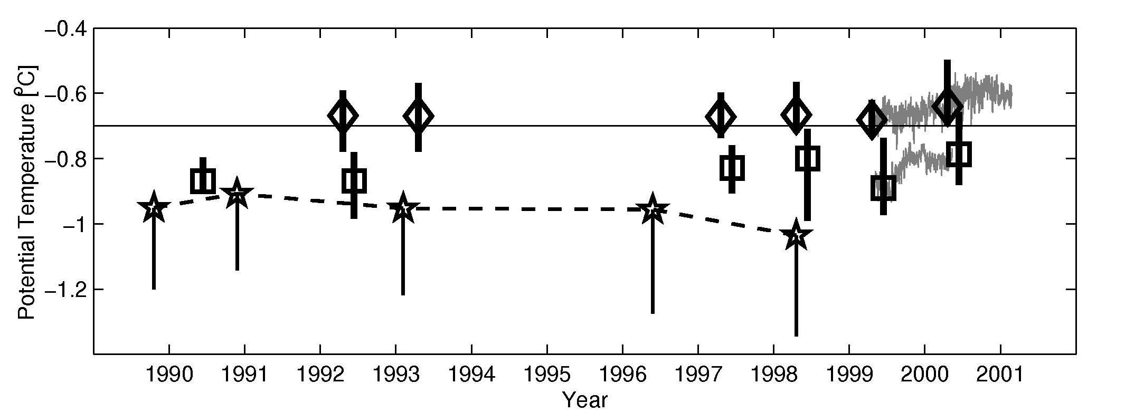Figure 2: Potential temperature time series as obtained from repeat hydrographic sections in the northwestern Weddell gyre. Diamonds denote the mean temperature between 2600 and 3200 m water depth near 62.5°S 43.5°W (near M2). Squares denote the mean temperature between 4000 and 4600 m water depth near 63.5°S 42.0°W (near M3). The bars covers the total range of observed temperatures. The thin gay lines represent the 40h low pass filtered temperatures averaged over all sensors at mooring M2 and M3 respectively. The stars are the plume mean temperatures from Fahrbach et al. (2001) at their upstream array location. The solid line connects the plume mean with the coldest temperature found during each survey [reproduced from Visbeck et al, 2001].

