Site: Weddell Sea proper
Position: 63° 42’S 50°52’W to 66°37’S 27°06’W
Categories: operating; Observatory; physical, sea ice

Safety distance for ship operations: subsurface moorings 2 nm from each mooring
Short description:
- 3 moorings
- Variables measured: currents, T, S, p, sea ice (for details see table 1)
- Start date of the timeseries, service interval:
First deployment 1989. Interruption 1996. Last redeployment in 2005.
The available mooring technology allows two year mooring periods. The required ship time is provided by AWI with the icebreaking research vessel “Polarstern.”

Scientific rationale:
In the Weddell Sea proper newly formed bottom and deep water is accumulated and provides a naturally low passed record of the time history of bottom and deep water formation. Additionally the Weddell Sea proper represents particular ice conditions which are supposed to be representative for the Atlantic sector of the Antarctic Ocean.
The measurements consist of large scale hydrographic sections with a repeat cycle between 2 and 4 years and moored instruments to avoid effects of alising. The observed parameters are used to estimate water mass properties and transports are temperature, salinity, CO₂, CFCs, currents and ice thickness. The moored observing system is maintained in the Weddell Sea Convection Control (WECCON) project since 1996 with minor modifications. Current meter moorings were redeployed in 2005 after a break in 1996. A redeployment is planned for the austral summer 2007/2008. The moorings are equipped with current meters, temperature and conductivity sensors and some with bottom pressure recorders (Tab.1). Additional to the moorings, vertically profiling floats are deployed in the context of the ARGO programme. The moorings carry sound sources for RAFOS location of the floats. Upward looking sonars in 150 m depth are installed on 4 moorings in the framework of WCRP’s Antarctic Sea-Ice Thickness Project (AnSITP) to determine the sea ice transports (http://www.awi-bremerhaven.de/Research/IntCoop/Oce /ansitp/index.html ). In 1989, 1990, 1993, 1996, 1998. 2005 hydrographic surveys were carried out in the Weddell Sea with a CTD-probe (Conductivity/Temperature/Depth) combined with a rosette water sampler). A repeat of this transect is planned for 2007/2008. XBTs are deployed north of the CTD transect. The continuation is envisaged.

Groups / P.I.s /labs /countries involved / responsible:
Eberhard Fahrbach (Alfred-Wegener-Institut für Polar- und Meeresforschung)

Status:
- operating
- time horizon / long-term plans: Funding assured until 2007/2008. It is planned to maintain the measurements to detect decal variability.
- funding status, source of funding:
The project is part of the Southern Ocean research project of the Alfred-Wegener-Institut für Polar- und Meeresforschung within the framework of the MARCOPOLI Programme of the Helmholtz-Gemeinschaft Deutscher Forschungszentren and a contribution to the German Atlantik project funded by BMBF.

Technology:
- moored sensors see Tab. 1
- SST measurements: only during CTD transects.
- Profile measurements: In the moorings only point measurements in different levels see Tab. 1.

Data policy:
- delayed mode data: data available after recovery, processing and evaluation.

Data management:
- Metadata scheme: See AWI data bank and CLIVAR data system
- Possibilities of evolution to comply with a more general JCOMM GTS scheme : Installation of profilers to allow quasi real time data transfer according technical feasibility and funding.

Societal value / Users / customers: Science

Role in the integrated global observing system:
The moorings provide data to monitor the status of a significant water mass formation area.

Contact Person: Gerd Rohardt: grohardt@awi-bremerhaven.de

Links / Web-sites:
- for Project information :
Eberhard Fahrbach (efahrbach@awi-bremerhaven.de) for more detail see:http://www.awi-bremerhaven.de/Research/IntCoop/Oce/weccon/index.html
- for data access : http://www.awi-bremerhaven.de/OZE/index.html

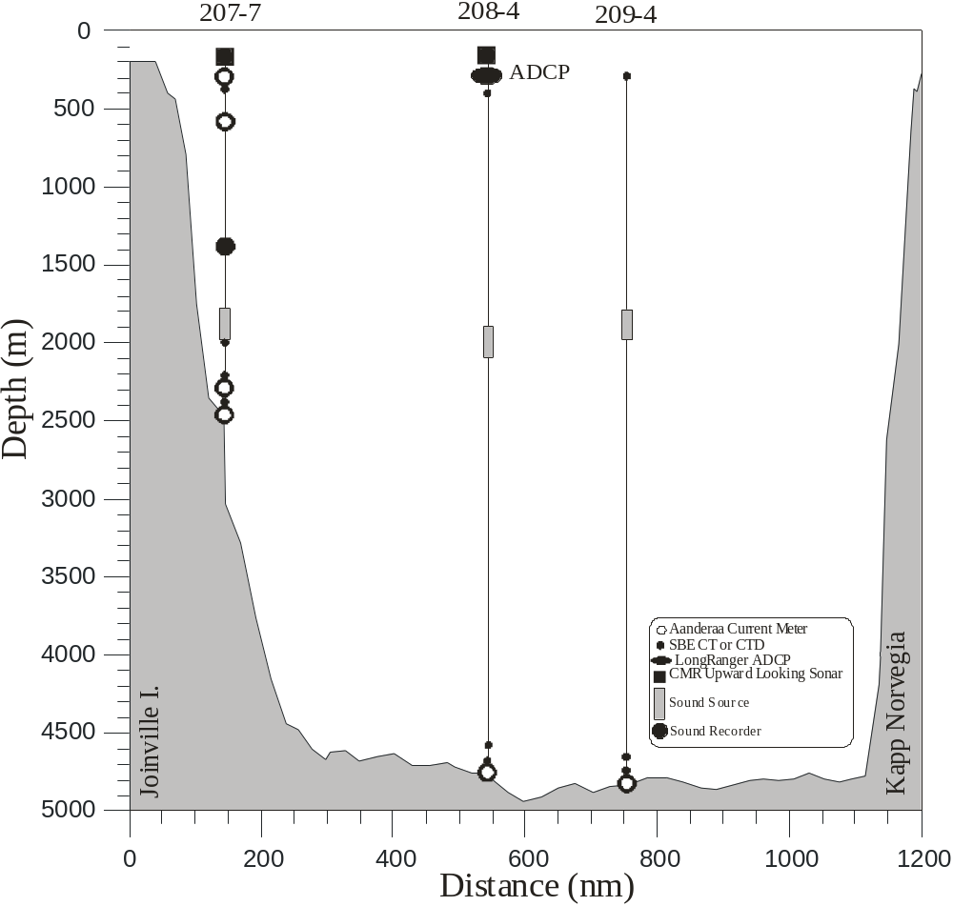Compiled by : Eberhard Fahrbach (April 2005)

Figure 1
Moorings deployed in January/February 2005 in the Weddell Sea.
Table 1

Mooring | Latitude  Longitude | Water Depth (m) | Date  Time | Type | SN | Depth  (m)
AWI209-4 | 66° 37.08’ S | 4860 | 01.03.2005 | SBE37PuP35 | 3814 | 282
 | 27° 06.29’ W |  | 10:08 | SQ | W4 | 1840
 |  |  |  | SBE16P10 | 319 | 4799
 |  |  |  | SBE37 | 226 | 4848
 |  |  |  | RCM 11 | 101 | 4849
AWI208-4 | 65° 37.15’ S | 4740 | 05.03.2005 | ULS | 42 | 154
 | 36° 23.53’ W |  | 18:31 | ADCP | 5691 | 291
 |  |  |  | SBE37P3 | 241 | 300
 |  |  |  | SQ | W5 | 2014
 |  |  |  | SBE37 | 228 | 4678
 |  |  |  | SBE37Pu | 1606 | 4728
 |  |  |  | AVT | 9182 | 4729
AWI207-6 | 63° 42.20’ S | 2500 | 14.03.2005 | ULS | 36 | 148
 | 50° 52.22’ W |  | 2:47 | AVTP | 9193 | 246
 |  |  |  | SBE37PuP35 | 3812 | 248
 |  |  |  | AVTPC | 10929 | 750
 |  |  |  | SR | C403 | 1457
 |  |  |  | SQ |  | 2000
 |  |  |  | SBE37 | 239 | 2099
 |  |  |  | SBE37PuP35 | 3813 | 2297
 |  |  |  | AVT | 10497 | 2303
 |  |  |  | SBE37Pu | 2097 | 2488
 |  |  |  | AVT | 10496 | 2489

Abbreviations:
AVTCP Aanderaa Current Meter with Temperature-, Conductivity-, and Pressure Sensor
AVTP Aanderaa Current Meter with Temperature- and Pressure Sensor
AVT Aanderaa Current Meter with Temperature Sensor
RCM 11 Aanderaa Doppler Current Meter
SBE16P# SeaBird Electronics intern recording CTD measuresTemperature, Conductivity, and Pressure, Type: Seacat; P# indicates the Depth Rating, e.g. P1 up to 1000psi or P3 up to 3000psi
ULS Upward Looking Sonar; Christian Michelsen Research Inc.
SBE26 SeaBird Electronics to measure the Bottom Pressure
SBE37 SeaBird Electronics, Type: MicroCat, to measure Temperature and Conductivity
SBE37Pu SeaBird Electronics, Type: MicroCat, to measure Temperature and Conductivity including external Pump
SBE37PuP# SeaBird Electronics, Type: MicroCat, to measure Temperature and Conductivity including external Pump and Pressure Sensor; P# indicates the Depth Rating, e.g. P3 up to 3000psi or P7 up to 7000psi and P35 for 3500 dbar
SQ Sound Source for SOFAR-Floats
SR Sound Recorder

