SOUTHERN OCEAN SITES

Site: Southern Indian Ocean DEOS
Position : 47.5S 60E
Remarks: recommended; observatory; physical, geophysical, meteorological, biochemical

Site: CLIOKER
Position: CLIOKER-1: 50°46'S, 68°52'E
CLIOKER-2: 49°28'S, 71°22'E
Categories: CTD observatory, physical measurements

Short description:
- 2 stations / moorings
- Variables measured: CTD from the surface to the bottom
- Start date of the timeseries, service interval: January 1999, monthly

Scientific rationale:
The CLIOKER (Ocean Climate at Kerguelen) seeks to monotor the climatic variability of the Antarctic zone off Kerguelen by monthly occupying two hydrographic time series stations

Groups / P.I.s /labs /countries involved / responsible:
PI: Young-Hyang Park, Museum National d'Histoire Naturelle, Paris France

Status:
- operating
- time horizon / long-term plans: 1999-2008 and continue if funded
- funding status, source of funding: funded by IPEV (Institut Polaire de Paul Emil Victor)

Technology:
- sensors lowering from a ship
- Profile measurements: CTD

Data policy: data available with 2 years delay

Societal value / Users / customers: researchers, modelers

Role in the integrated global observing system: SO hydrographic time series

Contact Person: Young-Hyang Park

Links / Web-sites:
- for Project information : e-mailing to yhpark@mnhn.fr
- for data access : contact SISMER/IFREMER

compiled /updated by: Young-Huang Park (December 2004)

Site: Subantarctic, Polar Frontal, and Antarctic Zones southwest of Tasmania
Positions (approximate): 47° S 140 °E
54° S 140 °E
61° S 140 °E
Categories: Time Series sites for sediment traps and some surface biogeochemical parameters including CO₂

Safety distance for ship operations: 5 mile
Short description:
- 47° S 2 moorings:
- sediment trap mooring with Mclane 21-cup traps at 500, 1000, 2000m below surface. 2-d current meters at 500m, 1000m. Deployed Sept 1997 - ongoing, annual service
- "PULSE" mixed layer biogeochemical sensor/sampler mooring with small surface float and hourly measurements of mixed layer depth (pressure, temperate loggers at 10m intervals from 50 to 100m), mixed layer salinity, fluorescence, and collection of ~48 surface water samples per year at 30m depth. First deployment scheduled for Nov. 2005. Additional sensors planned for future years: pCO2, spectral irradiance, particle samples, etc. 6-monthly service
- 54° S 1 mooring
- sediment trap mooring with Mclane 21-cup traps at 800, 1500m below surface. 2-d current meter at 800m. Deployed Sept 1997 - ongoing, annual service
- 61° S 1 mooring
- sediment trap mooring with Mclane 21-cup traps at 1000, 3000m below surface. 2-d current meter at 1000m. Deployed 2001-2002 only. Funds currently sought to re-establish site.
- A major ship-based field program in support of the 47 and 54S sites is planned for Jan. -Feb. 2006.

Scientific rationale:
The SAZ is a large net sink of atmospheric carbon dioxide and a region where anthropogenic carbon dioxide is accumulating. Ocean carbon models suggest the rate of carbon uptake in the Southern Ocean is likely to decrease in response to global warming, but the reliability of these projections is difficult to assess without a better understanding of the carbon cycle response to changes in physical forcing. Simultaneous physical and biogeochemical measurements spanning the seasonal cycle are required. Extensive ship-based, moored and Lagrangian measurements of physical and biogeochemical fields have been carried out for the last decade in this region and are continuing (e.g. Trull et al., 2001a,b,c; Rintoul and Trull, 2001). These measurements provide a spatial and temporal context within which to interpret the fixed point time series observations. The proposed site is "upwind" of the Cape Grim atmospheric monitoring station, providing a unique opportunity for studies of air-sea gas exchange, and is close to Hobart and Antarctic shipping routes, making it logistically feasible. The next major ship-based field program in support of these sites is planned for Jan. -Feb. 2006.

Groups / P.I.s /labs /countries involved / responsible:
Tom Trull, Steve Bray, Brian Griffiths, Bronte Tilbrook, Steve Rintoul
(ACE CRC, University of Tasmania, and CSIRO Marine Research, Hobart, Australia)
Sus Honjo, Steve Manganini (Woods Hole Oceanographic Institution, USA)
Frank Dehairs, Nicolas Savoye (Vrije Universitaat, Brussels)

Status:
- operating
- time horizon: ongoing
- funding status: currently funded through 2010 with contributions from ACE CRC, CSIRO Marine Research, Australian Antarctic Science program, US National Science Foundation, Belgian Office of Science and Technology, additional collaborators sought to expand sensor capabilities, and to participate in associated ship based field programs.

Technology:
- primarily moored sensors and samplers, with additional ARGO float deployments, including oxygen optode equipped floats.
- real-time telemetry : planned for 2006 for surface temperature and fluorescence
- Profile measurements : not currently funded, but desirable for study of SAMW formation

Data policy:
- delayed mode data: public - all variables

Data management:
- Satellite data collection system : future Iridium based transmission
- Metadata scheme : no decisions yet made
- Possibilities of evolution to comply with a more general JCOMM GTS scheme : possible, subject to funding

Societal value / Users / customers:
Improved projections of future carbon budgets and ocean ecosystem health

Role in the integrated global observing system:
The moorings offer a rolling series of process experiments of limited duration, coupled together to provide a long-term assessment of ocean carbon cycle processes.

Contact Person: Tom.Trull@utas.edu.au

Links / Web-sites: www.acecrc.org.au

Compiled by : Tom Trull (March 2005)

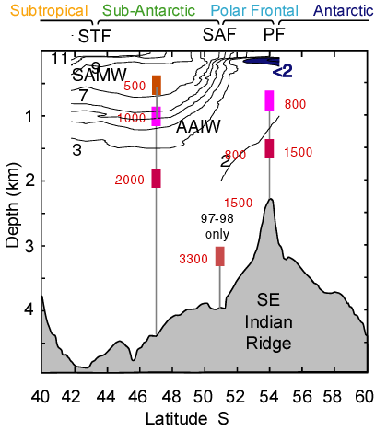

Figure 1.
SAZ Project sediment trap mooring locations along 140E shown against a late-summer (March 1998) temperature section.
An additional sediment trap mooring (not shown) was deployed at 61S in 2001-2002. Funds are currently being sought to re-establish
this site. The PULSE mooring planned for deployment at 47S in late 2005 is not shown.
Site: Ocean timeseries in the Ross Sea
Position: 71.5° S, 172.5° E
Categories: recommended physical observatory

Short description:
- 6 to 12 moorings (US, TAMU-OSU and LDEO)
- to observe Ross Sea Bottom Water overflow

Scientific Rationale:
The sinking of extremely cold upper waters at high latitudes drives the global thermohaline circulation. After entraining older relatively warmer ambient waters, these Antarctic Shelf Water outflows spread far toward lower latitudes along a system of abyssal boundary currents. Polar overturning becomes a critical regulator of earth's climate, since it provides the coldest waters involved in the global redistribution of heat. Based on inventories of chlorofluorocarbon concentration in the Southern Ocean, the escape rate of Shelf Water around Antarctica is estimated as 5.4 Sv. The Ross Sea sources are thought to contribute with as much as 40% of the circumpolar total [Orsi et al., 1999; Orsi et al., 2002]. Thus documenting the temporal variability in both the strength and the characteristics of the main
Antarctic Shelf Water outflows at seasonal to decadal scales is crucial to determine how the climate system changes in response to even subtle perturbations in the Antarctic thermohaline balance. Climate numerical models are particularly deficient in reproducing, and even more so in predicting, the expected anomalies in polar overturning cycles.

Recent repeat (2003-2004) hydrographic and direct current measurements across the Ross Sea slope collected during AnSlope indicate a strong input of salty Shelf Water from the Draygalsky Trough [Gordon et al., 2004]. AnSlope's pilot two-year records of deep and bottom currents, temperature and salinity measurements will greatly assist us in determining the ongoing variability in the characteristics and transport of extremely dense Shelf Water formed within the Ross Sea and in the lighter Antarctic Surface Waters entering the region along the Slope Current from farther east.

Sustained observations from moored arrays of current/CTP recorders and profilers will enable us to describe the interannual variability in the thermohaline structure and source strength of new deep and bottom waters sinking in the Ross Sea. Time series would tentatively start in 2007 during the International Polar Year. Repeat hydrographic sections will be occupied across the northwestern Ross Gyre and around a mooring array off Cape Adare, an accessible site where the collective outflow of Ross Sea Bottom Water can be accessed during the austral summer.

Status: planned field work to start in 2007 during the International Polar Year; pilot AnSlope field work (2003-2005) funded by NSF.

Groups/P.I.s/labs/countries interested:
The main effort is to be proposed by TAMU/LDEO (Orsi, Gordon). Some of the hydrographic work will be carried out in collaboration with the Italian CLIMA/POLAR DOVE program (Bergamasco). Funding and logistical support will be requested from NSF OPP.

compiled by: Alex Orsi (March 2005)

Site: New Zealand Ocean Time Series
Position: 41.5 S 178.5 E and 46.67 S 178.5 E
Categories: Observatory for physical, meteorological, biogeochemical measurements, CO2, particle flux, chlorophyll

Safety distance for ship operations: 10 n miles
Short description:
- 2 moorings: subtropical waters 41.5 S 178.5E;
subantarctic waters 46.6S 178.5 E
- Variables measured :
- 40 m depth (irradiance (10 minute mean), chlorophyll fluorescence (10 minute mean), temperature (hourly) , salinity (hourly) , CO2 (ten minute mean);
- 120 m depth current speed and direction (10 minute mean), temperature (hourly) , salinity (hourly);
- 250 m depth current speed and direction (10 minute mean), temperature (hourly) , salinity (hourly);
- 1500 m depth downward particle flux (mass flux, POC, PIC, opal, PON) every 5 days, current speed and direction (10 minute mean), temperature (hourly) , salinity (hourly).
- Start date of the timeseries, service interval:
The moorings have been deployed since October 2000. They are serviced every 4 months. During each servicing voyage, additional data are also collected (underway nutrients, deep CTD casts etc)

Scientific rationale:
The location of the subtropical convergence east of New Zealand provides the opportunity to obtain detailed time-series data in each of two distinct waters masses - subtropical and subantarctic waters. In particular, these water masses exhibit different biological signals, with subtropical waters characterised by a classical spring and autumn phytoplankton bloom, whereas subantarctic waters are perennially High Nitrate Low Chlorophyll due to low dissolved iron concentrations.
Our 2 identical moorings were designed to examine the degree of coupling between pelagic and deep water events in each of these water masses. We can assess if this coupling is stronger in the more productive subtropical waters relative to the subantarctic water mass. The latter, comprises a 10 degree N-S circumpolar ring and thus represents around 50% of the ice-free waters of the Southern Ocean. Thus, the data from the subantarctic water mooring will be of particular interest to the Southern Ocean biogeochemical community.

Groups / P.I.s /labs /countries involved / responsible:
Ocean Ecosystems group at NIWA (NZ) runs the moorings with Scott Nodder responsible for the deepwater traps, Philip Boyd for the bio-optical instruments, and Kim Currie for the SAMI pCO2 sensor. We have close links with other NIWA groups working on Ocean Colour. We have links with other S. ocean mooring groups from Australia (Tom Trull, Bronte Tilbrook) and elsewhere (Tommy Dickey).

Status:
- operating
- long-term plans
- funding status, source of funding: New Zealand

Technology:
- deep-moored sensors
- data downloaded every 4 months
- SST measurements: Seabird MICROCAT

Data policy:
- delayed mode data: not public at present – data dissemination via publications (Nodder et al. in review at JGR-Oceans)

Data management: internal at present – to be discussed later in 2005

Societal value / Users / customers:
Through assessment of the annual cycles of phytoplankton stocks and export of carbon to depth we are able to provide data to other New Zealand end-users on seasonal and interannual variability of these properties that will determine the carry capacity of local waters, and their ability to sequester carbon. We also have links with other groups with moorings in S. Ocean waters (CSIRO) and can thus compare our findings at various sites in subantarctic waters.

Role in the integrated global observing system:

Contact Person: Scott Nodder/ Philip Boyd (s.nodder@niwa.co.nz, p.boyd@niwa.co.nz )

Links / Web-sites: none at present

Compiled / updated by: Philip Boyd (March 2005)
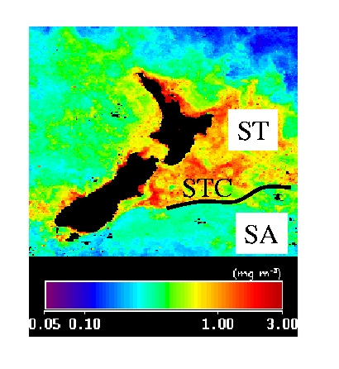

Figure 1: ST Spring bloom October 2000 SeaWiFs
The waters East of New Zealand are a natural laboratory to study Subantarctic (SA) and Suptropical (ST) waters. The SA Ring comprises 50 % of the open Southern Ocean.
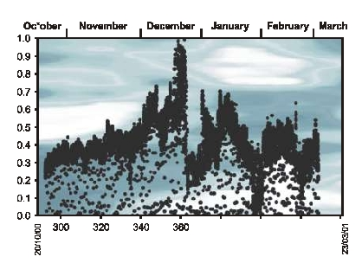
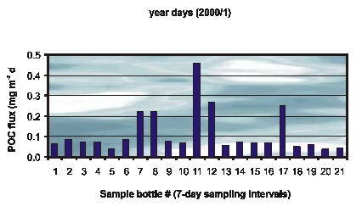

Figure 2: Time-series data from the Subantarctic mooring in late 2000 / early 2001 from 40 m subsurface (bio-optical instrument) and 1500 m (deep-moored sediment trap).
Site : AAIW formation region
Position : 55S 90W
Remarks: recommended; observatory; physical, meteorological, biochemical (CO2)

Site: Rothera Time Series (RaTS)
Position: Marguerite Bay (67S, 68W)
Categories: physical, biogeochemical, biological

Safety distance for ship operations:
There is no restriction on shipping (other than ice and water depth), but any work should be coordinated with the BAS base at Rothera.
Short description:
- 1 repeat CTD station, plus associated sampling for biogeochemical/biological variables
- Variables measured :
- CTD (temperature, conductivity, depth) profiling to ~450m
- Photosynthetically-active radiation profiled to ~450m
- Fluorescence profiled to ~450m
- Oxygen Isotopes sampled at 15m
- Chlorophyll sampled at 15m
- Nutrients sampled at 15m
- Other biological parameters sampled at 15m
- Start date of the timeseries, service interval: Started late 1997; repeat measurements ~weekly, subject to ice. (Profiling through hole cut in ice in winter).

Scientific rationale:
Antarctica as a whole is unusual in having a very deep continental shelf with relatively little freshwater or sediment input from rivers. It is, however, highly influenced by oceanographic processes associated with both surface ice and continental shelf ice. The Antarctic coastal marine system exhibits a marked seasonality, and also variability on a range of scales from interannual to Milankovitch. The RaTS site is towards the southern end of the Antarctic Peninsula, a region which has seen among the highest rates of regional climatic warming of the past 50 years. As the time series continues, we will be able to investigate the role of oceanographic variability on a range of timescales and its influence on the Antarctic marine ecosystem.
We have already discerned the impact of ENSO variability on the physical ocean system, and are currently tracking its progression through the associated biogeochemical and ecological system.

Groups / P.I.s /labs /countries involved / responsible:
Andrew Clarke (BAS, UK) for biogeochemistry and biology
Mike Meredith (BAS, UK) for physics

Status:
- Ongoing
- funding provided to the British Antarctic Survey by the UK Natural Environment Research Council as part of BAS's Long-Term Monitoring and Survey remit (LTMS)

Technology:
CTD and Niskin bottle sampling from small boat in Antarctic summer. When ice-covered, the sampling site is measured by cutting a hole through the ice, and conducting sledge-based profiling and sampling.

Data policy:
delayed mode data: public (available on request)

Data management:
At present, profile data relayed to UK by satellite (email). Some discrete samples analysed on base at Rothera Research Station; others returned to UK annually for laboratory analysis.

Contact Person:
Mike Meredith (physics, CTD, oxygen isotopes)
Andrew Clarke (biology, biogeochemistry)

Links / Web-sites:
- for Project information : some brief description on http://www.soc.soton.ac.uk/JRD/HYDRO/drake/rats.php
a more up-to-date website is being developed.

compiled / updated by: Mike Meredith (December 2004) ???????

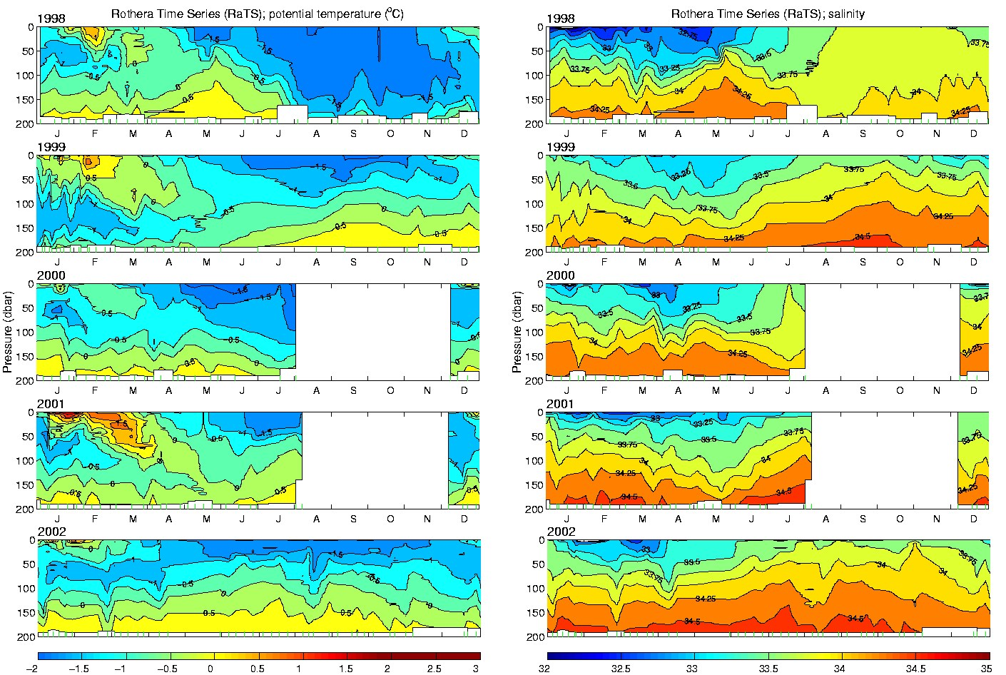

Figure: Temporal progression of the upper-layer temperature (left) and salinity (right) at the RaTS site, for the period 1998-2002. Note, in particular, the very deep homogeneous layer in austral winter of 1998, caused by the ENSO event that was then decaying.

Site: Drake Passage
Position: Drake North: 54.943 S, 58.392 W
Drake South: 60.8505 S, 54.7078 W
Categories: transport, physical

Short description:
- 2 stations / moorings
- Variables measured :
Bottom pressure changes, temperature (absolute temperature value poorly determined, but calibrated by hydrographic measurements) 1080 m depth, 15-minute averages.
- Start date of the timeseries, service interval: 13th (South) and 15th (North) Nov 1992, annual

Scientific rationale:
To monitor changes in Antarctic Circumpolar Transport at periods shorter than annual, and to look for interannual changes in temperature.

Groups / P.I.s /labs /countries involved / responsible:
Chris W. Hughes, Proudman Oceanographic Laboratory, UK
with help from British Antarctic Survey, UK, and collaboration with Southampton Oceanography Centre (now the National Oceanography Centre, Southampton)

Status:
- operating
- time horizon / long-term plans: Currently secure until 2006
- funding status, source of funding: Funded, UK Natural environment Research Council

Technology: autonomous sensors (Seafloor lander)

Data policy: all variables public available in delayed mode

Data management:
- Satellite data collection system : Potential future
- Metadata scheme : ascii files including metadata, see http://www.pol.ac.uk/psmslh/gloup/gloup.html

Societal value / Users / customers:
Study of climatic change and the Antarctic Circumpolar Current - global ocean circulation.

Role in the integrated global observing system: Choke-point monitoring

Contact Person: Chris W. Hughes (cwh@pol.ac.uk)

Links / Web-sites:
- for Project information : http://www.pol.ac.uk/home/research/p1t3comm.html
- for data access : http://www.pol.ac.uk/psmslh/gloup/gloup.html

compiled by: Chris Hughes (January 2005)
Site: Weddell Sea (Northwestern Station)
Position: ~62°S 44°W – 64°S 42°W
Categories: operating; transport; physical, bottom water

Safety distance for ship operations: 2 km
Short description:
- 3 moorings maintained since 1999, with CTD/tracer stations occupied at and between the mooring sites when logistically feasible.
- Variables measured :
Moorings: temperature, salinity, water velocities from the bottom to 500 m above bottom at approximately 100 m intervals. Sampling rates vary from 7.5 to 30 minutes.
CTD/tracer: to within 10 m of the bottom at most stations. Water samples collected for analysis of CFC, transient tracers
- Start date of the timeseries, service interval:
Moorings first deployed 1999; serviced at intervals dictated by available vessel time and local conditions [2000, 2001, 2005]

Scientific rationale:
The abyssal ocean is filled with cold, dense water that obtains it characteristics on the Antarctic continental shelf and by mixing while sinking along the slope. Recent estimates of water mass formation rates using CFC inventories suggest that a total of 8 Sv of Antarctic Bottom Water (AABW) are formed [Orsi et al. 1999]. The Weddell Sea Gyre transports about 5 Sv of Deep and Bottom water and thus contributes as much as 50% to the formation of AABW [e.g. Gordon et al. 2001, Fahrbach et al. 1994, 1995, Meredith et al. 2001]. Streams of relatively low salinity Weddell Sea Deep Water with temperature between 0° and -0.7°C are found along the outer rim of the Weddell Sea with varying degree of oxygen saturation (Figure 1) [Gordon et al. 2001]. Between 1989 and 1998 Fahrbach et al. [2001] deployed a current meter array east of Joinville Island which allowed for the first glimpse at interannual variability in temperature, thickness and transport of the WSBW formed in the Weddell gyre region. Starting in April 1999 LDEO/WHOI continued the time series at a down stream location south of the South Orkney Islands with a small mooring array (Figure 2) [Visbeck et al. 2001]. This location is easier to maintain since the sea ice covered season is shorter on average.

Groups / P.I.s /labs /countries involved / responsible:
The main effort is supported by LDEO (A. Gordon, W. Smethie, P. Schlosser). One mooring has been instrumented by WHOI (Toole). Some of the hydrographic work has been carried out in collaboration with a joint German/Brazilian program (Garcia, Hellmer). Funding has been received by NOAA, and the field work was made possible by arrangement with the NSF Office of Polar Programs.

Status:
- operational since 1999
- Funding has been provided by NOAA through 2005, with plans to continue funding the mooring efforts for several years more.

Technology:
The ongoing program has two elements: A repeat hydrographic section across the northwestern Weddell gyre outflow including observations of trace elements (CFCs and Tritium/Helium) and an array of three moorings. Two of them are equipped with nominally two current meters, two TS recorder and several T recorders covering a 500m thick layer above the sea floor. The third mooring consists of a profiling CTD and current meter package which is capable of obtaining a 1000m long profile every other day. All moorings have internal recording only and it is not feasible to add telemetry due to heavy sea ice.

Data policy:
- delayed mode data: The mooring and CTD data are available to the public in delayed mode, to allow for preliminary processing of the data prior to public release. All available data can be accessed from the project web site.

Data management: Under development.

Societal value / Users / customers:
The site is perfect to document changes in rates and types of bottom waters formed in the Weddell Sea. Even subtle changes in the climate system would be detectable and at some point can be compared with climate model solution. Note, however, that this is a region of the world where climate model simulations are quite inadequate. At this point assessments of the state of the global climate systems, such as the IPCC process are our customers.

Role in the integrated global observing system:
The global observing system is very thin in the Southern Hemisphere. Seasonal sea ice cover and its rather high latitude limit the amount of information that can be gained by space based measurements. Thus sites like this one contribute crucial and unique information that will be hard to get any other way.

Contact Person:
- for enquiry about addition of instrumentation or sensors to the site or for possible ancillary measurements during cruises to the site: Prof Arnold Gordon (agordon@ldeo.columbia.edu)
- for information about the site or data : Bruce Huber (bhuber@ldeo.columbia.edu)

Links / Web-sites:
- for Project information : http://www.ldeo.columbia.edu/res/div/ocp/projects/corc.shtml
- for data access : http://www.ldeo.columbia.edu/res/div/ocp/projects/corc.shtml

compiled/ updated by: Bruce Huber (April 205)

Figure 1:
Potential temperature section south of the South Orkney Islands with the location of the mooring array superimposed. Inset: Bathymetric map of the Weddel Sea Gyre indicating the position of several streams of newly formed Weddell Sea Bottom Water [Gordon et al. 2001] and the CORC/ARCHES repeat section and mooring array
[reproduced from Visbeck et al, 2001].
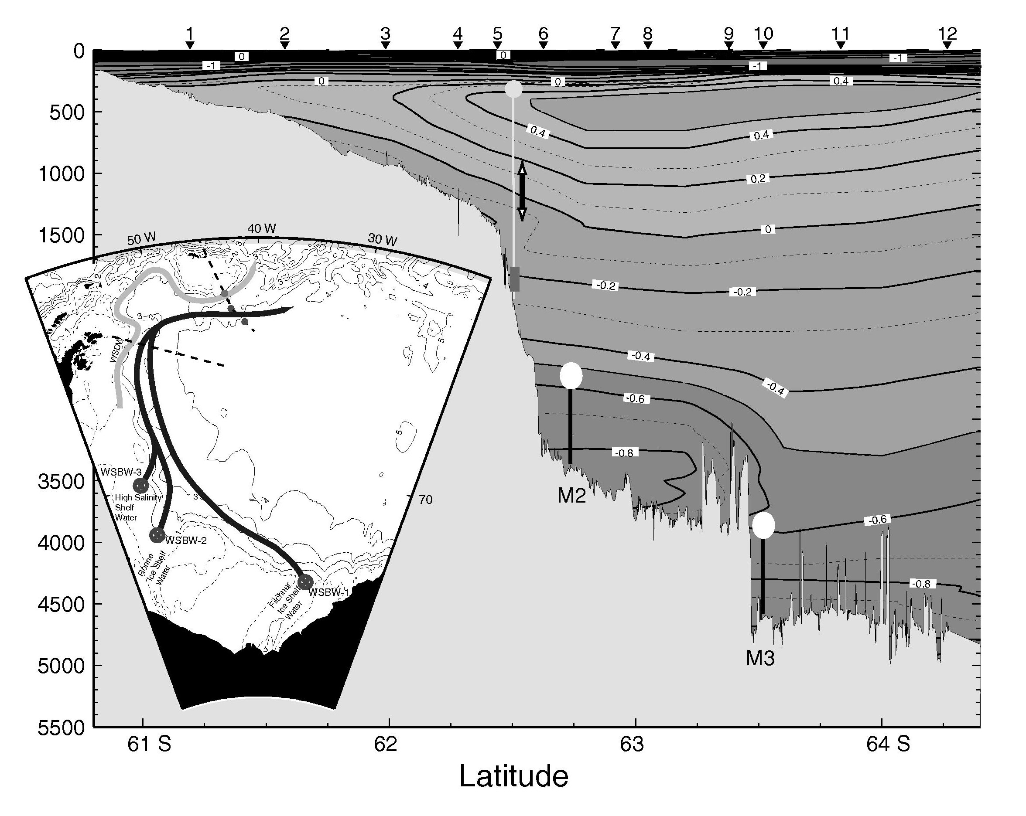
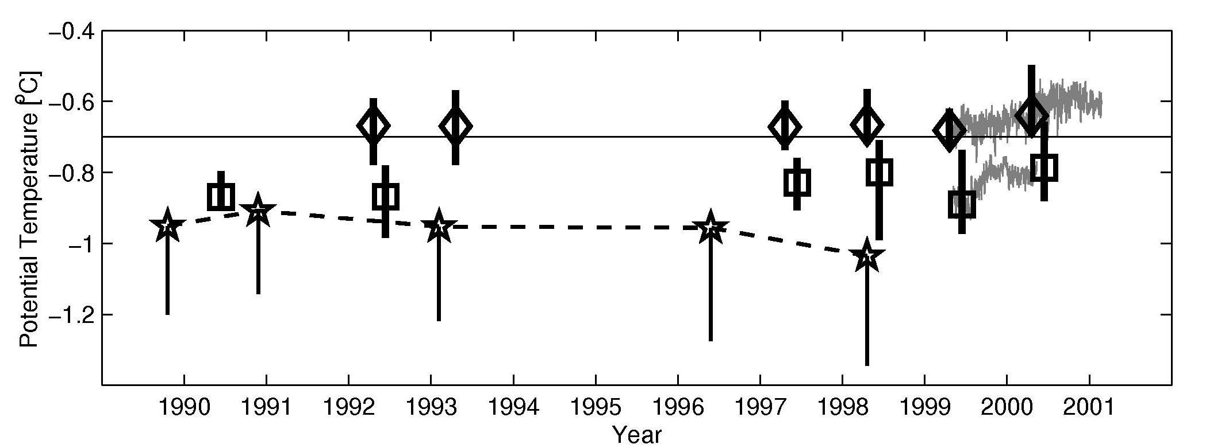 Figure 2: Potential temperature time series as obtained from repeat hydrographic sections in the northwestern Weddell gyre. Diamonds denote the mean temperature between 2600 and 3200 m water depth near 62.5°S 43.5°W (near M2). Squares denote the mean temperature between 4000 and 4600 m water depth near 63.5°S 42.0°W (near M3). The bars covers the total range of observed temperatures. The thin gay lines represent the 40h low pass filtered temperatures averaged over all sensors at mooring M2 and M3 respectively. The stars are the plume mean temperatures from Fahrbach et al. (2001) at their upstream array location. The solid line connects the plume mean with the coldest temperature found during each survey [reproduced from Visbeck et al, 2001].

Site: Weddell Sea proper
Position : 63° 42’S 50°52’W to 66°37’S 27°06’W
Categories: operating; Observatory; physical, sea ice

Safety distance for ship operations: subsurface moorings 2 nm from each mooring
Short description:
- 3 moorings
- Variables measured: currents, T, S, p, sea ice (for details see table 1)
- Start date of the timeseries, service interval:
First deployment 1989. Interruption 1996. Last redeployment in 2005.
The available mooring technology allows two year mooring periods. The required ship time is provided by AWI with the icebreaking research vessel “Polarstern.”

Scientific rationale:
In the Weddell Sea proper newly formed bottom and deep water is accumulated and provides a naturally low passed record of the time history of bottom and deep water formation. Additionally the Weddell Sea proper represents particular ice conditions which are supposed to be representative for the Atlantic sector of the Antarctic Ocean.
The measurements consist of large scale hydrographic sections with a repeat cycle between 2 and 4 years and moored instruments to avoid effects of alising. The observed parameters are used to estimate water mass properties and transports are temperature, salinity, CO₂, CFCs, currents and ice thickness. The moored observing system is maintained in the Weddell Sea Convection Control (WECCON) project since 1996 with minor modifications. Current meter moorings were redeployed in 2005 after a break in 1996. A redeployment is planned for the austral summer 2007/2008. The moorings are equipped with current meters, temperature and conductivity sensors and some with bottom pressure recorders (Tab.1). Additional to the moorings, vertically profiling floats are deployed in the context of the ARGO programme. The moorings carry sound sources for RAFOS location of the floats. Upward looking sonars in 150 m depth are installed on 4 moorings in the framework of WCRP’s Antarctic Sea-Ice Thickness Project (AnSITP) to determine the sea ice transports (http://www.awi-bremerhaven.de/Research/IntCoop/Oce /ansitp/index.html ). In 1989, 1990, 1993, 1996, 1998. 2005 hydrographic surveys were carried out in the Weddell Sea with a CTD-probe (Conductivity/Temperature/Depth) combined with a rosette water sampler). A repeat of this transect is planned for 2007/2008. XBTs are deployed north of the CTD transect. The continuation is envisaged.

Groups / P.I.s /labs /countries involved / responsible:
Eberhard Fahrbach (Alfred-Wegener-Institut für Polar- und Meeresforschung)

Status:
- operating
- time horizon / long-term plans: Funding assured until 2007/2008. It is planned to maintain the measurements to detect decal variability.
- funding status, source of funding:
The project is part of the Southern Ocean research project of the Alfred-Wegener-Institut für Polar- und Meeresforschung within the framework of the MARCOPOLI Programme of the Helmholtz-Gemeinschaft Deutscher Forschungszentren and a contribution to the German Atlantik project funded by BMBF.

Technology:
- moored sensors see Tab. 1
- SST measurements: only during CTD transects.
- Profile measurements: In the moorings only point measurements in different levels see Tab. 1.

Data policy:
- delayed mode data: data available after recovery, processing and evaluation.

Data management:
- Metadata scheme: See AWI data bank and CLIVAR data system
- Possibilities of evolution to comply with a more general JCOMM GTS scheme : Installation of profilers to allow quasi real time data transfer according technical feasibility and funding.

Societal value / Users / customers: Science

Role in the integrated global observing system:
The moorings provide data to monitor the status of a significant water mass formation area.

Contact Person: Gerd Rohardt: grohardt@awi-bremerhaven.de

Links / Web-sites:
- for Project information :
Eberhard Fahrbach (efahrbach@awi-bremerhaven.de) for more detail see:http://www.awi-bremerhaven.de/Research/IntCoop/Oce/weccon/index.html
- for data access : http://www.awi-bremerhaven.de/OZE/index.html

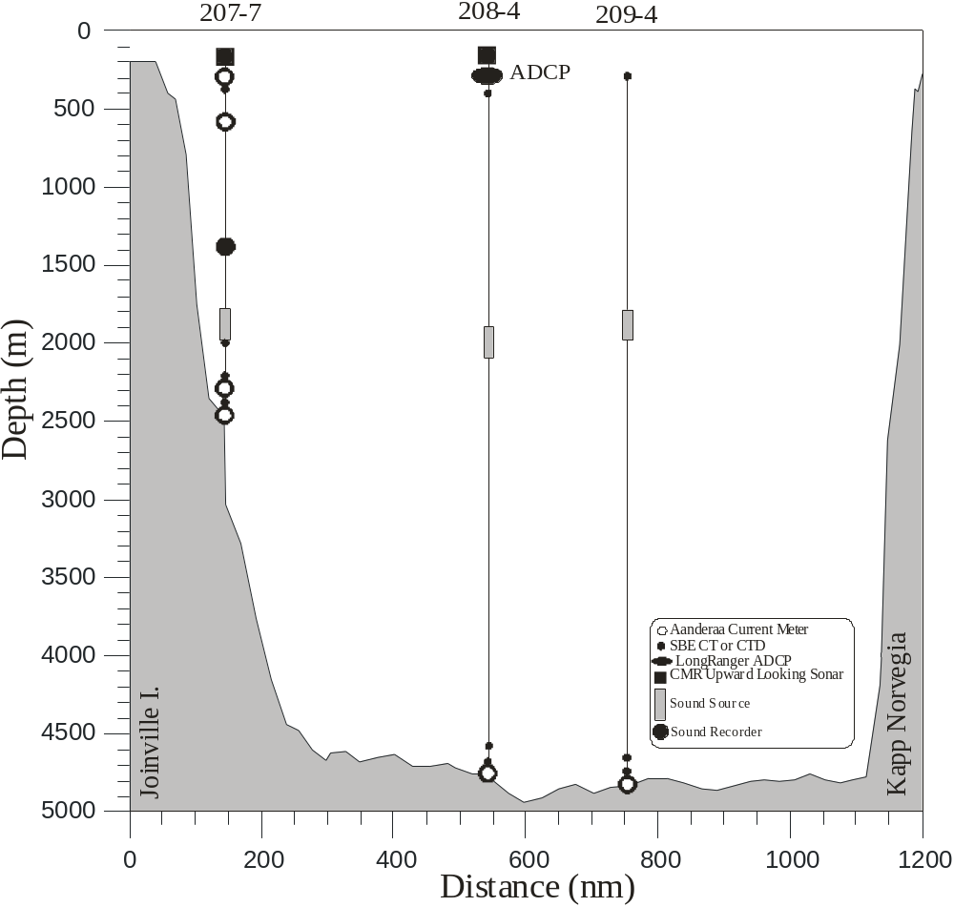Compiled by : Eberhard Fahrbach (April 2005)

Figure 1
Moorings deployed in January/February 2005 in the Weddell Sea.

Table 1

Mooring | Latitude  Longitude | Water Depth (m) | Date  Time | Type | SN | Depth  (m)
AWI209-4 | 66° 37.08’ S | 4860 | 01.03.2005 | SBE37PuP35 | 3814 | 282
 | 27° 06.29’ W |  | 10:08 | SQ | W4 | 1840
 |  |  |  | SBE16P10 | 319 | 4799
 |  |  |  | SBE37 | 226 | 4848
 |  |  |  | RCM 11 | 101 | 4849
AWI208-4 | 65° 37.15’ S | 4740 | 05.03.2005 | ULS | 42 | 154
 | 36° 23.53’ W |  | 18:31 | ADCP | 5691 | 291
 |  |  |  | SBE37P3 | 241 | 300
 |  |  |  | SQ | W5 | 2014
 |  |  |  | SBE37 | 228 | 4678
 |  |  |  | SBE37Pu | 1606 | 4728
 |  |  |  | AVT | 9182 | 4729
AWI207-6 | 63° 42.20’ S | 2500 | 14.03.2005 | ULS | 36 | 148
 | 50° 52.22’ W |  | 2:47 | AVTP | 9193 | 246
 |  |  |  | SBE37PuP35 | 3812 | 248
 |  |  |  | AVTPC | 10929 | 750
 |  |  |  | SR | C403 | 1457
 |  |  |  | SQ |  | 2000
 |  |  |  | SBE37 | 239 | 2099
 |  |  |  | SBE37PuP35 | 3813 | 2297
 |  |  |  | AVT | 10497 | 2303
 |  |  |  | SBE37Pu | 2097 | 2488
 |  |  |  | AVT | 10496 | 2489

Abbreviations:
AVTCP Aanderaa Current Meter with Temperature-, Conductivity-, and Pressure Sensor
AVTP Aanderaa Current Meter with Temperature- and Pressure Sensor
AVT Aanderaa Current Meter with Temperature Sensor
RCM 11 Aanderaa Doppler Current Meter
SBE16P# SeaBird Electronics intern recording CTD measuresTemperature, Conductivity, and Pressure, Type: Seacat; P# indicates the Depth Rating, e.g. P1 up to 1000psi or P3 up to 3000psi
ULS Upward Looking Sonar; Christian Michelsen Research Inc.
SBE26 SeaBird Electronics to measure the Bottom Pressure
SBE37 SeaBird Electronics, Type: MicroCat, to measure Temperature and Conductivity
SBE37Pu SeaBird Electronics, Type: MicroCat, to measure Temperature and Conductivity including external Pump
SBE37PuP# SeaBird Electronics, Type: MicroCat, to measure Temperature and Conductivity including external Pump and Pressure Sensor; P# indicates the Depth Rating, e.g. P3 up to 3000psi or P7 up to 7000psi and P35 for 3500 dbar
SQ Sound Source for SOFAR-Floats
SR Sound Recorder
Site: Weddell Sea/Greenwich Meridian
Position : 54° 30’S 0° to 69°24’S 0°
Categories: operating; Observatory, Transport; physical, sea ice

Safety distance for ship operations: subsurface moorings 2 nm from each mooring
Short description:
- 9 moorings (positions see table 1)
- Variables measured: currents, T, S, p, sea ice (for details see table 1)
- Start date of the time series, service interval: First deployment 1996. Last redeployment in 2005.
The available mooring technology allows two year mooring periods. The required ship time is provided by AWI with the icebreaking research vessel “Polarstern.”

Scientific rationale:
On the Greenwich Meridian water masses enter the formation areas of bottom water from the east, newly formed bottom water fills the basin from the west and Maud Rise represents a topographic feature which has the potential to induce the formation of a large polynya with consequent deep water formation in the open ocean. Therefore the Greenwich Meridian is a key area where the status of the Weddell Sea as a water mass formation area can be monitored

The measurements consist of large scale hydrographic sections with a repeat cycle between 2 and 4 years and moored instruments to avoid effects of alising. The observed parameters are used to estimate water mass properties and transports are temperature, salinity, CO₂, CFCs, currents and ice thickness. The moored observing system is maintained in the Weddell Sea Convection Control (WECCON) project since 1996 with minor modifications. Current meter moorings were exchanged in 1998, 1999, 2001, 2003 and 2005. A redeployment is planned for the austral summer 2007/2008. The moorings are equipped with current meters, temperature and conductivity sensors and some with bottom pressure recorders (Tab.1). The mooring work occurs in cooperation with the University Bergen, Norway. Additional to the moorings, vertically profiling floats are deployed in the context of the ARGO programme. The moorings carry sound sources for RAFOS location of the floats. Upward looking sonars in 150 m depth are installed on 4 moorings in the framework of WCRP’s Antarctic Sea-Ice Thickness Project (AnSITP) to determine the sea ice transports (http://www.awi-bremerhaven.de/Research/IntCoop/Oce /ansitp/index.html ). In 1996, 1998, 1999, 2001, 2003. 2005 hydrographic surveys were carried out along the Greenwich Meridian with a CTD-probe (Conductivity/Temperature/Depth) combined with a rosette water sampler). A repeat of this transect is planned for 2007/2008. XBTs are deployed north of the CTD transect. The continuation is envisaged.
To monitor the ACC transports a series of PIES is deployed In a final state 8 PIES will be located along a Jason track from the northern end of the mooring line toward South Africa.

Groups / P.I.s /labs /countries involved / responsible:
Eberhard Fahrbach and Olaf Boebel (Alfred-Wegener-Institut für Polar- und Meeresforschung)

Status:
- operating
- time horizon / long-term plans: funding assured until 2007/2008
- funding status, source of funding: The project is part of the Southern Ocean research project of the Alfred-Wegener-Institut für Polar- und Meeresforschung within the framework of the MARCOPOLI Programme of the Helmholtz-Gemeinschaft Deutscher Forschungszentren and a contribution to the German Atlantik project funded by BMBF.

Technology:
- moored sensors see Tab. 1
- SST measurements: only during CTD transects.
- Profile measurements: In the moorings only point measurements in different levels see Tab. 1.

Data policy:
- delayed mode data: available after recovery, processing and evaluation

Data management:
- Metadata scheme : See AWI data bank and CLIVAR data system
- Possibilities of evolution to comply with a more general JCOMM GTS scheme: Installation of profilers to allow quasi real time data transfer according technical feasibility and funding.

Societal value / Users / customers: Science

Role in the integrated global observing system:
The moorings provide data to monitor the status of a significant water mass formation area. However, they are very much influenced be the local conditions. Therefore, repeat hydrography and XBT launches have to cover a larger area to extend the observations over different water mass regimes. The repeat sequence of 2 to 4 years includes a large risk by aliasing and can not replace the moored instruments.

Contact Person: Gerd Rohardt: grohardt@awi-bremerhaven.de

Links / Web-sites:
- for Project information:
Eberhard Fahrbach (efahrbach@awi-bremerhaven.de) for more detail see:http://www.awi-bremerhaven.de/Research/IntCoop/Oce/weccon/index.html
- for data access : http://www.awi-bremerhaven.de/OZE/index.html

Compiled / updated by : Eberhard Fahrbach (April 2005)
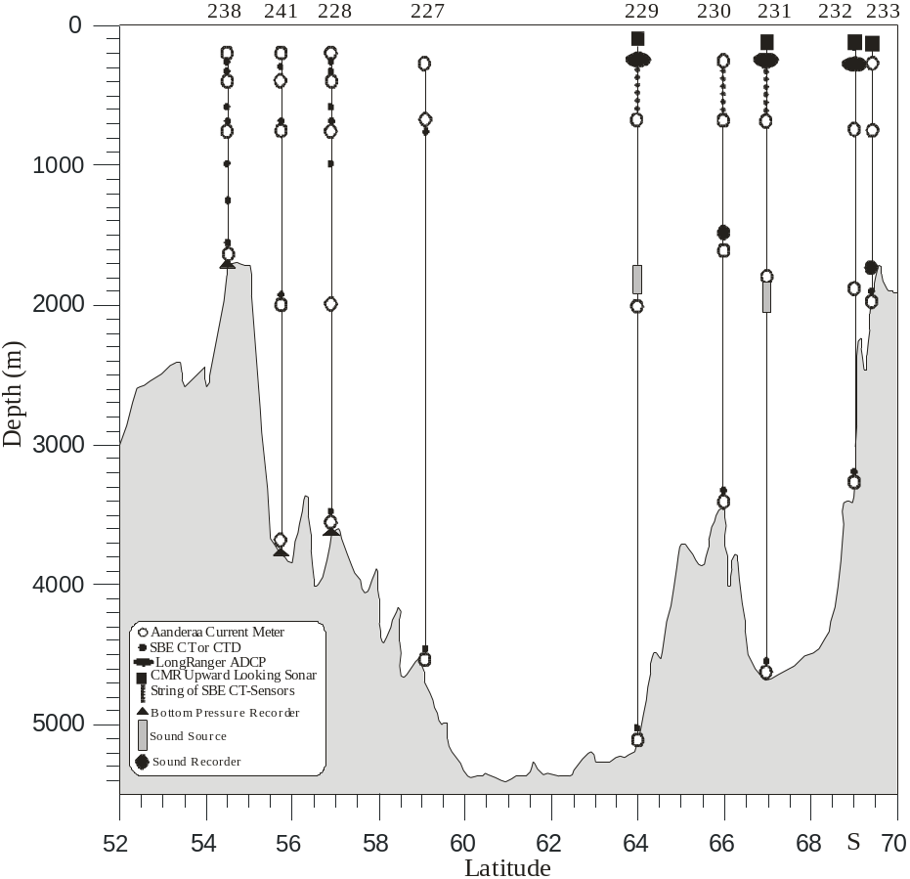

Figure
Moorings deployed in January/February 2005 along the Greenwich Meridian.

Table 1

Mooring | Latitude  Longitude | Water Depth (m) | Date  Time | Type | SN | Depth  (m)
AWI233-7 | 69° 23.60’ S | 1950 | 17.02.2005 | ULS | 46 | 150
 | 00° 04.29’ W |  | 21:06 | AVTP | 11890 | 202
 |  |  |  | RCM11 | 100 | 699
 |  |  |  | SR | W402 | 1700
 |  |  |  | SBE37PuP35 | 3810 | 1903
 |  |  |  | RCM 11 | 146 | 1904
AWI232-7 | 68° 59.75’ S | 3370 | 17.02.2005 | ULS | 47 | 151
 | 00° 00.11’ W |  | 12:43 | ADCP | 5373 | 375
 |  |  |  | AVTPC | 10927 | 752
 |  |  |  | AVT | 9186 | 1808
 |  |  |  | SBE37 | 230 | 3313
 |  |  |  | AVT | 6854 | 3314
AWI231-6 | 66° 30.66’ S | 4540 | 09.02.2005 | ULS | 56 | 151
 | 00° 01.91’ W |  | 15:47 | SBE37PuP3 | 1237 | 200
 |  |  |  | SBE37 | 216 | 300
 |  |  |  | ADCP | 3813 | 353
 |  |  |  | SBE37 | 224 | 400
 |  |  |  | SBE37 | 227 | 500
 |  |  |  | SBE37 | 229 | 600
 |  |  |  | SBE37P3 | 242 | 700
 |  |  |  | AVTPC | 10928 | 700
 |  |  |  | AVT | 9391 | 1802
 |  |  |  | SQ | W2-2 | 1900
 |  |  |  | SBE37 | 231 | 4493
 |  |  |  | AVT | 9180 | 4494
AWI230-5 | 66° 00.66’ S | 3450 | 08.02.2005 | AVTPC | 9204 | 194
 | 00° 11.28’ E |  | 21:00 | SBE37P3 | 243 | 200
 |  |  |  | SBE37 | 233 | 300
 |  |  |  | SBE37 | 232 | 400
 |  |  |  | SBE37 | 235 | 500
 |  |  |  | SBE37 | 236 | 600
 |  |  |  | SBE37PuP35 | 2721 | 700
 |  |  |  | AVTP | 9214 | 700
 |  |  |  | SR | A401 | 1550
 |  |  |  | AVTP | 9998 | 1590
 |  |  |  | SBE37 | 238 | 3400
 |  |  |  | RCM 11 | 25 | 3400
AWI229-6 | 63° 57.16’ S | 5200 | 07.02.2005 | ULS | 57 | 147
 | 00° 00.37’ W |  | 15:58 | SBE37PuP3 | 1236 | 200
 |  |  |  | SBE37 | 240 | 300
 |  |  |  | ADCP | 0825 | 380
 |  |  |  | SBE37Pu | 435 | 400
 |  |  |  | SBE37Pu | 436 | 500
 |  |  |  | SBE37Pu | 438 | 600
 |  |  |  | SBE37P3 | 248 | 700
 |  |  |  | AVT | 9769 | 700
 |  |  |  | SQ | W1-2 | 1814
 |  |  |  | AVT | 9188 | 2002
 |  |  |  | SBE37 | 439 | 5153
 |  |  |  | AVT | 9770 | 5154
AWI227-9 | 59° 04.11’ S | 4627 | 04.02.2005 | AVTP | 10003 | 231
 | 00° 04.92’ E |  | 18:39 | AVTPC | 10926 | 723
 |  |  |  | SBE37PuP10 | 1234 | 724
 |  |  |  | AVT | 11937 | 2019
 |  |  |  | SBE37Pu | 1603 | 4581
 |  |  |  | AVT | 9767 | 4582
AWI228-7 | 56° 57.56’ S | 3700 | 03.02.2005 | AVTP | 9763 | 191
 | 00° 01.07’ E |  | 16:03 | SBE37PuP3 | 1232 | 197
 |  |  |  | SBE37 | 441 | 247
 |  |  |  | SBE37 | 442 | 297
 |  |  |  | SBE37PuP3 | 1233 | 347
 |  |  |  | AVTP | 10539 | 401
 |  |  |  | SBE37 | 447 | 403
 |  |  |  | SBE37P3 | 247 | 582
 |  |  |  | AVTP | 8037 | 747
 |  |  |  | SBE37PuP3 | 1230 | 749
 |  |  |  | SBE37 | 444 | 998
 |  |  |  | SBE37 | 440 | 1247
 |  |  |  | RCM 11 | 214 | 2003
 |  |  |  | RCM 11 | 26 | 3654
 |  |  |  | SBE37Pu | 1607 | 3656
 |  |  |  | SBE26 | 257 | 3700
AWI241-1 | 55° 31.94’ S | 3810 | 02.02.2005 | AVTPC | 9200 | 212
 | 00° 00.05’ W |  | 15 :37 | SBE37P3 | 246 | 317
 |  |  |  | AVTP | 9785 | 424
 |  |  |  | AVT | 10532 | 770
 |  |  |  | SBE16P3 | 245 | 772
 |  |  |  | RCM 11 | 216 | 2017
 |  |  |  | SBE37 | 269 | 2000
 |  |  |  | RCM 11 | 219 | 3744
 |  |  |  | SBE26 | 228 | 3810
AWI238-5 | 54° 30.76’ S | 1700 | 01.02.2005 | AVTP | 10541 | 201
 | 00° 01.39’ E |  |  | SBE16PuP3 | 1235 | 208
 |  |  |  | SBE37P3 | 244 | 257
 |  |  |  | SBE37 | 218 | 306
 |  |  |  | SBE37PuP35 | 2719 | 356
 |  |  |  | AVTP | 9211 | 402
 |  |  |  | SBE37PuP35 | 2720 | 403
 |  |  |  | SBE37 | 225 | 573
 |  |  |  | AVTP | 7727 | 748
 |  |  |  | SBE37PuP35 | 2722 | 750
 |  |  |  | SBE37PuP35 | 2723 | 1000
 |  |  |  | SBE37 | 437 | 1250
 |  |  |  | RCM 11 | 215 | 1644
 |  |  |  | SBE37PuP35 | 3811 | 1646
 |  |  |  | SBE26 | 227 | 1700

Abbreviations:
ADCP RD-Instruments, Self Contained Acoustic Doppler Current Profiler
AVTCP Aanderaa Current Meter with Temperature-, Conductivity-, and Pressure Sensor
AVTP Aanderaa Current Meter with Temperature- and Pressure Sensor
AVT Aanderaa Current Meter with Temperature Sensor
RCM 11 Aanderaa Doppler Current Meter
SBE16P# SeaBird Electronics intern recording CTD measuresTemperature, Conductivity, and Pressure, Type: Seacat; P# indicates the Depth Rating, e.g. P1 up to 1000psi or P3 up to 3000psi
ULS Upward Looking Sonar; Christian Michelsen Research Inc.
SBE26 SeaBird Electronics to measure the Bottom Pressure
SBE37 SeaBird Electronics, Type: MicroCat, to measure Temperature and Conductivity
SBE37Pu SeaBird Electronics, Type: MicroCat, to measure Temperature and Conductivity including external Pump
SBE37PuP# SeaBird Electronics, Type: MicroCat, to measure Temperature and Conductivity including external Pump and Pressure Sensor; P# indicates the Depth Rating, e.g. P3 up to 3000psi or P7 up to 7000psi and P35 for 3500 dbar
SQ Sound Source for SOFAR-Floats
SR Sound Recorder

