**Comparison of the observations to a Lagrangian modeling framework**

The observed estimate of litter items that have potentially arrived via ocean currents is compared to a Lagrangian model study to investigate whether the observed spatial variability can be explained by the large-scale ocean circulation in the South East Pacific. The novel field work methodology presented in this paper provides the opportunity to overcome some of the current challenges in Lagrangian model comparisons to observations (see section 1), as it focuses on the relative presence of biotic interactions instead of the absolute abundance of items found. It is likely that the relative composition of items on beaches depends on the pathway taken by the macroplastic to arrive at the coast, which can be investigated studying simulated particle trajectories. To compare the observations to the model simulation our main assumption is that the longer an object is in the open ocean, the more likely it will show interaction. The setup of the Lagrangian particle simulation is described in section 2, followed by a description of the methodology used to compare (section 3) and tune (section 4) the simulation to the observations.

## 1. Current challenges in the validation of Lagrangian models simulating marine debris pathways

Lagrangian modeling studies simulating marine debris pathways are useful to e.g. identify sources of observed debris distributions (cite) or improve mitigation measures by predicting accumulation zones in the ocean and along coastlines (cite). However, plastic transport in the ocean does not only depend on the ocean, wind, wave and tidal velocities, but also on processes that are not resolved or included in general circulation models such as fragmentation processes, biofouling and coastal processes related to beaching and resuspension of marine debris (Sebille et al., 2020). These processes are often parameterized (Isobe & Iwasaki, 2022), where comparison to observations is key to validate the choices made in the setup of the simulation.

Due to the stochastic nature of Lagrangian particle simulations it is however not straightforward to compare particle numbers and pathways to diagnostics used in the field. Often the spatial and temporal resolution of observations is not sufficient to draw any statistically significant conclusions (cite). Furthermore, although there are efforts to standardize the methodologies for observing litter quantities in the marine environment (cite), various units (mass vs. number of items, concentration vs. length scale etc.) are commonly used that are difficult to converse from one to the other (Browne et al., 2015).

Above all, to be able to compare the particle simulation to marine debris observations it should be clear what the particle itself represents. It is common practice to weigh particles by either a mass or a number of items (cite), but some argue that doing so the diffusion along the trajectories of marine debris is less well represented (cite). Furthermore, this conversion between particles and observed units has to be done twice, both at the start of the trajectory matching estimates of mismanaged waste entering the marine system and at the end of the trajectory at the location of interest to match the observed distribution. As it is unclear what the best strategies are to do so, state-of-the-art global Lagrangian marine debris simulations still show large discrepancies with observations regarding e.g. litter quantities along coastlines (Onink et al., 2021) and the mismatch between mass budgets of plastic in the marine system and the input of mismanaged waste (Isobe & Iwasaki, 2022).

To reduce the number of uncertainties in the model simulations, additional parameters such as the buoyancy of the observed marine debris and the level of biotic interactions can be very useful. These parameters would not need a translation to a specific number of particles but instead could provide insight in processes that occurred along the pathway of an item before arrival. The aim of this paper is to investigate whether it is indeed possible to use these alternative diagnostics to compare Lagrangian simulations to observations.

## 2. Lagrangian particle simulation

We have released particles in the daily-mean surface velocity fields of the CMEMS global ocean physics analysis and forecast model (MOI GLO12[1]), which is described in detail by Lellouche et al. (2018) and Gasparin et al., (2018). The model has a 1/12° horizontal nominal resolution and is forced by 3-hourly ECMWF operational winds and related heat and freshwater fluxes. Satellite and in-situ data are assimilated into the model to continuously update and correct the simulated ocean state. It therefore provides a state-of-the-art ocean description, with an accurate representation of global ocean currents and mesoscale activity (Lellouche et al., 2018), and has been used for studying marine debris trajectories before (Durgadoo et al., 2021).

To investigate the pathways of the items recorded during the beach observations, particles are released at the measurement locations and traced backward in time for 100 days (see for example Fig. 1). This timescale is sufficient to allow for biotic interactions, such as the growth of epibionts (cite). As the focus is on positively buoyant macroplastic (>0.5 cm), only the surface velocity fields are used for advection. It is unclear how long the items have been lying on the beach before investigation by the participants took place. Therefore, 50 particles have been released daily in the year leading up to the measurement activity, leading to 803.000 particles in total, or 18.250 (365 x 50) particles per measurement location. No artifical diffusion is added to the particle movement, but to account for dispersion the particle release location is offset by a small (<1/25 degree) random number, so no two particles were released at exactly the same time and place. For this simulation, the impact of wind, waves and tides on the movement of the plastic items is not taken into account, nor the buoyancy changes or fragmentation processes. With respect to the time scale of interest and the choices made in the observed estimates, we argue that these effects are of less importance.

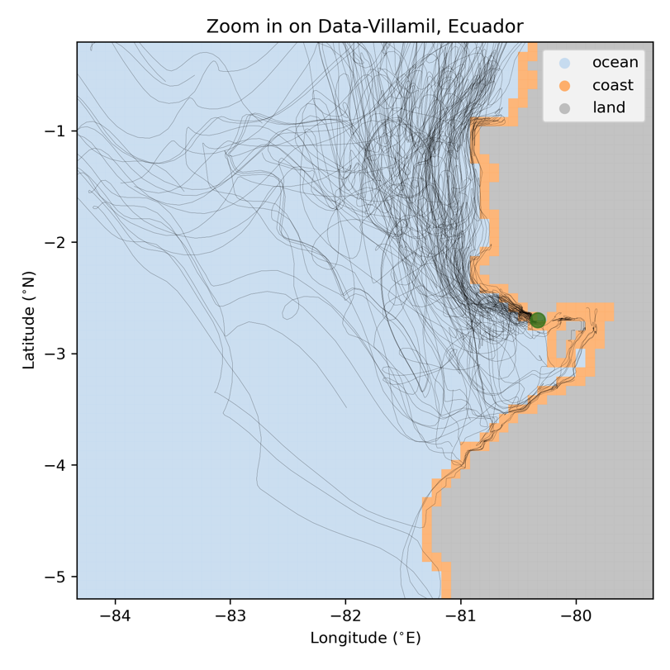

Figure 1 Example backward trajectories (black lines) for Data-Villamil in Ecuador (green marker). The corresponding ocean model land mask in grey and the ocean coastal grid cells in orange are indicated.

## 3. Translation of observed estimate to model diagnostic

As mentioned in the introduction of this section, we assume that the longer a particle has been floating in the open ocean before washing ashore, the more likely it is that biotic interactions have occurred. We have defined a particle to be ‘afloat’ when it is located outside a coastal grid cell (a 1/12° x 1/12° grid point sharing at least one of its corners with a land grid point, Fig. 1). If a particle has been in coastal grid cells before eventually washing ashore, it is not known whether it has resuspended locally or has been floating in the nearshore as coastal processes are not included in the particle simulation. Assuming there is a minimum time *T* that items need to have been afloat to have biotic interactions, the relative time afloat of each 100-day trajectory can provide insight in where to expect a higher relative abundance of items with interactions.

We therefore calculate for every particle how long it has been afloat. Then, we quantify the percentage of particles that arrives at each measurement location that have been afloat longer than time *T* (see Fig. 2). There are large differences between the various measurement locations. For example, the particles arriving at Rapa Nui (location 5 in Fig. 2) all have been afloat for longer than 90 days. This is not surprising, as in the model the island of Rapa Nui only consists out of one ocean grid cell. However, the result is still a good representation of reality, as most plastic pollution at Rapa Nui has a remote origin and arrives through ocean currents (cite). In contrast, most particles arriving at Puerto Chancay in Perú (location 10 in Fig. 2) did not leave the coastal grid cells indicating that plastic found here most likely has a local origin.

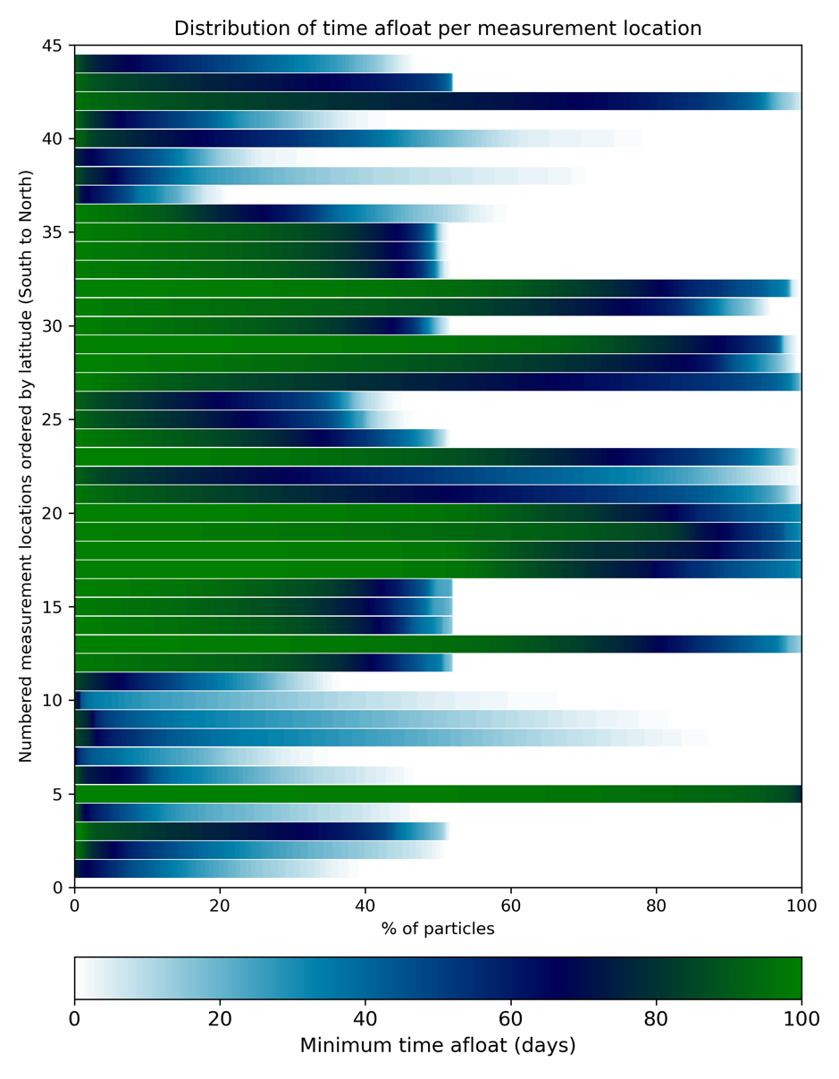

Figure 2 The distribution of the minimum time (in days) particles have been afloat before arriving at each measurement location.

## 4. Tuning method

We can now tune the 'minimum time afloat' *T* to find the best fit with the observed distribution (Fig 3). For this we only include all 'confident' measurements and exclude the measurement on Rapa Nui, as this outlier dominates the correlation.

The maximum Pearson correlation coefficient is found for a 'minimum time afloat' of 72 days. This result suggests that particles that have been afloat for longer than 72 days are most likely to show biotic interactions. The correlation, when including Rapa Nui, is relatively low (0.38, with a p-value of 0.035), but if we look at the large scale, we do seem to capture some of the spatial variability observed with this approach (Fig. 4).

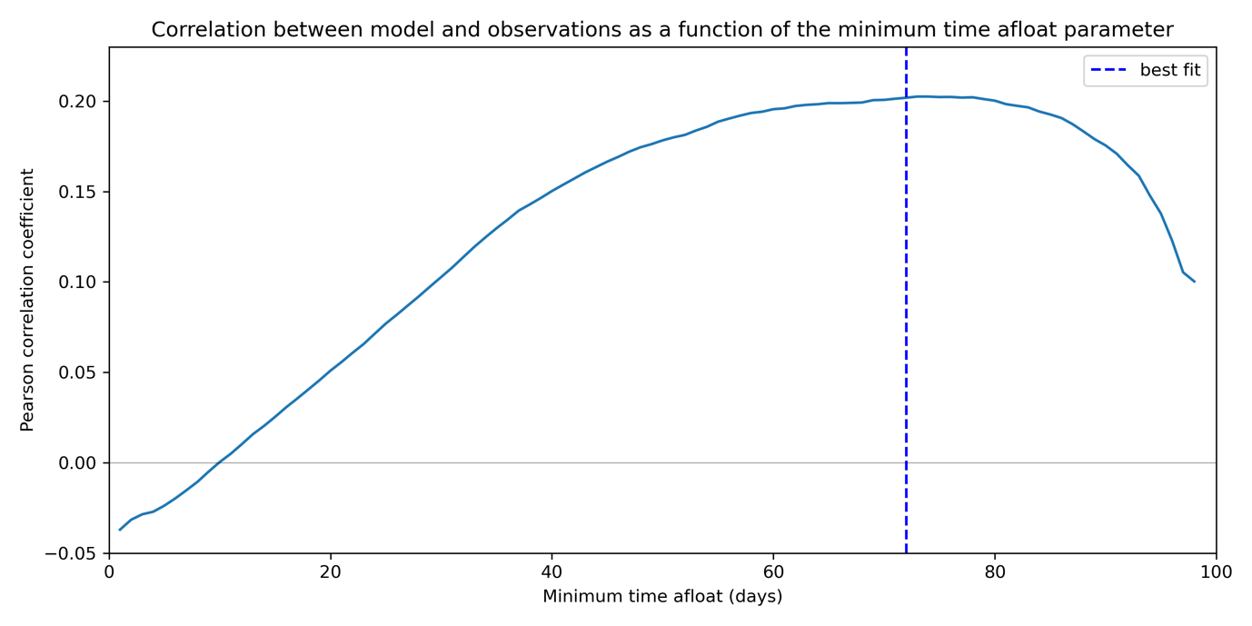

Figure 3 The Pearson correlation between the observed estimates and the percentage of particles being afloat longer than time T (the minimum time afloat) as a function of T. Maximum correlation is found for T = 72 days (dotted line).

The two main oceanic systems that impact the distribution seen are the large upwelling zone along the coastlines of Chile and Peru making the arrival of remotely sourced plastic unlikely and the North Equatorial Return Current that potentially transports marine debris towards the coastlines of Nicaragua and Panama. The particles washing ashore at Rapa Nui do not show a dominant arrival pattern, but rather randomly travel towards the island. This can be explained by the fact that Rapa Nui is located close to the center of the South-East Pacific Gyre, where the ocean circulation is characterized by slow varying velocities.

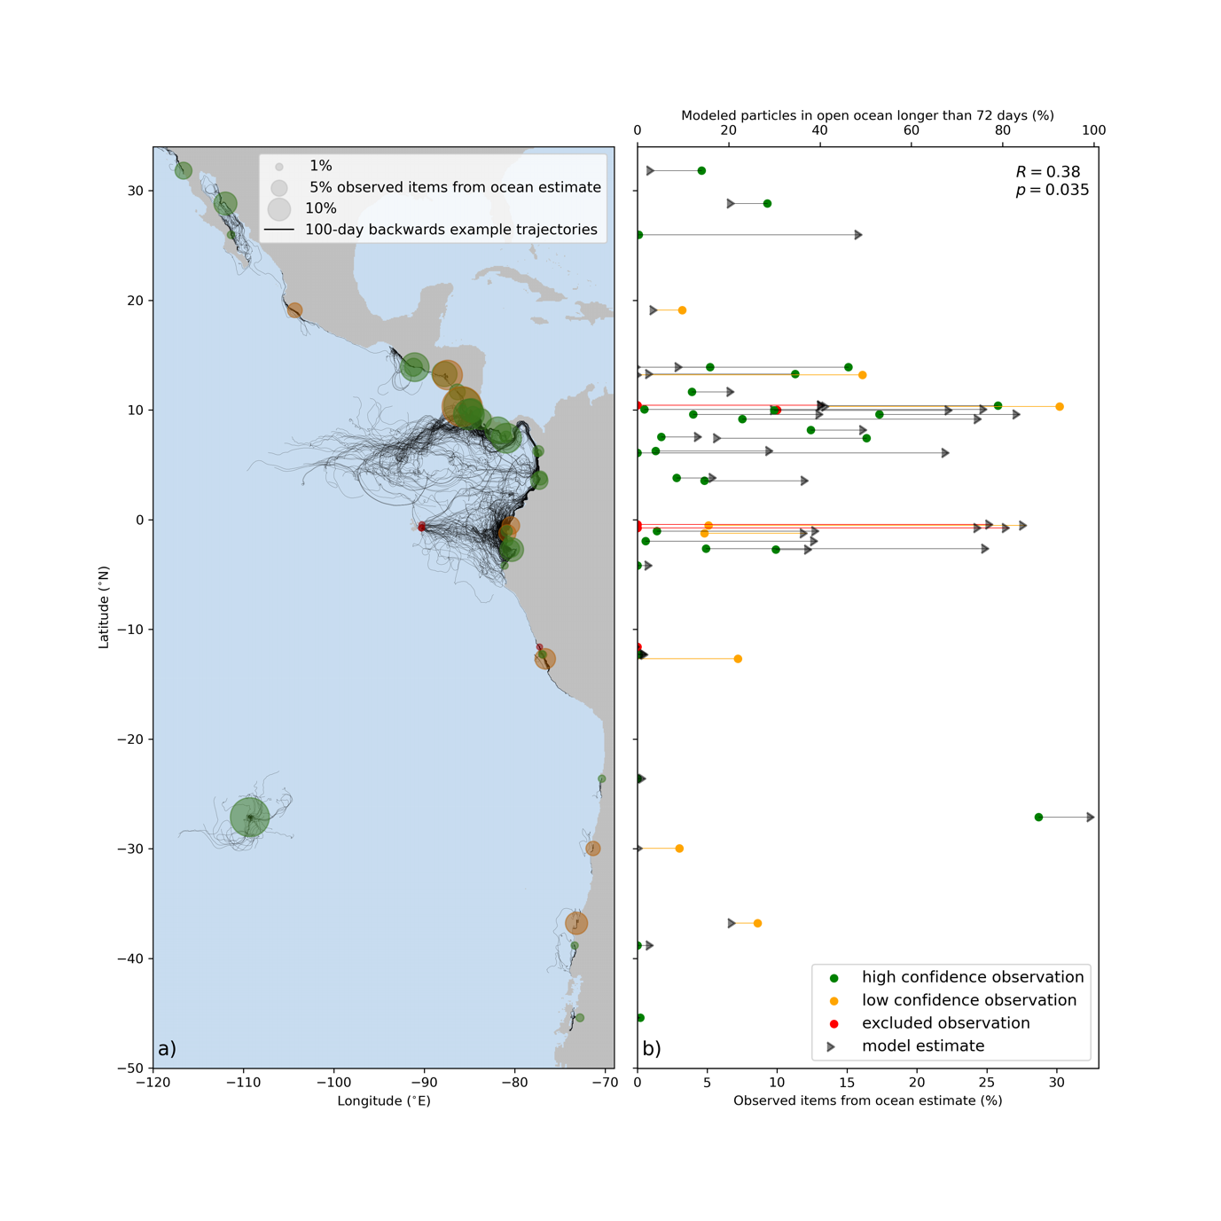

Figure 4 showing (a) the observed distribution of the fraction of positively buoyant items with biotic interactions (markers) and a subset of the 100-day backward particle trajectories arriving at each measurement location. The observed estimates (colored markers) are compared with the fraction of particles that have been afloat for longer than 72 days (gray triangles) in (b). The straight lines indicate the difference between the observed and modeled estimate. Note the different scale for the observed and modeled estimate.

1. <https://www.mercator-ocean.eu/en/solutions-expertise/accessing-digital-data/product-details/?offer=4217979b-2662-329a-907c-602fdc69c3a3&system=d35404e4-40d3-59d6-3608-581c9495d86a>