**ELECTRONIC SUPPLEMENT**

**Appendix 1: *The central and southern East Pacific coast as a model system***

The large-scale oceanographic circulation along the East Pacific coast is dominated by the California Current System (CCS), flowing from the north in equatorward direction along the coast of California and Baja California (Mexico), the Equatorial Current System (ECS), and the Humboldt Current System (HCS), which flows from the south in equatorward direction along the coasts of Chile, Peru, and Ecuador. The CCS and the HCS are Eastern Boundary Currents with intense coastal upwelling, where broad-scale offshore transport of surface waters pushes floating items away from the coast towards the open ocean (Miranda-Urbina et al. 2015; van Gennip et al. 2019) or blocks oceanic litter from reaching the coast (Ribic et al. 2012). Consequently, the litter found on the shores of these countries does not come from the ocean, as is being reflected in the high proportion of local sources (80% - 100%; Onink et al. 2021). Generally, land sources are activities on the coast where the contribution of litter via rivers is comparatively low because many mountain-fed watersheds are short and/or dry (California, Peru, Chile). Coastal populations (Chenillat et al. 2021) or fisheries off the coasts of Peru and northern Chile (van Gennip et al. 2019) are important sources of floating marine litter that ends up in the South Pacific Subtropical Gyre (SPSG). Oceanographic models described similar dynamics of litter transport in the North Pacific Ocean where buoyant plastics accumulate off the coast (Wilcox et al. 2015; Good et al. 2020) and within the North Pacific Subtropical Gyre (NPSG), eventually stranding on the Hawaiian coast (Kubota 1994). Even though large-scale models predict that litter in the open ocean is accumulated in the center of the gyres, recent modelling efforts indicate that large amounts of buoyant plastic litter remain close to the shorelines during the first years after release from land sources (Onink et al. 2021).

The ECS is located between latitudes of 15°N and 5°S and includes a complex system of east- and westward currents, the North Equatorial Current (NEC), the North Equatorial Countercurrent (NECC), and the South Equatorial Current (SEC) (Fiedler & Lavin 2017). Oceanographic models indicate that the Central American coast is receiving floating plastic from the ocean with estimates ranging from 20% to 80% of stranded floating plastic coming from distant sources (Onink et al. 2021). In this region, the large-scale oceanic circulation overlaps with meso-scale processes over the continental shelf (Rodríguez-Rubio & Schneider, 2003), where local eddies could be retaining floating litter before expelling it, similar to eddies in the North Atlantic (Brach et al. 2018), as they occur at similar latitudes along the Western coast of the Pacific (Ko et al. 2018). The effects of meso-scale processes transporting floating litter can also be influenced by temporal variations (Hajbane et al. 2021; van Sebille et al. 2020), which are still poorly understood along the Pacific Coast of Central America.

Due to its longevity, floating marine litter can potentially be transported over large distances by large-scale and meso-scale oceanographic processes (van Sebille et al. 2020). Oceanographic models have identified hotspots along the continental coast of Latin America that are receiving higher proportions of floating marine litter from the open ocean (e.g. Chenillat et al. 2021). However, few studies have examined marine litter along the continental coast of the South-East Pacific and most of these have focused on beach litter composition and densities to identify sources (e.g. Gaibor et al. 2020; Garcés-Ordóñez et al. 2020; Honorato-Zimmer et al. 2019), but did not report organism interactions. Knowing where floating litter (with epibionts) arrives after extended journeys with ocean currents will help to fine-tune oceanographic models (Viatte et al. 2020; van Sebille et al. 2020). In order to achieve this goal, in this study, we contrasted the proportion of floating litter items, with epibionts, collected on beaches along the continental East Coast of the Pacific (from 35°N to 55°S) with oceanographic model predictions.

**Appendix 2: Data quality assurance procedure**

***2.1. General description***

The field observations of litter items with epibionts were conducted by citizen scientists. This protocol describes the data quality assurance process starting from the total number of litter items on the beach (collected and counted by schoolchildren) concluding with the proportion of litter that could have arrived with marine currents (validated by experts in the laboratory). We are using two proxy variables (buoyancy and the presence of epibionts on litter) to estimate the proportion of litter items that could have arrived at continental and island beaches along the Pacific Coast of Latin American countries via marine currents. This document summarizes the steps taken to measure the proportion of litter that could have arrived with currents and was calculated from data collected by citizen scientist from 47 schools distributed more or less evenly along the East Pacific coast between Mexico and Chile.

***2.2. Objectives***

1) Ensure the calculations done by schoolchildren in the datasheet are correct and have reliable values of “Total number of litter items” found on the beach.

2) Estimate a reliable percentage of floating litter items with epibionts that have a high probability of arrival with marine currents.

***2.3. Citizen Science Approach***

The citizen scientists involved in this research were teachers and their schoolchildren aged between 10 and 18 years old. Participants belonged to schools from the 11 Latin American coastal countries along the Pacific Ocean (from Mexico to Chile), and since 2018, they have been part of the ReCiBa network (The international network of litter scientists, or “Red de Científicos de la Basura” in Spanish).

In the second semester of 2019, the scientific team of the program designed (i) a set of 8 educational guides of activities to determine litter with biotic interactions (<https://doi.org/10.5281/zenodo.5906766>), and (ii) a manual to identify organisms growing on marine litter (<https://doi.org/10.5281/zenodo.5904156>). The educational guides introduce the issue of marine currents, floating litter, and organism interactions (guides 1-5), the specific sampling procedures (guides 6 & 7), and the evaluation and interpretation of the results (guide 8).

Guide number 6 offers instructions about how to collect litter samples on the beach (the sampling occurs in one day), while guide number 7 allows the schoolchildren to identify the main organisms interacting with the litter items, mainly the epibionts growing on them. The first activity (guide 6) took place on the beach on the same day of the sampling, whereas the second activity (guide 7) was done another day at the school. Data collection occurred between September and December 2019.

On the beach, the schoolchildren followed the instructions of guide 6 of the educational material (for the complete guide see <https://doi.org/10.5281/zenodo.5906766>). On the sampling day, the teachers with their class went to their local beach, where they formed small groups of 4 to 5 children. Each group then collected around 100 litter items on the beach, or if they could not gather 100 items, they searched for litter for a maximum of 30 minutes. The total number of items collected by each group was very variable, with some groups collecting more than 100 items and other groups not finding that many litter items on their beaches.

Following collection, the schoolchildren classified litter items according to material composition, and they counted how many items from each category presented signs of interactions with marine organisms. The type of registered interactions were adherences of organisms growing on the litter (epibionts), bitemarks, entanglement, or more than one type of interaction at the same time. All these data were registered in a data table. Teachers sent an image or a scanned copy of the completed data table to the scientific team (per email or whatsapp).

Using guide 7 of the educational material elaborated by Cientificos de la Basura (see guide at <https://doi.org/10.5281/zenodo.5906766>), schoolchildren conducted a second activity where they took a subsample of those items they considered to have interactions. The subsample size was variable, as some groups found a lot of litter with interactions and only returned a fraction of these items to the school, while other groups found very few items with interactions, retaining all of them for later inspection. Back at the school, each litter item with putative interactions was then reviewed in detail, usually at a later day. If the items had epibionts, the schoolchildren registered the taxon group in a table, supporting their observations with the help of an identification manual (see manual at <https://doi.org/10.5281/zenodo.5904156>). Each item was photographed with a label that included the number of the item (corresponding with the data table) and a size reference.

***2.4. Data quality assurance procedure***

***2.4.1 Overview of data quality assurance process***

The complete data quality assurance procedure is summarized in Figure 1. It involves three modules of actions which lead to acceptance, correction, or rejection of the data.

*2.4.1. Module 1 – Revision of calculations*

Schoolchildren reported the number of items found on the beach using a data table form. To detect and correct mistakes in the calculations in this table, we carefully checked the data, and we followed a protocol for data selection and corrections of mistakes described in detail below (Figure 1: Steps 1 & 2).

*2.4.2. Module 2 – Expert evaluation of the items*

From the total items found on the beach, the schoolchildren took a subsample of items that presented interactions. To accept litter items for further detailed analysis, these interactions must be correctly registered in a data table (Figure 1: Step 3). To ensure the number of items with epibionts as registered by the schoolchildren, experts confirmed the presence of epibionts on the items with three alternative approaches: samples were received and evaluated in the laboratory (Figure 1: Steps 4 & 7), pictures (but no physical sample) were received and checked for epibionts (Figure 1: Steps 5 & 7), or experts directly supervised the identification process in the field (Figure 1: Steps 6 & 7). At the end of this module, we used the proportion of items with epibionts as determined by the experts in the subsample to correct and estimate the number of litter items with epibionts on each beach (Figure 1: Step 8). This proportion (which had the value of 1 if experts and schoolchildren coincided in their evaluation) was multiplied by the total number of litter items with interactions reported by the schoolchildren in guide 6.

*2.4.3. Module 3- Buoyancy correction*

To determine the buoyancy of the collected litter items, similar to epibiont evaluation (see above), we used three alternative methods. We either tested the buoyancy in the laboratory (Figure 1: Steps 4 & 9), asked a group of experts to estimate the buoyancy based on images of those items that were not physically available (Figure 1: Steps 5 & 9), or an expert evaluated buoyancy features of items directly in the field (Figure 1: Steps 6 & 9).

To obtain the final estimate for the number of items that could have arrived with currents, we used the proportion of items with positive buoyancy in the subsample to correct the number of all litter items with epibionts (Figure 1: Step 10). This proportion was multiplied with the second estimation of the total items with epibionts.

*Figure 1. Overview of the 10 key steps (numbers in quadrats) during data quality assurance bound together in three modules. *If discrepancies in calculations were of 10 units or less, they were corrected following the protocol detailed below.*

***2.5. Module 1: Revision of calculations***

*2.5.1. Checking and correction of original submitted data tables*

*Step 1:* The data tables from activity guide 6 were received as images by the project coordinator (see an example in Figure 2), who verified the information about the name of the beach, the sampling date, and the number of the group. Only data tables with this information were advanced to Step 2.

*Step 2:* Original numbers submitted by the schools included data of the total number of litter items collected by each participating group of schoolchildren. The items were classified according to the material type, and by the presence/absence of epibionts, bitemarks, entanglements or multiple interactions. First, schoolchildren separated all the collected litter items by material type and then, by the presence or absence of interactions. The column of the “Total items” corresponded to the sum of items with and without interactions, which was the final calculation that the schoolchildren made.

*Figure 2. Picture of an original data table of guide 6 completed by the schoolchildren. In order to detect calculation mistakes made by them, in the first step, the coherence in calculations was estimated for each row (example highlighted by red border). Rows correspond to litter material types (plastics and rubber, glass, metal, processed wood, leftover food, fabric, paper and cardboard, others). Columns from left to the right: “Total items”, “Total items without traces”, “Litter with traces of interactions”. This last section contains four sections differenced with drawings that indicate “adherences or epibionts”, “bitemarks”, “entanglements” and “More than one interaction”.*

Based on that table, we were able to recheck the data in the following equation for each row:

*Total litter = Total litter with interactions + Total litter without interactions*.

Schoolchildren might have made two types of mistakes when completing the data table, (i) wrong sums of items with more than one interaction, which were counted twice or more times in the table (each time for the column of interactions and in the column of “more than one interaction”), and (ii) wrong sums of total items. These two potential mistakes were corrected as follows:

(1) To avoid overestimations, the number of items that were registered in the column “more than one interaction” were excluded from the total. We decided this because, through communications with the teachers, we learned that the interpretation of the instructions was ambiguous among the participating groups, leading to frequent overestimation of litter items with interactions, as items with more than one interaction were counted two or three times in the corresponding columns (e.g. if one item had epibionts and bitemarks, this single item was erroneously counted several times, once as having epibionts, then also as having bitemarks, and finally as an item with more than one interaction).

(2) If the sum of the total items was wrong and discrepancies between “Total items” and the sum of “Total items without interactions” + “Total items with interactions” were < 10 units, we corrected the numbers. This mistake was very frequent for the row of plastic items, most likely because plastics were very abundant on the surveyed beaches. The schoolchildren reported on dozens of plastic items, making calculations difficult. Three cases are possible:

*2a) “Total items > Total items without interactions + Total items with interactions” (but discrepancies < 10 units)*

In this case, we don’t know if the “extra” items did or did not have interactions and we discounted the items from the total as shown in the example in Figure 3.

*Figure 3. Case 2a. In this example, the original data reported 9 metal items as the total, 8 of which had no interactions. However, for the remaining item it was unknown whether it did or did not have interactions. As this is only one item (i.e. < 10 items), in the corrected table we discounted that one item from the total number of metal items.*

*2b) “Total items < Total items without interactions + Total items with interactions” (but discrepancies < 10 units)*

The Total is replaced with the correct sum of items with and without epibionts (Figure 4).

*Figure 4. Case 2b. In this example, the original data reported a wrong sum of items with and without interactions. As the discrepancy was small (i.e. < 10 items), the Total was replaced by the correct sum.*

*2c) Discrepancies in calculations are* *≥ 10 units*

If discrepancies in the additions were *≥* 10 units, we excluded the group from the data analysis because it would potentially cause overestimations of the total number of items with epibionts, or the total number of items examined by the schoolchildren (see example in figure 5). Each beach was surveyed by different numbers of groups, depending on the total number of the students that conducted the activity. If a beach did not have data approved from at least one group after this first step, that entire beach was excluded from further analysis.

*Figure 5. Case 2c. Example of a group that was excluded because discrepancies in additions were 10 units or more. In this case corrections were not possible and the total overestimated total plastic litter with unknown interactions.*

*2.5.2. First estimation*

From the 47 beaches that had records for the total number of items collected on the beach, the number of items with interactions, and the number of items without interactions, 44 beaches advanced to the next step (Table 1). Three beaches had to be excluded because they did not have at least one group with accepted data. From the 44 beaches with available data, 22 groups were excluded because calculation mistakes could not be corrected (discrepancies in calculations were ≥ 10 units), or they did not report the minimum information necessary for data quality assurance.

*Table 1. Accepted number of sampling sites and groups after revision of calculations.*

|  |  |  |  |
| --- | --- | --- | --- |
| Original data (G.6) | | Accepted/corrected data (G.6) | |
| N beaches | N groups | N beaches | N groups |
| 47 | 163 | 44 | 141 |

As a result of the revision and correction of all calculations, we obtained the percentage of items with interactions based on guide 6 from 44 beaches (Table 2).

*Table 2. Percentage of items with interactions based on guide 6 (n = 44 beaches) and the data quality assurance process in module 1. The last 4 rows (light grey shading) correspond to sampling sites on oceanic islands. The rest of continental sampling sites are ordered from North to South.*

|  |  |  |  |  |
| --- | --- | --- | --- | --- |
| Country | Name | Accepted number of items with interactions | Accepted total items found on the beach | First estimation of the percentage of items with interactions |
| México | Hermosa | 25 | 71 | 35.2% |
| México | Bahía Kino | 74 | 531 | 13.9% |
| México | Salinitas | 8 | 464 | 1.7% |
| México | Salahua | 6 | 188 | 3.2% |
| Guatemala | San José-Rama Blanca | 22 | 199 | 11.1% |
| Guatemala | El Paredón | 37 | 167 | 22.2% |
| El Salvador | Chiquirín | 28 | 200 | 14.0% |
| Honduras | Cedeño | 50 | 310 | 16.1% |
| Nicaragua | Posa del Padre | 37 | 78 | 47.4% |
| Costa Rica | Potrero | 14 | 75 | 18.7% |
| Costa Rica | Puerto Viejo | 8 | 31 | 25.8% |
| Costa Rica | Grande | 32 | 106 | 30.2% |
| Costa Rica | Cabuya | 68 | 373 | 18.2% |
| Costa Rica | Puntarenas | 35 | 309 | 11.3% |
| Costa Rica | Azul | 7 | 253 | 2.8% |
| Costa Rica | Jacó | 22 | 332 | 6.6% |
| Costa Rica | Hermosa | 25 | 105 | 23.8% |
| Panamá | Las Lajas | 100 | 542 | 18.5% |
| Panamá | Torio | 13 | 219 | 5.9% |
| Panamá | Mataoscura | 59 | 195 | 30.3% |
| Colombia | El Bajo-Punta Bonita | 24 | 348 | 6.9% |
| Colombia | Ciudad Mutis | 50 | 454 | 11.0% |
| Colombia | La Bocana | 9 | 281 | 3.2% |
| Colombia | El Almejal | 0 | 481 | 0.0% |
| Ecuador | Briceño-San Vicente | 12 | 236 | 5.1% |
| Ecuador | San José-Manta | 12 | 248 | 4.8% |
| Ecuador | Ligüiqui | 10 | 126 | 7.9% |
| Ecuador | Valdivia | 9 | 508 | 1.8% |
| Ecuador | El Pelao | 31 | 379 | 8.2% |
| Ecuador | Data-Villamil | 91 | 687 | 13.2% |
| Perú | Los Órganos | 14 | 342 | 4.1% |
| Perú | San Pedro de Lurin | 22 | 411 | 5.4% |
| Perú | Totoritas | 14 | 194 | 7.2% |
| Perú | Venecia | 0 | 141 | 0.0% |
| Perú | Puerto Chancay | 16 | 47 | 34.0% |
| Chile | Changa | 18 | 610 | 3.0% |
| Chile | Bahía Acantilado | 1 | 216 | 0.5% |
| Chile | Puerto Saavedra | 2 | 327 | 0.6% |
| Chile | Lenga | 61 | 710 | 8.6% |
| Chile | Trocadero | 0 | 667 | 0.0% |
| Ecuador | Los Millonarios | 7 | 31 | 22.6% |
| Ecuador | Tortuga Bay | 3 | 86 | 3.5% |
| Ecuador | Los Alemanes | 8 | 86 | 9.3% |
| Chile | Taharoa | 125 | 407 | 30.7% |
| **TOTAL** | | **1,209** | **12,771** |  |

***2.6. Module 2 – Expert evaluation of epibionts***

The second module of the data quality assurance procedure was made by experts, with three alternative options for item analysis (see also Figure 1) being either item analysis in the laboratory (Figure 1: Step 4), item analysis by image (Figure 1: Step 5), or item analysis by an expert in the field (Figure 1: Step 6). The proportion of items with epibionts confirmed by experts in relation to the total items of each subsample was used to obtain the second estimation of the “Total items with epibionts” (Figure 1: Step 8). The second module of actions involves Steps 3, 4, 5, 6, 7, and 8, which are described here below.

*2.6.1 Checking the presence of epibionts on the items*

*Step 3:* First, we verified the correct reception of the data table from activity guide 7 with the taxon identifications made by schoolchildren during the identification activity. If this information was not available for an item, the item could not be validated, and hence it was excluded from the analysis.

*Step 4:* 434 items that had the data table with the identifications made by the schoolchildren were received in the laboratory of Universidad Catolica del Norte in Coquimbo, Chile. These items were brought to Coquimbo by the coordinating teachers when they came to an international training workshop in January 2020. In the laboratory, experts made a direct evaluation of the presence of epibionts, and the main taxa were identified using a magnifying glass (Figure 1: Step 7). Items had to be excluded from further analysis if they either did not arrive at the laboratory, no image was available, or no expert supervised the identification.

*Step 5:* 200 items that did not arrive at the laboratory were validated using the image taken by the schoolchildren. The images that were available for analysis had a label with the item number, which corresponded to the data table the schoolchildren had registered their identifications on (see Figure 6).

*Figure 6. Picture of a labelled sample.*

These images were evaluated by experts to confirm the presence of epibionts and the main taxa (Figure 1: Step 7).

*Step 6:* At one site (Taharoa, Chile), an expert directly supervised the identification activity and the buoyancy features of the items collected on that beach. In this case, no item or image was needed for data quality assurance.

*Step 7:* Experts validated the presence of epibionts growing on the items in the laboratory, based on the image or directly in the field. In the laboratory, each sample was carefully analysed using a magnifying glass and naked eye. When only the image was available, the presence of epibionts was registered using the zoom tool. If no organisms were identifiable, then these items were counted as “without epibionts”. We assumed that if the item did not present epibionts, the item could not have arrived on the beach via marine currents.

*2.6.2. Correction based on the presence of the epibionts*

*Step 8:* We calculated the proportion of items with epibionts that experts determined for the subsample. Then, we multiplied this proportion by the total number of items with interactions calculated in the first estimation, which resulted in a second estimation, the “number of items with epibionts.”

*2.6.3. Second estimation*

31 beaches were validated for the presence or absence of epibionts on litter items. 28 beaches were validated by experts for the presence of epibionts in the subsample of litter items selected and examined by the schoolchildren, using the sample or the image of the sample. On the other hand, no subsamples were analysed for three beaches (El Almejal, Venecia and Trocadero) because on these beaches no items with epibionts were found during the sampling. 13 of the 44 beaches could not be validated completely (Modules 2 & 3) because no table with species identifications by the schoolchildren was received; without this data table from activity guide 7, it was not possible to verify the presence of epibionts on the respective litter items.

From the reported identifications of schoolchildren in guide 7, experts validated the presence/absence of epibionts on 694 items, confirming the presence of epibionts on 416 items (they found no epibionts on 277 items). After multiplying the proportion of epibionts in each subsample by the number of items from the first estimation, we obtained a second estimation of 663 items with epibionts.

Table 3. The 2nd estimated number of items with epibionts on each beach appears in the last column. These values are obtained based on the proportion of items with epibionts that were present in each subsample multiplied by the total number of items with interactions. Last 4 rows (in light grey) correspond to sampling sites on oceanic islands. The rest of continental sampling sites are ordered from the North to the South. 13 beaches were excluded because they had no subsample to validate the number of items with epibionts.

|  |  |  |  |  |  |
| --- | --- | --- | --- | --- | --- |
| Country | Beach | (A) 1st estimation total items with interactions | (B) N items with interactions by subsample | (C) N items with epibionts (confirmed by experts) | 2nd estimation total items with epibionts for the beach (C/B × A) |
| México | Hermosa | 25 | 13 | 2 | 4 |
| México | Bahía Kino | 74 | 3 | 2 | 49 |
| México | Salinitas | 8 | 8 | 2 | 2 |
| México | Salahua | 6 | ND | ND | ND |
| Guatemala | San José-Rama Blanca | 22 | 21 | 11 | 12 |
| Guatemala | El Paredón | 37 | 20 | 16 | 30 |
| El Salvador | Chiquirín | 28 | 25 | 24 | 27 |
| Honduras | Cedeño | 50 | ND | ND | ND |
| Nicaragua | Posa del Padre | 37 | 39 | 9 | 9 |
| Costa Rica | Potrero | 14 | ND | ND | ND |
| Costa Rica | Puerto Viejo | 8 | 2 | 2 | 8 |
| Costa Rica | Grande | 32 | ND | ND | ND |
| Costa Rica | Cabuya | 68 | 40 | 39 | 66 |
| Costa Rica | Puntarenas | 35 | 37 | 32 | 30 |
| Costa Rica | Azul | 7 | 11 | 2 | 1 |
| Costa Rica | Jacó | 22 | 21 | 14 | 15 |
| Costa Rica | Hermosa | 25 | 19 | 6 | 8 |
| Panamá | Las Lajas | 100 | 53 | 37 | 70 |
| Panamá | Torio | 13 | 17 | 6 | 5 |
| Panamá | Mataoscura | 59 | 64 | 39 | 36 |
| Colombia | El Bajo-Punta Bonita | 24 | 22 | 20 | 22 |
| Colombia | Ciudad Mutis | 50 | 43 | 30 | 37 |
| Colombia | La Bocana | 9 | 9 | 9 | 9 |
| Colombia | El Almejal | 0 | No interactions | | 0 |
| Ecuador | Briceño-San Vicente | 12 | ND | ND | ND |
| Ecuador | San José-Manta | 12 | ND | ND | ND |
| Ecuador | Ligüiqui | 10 | 11 | 2 | 2 |
| Ecuador | Valdivia | 9 | 11 | 4 | 3 |
| Ecuador | El Pelao | 31 | 5 | 3 | 19 |
| Ecuador | Data-Villamil | 91 | 49 | 40 | 74 |
| Perú | Los Órganos | 14 | 13 | 0 | 0 |
| Perú | San Pedro de Lurin | 22 | 74 | 2 | 1 |
| Perú | Totoritas | 14 | ND | ND | ND |
| Perú | Venecia | 0 | No interactions | | 0 |
| Perú | Puerto Chancay | 16 | ND | ND | ND |
| Chile | Changa | 18 | ND | ND | ND |
| Chile | Bahía Acantilado | 1 | 2 | 2 | 1 |
| Chile | Puerto Saavedra | 2 | 2 | 1 | 0 |
| Chile | Lenga | 61 | ND | ND | ND |
| Chile | Trocadero | 0 | No interactions | | 0 |
| Ecuador | Los Millonarios | 7 | ND | ND | ND |
| Ecuador | Tortuga Bay | 3 | ND | ND | ND |
| Ecuador | Los Alemanes | 8 | ND | ND | ND |
| Chile | Taharoa | 125 | 60 | 60 | 125 |
| **TOTAL** | | **1,209** | **694** | **416** | **663** |

***2.7. Module 3 – Expert evaluation of buoyancy***

*2.7.1. Checking the buoyancy conditions of litter items*

At the same time that items were evaluated for the presence of epibionts, experts determined their buoyancy.

*Step 9:* Experts determined the buoyancy of these items in the conditions they had at the moment of sampling (e.g. intact versus broken glass bottle). In the case that items had arrived at the laboratory, buoyancy was determined directly in a tray or bucket with seawater. For the items that were not physically available, we used the images through consultations of marine litter experts who scored buoyancy based on their knowledge of material types and item features (see examples in Table 4). Additional criteria to score negative buoyancy were that litter items had soil attached to them, or that PET or glass bottles had no lid at the moment of collection (Table 4).

Table 4. Orientations to determine buoyancy based on the image analysis

|  |  |  |
| --- | --- | --- |
| **Item type or condition** | **Buoyancy condition** | **Reference** |
| HDPE Bottles or containers with or without cap | Positive buoyancy | Ryan 2020 |
| PET bottles with cap | Positive buoyancy | Roman et al., 2020 |
| Plastic bottlecaps | Positive buoyancy | Roman et al., 2020  Veen et al., 2021 |
| Glass fragments or metal items | Negative buoyancy | Common sense |
| PET bottles without cap | Negative buoyancy | Turner & Williams, 2021 |
| Plastic fishing ropes | Negative buoyancy | Turner & Williams, 2021 |

*2.7.1.1. Calibration of experts’ knowledge using photographs of items with known buoyancy*

Seven experts from our scientific team, who commonly work with the topic of rafting and marine litter, scored the buoyancy of floating items based on images. First, we tested the accuracy of the experts by asking them to determine the buoyancy of 100 items with known buoyancy, which we had previously tested in the laboratory. The expert evaluations were included in the data quality assurance process (Step 5 and 7, Figure 1) when they correctly classified the buoyancy of 70 or more items (≥ 70%). Five experts correctly scored the buoyancy features of the majority of these test items (72% - 97% accuracy), and hence their evaluations were considered in further analysis.

*2.7.1.2. Items with unknown buoyancy*

For the items where we only had images, the buoyancy could not be tested directly (n=200 items), and thus we contrasted the agreement between the 5 selected expert evaluations. If at least 3 of the 5 experts agreed about the buoyancy status of an item (either positive or negative), then the buoyancy of this item was registered as scored by the majority of the experts. In several cases, experts had doubts about the buoyancy (“Not sure” responses). If there was no consensus about the buoyancy of an item (positive or negative), the item was classified to have uncertain buoyancy. To avoid overestimations, these items with uncertain buoyancy were then considered as having negative buoyancy. This is important for the corrections in the following steps of the data quality assurance procedure (Figure 1: Step 10), and also tends to be a conservative estimate (conservative in the sense that the true proportion of positively buoyant items could have been higher).

*2.7.2. Correction based on buoyancy*

*Step 10:* Based on the expert analysis, the proportion of items with positive buoyancy in the subsample, as determined for each beach, was multiplied by the total number of items with epibionts (from the second estimation) to calculate the number of items that could have arrived with currents.

*2.7.3. Final estimation*

In this final step, we aimed to obtain the proportion of items that could have arrived with marine currents for those beaches for which a subsample could be analysed for epibionts and buoyancy (Table 5). Buoyancy was the determining factor of this differentiation because some of the items that had epibionts did not float in seawater, indicating that they could have been colonized on the seafloor by benthic organisms. These items did not arrive floating with currents, but other processes caused them to re-emerge on the beach. Similarly, the schoolchildren could have collected the litter items along the intertidal zone, where they were trapped or buried in the sand or rocks.

Table 5. Total litter items that could have arrived with currents after applied the buoyancy correction to the number of items with epibionts. Last 4 rows (light grey shading) correspond to sampling sites on oceanic islands. The rest of continental sampling sites are ordered from the North to the South.

|  |  |  |  |  |  |
| --- | --- | --- | --- | --- | --- |
| Country | Beach | 2nd estimation total items with epibionts for the beach | N items by subsample | N items with positive buoyancy | 3rd estimation total items that could have arrived with currents |
| México | Hermosa | 4 | 13 | 11 | 3 |
| México | Bahía Kino | 49 | 3 | 3 | 49 |
| México | Salinitas | 2 | 8 | 2 | 1 |
| México | Salahua | ND | ND | ND | ND |
| Guatemala | San José-Rama Blanca | 12 | 21 | 19 | 10 |
| Guatemala | El Paredón | 30 | 20 | 17 | 25 |
| El Salvador | Chiquirín | 27 | 25 | 21 | 23 |
| Honduras | Cedeño | ND | ND | ND | ND |
| Nicaragua | Posa del Padre | 9 | 39 | 14 | 3 |
| Costa Rica | Potrero | ND | ND | ND | ND |
| Costa Rica | Puerto Viejo | 8 | 2 | 2 | 8 |
| Costa Rica | Grande | ND | ND | ND | ND |
| Costa Rica | Cabuya | 66 | 40 | 39 | 65 |
| Costa Rica | Puntarenas | 30 | 37 | 37 | 30 |
| Costa Rica | Azul | 1 | 11 | 11 | 1 |
| Costa Rica | Jacó | 15 | 21 | 19 | 13 |
| Costa Rica | Hermosa | 8 | 19 | 19 | 8 |
| Panamá | Las Lajas | 70 | 53 | 51 | 67 |
| Panamá | Torio | 5 | 17 | 14 | 4 |
| Panamá | Mataoscura | 36 | 64 | 57 | 32 |
| Colombia | El Bajo-Punta Bonita | 22 | 22 | 17 | 17 |
| Colombia | Ciudad Mutis | 37 | 43 | 7 | 6 |
| Colombia | La Bocana | 9 | 9 | 8 | 8 |
| Colombia | El Almejal | 0 | No interactions | | 0 |
| Ecuador | Briceño-San Vicente | ND | ND | ND | ND |
| Ecuador | San José-Manta | ND | ND | ND | ND |
| Ecuador | Ligüiqui | 2 | 11 | 11 | 2 |
| Ecuador | Valdivia | 3 | 11 | 11 | 3 |
| Ecuador | El Pelao | 19 | 5 | 5 | 19 |
| Ecuador | Data-Villamil | 74 | 49 | 45 | 68 |
| Perú | Los Órganos | 0 | 13 | 13 | 0 |
| Perú | San Pedro de Lurin | 1 | 74 | 58 | 0 |
| Perú | Totoritas | ND | ND | ND | ND |
| Perú | Venecia | 0 | No interactions | | 0 |
| Perú | Puerto Chancay | ND | ND | ND | ND |
| Chile | Changa | ND | ND | ND | ND |
| Chile | Bahía Acantilado | 1 | 2 | 1 | 1 |
| Chile | Puerto Saavedra | 0 | 2 | 1 | 0 |
| Chile | Lenga | ND | ND | ND | ND |
| Chile | Trocadero | 0 | No interactions | | 0 |
| Ecuador | Los Millonarios | ND | ND | ND | ND |
| Ecuador | Tortuga Bay | ND | ND | ND | ND |
| Ecuador | Los Alemanes | ND | ND | ND | ND |
| Chile | Taharoa | 125 | 60 | 56 | 117 |
| **TOTAL** | | **663** | **694** | **569** | **583** |

In Posa del Padre (Nicaragua) and Ciudad Mutis (Colombia), schoolchildren reported a large number of items with epibionts, but these items did not have positive buoyancy, so there is a low probability that they could have arrived with currents.

**2.8. Percentage of items that could have arrived with currents**

The data quality assurance process allowed us to identify items that probably could have arrived with currents on the respective beaches (Table 6). From the first estimation, based on the original data reported by the schoolchildren, we arrived at a more conservative estimation of 583 items with epibionts and positive buoyancy that have a high likelihood to have arrived with currents on the beach in relation to a total of 12,771 accepted litter items and 1,209 items with interactions based on the first estimation.

*Table 6. Percentage of the first estimation of items with interactions obtained after the revision of guide 6 (n=44 beaches) and the final estimation of items that could have arrived with currents after the data quality assurance process (n=31 beaches). Last 4 rows (light grey shading) correspond to sampling sites on oceanic islands. The rest of continental sampling sites are ordered from North to South. ND – no data (samples, images, table with species identification) available for this step.*

|  |  |  |  |
| --- | --- | --- | --- |
| Country | Beach | 1st estimation of the percentage of items with interactions | Final estimation of the percentage of items that could have come with currents |
| México | Hermosa | 35.2% | 4.6% |
| México | Bahía Kino | 13.9% | 9.3% |
| México | Salinitas | 1.7% | 0.1% |
| México | Salahua | 3.2% | ND |
| Guatemala | San José-Rama Blanca | 11.1% | 5.2% |
| Guatemala | El Paredón | 22.2% | 15.1% |
| El Salvador | Chiquirín | 14.0% | 11.3% |
| Honduras | Cedeño | 16.1% | ND |
| Nicaragua | Posa del Padre | 47.4% | 3.9% |
| Costa Rica | Potrero | 18.7% | ND |
| Costa Rica | Puerto Viejo | 25.8% | 25.8% |
| Costa Rica | Grande | 30.2% | ND |
| Costa Rica | Cabuya | 18.2% | 17.3% |
| Costa Rica | Puntarenas | 11.3% | 9.8% |
| Costa Rica | Azul | 2.8% | 0.5% |
| Costa Rica | Jacó | 6.6% | 4.0% |
| Costa Rica | Hermosa | 23.8% | 7.5% |
| Panamá | Las Lajas | 18.5% | 12.4% |
| Panamá | Torio | 5.9% | 1.7% |
| Panamá | Mataoscura | 30.3% | 16.4% |
| Colombia | El Bajo-Punta Bonita | 6.9% | 4.8% |
| Colombia | Ciudad Mutis | 11.0% | 1.3% |
| Colombia | La Bocana | 3.2% | 2.8% |
| Colombia | El Almejal | 0.0% | 0.0% |
| Ecuador | Briceño-San Vicente | 5.1% | ND |
| Ecuador | San José-Manta | 4.8% | ND |
| Ecuador | Ligüiqui | 7.9% | 1.4% |
| Ecuador | Valdivia | 1.8% | 0.6% |
| Ecuador | El Pelao | 8.2% | 4.9% |
| Ecuador | Data-Villamil | 13.2% | 9.9% |
| Perú | Los Órganos | 4.1% | 0.0% |
| Perú | San Pedro de Lurin | 5.4% | 0.1% |
| Perú | Totoritas | 7.2% | ND |
| Perú | Venecia | 0.0% | 0.0% |
| Perú | Puerto Chancay | 34.0% | ND |
| Chile | Changa | 3.0% | ND |
| Chile | Bahía Acantilado | 0.5% | 0.2% |
| Chile | Puerto Saavedra | 0.6% | 0.0% |
| Chile | Lenga | 8.6% | ND |
| Chile | Trocadero | 0.0% | 0.0% |
| Ecuador | Los Millonarios | 22.6% | ND |
| Ecuador | Tortuga Bay | 3.5% | ND |
| Ecuador | Los Alemanes | 9.3% | ND |
| Chile | Taharoa | 30.7% | 28.7% |

**2.9. Data selected to contrast field observations with oceanographic model predictions**

Of the 47 surveyed beaches, 31 could be validated for the percentage of floating litter that could have arrived with currents with high confidence because the data quality assurance procedure could completely apply to correct estimations. For 13 beaches, only the first steps of this protocol (Module 1) could be done, because no samples or images of the samples were available for the other steps (Modules 2 & 3). In these cases, we used the number of items that schoolchildren identified to have interactions to calculate the percentage of items that could have arrived with currents; consequently, these values have very low levels of confidence and must be interpreted with caution. In order to contrast predictions of the oceanographic model with field observations, from these 13 beaches we only considered those beaches that had at least 100 items collected on the beach (Table 7). Finally, a total of 38 sampling sites from the continental coasts of the East Pacific could be considered for this contrast; data from one beach of Rapa Nui are presented for comparative reasons.

Table 7. Last column presents the final values selected for the following model validation, colored by confidence level. Green cells are estimations with high confidence (n=31), orange cells have low confidence (n=8 beaches that did not have a subsample to complete the data quality assurance procedure until the last step, but where more than 100 items were collected during the beach sampling), and red cells are excluded values (n = 5 beaches that did not have a subsample to complete the data quality assurance procedure until the last step, and where less than 100 items were collected during the beach sampling).

|  |  |  |  |  |  |
| --- | --- | --- | --- | --- | --- |
| Country | Beach | Total items on the beach (validated) | 1st Estimation of the percentage of items with interactions | Final estimation of the percentage of items that could have come with currents | Data selected for model validation |
| México | Hermosa | 71 | 35.2% | 4.6% | 4.6% |
| México | Bahía Kino | 531 | 13.9% | 9.3% | 9.3% |
| México | Salinitas | 464 | 1.7% | 0.1% | 0.1% |
| México | Salahua | 188 | 3.2% | ND | 3.2% |
| Guatemala | San José-Rama Blanca | 199 | 11.1% | 5.2% | 5.2% |
| Guatemala | El Paredón | 167 | 22.2% | 15.1% | 15.1% |
| El Salvador | Chiquirín | 200 | 14.0% | 11.3% | 11.3% |
| Honduras | Cedeño | 310 | 16.1% | ND | 16.1% |
| Nicaragua | Posa del Padre | 78 | 47.4% | 3.9% | 3.9% |
| Costa Rica | Potrero | 75 | 18.7% | ND | Excluded |
| Costa Rica | Puerto Viejo | 31 | 25.8% | 25.8% | 25.8% |
| Costa Rica | Grande | 106 | 30.2% | ND | 30.2% |
| Costa Rica | Cabuya | 373 | 18.2% | 17.3% | 17.3% |
| Costa Rica | Puntarenas | 309 | 11.3% | 9.8% | 9.8% |
| Costa Rica | Azul | 253 | 2.8% | 0.5% | 0.5% |
| Costa Rica | Jacó | 332 | 6.6% | 4.0% | 4.0% |
| Costa Rica | Hermosa | 105 | 23.8% | 7.5% | 7.5% |
| Panamá | Las Lajas | 542 | 18.5% | 12.4% | 12.4% |
| Panamá | Torio | 219 | 5.9% | 1.7% | 1.7% |
| Panamá | Mataoscura | 195 | 30.3% | 16.4% | 16.4% |
| Colombia | El Bajo-Punta Bonita | 348 | 6.9% | 4.8% | 4.8% |
| Colombia | Ciudad Mutis | 454 | 11.0% | 1.3% | 1.3% |
| Colombia | La Bocana | 281 | 3.2% | 2.8% | 2.8% |
| Colombia | El Almejal | 481 | 0.0% | 0.0% | 0.0% |
| Ecuador | Briceño-San Vicente | 236 | 5.1% | ND | 5.1% |
| Ecuador | San José-Manta | 248 | 4.8% | ND | 4.8% |
| Ecuador | Ligüiqui | 126 | 7.9% | 1.4% | 1.4% |
| Ecuador | Valdivia | 508 | 1.8% | 0.6% | 0.6% |
| Ecuador | El Pelao | 379 | 8.2% | 4.9% | 4.9% |
| Ecuador | Data-Villamil | 687 | 13.2% | 9.9% | 9.9% |
| Perú | Los Órganos | 342 | 4.1% | 0.0% | 0.0% |
| Perú | San Pedro de Lurin | 411 | 5.4% | 0.1% | 0.1% |
| Perú | Totoritas | 194 | 7.2% | ND | 7.2% |
| Perú | Venecia | 141 | 0.0% | 0.0% | 0.0% |
| Perú | Puerto Chancay | 47 | 34.0% | ND | Excluded |
| Chile | Changa | 610 | 3.0% | ND | 3.0% |
| Chile | Bahía Acantilado | 216 | 0.5% | 0.2% | 0.2% |
| Chile | Puerto Saavedra | 327 | 0.6% | 0.0% | 0.0% |
| Chile | Lenga | 710 | 8.6% | ND | 8.6% |
| Chile | Trocadero | 667 | 0.0% | 0.0% | 0.0% |
| Ecuador | Los Millonarios | 31 | 22.6% | ND | Excluded |
| Ecuador | Tortuga Bay | 86 | 3.5% | ND | Excluded |
| Ecuador | Los Alemanes | 86 | 9.3% | ND | Excluded |
| Chile | Taharoa | 407 | 30.7% | 28.7% | 28.7% |

Table 8. Summary. Columns A and B are validated numbers registered on each beach after correcting calculations in the first data quality assurance module. C are the available items to data quality assurance in module 2, as column D are the number of items that experts confirmed the presence of epibionts, and E are the number of items with positive buoyancy. Proportions of items with epibionts and items with positive buoyancy in the subsample were applied to estimate the column F corresponding with items that could have arrived with currents. Column. The last column summarizes the final percentages that were used to the model validation. Colours indicate the confidence of these percentages, which is low for those beaches for which only module 1 of the data quality assurance procedure could be applied and high for the rest. Five beaches were excluded because the total number evaluated on the beach (column B) did not reach the minimum of 100 items and no subsample was available for module 2 & 3.

|  |  |  |  |  |  |  |  |  |
| --- | --- | --- | --- | --- | --- | --- | --- | --- |
|  |  | **Module 1** | |  | **Module 2** | **Module 3** |  | **Percentages used for model validation** |
| Country | Beach | A. Accepted total items found on the beach | B. Accepted number of items with interactions | C. Subsample size (number of items) | D. N items with epibionts (confirmed by experts) | E. N items with positive buoyancy | F. Estimation total items that could have arrived with currents  =(D/C)x(E/C)xB | Red: Excluded  Orange: Low confidence B/A  Green: High confidence F/A |
| México | Hermosa | 71 | 25 | 13 | 2 | 11 | 3 | 4.6% |
| México | Bahía Kino | 531 | 74 | 3 | 2 | 3 | 49 | 9.3% |
| México | Salinitas | 464 | 8 | 8 | 2 | 2 | 1 | 0.1% |
| México | Salahua | 188 | 6 | ND | ND | ND | ND | 3.2% |
| Guatemala | San José-Rama Blanca | 199 | 22 | 21 | 11 | 19 | 10 | 5.2% |
| Guatemala | El Paredón | 167 | 37 | 20 | 16 | 17 | 25 | 15.1% |
| El Salvador | Chiquirín | 200 | 28 | 25 | 24 | 21 | 23 | 11.3% |
| Honduras | Cedeño | 310 | 50 | ND | ND | ND | ND | 16.1% |
| Nicaragua | Posa del Padre | 78 | 37 | 39 | 9 | 14 | 3 | 3.9% |
| Costa Rica | Potrero | 75 | 14 | ND | ND | ND | ND | Excluded |
| Costa Rica | Puerto Viejo | 31 | 8 | 2 | 2 | 2 | 8 | 25.8% |
| Costa Rica | Grande | 106 | 32 | ND | ND | ND | ND | 30.2% |
| Costa Rica | Cabuya | 373 | 68 | 40 | 39 | 39 | 65 | 17.3% |
| Costa Rica | Puntarenas | 309 | 35 | 37 | 32 | 37 | 30 | 9.8% |
| Costa Rica | Azul | 253 | 7 | 11 | 2 | 11 | 1 | 0.5% |
| Costa Rica | Jacó | 332 | 22 | 21 | 14 | 19 | 13 | 4.0% |
| Costa Rica | Hermosa | 105 | 25 | 19 | 6 | 19 | 8 | 7.5% |
| Panamá | Las Lajas | 542 | 100 | 53 | 37 | 51 | 67 | 12.4% |
| Panamá | Torio | 219 | 13 | 17 | 6 | 14 | 4 | 1.7% |
| Panamá | Mataoscura | 195 | 59 | 64 | 39 | 57 | 32 | 16.4% |
| Colombia | El Bajo-Punta Bonita | 348 | 24 | 22 | 20 | 17 | 17 | 4.8% |
| Colombia | Ciudad Mutis | 454 | 50 | 43 | 30 | 7 | 6 | 1.3% |
| Colombia | La Bocana | 281 | 9 | 9 | 9 | 8 | 8 | 2.8% |
| Colombia | El Almejal | 481 | 0 | No interactions | | | 0 | 0.0% |
| Ecuador | Briceño-San Vicente | 236 | 12 | ND | ND | ND | ND | 5.1% |
| Ecuador | San José-Manta | 248 | 12 | ND | ND | ND | ND | 4.8% |
| Ecuador | Ligüiqui | 126 | 10 | 11 | 2 | 11 | 2 | 1.4% |
| Ecuador | Valdivia | 508 | 9 | 11 | 4 | 11 | 3 | 0.6% |
| Ecuador | El Pelao | 379 | 31 | 5 | 3 | 5 | 19 | 4.9% |
| Ecuador | Data-Villamil | 687 | 91 | 49 | 40 | 45 | 68 | 9.9% |
| Perú | Los Órganos | 342 | 14 | 13 | 0 | 13 | 0 | 0.0% |
| Perú | San Pedro de Lurin | 411 | 22 | 74 | 2 | 58 | 0 | 0.1% |
| Perú | Totoritas | 194 | 14 | ND | ND | ND | ND | 7.2% |
| Perú | Venecia | 141 | 0 | No interactions | | | 0 | 0.0% |
| Perú | Puerto Chancay | 47 | 16 | ND | ND | ND | ND | Excluded |
| Chile | Changa | 610 | 18 | ND | ND | ND | ND | 3.0% |
| Chile | Bahía Acantilado | 216 | 1 | 2 | 2 | 1 | 1 | 0.2% |
| Chile | Puerto Saavedra | 327 | 2 | 2 | 1 | 1 | 0 | 0.0% |
| Chile | Lenga | 710 | 61 | ND | ND | ND | ND | 8.6% |
| Chile | Trocadero | 667 | 0 | No interactions | | | 0 | 0.0% |
| Ecuador | Los Millonarios | 31 | 7 | ND | ND | ND | ND | Excluded |
| Ecuador | Tortuga Bay | 86 | 3 | ND | ND | ND | ND | Excluded |
| Ecuador | Los Alemanes | 86 | 8 | ND | ND | ND | ND | Excluded |
| Chile | Taharoa | 407 | 125 | 60 | 60 | 56 | 117 | 28.7% |

**Appendix 3:** ***Comparison of the observations to a Lagrangian modeling framework***

**3.1. General approach**

The observed estimates of litter items that have potentially arrived via ocean currents are compared to the results from a Lagrangian model study to investigate whether the observed spatial variability can be explained by the large-scale ocean circulation in the South East Pacific. The novel field work methodology presented in this paper provides the opportunity to overcome some of the current challenges in Lagrangian model comparisons to observations (see section 3.2), as it focuses on the relative presence of biotic interactions instead of the absolute abundance of items found. It is likely that the relative composition of items on beaches depends on the pathway taken by the floating litter objects before arriving at the coast, which can be investigated studying simulated particle trajectories. To compare the field observations with the model simulation our main assumption is that the longer an object is in the open ocean, the more likely it will have marine organisms growing on it. The setup of the Lagrangian particle simulation is described in section 3.3, followed by a description of the methodology used to compare (section 3.4) and tune (section 3.5) the simulation to the observations.

**3.2. Current challenges in the validation of Lagrangian models simulating marine debris pathways**

Lagrangian modeling studies simulating marine debris pathways are useful to e.g. identify sources of observed debris distributions (e.g. van Duinen et al., 2022) or improve mitigation measures by predicting accumulation zones in the ocean and along coastlines (e.g. Kaandorp et al., 2020). However, plastic transport in the ocean does not only depend on the ocean, wind, wave and tidal velocities, but also on processes that are not resolved or included in general circulation models such as fragmentation processes, biofouling and coastal processes related to beaching and resuspension of marine debris (Sebille et al., 2020). These processes are often parameterized (Isobe & Iwasaki, 2022), and comparison to field observations is key to validate the choices made in the setup of the simulation.

Due to the stochastic nature of Lagrangian particle simulations it is, however, not straightforward to compare particle numbers and pathways to diagnostics used in the field. Often the spatial and temporal resolution of observations is not sufficient to draw any statistically significant conclusions (e.g. Serra-Gonçalves et al., 2019, Uhrin et al., 2022). Furthermore, although there are efforts to standardize the methodologies for observing litter quantities in the marine environment (e.g. Maximenko et al., 2019), various units (mass vs. number of items, concentration vs. length scale etc.) are commonly used that are difficult to converse from one to the other (Browne et al., 2015, Serra-Conçalves et al., 2019, Uhrin et al., 2022).

Above all, to be able to compare the particle simulation to marine debris observations it should be clear what the particle itself represents. One method is to assign a constant mass to each particle, so the number of particles released can be scaled to the mass of the estimated mismanaged waste (e.g. Onink et al., 2021). It is however difficult to compare modeled sink distributions to observations if for example only the number of items were reported and not their weight. Furthermore, this conversion between particles and observed units has to be done twice, both at the start of the trajectory matching estimates of mismanaged waste entering the marine system and at the end of the trajectory at the location of interest to match the observed distribution. As it is unclear what the best strategies are to do so, state-of-the-art global Lagrangian marine debris simulations still show large discrepancies with observations regarding e.g. litter quantities along coastlines (Onink et al., 2021) and the mismatch between mass budgets of plastic in the marine system and the input of mismanaged waste (Isobe & Iwasaki, 2022).

To reduce the number of uncertainties in the model simulations, additional parameters such as the buoyancy of the observed marine debris and the level of biotic interactions (in particular epibionts growing on floating litter) can be very useful. These parameters would not need a translation to a specific number of particles but instead could provide insight in processes that occurred along the oceanic pathway of an item shortly before arrival on the shore. The aim of this paper is to investigate whether it is indeed possible to use these alternative diagnostics to compare Lagrangian simulations to field observations.

**3.3. Lagrangian particle simulation**

We have released particles in the daily-mean surface velocity fields of the CMEMS global ocean physics analysis and forecast model (MOI GLO12[1]), which is described in detail by Lellouche et al. (2018) and Gasparin et al., (2018). The model has a 1/12° horizontal nominal resolution and is forced by 3-hourly ECMWF operational winds and related heat and freshwater fluxes. Satellite and in-situ data are assimilated into the model to continuously update and correct the simulated ocean state. It therefore provides a state-of-the-art ocean description, with an accurate representation of global ocean currents and mesoscale activity (Lellouche et al., 2018), and has been used for studying marine debris trajectories before (Durgadoo et al., 2021).

To investigate the pathways of the items recorded during the beach observations, particles are released at the measurement locations and traced backward in time for 100 days (see for example Fig. 1). This timescale is sufficient to allow for biotic interactions, such as the growth of epibionts (Thiel & Gutow, 2005, Bravo et al., 2011). As the focus is on positively buoyant macroplastic (>0.5 cm), only the surface velocity fields are used for advection. It is unclear how long the items have been lying on the beach before investigation by the participants took place. Therefore, 630 particles have been released daily, in the 30 days leading up to the measurement activity, leading to 831.600 particles in total, or 18.900 (630 x 30) particles per measurement location. No artificial diffusion is added to the particle movement, but to account for dispersion the particle release location is offset by a small (<1/25 degree) random number, so no two particles were released at exactly the same time and place. For this simulation, the impact of wind, waves and tides on movement of the plastic items is not taken into account, nor the buoyancy changes or fragmentation processes. With respect to the time scale of interest and the choices made in the observed estimates, we argue that these effects are of less importance.

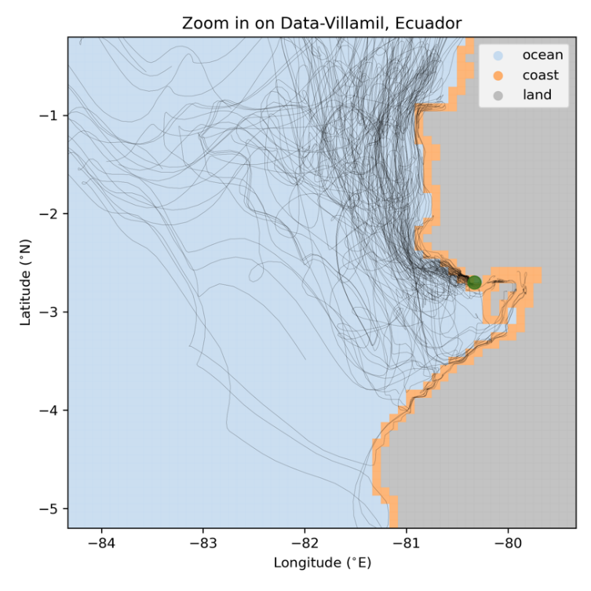

Figure 1 Example for backward trajectories (black lines) for Data-Villamil in Ecuador (green marker). The corresponding ocean model land mask in grey and the ocean coastal grid cells in orange are indicated.

**3.4. Translation of observed estimate to model diagnostic**

As mentioned in the introduction of this section, we assume that the longer a particle has been floating in the open ocean before washing ashore, the more likely it is that it has epibionts. We have defined a particle to be ‘afloat’ when it is located outside a coastal grid cell (a 1/12° x 1/12° grid point sharing at least one of its corners with a land grid point, Fig. 1). If a particle has been in coastal grid cells before eventually washing ashore, it is not known whether it has resuspended locally or has been floating in the nearshore as coastal processes are not included in the particle simulation. Assuming there is a minimum time *T* that items need to have been afloat to have visible epibionts, the relative time afloat of each 100-day trajectory can provide insight in where to expect a higher relative abundance of items with interactions.

We therefore calculate for every particle how long it has been afloat. Then, we quantify the percentage of particles that arrives at each measurement location that have been afloat longer than time *T* (see Fig. 2). There are large differences between the various measurement locations. For example, the particles arriving at Rapa Nui (location 5 in Fig. 2) all have been afloat for longer than 90 days. This is not surprising, as in the model the island of Rapa Nui only consists out of one ocean grid cell. However, the result is still a good representation of reality, as most plastic pollution at Rapa Nui has a remote origin and arrives through ocean currents (Thiel et al., 2021). In contrast, most particles arriving at Puerto Chancay in Perú (location 10 in Fig. 2) did not leave the coastal grid cells indicating that plastic found here most likely has a local origin.

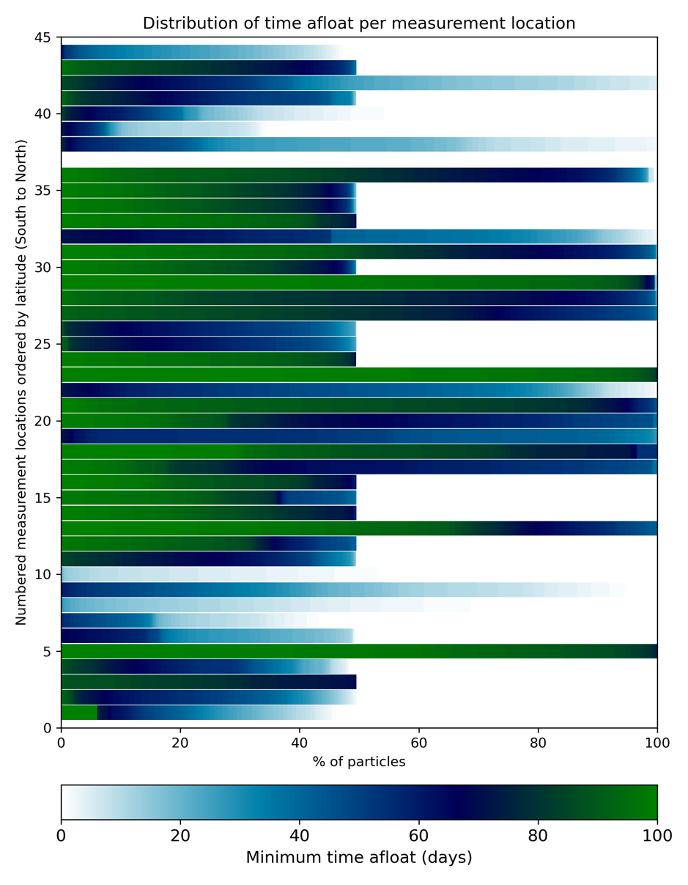

Figure 2 The distribution of the minimum time (in days) particles have been afloat before arriving at each measurement location.

**3.5. Tuning method**

We can now tune the 'minimum time afloat' *T* to find the best fit with the observed distribution (Fig. 3). For this we only include all 'confident' measurements and exclude the measurement on Rapa Nui, as we’re only interested in the distribution along the main-land. The maximum Pearson correlation coefficient is found for a 'minimum time afloat' of 70 days. This result suggests that particles that have been afloat for longer than 70 days are most likely to show biotic interactions. The correlation is low (R = 0.23) and insignificant (p-value = 0.23), but if we look at the large scale, the modeled spatial variability seems promising compared to the observations using this approach (Fig. 4).

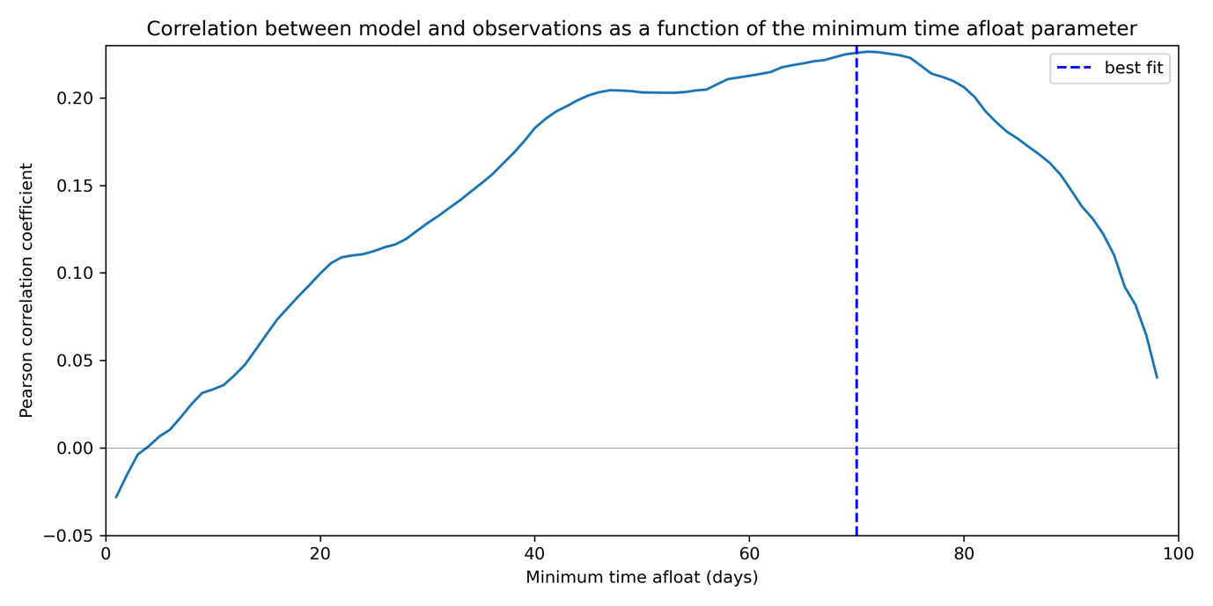

Figure 3 The Pearson correlation between the observed estimates and the percentage of particles being afloat longer than time T (the minimum time afloat) as a function of T. Maximum correlation is found for T = 70 days (dotted line).

The two main oceanic systems that may impact the spatial distribution are the large upwelling zone along the coastlines of Chile and Peru making the arrival of remotely sourced plastic unlikely and the North Equatorial Return Current that potentially transports marine debris towards the coastlines of Central America. The particles washing ashore at Rapa Nui do not show a dominant arrival pattern, but rather randomly travel towards the island. This can be explained by the fact that Rapa Nui is located close to the center of the South-East Pacific Gyre, where the ocean circulation is characterized by slow varying velocities.

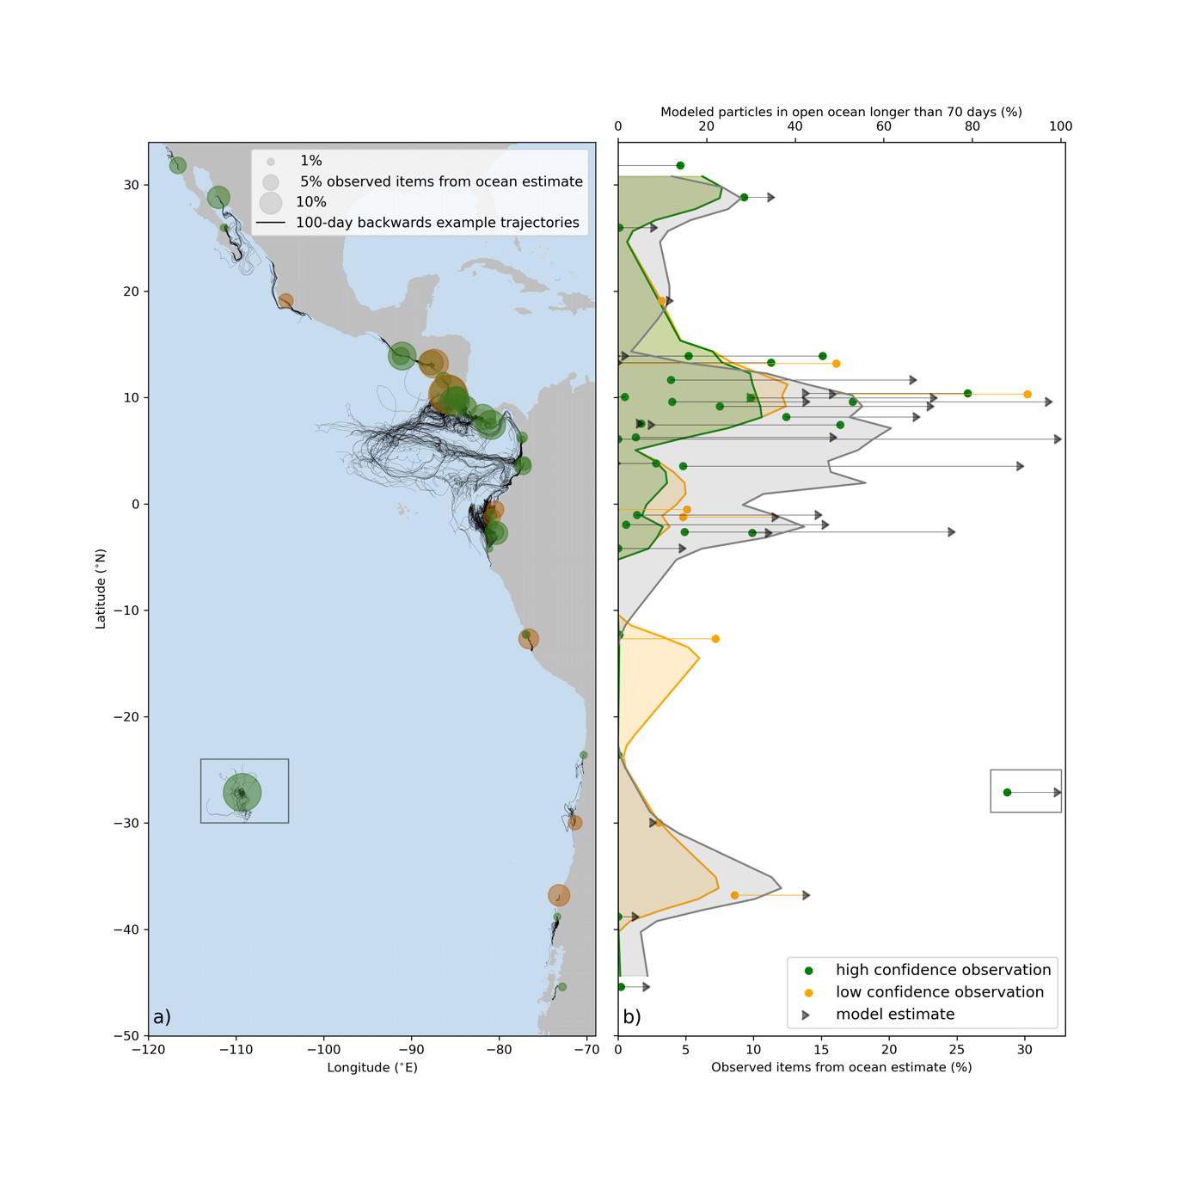

Figure 4 showing (a) the observed distribution of the fraction of positively buoyant items with biotic interactions (markers) and a subset of the 100-day backward particle trajectories arriving at each measurement location. The observed estimates (colored markers) are compared with the fraction of particles that have been afloat for longer than 70 days (gray triangles) in (b). The straight lines indicate the difference between the observed and modeled estimate. Note the different scale for the observed and modeled estimate. The shaded lines are derived by first linearly interpolating the modeled (gray) and observed (green and orange) estimates to a 1 degree latitudinal resolution and subsequently applying a running-average of 3 degrees.

**References**

Bravo, M., Astudillo, J. C., Lancellotti, D., Luna-Jorquera, G., Valdivia, N., & Thiel, M. (2011). Rafting on abiotic substrata: Properties of floating items and their influence on community succession. *Marine Ecology Progress Series*, *439*, 1–17. <https://doi.org/10.3354/meps09344>

Browne, M. A., Chapman, M. G., Thompson, R. C., Amaral Zettler, L. A., Jambeck, J., & Mallos, N. J. (2015). Spatial and Temporal Patterns of Stranded Intertidal Marine Debris: Is There a Picture of Global Change? *Environmental Science & Technology*, *49*(12), 7082–7094. <https://doi.org/10.1021/es5060572>

van Duinen, B., Kaandorp, M. L. A., & van Sebille, E. (2022). Identifying Marine Sources of Beached Plastics Through a Bayesian Framework: Application to Southwest Netherlands. *Geophysical Research Letters*, *49*(4), e2021GL097214. <https://doi.org/10.1029/2021GL097214>

Durgadoo, J. V., Biastoch, A., New, A. L., Rühs, S., Nurser, A. J. G., Drillet, Y., & Bidlot, J.-R. (2021). Strategies for simulating the drift of marine debris. *Journal of Operational Oceanography*, *14*(1), 1–12. <https://doi.org/10.1080/1755876X.2019.1602102>

Gasparin, F., Greiner, E., Lellouche, J.-M., Legalloudec, O., Garric, G., Drillet, Y., Bourdallé-Badie, R., Traon, P.-Y. L., Rémy, E., & Drévillon, M. (2018). A large-scale view of oceanic variability from 2007 to 2015 in the global high resolution monitoring and forecasting system at Mercator Océan. *Journal of Marine Systems*, *187*, 260–276. <https://doi.org/10.1016/j.jmarsys.2018.06.015>

Isobe, A., & Iwasaki, S. (2022). The fate of missing ocean plastics: Are they just a marine environmental problem? *Science of The Total Environment*, *825*, 153935. <https://doi.org/10.1016/j.scitotenv.2022.153935>

Kaandorp, M. L. A., Dijkstra, H. A., & van Sebille, E. (2020). Closing the Mediterranean Marine Floating Plastic Mass Budget: Inverse Modeling of Sources and Sinks. *Environmental Science & Technology*, *54*(19), 11980–11989. <https://doi.org/10.1021/acs.est.0c01984>

Lellouche, J.-M., Greiner, E., Le Galloudec, O., Garric, G., Regnier, C., Drevillon, M., Benkiran, M., Testut, C.-E., Bourdalle-Badie, R., Gasparin, F., Hernandez, O., Levier, B., Drillet, Y., Remy, E., & Le Traon, P.-Y. (2018). Recent updates to the Copernicus Marine Service global ocean monitoring and forecasting real-time 1∕12° high-resolution system. *Ocean Science*, *14*(5), 1093–1126. <https://doi.org/10.5194/os-14-1093-2018>

Maximenko, N., Corradi, P., Law, K. L., Van Sebille, E., Garaba, S. P., Lampitt, R. S., Galgani, F., Martinez-Vicente, V., Goddijn-Murphy, L., Veiga, J. M., Thompson, R. C., Maes, C., Moller, D., Löscher, C. R., Addamo, A. M., Lamson, M. R., Centurioni, L. R., Posth, N. R., Lumpkin, R., … Wilcox, C. (2019). Toward the Integrated Marine Debris Observing System. *Frontiers in Marine Science*, *6*. <https://www.frontiersin.org/articles/10.3389/fmars.2019.00447>

Onink, V., Jongedijk, C. E., Hoffman, M. J., Sebille, E. van, & Laufkötter, C. (2021). Global simulations of marine plastic transport show plastic trapping in coastal zones. *Environmental Research Letters*, *16*(6), 064053. <https://doi.org/10.1088/1748-9326/abecbd>

Sebille, E. van, Aliani, S., Law, K. L., Maximenko, N., Alsina, J. M., Bagaev, A., Bergmann, M., Chapron, B., Chubarenko, I., Cózar, A., Delandmeter, P., Egger, M., Fox-Kemper, B., Garaba, S. P., Goddijn-Murphy, L., Hardesty, B. D., Hoffman, M. J., Isobe, A., Jongedijk, C. E., … Wichmann, D. (2020). The physical oceanography of the transport of floating marine debris. *Environmental Research Letters*, *15*(2), 023003. <https://doi.org/10.1088/1748-9326/ab6d7d>

Serra-Gonçalves, C., Lavers, J. L., & Bond, A. L. (2019). Global Review of Beach Debris Monitoring and Future Recommendations. *Environmental Science & Technology*, *53*(21), 12158–12167. <https://doi.org/10.1021/acs.est.9b01424>

Thiel, M., & Gutow, L. (2005). The ecology of rafting in the marine environment. II. The rafting organisms and community. In *Oceanography and marine biology* (pp. 289-428). CRC Press.

Thiel, M., Lorca, B. B., Bravo, L., Hinojosa, I. A., & Meneses, H. Z. (2021). Daily accumulation rates of marine litter on the shores of Rapa Nui (Easter Island) in the South Pacific Ocean. *Marine Pollution Bulletin*, *169*, 112535. <https://doi.org/10.1016/j.marpolbul.2021.112535>

Uhrin, A. V., Hong, S., Burgess, H. K., Lim, S., & Dettloff, K. (2022). Towards a North Pacific long-term monitoring program for ocean plastic pollution: A systematic review and recommendations for shorelines. *Environmental Pollution*, 119862. <https://doi.org/10.1016/j.envpol.2022.119862>

|  |  |  |  |  |  |
| --- | --- | --- | --- | --- | --- |
| **Coast Name** | **N° Sampled sites** | **Total items** | **% Sea** | **Method** | **Reference** |
| East Pacific Coast | 38 | 12446 | **4.7%** | Positive buoyancy and epibionts presence | This study |
| Global | - | - | 9% | ICC Beach Clean Ups | Report for European Commission DG Environment 2016 |
| Coast of Qatar | 12 | 2376 | 8.75%+20.4% (29.15%) * | Attribution-by-litter type method | Veerasingam et al. 2020 |
| Adriatic-Ionian macroregion | 31 | 70581 | 6.3% | item-to-source attribution  scheme | Vlachogianni et al. 2018 |
| Coast of Kenya |  | 2560 | 16% | Epibionts on plastic bottles | Ryan 2020 |
| East Coast Asutralia |  | 694 | 6% | Epibionts on plastic bottles | Smith et al. 2018 |
| Cape Town |  | 1769 | 9% | Epibionts on marine litter | Fazey & Ryan 2016 |
| South Africa | 32 | 13240 | 6% | Epibionts on plastic bottles | Ryan et al. 2021 |

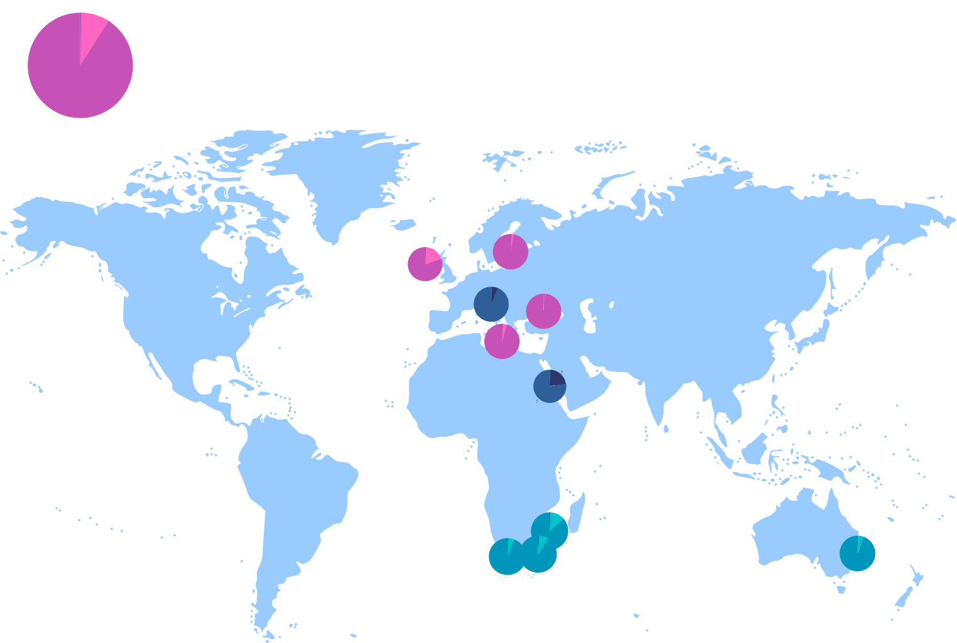

1. <https://www.mercator-ocean.eu/en/solutions-expertise/accessing-digital-data/product-details/?offer=4217979b-2662-329a-907c-602fdc69c3a3&system=d35404e4-40d3-59d6-3608-581c9495d86a>