Medium Post - https://medium.com/@thomas.m.canty/before-you-post-to-host-64415587044a

BEFORE YOU POST TO HOST: KNOW YOUR WORTH

AirBnB is a great way to vehicle to help you rent your property whether you are putting a year round retnal property on the market or you are looking to rent a room out of your house for a little extra money. It is important to know know what to price your rental at. Price it too high and you risk not filling your vacancy, too low and you might leave money on the table.

Let’s look at a few dimensions of data:

* What property attributes correlate with higher rental prices?
* Which neighborhoods the best neighborhoods for price?
* When is the best time of year to rent?

**What kind of property attributes dictate higher prices?**

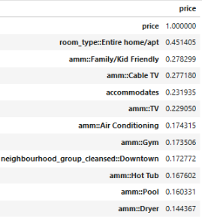

I performed a pairwise correlation of property attributed with price to find which attributed drew the highest correlations. Let’s look at the top few property attributes.

* Property Type:

The graph below shows that an entire house or apt is clearly higher prices than a private room in a shared space and shared room. The median price of this type of property is about $139, whereas private room and shred room are $70 and $40 respectively.

* Cable TV

Properties with cable TV have a median price approximately $130 whereas it is $40 less without cable

* Family Friendliness

Properties that are listed as family friendly have a median price approximately $130 whereas it is $40 less is not listed.

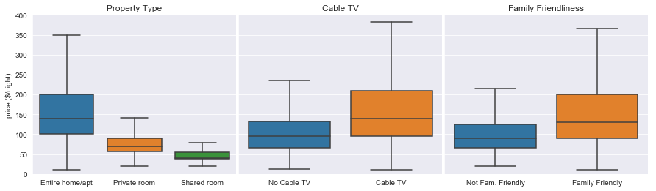

* Number of People Accommodated

The price increase steadily from $100 at 2 people and peaks at $600 at 11 people, starts dropping off and picks up again after 15 people.

This is a good example where correlation does not equal causation. It is likely the real driver here is square footage of the property. Square footage data available plotted them with their corresponding accommodations. You can see that there is a relatively good correlation between size and accommodation. Therefore, listing your 1-bedroom apartment as accommodating 11, won’t get you that $300-$400 bump.

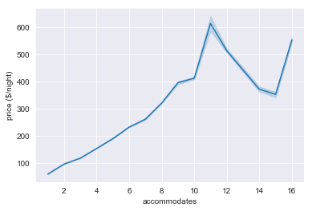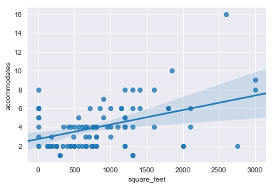

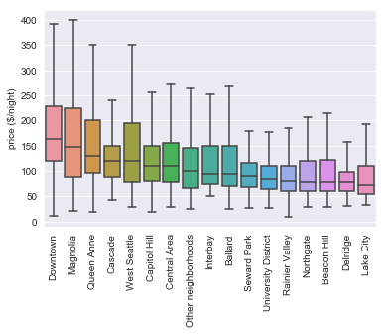**Which Neighborhoods go for a better price?**

The neighborhoods median rent ranges from $164 (Downtown) down to $72 (Lake City). The range, however, is much larger for 4 neighborhoods: Downtown, Magnolia, Queen Anne and West Seattle.

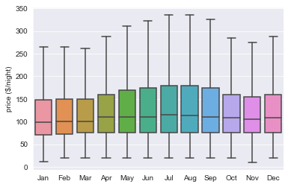**What do price fluctuations look like throughout the year?**

The median daily rental price is about a $99/night in the colder months and increases to $115/night in the summer months, as well as a little bump near the holidays ($109/night). Ultimately the seasonal swing is about $20 What is more interesting is that 50% of the seems to span a wider price range during the summer months and during the holiday season.

Below we evaluated some of the parameters discussed above over the course of the year.

* Home/apt
* Family Friendliness
* Cable TV
* Neighborhood (hot neighborhoods vs others)
  + Hot neighborhoods (Downtown, Magnolia, Queen Anne and West Seattle.)

And what we found is that this seasonal swing is primarily impactful for the properties with the preferential attributes! So if we separate this data we can see $20-40 seasonal swings

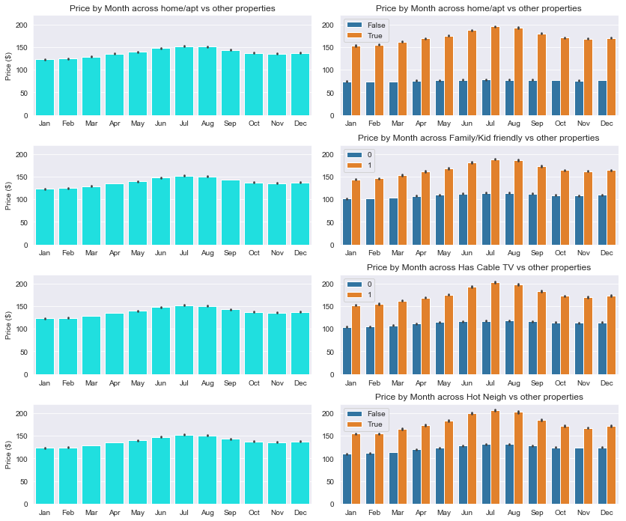

**Conclusion:**

When you are setting up your rental profile, make sure that you are maximizing your potential:

* Make sure you note the highly coveted attributes if your property meets these conditions.
  + Note: Cable TV and family friendliness can give you that a significant bump so don’t forget to list these things if they are applicable.
* Set your price appropriately for your neighborhood, so you can compete reasonably for your area
* Make sure you are adjusting your prices seasonally (July and August) are peak seasons