ISCG7444

Aditya Ahuwalia (ID:1467619)

Abhishek Sharma (ID:1464885)

Ravi Bhatt (ID:1468124)

13 April 2017

MILESTONE 2: REPORT

CLOUD APPLICATION DESIGN AND DEVELOPMENT PROJECT

Contents

INTRODUCTION 2

VISION STATEMENT 2

INITIAL PRODUCT BACKLOG 2

INITIAL SCOPE OF PROTOTYPE 3

USER INTERFACE DESIGN 3

LIST OF CLOUD RUNTIME AND SERVICES 3

ARCHITECTURAL DIAGRAM 4

PROJECT PLAN 4

# INTRODUCTION

This is a design document outlining the design ,architecture and features of the web application named ‘FindSpot’. The report will highlight the vision ,initial product backlog, user interface design and project plan.Architectural diagram will highlight the service usage and interactions.The report also shows the indication of implementation of earliest prototype services and features.

# VISION STATEMENT

Currently the arriving international students or immigrants face a problem of finding a suitable home stay or paying guest.They tend to find a place which is convinient, within the budget and resembels their culture. With such a vision we will built an application that helps people to find a stay for them.

Application will not only find the house according to the location and budget but also according to the house’s staying criteria(do’s and don’t), roomates, commodities and facilities checklist,parking options and nearest transport service options. This app will help to find perfect match between the tenant and the renter. This app will be also usefull to people who decides to share a room or house. A feedback option will be further added in future extension.The app is truly a new initiative and many amendments will be added for future version.

# INITIAL PRODUCT BACKLOG

Following are the user stories which will cover all the features our project will have.

* As a user, I want to create an account.
* As a user, I want to log-in.
* As a user, I want to log-out.
* As a user, I want to find a rooms available.
* As a user, I want to see the list of rooms available.
* As a user, I want to sort/search the room based on my budget.
* As a user, I want to sort/search the room based on facilities provided.
* As a user, I want to sort/search the room based on parking option available.
* As a user, I want to sort/search the room based on flatmates.
* As a user, I want to sort/search the room based on ratings/feedback.
* As a user, I want to sort/search the room based on transport facilities.
* As a user, I want to give feedback and reviews.
* As a user, I want to add my room in the list of available rooms.
* As a user, I want to add specification of my room.
* As a user, I want to add rent of my room.
* As a user, I want to add rules and regulations (including restrictions) of my room.
* As a admin, I want to see all the users.
* As a admin, I want to see all the listed rooms.
* As a admin, I want to generate report.

# INITIAL SCOPE OF PROTOTYPE

Following are the stories we will develop/implement in milestone 3.

* As a user, I want to create an account.
* As a user, I want to log-in.
* As a user, I want to log-out.
* As a user, I want to find a rooms available.
* As a user, I want to see the list of rooms available.
* As a user, I want to sort/search the room based on my budget.
* As a user, I want to add my room in the list of available rooms.
* As a user, I want to add specification of my room.
* As a user, I want to add rent of my room.
* As a user, I want to add rules and regulations (including restrictions) of my room.
* As a admin, I want to see all the users.
* As a admin, I want to see all the listed rooms.

# USER INTERFACE DESIGN

Windows Navigation Diagram

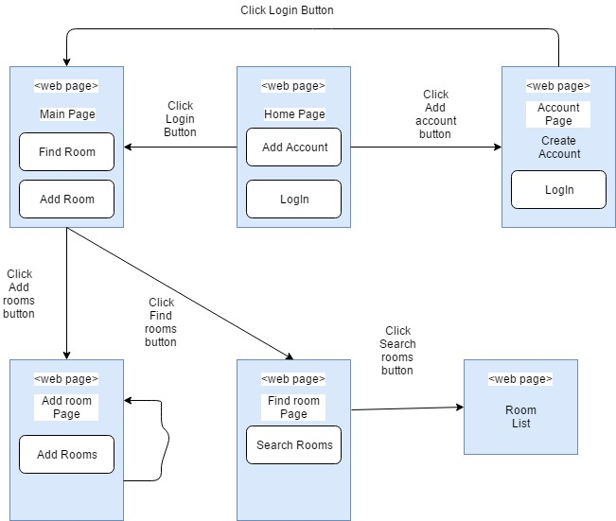

# LIST OF CLOUD RUNTIME AND SERVICES

Following are the cloud runtime and services which are required to develop milestone 3.

* Cloudant Starter: We use Cloudant Starter database as a service to store and retrieve data from the database.
* Tiny Queries: We use Tiny Queries as a service to make complex queries easy.
* Document Conversion: We use Document Conversion as a service to convert our HTML, PDFs, word file into normalized HTML.
* Application Security on Cloud: We use Application Security on Cloud as a service to provide security and robust our application.
* IBM Alert Notification: We use IBM Alert Notification as a service to send alert notification to the user for available rooms.
* App ID: We use App ID as a service to add authentication to our application.
* Context Mapping: We use Context Mapping as a service to provide map to our application.

# ARCHITECTURAL DIAGRAM

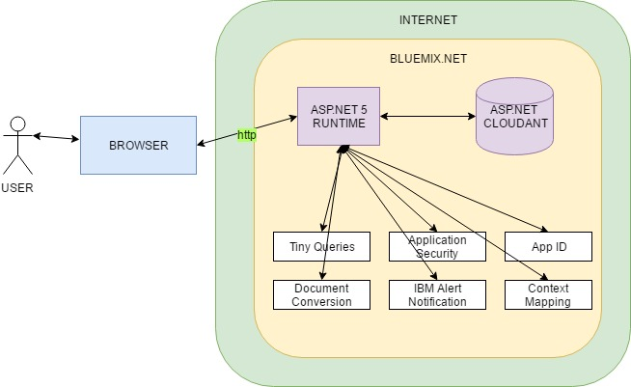

# PROJECT PLAN

Imprecise pathway for developing application by the team members

|  |  |  |  |
| --- | --- | --- | --- |
| **Task And Time** | **Ravi Bhatt** | **Aditya Ahluwalia** | **Abhishek Kumar** |
| Application Start |  |  | 1st week |
| Database Connection |  |  | 1st week |
| Add Registration Page | 1st week |  |  |
| Login/Logout |  | 1st week |  |
| Add room | 2nd week |  |  |
| Add Specifications | 2nd week-3rd week | 2nd week-3rd week | 2nd week-3rd week |
| Search room logic | 4th week | 4th week |  |
| Get Contact Details |  | 5th week | 5th week |
| Feedbacks and Review | 6th week | 6th week | 6th week |
| Other features | 7th week | 7th week | 7th week |