

IVAO - XO

# ATC Ops Manual

# Adelaide ADC

# *YPAD_TWR*

# *YPAD_GND*

# *YPAD_DEL*

### Airport Information

|  |  |
| --- | --- |
| Information | |
| ICAO Code | YPAD |
| IATA Code | ADL |
| Airport name | *Adelaide Airport* |
| Time zone conversion | UTC +9:30 |
| Permitted traffic types | IFR / VFR |
| Runways | 05/23, 12/30 |

### Aerodrome Control Positions

|  |  |  |  |
| --- | --- | --- | --- |
| Logon: | Callsign | Frequency | FRA |
| YPAD_TWR | Adelaide Tower | 120.500MHz |  |
| YPAD_GND | Adelaide Ground | 121.700MHz |  |
| YPAD_DEL | Adelaide Delivery | 121.600MHz |  |

1. YPAD_TWR is the standard position for Adelaide ADC. This position shall be opened first, and can be opened any time.
2. YPAD_GND is the only ground position for Adelaide. This position shall be opened only once YPAD_TWR is online.
3. YPAD_DEL is the clearance delivery position for Adelaide. This position shall be opened only once YPAD_TWR and YPAD_GND are online.

### Responsibilities

Adelaide Tower is responsible for the class C Adelaide CTR (SFC-1500ft). Tower are also responsible for both runways, the helipad, and taxiways E and D. Ground are responsible for the remainder of the maneuvering area.

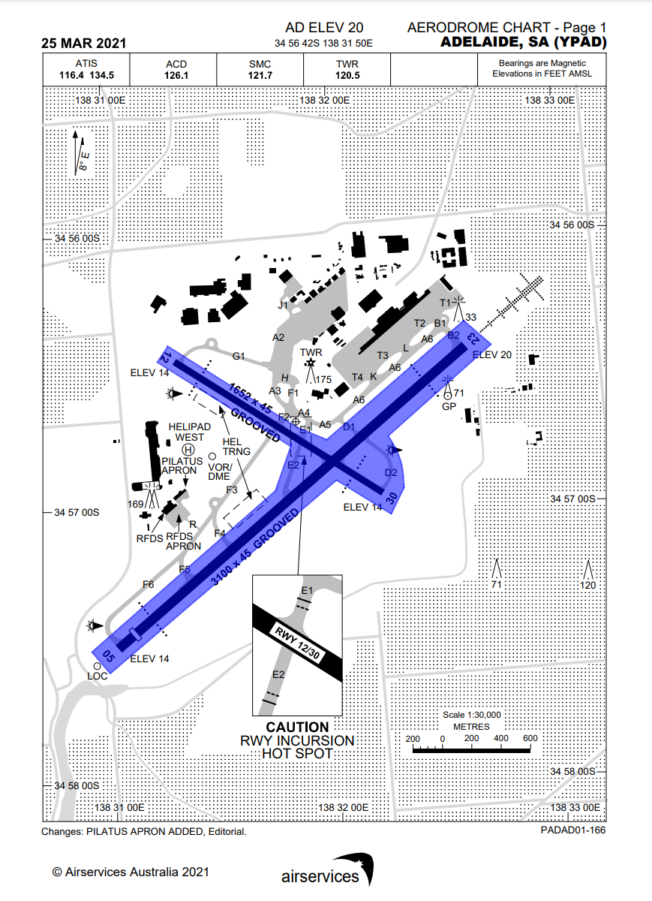

*Image from AIP Sept 2023. Uncontrolled.*

*Blue – YSSY_W_GND*

*Orange – YSSY_E_GND*

### Standard Taxi Routes

Sydney utilises a one-way taxi system along taxiways B and C. Where practical, controllers should send aircraft taxiing northbound via L & B, and southbound via C and B10. This in no way prevents a controller from deviating to improve traffic flow, particularly when aircraft are pushing back onto B from DOM1.

*Note aircraft pushing back from bays 11-19, 49-57, and 59 will ordinarily be instructed to push tail north to achieve this traffic flow, even when assigned Runway 16R.*

*Image from AIP Sept 2023. Uncontrolled.*

*Blue – Northbound (TWY B, L)*

*Yellow – Southbound (TWY C, B10)*

### Aircraft Bay Assignment

Sydney can be split into two sides, the international side to the west of Runway 16R/34L, and the domestic side to the east.

Domestic:

|  |  |
| --- | --- |
| Stand | Airlines |
| 1-19 | QFA, QLK, QJE |
| 64-70 | QLK |
| 49-59 | JST, RXA |
| 31-54 odd only | JST, RXA, VOZ |
| 32-44 even only | VOZ |
| F1-F16 | *Prop airliners excl QLK (see 64-70)* |
| 90-94 | *Cargo* |
| 102-112 | AM*, private jets (including international)* |
| 96-99 & 120-121 | *Overflow* |

International:

|  |  |
| --- | --- |
| Stand | Airlines |
| 20 &, 85, 88 | QFA mediums *(international)* |
| 1-6 | Cargo *(international)* |
| 71-77 | *Overflow* *(domestic)* |
| 58-61 | Emirates *(preferred)* |
| All others | *Internationals* |

Notes:

* *Few domestic bays can accommodate aircraft larger than 737/A320. Apron Chart Domestic Page 2 & 3 refer.*
* *See chart below*

Domestic Bay Assignment

*Image from AIP Sept 2023. Uncontrolled.*

Red: QFA, QJE, QLK

Orange: Jetstar, Rex

White: Virgin Australia, Rex

Blue: Light (prop) airliners and cargo

Green: Ambulance and private jets

*Any other operators flying domestic flights into Sydney shall be assigned DOM2 or DOM3 unless specifically requested otherwise, or unable due to aircraft size.*

### Runway Release

When runway 07/25 is not in use, ground may request a release of the runway. In this case the runway is owned by ground, and ground do not need to coordinate runway crossing, backtracks, or taxiing on 07 or 25. In the rare case of parallel runways not being in use, the same principle applies. At any time Tower can withdraw this release.

### Intersectional Departures

Due to noise abatement procedures, intersectional departures are to be avoided from Runways 34L & R unless required for operational reasons, or by pilot request.

### Helicopters

Ordinarily Ground will not work helicopters, they will be transferred from the Delivery frequency straight to Tower, and depart/arrive from stand or the helipad (heli 1). An exception will apply when helicopters request to route via taxiways.

### Transfer to Tower

In real life, Australian operated aircraft will usually transfer to Tower without instruction, however due to the nature of IVAO this cannot always be expected, therefore Ground must transfer all aircraft to Tower when practical (no further ground traffic to effect).

When Tower is split into YSSY_E_TWR and YSSY_W_TWR, departures for runway 16R/34L and 07/25 will be transferred to YSSY_W_TWR on 120.500MHz, and departures for runway 34R/16L will be transferred to YSSY_E_TWR on 124.700MHz. The same applies to coordinating runway crossing clearances.

*In addition to this manual, we recommend you read the Sydney Tower & Sydney Delivery Ops Manuals to fully understand the position and related procedures.*