

IVAO - XO

# ATC Ops Manual

# Sydney Delivery

# *YSSY_DEL*

### Airport Information

|  |  |
| --- | --- |
| Information | |
| ICAO Code | YSSY |
| IATA Code | SYD |
| Airport name | *Sydney Kingsford Smith Airport* |
| Time zone conversion | UTC +10 |
| Permitted traffic types | IFR / VFR |
| Runways | 16L/34R, 16R/34L, 07/25 |

### Delivery Positions

|  |  |  |  |
| --- | --- | --- | --- |
| Logon: | Callsign | Frequency | FRA |
| YSSY_DEL | Sydney Delivery | 121.700MHz |  |

1. YSSY_DEL shall **only** be opened when YSSY_GND and YSSY_TWR are already online.

### Responsibilities

Sydney Delivery is solely responsible for the handling of clearance delivery. It has no authority over any of the maneuvering areas or aprons.

### Coordination

Delivery is responsible for coordinating where required with the relevant departure controller, prior to giving clearances involving the following:

* Departure from a runway not included on the ATIS.
* VFR departures
* Non-standard requests
* High performance jet departures
* Local flights

The departure controller may then issue instructions including a routing, heading, or altitude constraint, which must be passed on in the clearance.

*Note: The departure controller refers to the controller responsible for working departures, this may be YSSY_DEP, YSSY_NE_DEP, YSSY_SW_DEP, YSSY_APP, or in rare cases YSSY_N_APP, or YSSY_S_APP, depending on positions open and runway in use. See the ‘Transfer to Departures’ section within Sydney Tower Ops Manual for clarification.*

### Runway Assignment

When operating parallel runway operations, aircraft departing to the north and east should be assigned runway 16L or 34R, and aircraft departing to the south and west should be assigned runway 16R or 34L. An exception applies for large aircraft which require 16L or 34R due to the runway length.

With PROps in use, consideration should be given to offering runway 25 to AM (Ambulance) flights operating from DOM5 due to their priority status, dependent on winds and traffic capacity.

### Standard Assignable Level

Clearance Delivery are responsible for assigning an initial climb in the clearance. Unless otherwise coordinated between Delivery and Departures, this shall be:

Jets: 5000ft, or the requested RFL, whichever is lower.

Props: 3000ft, or the requested RFL, whichever is lower.

### VFR Clearance

Clearance Delivery will issue a standard VFR clearance to VFR aircraft only after coordinating with Approach (see coordination).

Example:

ABC Sydney Delivery g’day. Cleared to Canberra via Dolls Point. Maintain 3,000. Squawk 5634. Departures on 123.0.

What if Departures issue instructions?

*DEP > DEL: ABC cleared to Canberra via PNP. 2000ft. Assigned left heading 330.*

*DEL > DEP: Cleared to Canberra via PNP. 2000ft. Assigned left heading 330, ABC.*

DEL > ABC: ABC Sydney Delivery g’day. Cleared to Canberra via Picnic Park. Maintain 2,000. Squawk 5634. Departures on 123.0.

**\*\*H330 MUST BE INCLUDED ON THE STRIP FOR TOWER TO ASSIGN WITH TAKEOFF CLEARANCE, IT IS ALSO RECOMMENDED TO COORDINATE DIRECTLY WITH TOWER\*\***

*See VFR GEN 1 for Australian VFR waypoint codes, names, and positions.*

### SID Assignment

Where able, all IFR jets should be assigned the procedural SID which terminates at the appropriate waypoint according to their flight plan, or rerouted via the most appropriate SID according to runway in use and direction of flight.

Note that Sydney SID’s often have multiple transitions, and it is imperative that Delivery specifies which transition the aircraft needs to take to complete the SID if applicable. This may be the radar transition. See the table on the next page for SID assignments and transitions.

*Examples:*

*‘JST123 Sydney Delivery g’day. Cleared to Melbourne via WOL planned route, runway 34R, MARUB7 departure, WOL transition. Climb via the SID to 5000. Squawk 1234. Departures on 123.0.’*

*‘QFA456 Sydney Delivery g’day. Cleared to Singapore via RIC planned route, runway 34L, RIC6 departure, RIC transition*. Climb via the SID to 5000. Squawk 5677. Departures on 123.0’*

*‘VOZ789 Sydney Delivery g’day. Cleared to Perth via KADOM planned route, runway 34L, KADOM1 departure**. Climb via the SID to 5000. Squawk 4321. Departures on 123.0’*

*\*even though QFA456 is on the RIC SID, the SID has both a RIC & radar transition, therefore we must include the transition in the clearance.*

*\*\*KADOM1 has only one transition, therefore we do not need to specify the transition.*

IFR jet aircraft unable to fly the procedural SID, and all IFR prop aircraft shall be assigned the SY radar departure.

*Examples:*

*‘QLK987 Sydney Delivery g’day, cleared to Melbourne via WOL planned route, runway 34R, SY3 departure. Climb via the SID to 3000. Squawk 7654. Departures on 123.0.’*

|  |  |  |  |
| --- | --- | --- | --- |
| Runway | Via | SID | Transition |
| **07** | *all* | **SY (radar)** | *N/A* |
| **25** | *all* | **SY (radar)** | *N/A* |
| **16L** | **OLSEM** | **KEVIN** | **OLSEM** |
| **16L** | **NOBAR** | **KEVIN** | **NOBAR** |
| **16L** | **DIPSO** | **KEVIN** | **DIPSO** |
| **16L** | **EVONN** | **KEVIN** | **EVONN** |
| **16L** | **CAWLY** | **KEVIN** | **CAWLY** |
| **16L** | **WOL\*** | **ABBEY** | **WOL** |
| **16L** | *all others* | **KEVIN** | *radar* |
| **16R** | **RIC** | **KAMPI** | **RIC** |
| **16R** | **KADOM** | **KAMPI** | **KADOM** |
| **16R** | **WOL\*** | **KAMPI** | **WOL** |
| **16R** | *all others* | **KAMPI** | *radar* |
| **34L** | **WOL\*** | **WOL** | *N/A* |
| **34L** | **KADOM** | **KADOM** | *N/A* |
| **34L** | **RIC** | **RIC** | **RIC** |
| **34L** | *all others* | **RIC** | *radar* |
| **34R** | **OLSEM** | **OLSEM** | *N/A* |
| **34R** | **WOL\*** | **MARUB** | **WOL** |
| **34R** | *all others* | **MARUB** | *radar* |

*\*Note that both 34L & 34R, and 16L & 16R are available for WOL deps. Delivery will issue WOL deps from the international terminal the western runway (16R/34L), and WOL deps from the domestic terminal the eastern runway (16L/34R), in order to balance traffic and minimise runway crossings (particularly for 34L&R).*

### Transfer to Ground

After reading back clearance, Delivery should instruct aircraft to contact Sydney Ground when ready for pushback, on the following frequencies:

When Sydney Ground is bandboxed as YSSY_GND:

All aircraft: 121.7

When Sydney Ground is split into YSSY_E_GND and YSSY_W_GND:

Aircraft east of 16R/34L: 121.7

Aircraft west of 16L/34R: 126.5

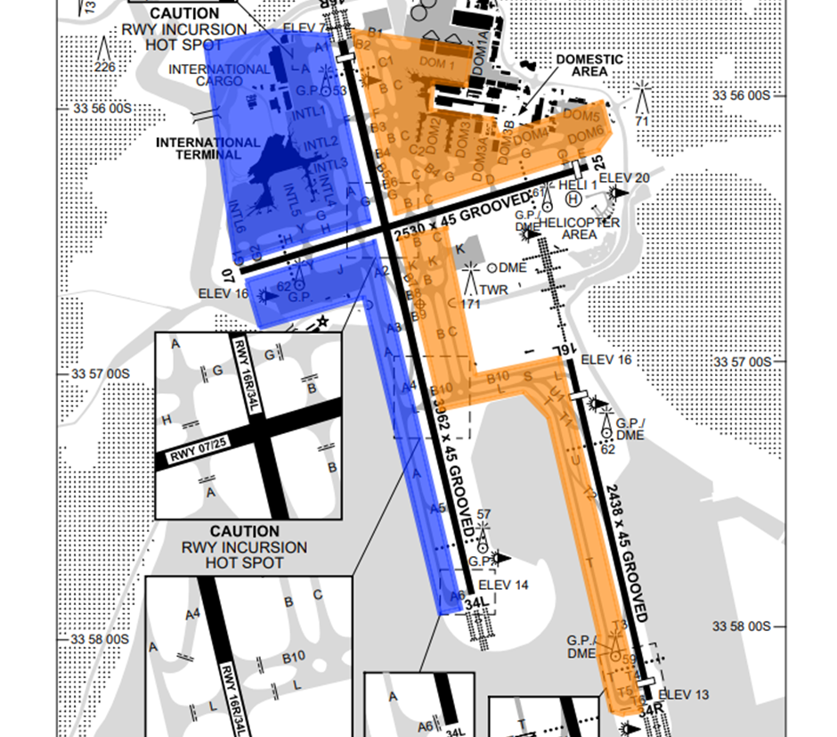

*Image from AIP Sept 2023. Uncontrolled.*

*Orange – YSSY_E_GND (121.7)*

*Blue – YSSY_W_GND (126.5)*

*Note the phraseology ‘Readback Correct’ is not used in Australia.*

*In addition to this manual, we recommend you read the Sydney Approach, Sydney Tower & Sydney Ground Ops Manuals to fully understand the position and related procedures.*