

IVAO - XO

# ATC Ops Manual

# Sydney Tower

# *YSSY_TWR*

# *YSSY_E_TWR*

# *YSSY_W_TWR*

### Airport Information

|  |  |
| --- | --- |
| Information | |
| ICAO Code | YSSY |
| IATA Code | SYD |
| Airport name | *Sydney Kingsford Smith Airport* |
| Time zone conversion | UTC +10 |
| Permitted traffic types | IFR / VFR |
| Runways | 16L/34R, 16R/34L, 07/25 |

### Tower Positions

|  |  |  |  |
| --- | --- | --- | --- |
| Logon: | Callsign | Frequency | FRA |
| YSSY_TWR | Sydney Tower | 120.500MHz |  |
| YSSY_E_TWR | Sydney Tower | 124.700MHz |  |
| YSSY_W_TWR | Sydney Tower | 120.500MHz |  |

1. YSSY_TWR is the default position for Tower and is the first aerodrome position which should be opened.
2. YSSY_TWR may be split into YSSY_E_TWR and YSSY_W_TWR only once YSSY_E_GND, YSSY_W_GND, and YSSY_DEL are online.
3. When splitting Tower, the position YSSY_TWR is no longer to be used, instead YSSY_E_TWR and YSSY_W_TWR will be used.

### Responsibilities

Sydney Tower is responsible for the runways and the helipad Heli 1. When split into YSSY_E_TWR and YSSY_W_TWR, E_TWR assumes responsibility for the easterly runway (16L/34R), and W_TWR assumes responsibility for the westerly runway (16R & 34L) and cross runway (07/25). The responsibility for Heli 1 falls on W_TWR 07/25 is in use, and E_TWR at all other times.

Sydney Tower is responsible for the Sydney CTR (Class C) SFC-1000. This allows Tower to operate the circuit without an airspace release, whilst maintaining separation from the approaches. See the chart below:

Sydney Tower is not responsible for departures/arrivals from Helicopter area, excluding Heli 1, therefore unless helicopters are departing from Heli 1 or a runway, they shall be instructed to report airborne/on the ground, and not cleared for takeoff/landing.

### Runway Selection

Sydney Tower is responsible for selecting the duty runway. The preferred runway mode at Sydney is ‘Parallel Runway Operations’ (PROps) on either 34L/34R, or 16L/16R dependent on wind. Consider the TAF as well as the METAR.

Sydney also has runway modes for noise abatement purposes when quieter traffic allows. These include curfew operations, routinely used overnight (16R for departures, 34L for arrivals), and ‘Simultaneous Opposite Direction Parallel Runway Operations’ (SODPROps) (16L for departures, 34L for arrivals). SODPROps allows for a slightly higher traffic flow than curfew.

Runway 07/25 can be used where meteorological conditions or operational considerations require. Consider that there are no procedural SIDs available for these runways, therefore using these runways for departures will increase the Tower & Departure controllers’ workload.

### Auto Release

Auto Release applies at Sydney for aircraft:

* Assigned a procedural SID or radar SID with a standard assignable heading from a runway nominated on the ATIS and;
* Assigned the standard assignable level

All other departures require a release from Departures, via a ‘Next’ call.

Auto Release does not apply to:

* VFR departures
* Departures to aerodromes within the Sydney TCU
* High performance jet departures
* All departures during Curfew nomination

Additionally, Tower will coordinate the following with Departures:

* Go arounds/missed approach

### Circuits

Circuits are authorised up to 1000ft when PROps are in use. An airspace release is not required, however Approach must be informed, as this will remove the option to use Runway 07/25. Aircraft shall conduct circuit patterns to the west on Runway 16R/34L, and the east on Runway 16L/34R.

Circuits may be authorised on 07/25 up to 1000ft to the south ONLY when it is the only runway in use.

At no point are circuits to be authorised when cross runway operations or curfew nomination are being used.

Higher performance aircraft (above 150kt) will ordinarily conduct circuits at 1500ft, therefore an airspace release is required from the relevant Approach/Departure position. This will be at the Approach/Departure controllers discretion subject to traffic, as any level above 1000ft has the potential to cause conflicts with approaches.

### Runway Release

When runway 07/25 is not in use, ground may request a release of the runway. In this case the runway is owned by ground, and ground do not need to coordinate runway crossing, backtracks, or taxiing on 07 or 25. In the rare case of parallel runways not being in use, the same principle applies. At any time Tower can withdraw this release.

### Standard Assignable Headings

The following standard assignable headings exist for the SY radar departure. At any time, the Departures controller can issue a different assigned heading.

|  |  |  |
| --- | --- | --- |
| Runway | Jet HDG | Non-Jet HDG |
| **07** | 070 | 040, 100 |
| **25** | 250 | 220, 280 |
| **16L** | 130 | 110 |
| **16R** | 190 | 210 |
| **34L** | 310 | 290 |
| **34R** | 370 | 390 |

*Example:*

*“RXA155 assigned left heading 110, winds calm, runway 16L cleared for takeoff”*

The headings can also be given with a lineup clearance, or when instructing an aircraft to hold. If given with a hold instruction, instruct the aircraft to hold position first, to prevent the crew from assuming a clearance will follow and causing a runway incursion.

*Example:*

*“FRE1616 hold at T6, assigned right heading 390”*

### Vacate Instructions

Aircraft should be instructed to vacate runway 16R/34L according to their parking requirements (to the west for internationals, and to the east for domestics and private jets). Use the Ground Ops Manual Aircraft Bay Assignments section if required.

### Transfer to Ground

On vacating, all aircraft shall be instructed to contact ground on the following frequencies:

When Sydney Ground is bandboxed as YSSY_GND:

All aircraft: 121.7

When Sydney Ground is split into YSSY_E_GND and YSSY_W_GND:

Aircraft east of 16R/34L: 121.7

Aircraft west of 16L/34R: 126.5

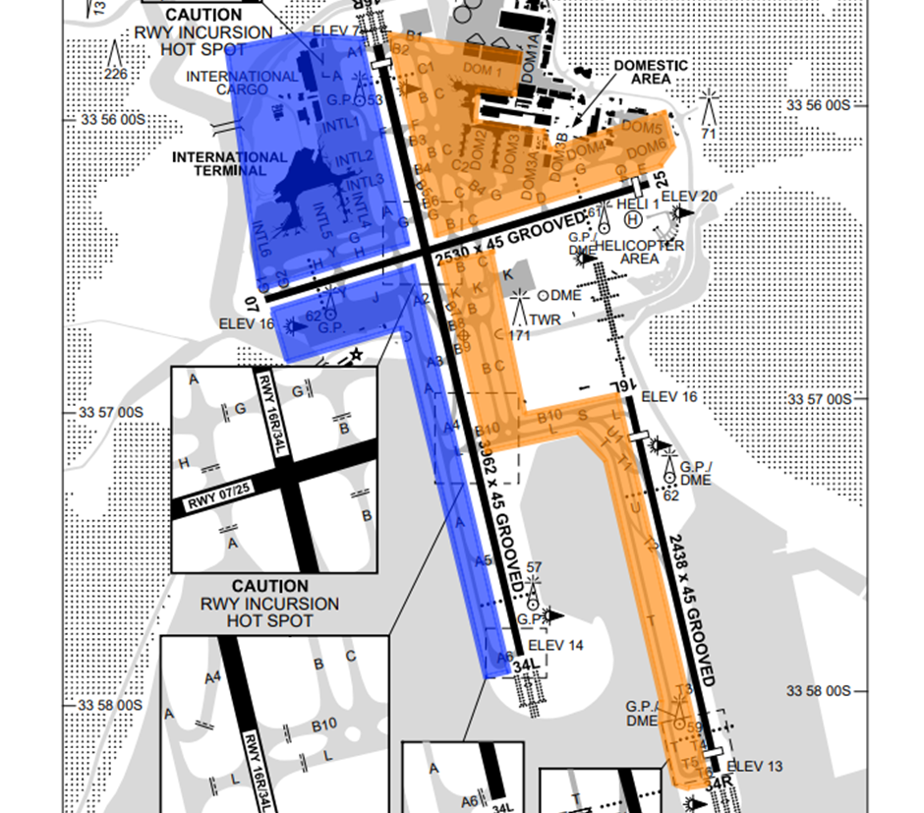

*Image from AIP Sept 2023. Uncontrolled.*

*Orange – YSSY_E_GND (121.7)*

*Blue – YSSY_W_GND (126.5)*

### Transfer to Departures

The frequency for departures will follow this priority order:

**Runway 16L: Runway 16R:**

YSSY_NE_DEP YSSY_SW_DEP

YSSY_DEP YSSY_DEP

YSSY_APP YSSY_APP

YMME_ML_CTR YMME_ML_CTR

YMME_CTR YMME_CTR

**Runway 34L: Runway 34R:**

YSSY_SW_DEP YSSY_NE_DEP

YSSY_DEP YSSY_DEP

YSSY_APP YSSY_APP

YMME_ML_CTR YMME_ML_CTR

YMME_CTR YMME_CTR

**Runway 07: Runway 25:**

YSSY_NE_DEP YSSY_SW_DEP

YSSY_DEP YSSY_DEP

YSSY_APP YSSY_APP

YMME_ML_CTR YMME_ML_CTR

YMME_CTR YMME_CTR

In absence of all these positions, aircraft will be transferred to unicom, unless YBBE_BN_CTR, YBBE_BL_CTR, or YBBE_CTR are online, in which case aircraft tracking north into the Brisbane FIR can be transferred straight to Brisbane Centre in that order or preference.

*In addition to this manual, we recommend you read the Sydney Approach, Sydney Delivery & Sydney Ground Ops Manuals to fully understand the position and related procedures.*