# **PROJECT: WeRateDogs_Tweets Data Wrangling and Analysis**[¶](http://localhost:8888/notebooks/Documents/Result%20of%20Analysis/UDACITY/WeRateDogs_wrangle_act.ipynb#Project:--WeRateDogs_Tweets-Data-Wrangling-and-Analysis)

**ANALYSIS REPORT**

The dataset used for analysis in the project was combined from the three datasets provided by WeRateDogs. Some questions were answered in the course of this analysis. They include;

**Questions for analysis:**

* What is the most popular dog name?
* Which dog is most loved by people?
* What is the most popular Dog stages?

The answers to the questions were gotten after some analysis were done. These answers were documented in the form of visualization to make them easier to understand. The following are answers to the analysis question:

* **What is the most popular dog name?**

I got the count of each dog name and then replaced every none values with Null values. Then I selected only rows having a name from the dataset and visualized only names having '10' or more appearance in descending order. The count limit to be displayed was set to ‘12’. It was seen that the most popular dog names are LUCY and CHARLIE.

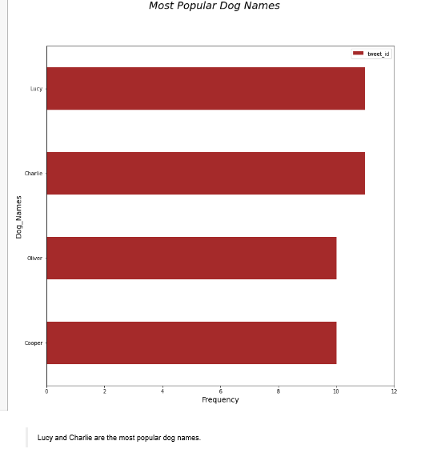

* **Which dog is most loved by people?**

To answer this, only rows having a dog name from the dataset were selected. Then I selected the row with a dog name whose favorite_count is the maximum.

The most loved dog is named is Duddles with a favorite_count of 107956.0 and rating of 13/10.

* **What is the most popular Dog stages?**

To answer this, the ‘dog stages’ column was visualized. The Pupper stage is the most popular dog stage.

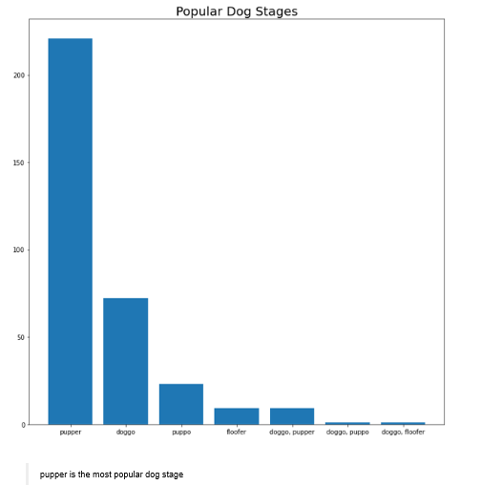

Some **Insights** were gotten. They include:

1. Most popular Dog names are Lucy and Charlie.

2. Retweet_count and Favorite_count are highly correlated positively with a correlation coefficient of 0.91.

3. The most loved dog with a name is Duddles with a rating of 13/10.

4. The most popular dog stage is Pupper with a count of over 200 dogs.

5. The least popular dog stage is 'doggo, floofer' stage.