**Estructura**

**Header**

El Header está Compuesto de dos Filas la Primera que contiene las Opciones de Registrar Un Usuario y la otra para iniciar sección además de un hipervínculo que re direccionara a la vista principal.



**Tamaño**

|  |  |
| --- | --- |
| **Etiqueta** | **Tamaño en Pixeles** |
| **<div class = ‘header-top’>** | **1319px X 50px** |

Y la segunda que contendrá los datos del comercio, contacto, redes sociales, así como las opciones de búsqueda y el carrito de compras, también el catalogo disponible del comercio

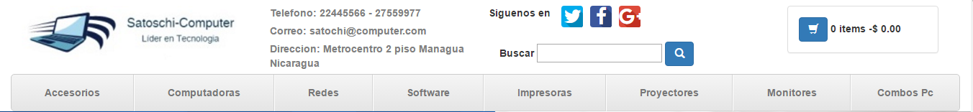

**Tamaño**

|  |  |
| --- | --- |
| **Etiqueta** | **Tamaño en Pixeles** |
| **<div class = ‘navmaster>** | **1319px X 95px** |

**Colores**

|  |  |  |  |
| --- | --- | --- | --- |
| |  | | --- | |  | | **Primera Fila** | |
| **<div>** | |
| **Hexadecimal** | **#00365b** |
| **H =204** | **R =0** |
| **S =100** | **G =54** |
| **B =36** | **B =91** |

|  |  |  |  |
| --- | --- | --- | --- |
| |  | | --- | |  | | **Segundo Fila** | |
| **<div>** | |
| **Hexadecimal** | **#FFF** |
| **H =0** | **R =255** |
| **S =0** | **G =255** |
| **B =100** | **B =255** |

|  |  |  |  |
| --- | --- | --- | --- |
| |  | | --- | |  | | **Catalogo** | |
| **<a>** | |
| **Hexadecimal** | **#808080** |
| **H =0** | **R =128** |
| **S =0** | **G =128** |
| **B =50** | **B =125** |

**Footer**

El Footer está Compuesto de dos Filas la Primera que contiene los datos del comercio así como su contacto, las diferentes categorías de producto que este ofrece, publicaciones recientes de su web y sus redes sociales.



**Tamaño**

|  |  |
| --- | --- |
| **Etiqueta** | **Tamaño en Pixeles** |
| **<div class = ‘masterinfo>** | **1140px X 347px** |

La Segunda parte el Copyright de la página



**Tamaño**

|  |  |
| --- | --- |
| **Etiqueta** | **Tamaño en Pixeles** |
| **<div class = ‘masterinfo>** | **1140px X 40px** |

**Tipo de Fuente**



**Tamaño de las Fuente**

**Header**

|  |  |
| --- | --- |
| **Etiqueta** | **Tamaño en Pixeles** |
| **<label>** | **14 px** |
| **<span>** | **14 px** |
| **<a>** | **14 px** |

**Body**

|  |  |
| --- | --- |
| **Etiqueta** | **Tamaño en Pixeles** |
| **<h3>** | **24 px** |
| **<h5>** | **14 px** |
| **<span>** | **14 px** |
| **<a>** | **14 px** |

**Footer**

|  |  |
| --- | --- |
| **Etiqueta** | **Tamaño en Pixeles** |
| **<h3>** | **25 px** |
| **<h6>** | **21 px** |
| **<p>** | **12 px** |
| **<span>** | **inherit** |
| **<a>** | **17.5 px (Social Network)** |
| **<a>** | **12 px** |

**Colores para las Fuente Utilizadas**

|  |  |  |  |
| --- | --- | --- | --- |
| |  | | --- | |  | | **Link Por Defecto** | |
| **<a>** | |
| **Hexadecimal** | **#0095DD** |
| **H =199** | **R =0** |
| **S =100** | **G =150** |
| **B =87** | **B =221** |

|  |  |  |  |
| --- | --- | --- | --- |
| |  | | --- | |  | | **Hover Link** | |
| **<a>** | |
| **Hexadecimal** | **#00539F** |
| **H =209** | **R =0** |
| **S =100** | **G =83** |
| **B =62** | **B =159** |

|  |  |  |  |
| --- | --- | --- | --- |
| |  | | --- | |  | | **Texto Normal** | |
| **<label>** | |
| **Hexadecimal** | **#333333** |
| **H =0** | **R =51** |
| **S =0** | **G =51** |
| **B =20** | **B =51** |

|  |  |  |  |
| --- | --- | --- | --- |
| |  | | --- | |  | | **Texto Deshabilitado** | |
| **<label>** | |
| **Hexadecimal** | **#808080** |
| **H =0** | **R =128** |
| **S =0** | **G =128** |
| **B =50** | **B =125** |

|  |  |  |  |
| --- | --- | --- | --- |
| |  | | --- | |  | | **Encabezados** | |
| **<h3>** | |
| **Hexadecimal** | **#333333** |
| **H =0** | **R =51** |
| **S =0** | **G =51** |
| **B =20** | **B =51** |

|  |  |  |  |
| --- | --- | --- | --- |
| |  | | --- | |  | | **Encabezados Footer** | |
| **<h6>** | |
| **Hexadecimal** | **#fff** |
| **H =0** | **R =255** |
| **S =0** | **G =255** |
| **B =100** | **B =255** |

|  |  |  |  |
| --- | --- | --- | --- |
| |  | | --- | |  | | **Nav Link** | |
| **< a>** | |
| **Hexadecimal** | **#777** |
| **H =0** | **R =119** |
| **S =0** | **G =119** |
| **B =47** | **B =119** |

|  |  |  |  |
| --- | --- | --- | --- |
| |  | | --- | |  | | **Parrafo Footer** | |
| **<p>** | |
| **Hexadecimal** | **#fff** |
| **H =0** | **R =255** |
| **S =0** | **G =255** |
| **B =100** | **B =255** |

|  |  |  |  |
| --- | --- | --- | --- |
| |  | | --- | |  | | **Span Footer** | |
| **< span>** | |
| **Hexadecimal** | **#777** |
| **H =0** | **R =119** |
| **S =0** | **G =119** |
| **B =47** | **B =119** |

|  |  |  |  |
| --- | --- | --- | --- |
| |  | | --- | |  | | **Texto Normal Footer** | |
| **<label>** | |
| **Hexadecimal** | **#fff** |
| **H =0** | **R =255** |
| **S =0** | **G =255** |
| **B =100** | **B =255** |

|  |  |  |  |
| --- | --- | --- | --- |
| |  | | --- | |  | | **Glyphicons Header** | |
| **<span>** | |
| **Hexadecimal** | **#fff** |
| **H =0** | **R =255** |
| **S =0** | **G =255** |
| **B =100** | **B =255** |

|  |  |  |  |
| --- | --- | --- | --- |
| |  | | --- | |  | | **Glyphicons Body** | |
| **<span>** | |
| **Hexadecimal** | **#fff** |
| **H =0** | **R =255** |
| **S =0** | **G =255** |
| **B =100** | **B =255** |

|  |  |  |  |
| --- | --- | --- | --- |
| |  | | --- | |  | | **Glyphicons Footer** | |
| **< span>** | |
| **Hexadecimal** | **#777** |
| **H =0** | **R =119** |
| **S =0** | **G =119** |
| **B =47** | **B =119** |

**PAGINA PRINCIPAL (INDEX)**

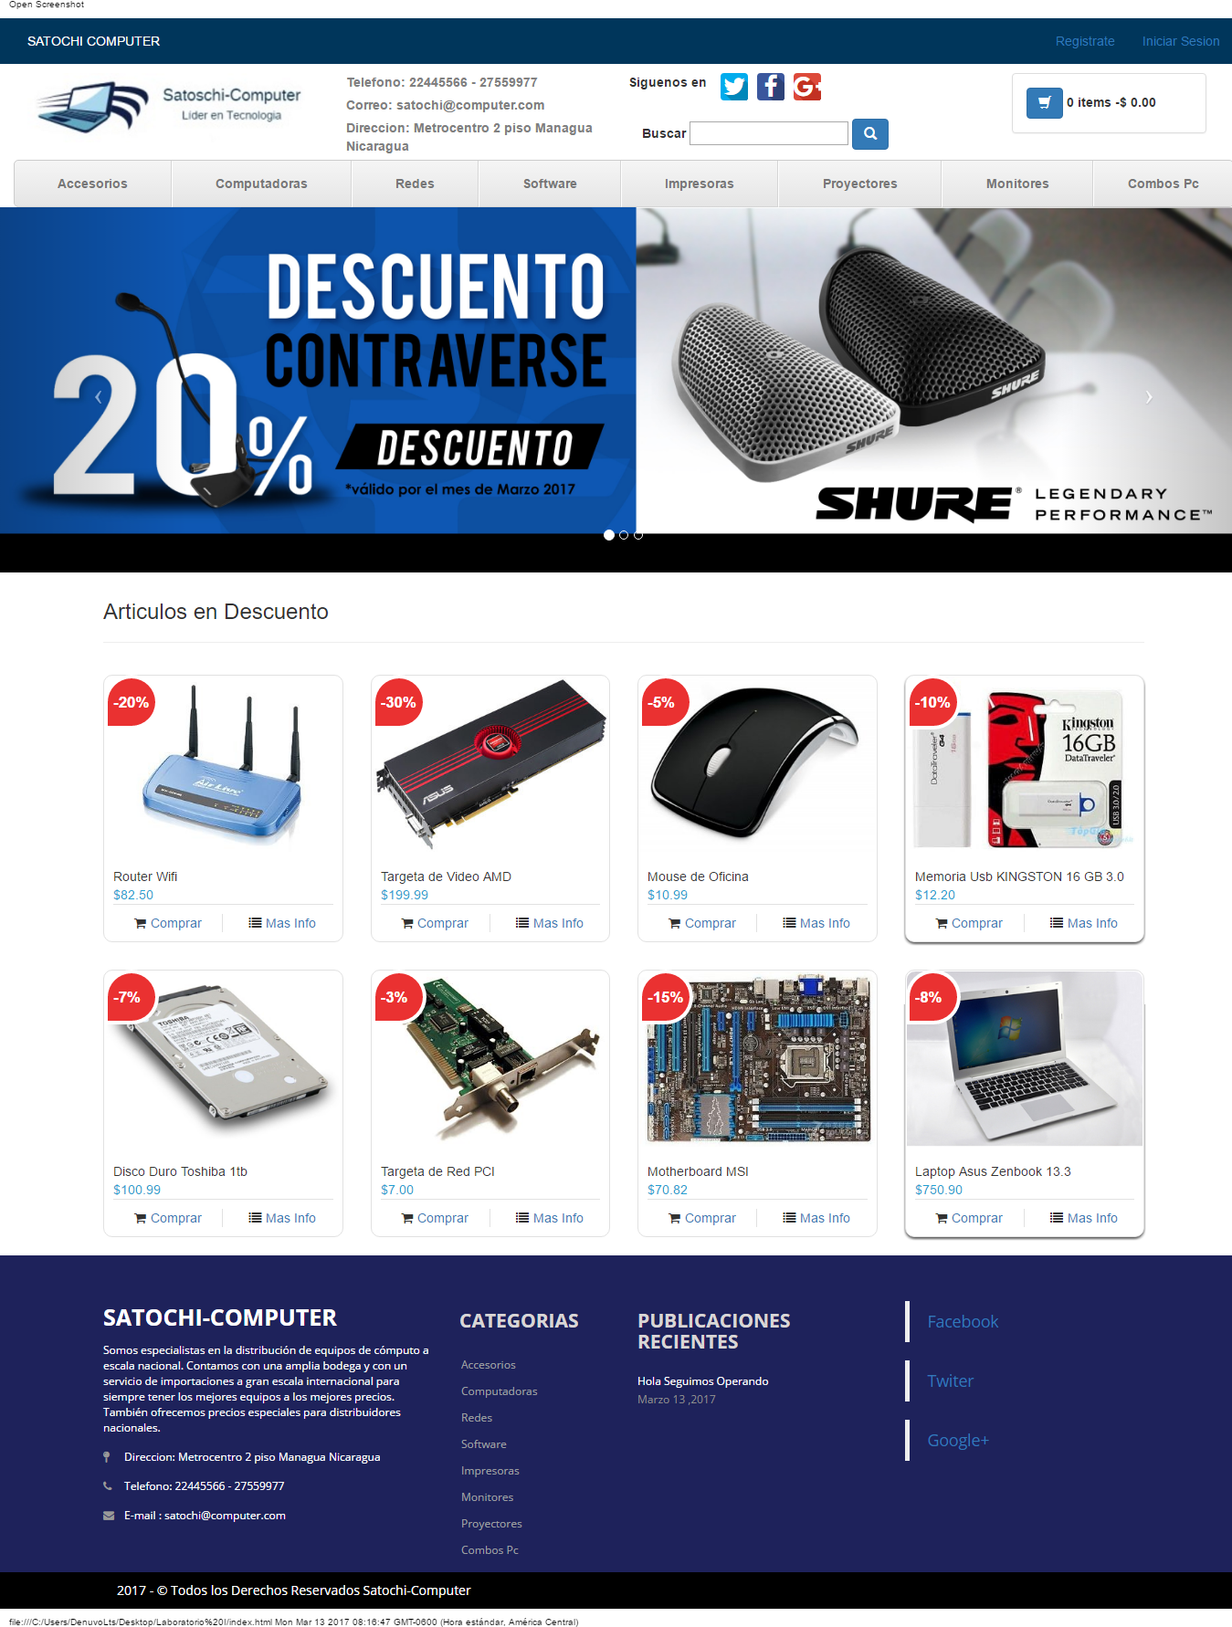

**Pruebas de Rendimiento**

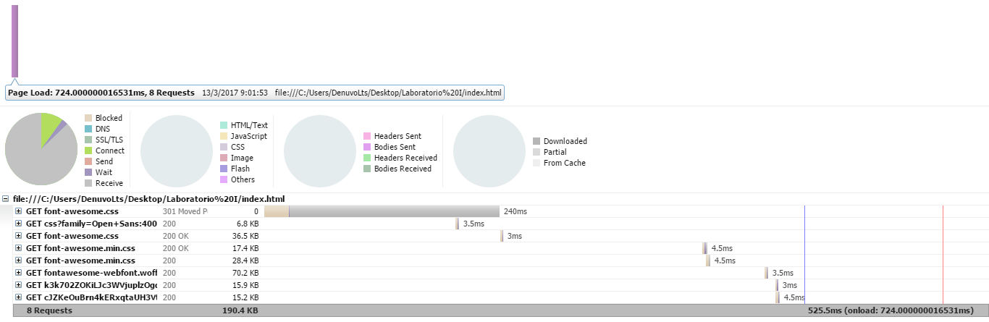

**Estructura de Diseño**

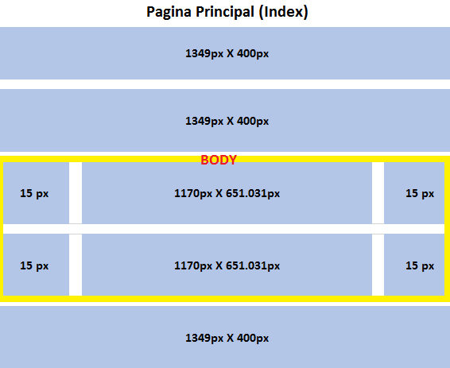

El BODY de la página Principal (Index), se establecen todos los productos en oferta con su determinado descuento.

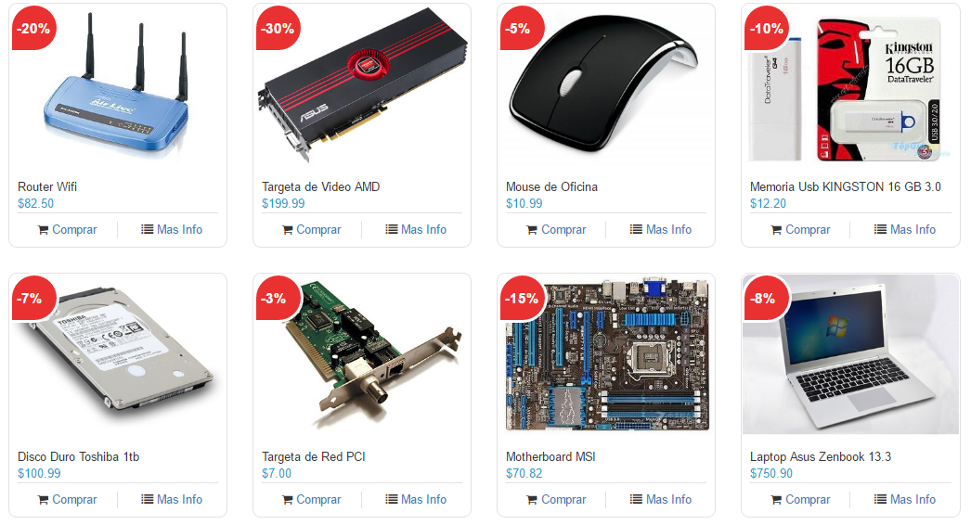

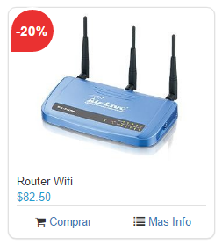

**Cada Item del Body es un Elemento div llamado myCarousel-item este posee las siguietes propiedades**

|  |  |
| --- | --- |
| **myCarousel-item** | |
| **Propiedad** | **Tamaño en Pixeles** |
| **Margin-top** | **30px** |
| **Margin-left** | **15px** |
| **Margin-right** | **15px** |
| **Weight-Height Div** | **262.500px X 293.177px** |
| **Imagen-Size** | **350px X 260px** |

**Categoría**

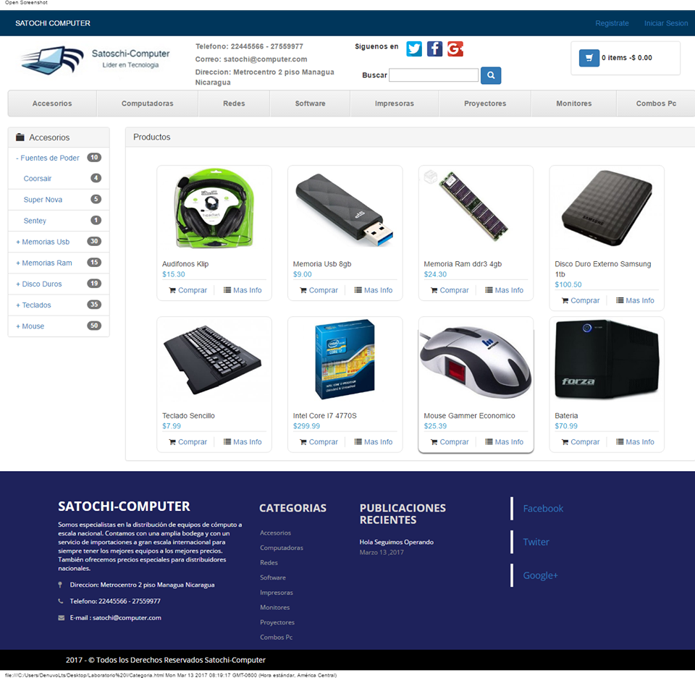

**Pruebas de Rendimiento**

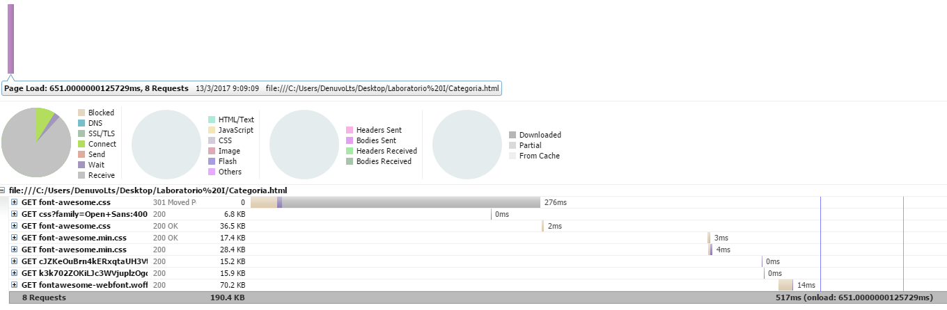

**Estructura de Diseño**

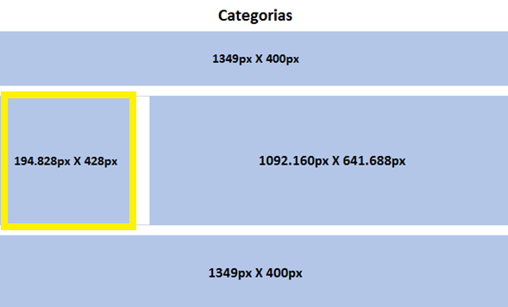

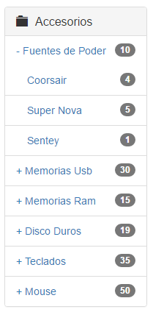

**La Interfaz Categorías tiene un panel Llamado Panel-Group Acordion al lado izquierdo donde se muestran todos los productos existente según la Categoria Seleccionada y este su vez lo divide por sus respectivas marcas , asi mismo como la cantidad existente del mismo**

|  |  |
| --- | --- |
| **Panel-Group Acordion** | |
| **Propiedad** | **Tamaño en Pixeles** |
| **Margin-button** | **30px** |
| **Padding-Left** | **15px** |
| **Padding-Right** | **15px** |
| **Weight-Height Div** | **192.828px X 406px** |

**Descripción del Producto**

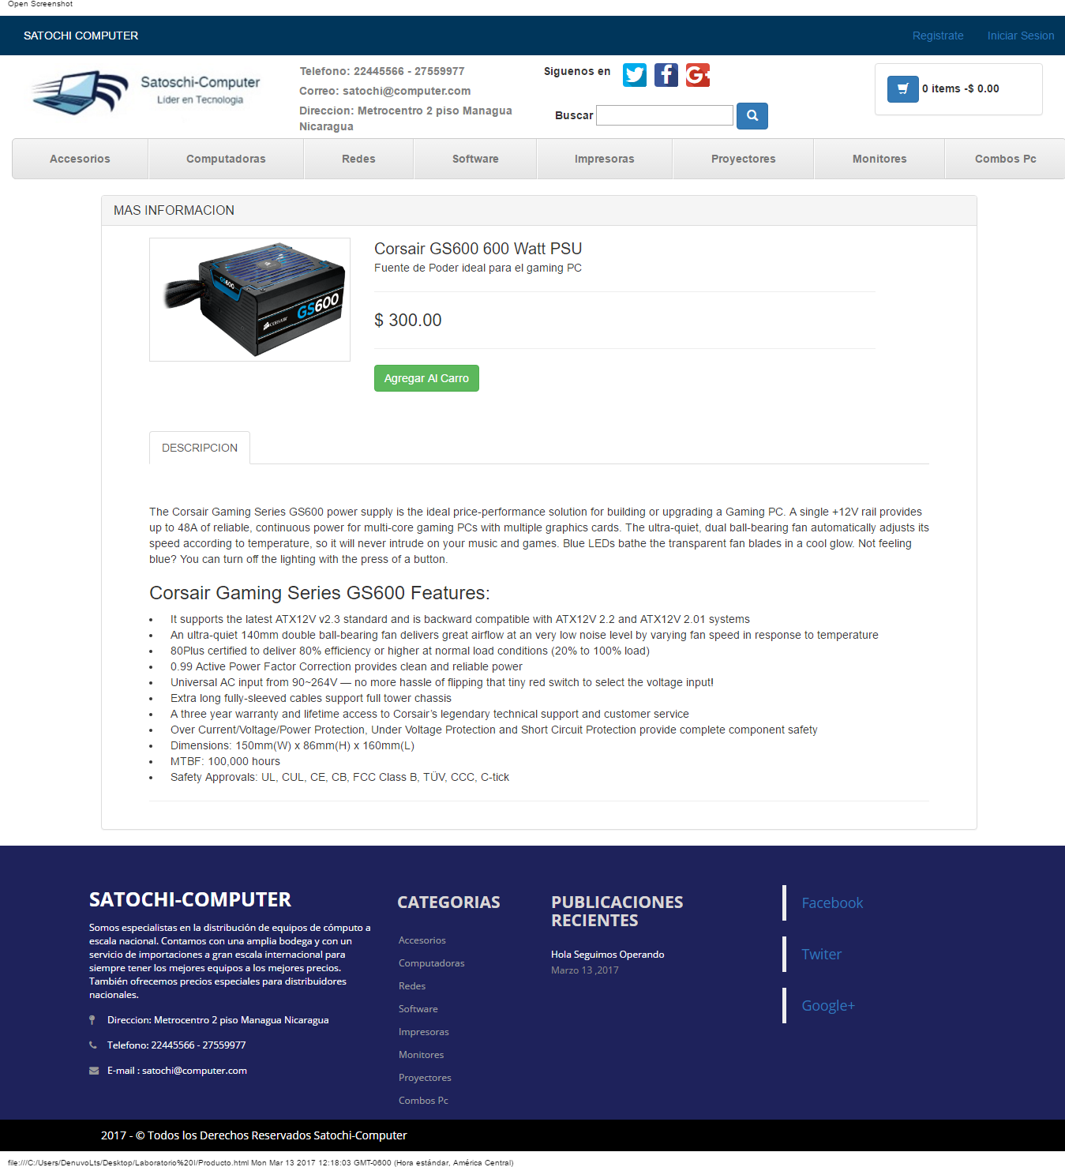

**Pruebas de Rendimiento**

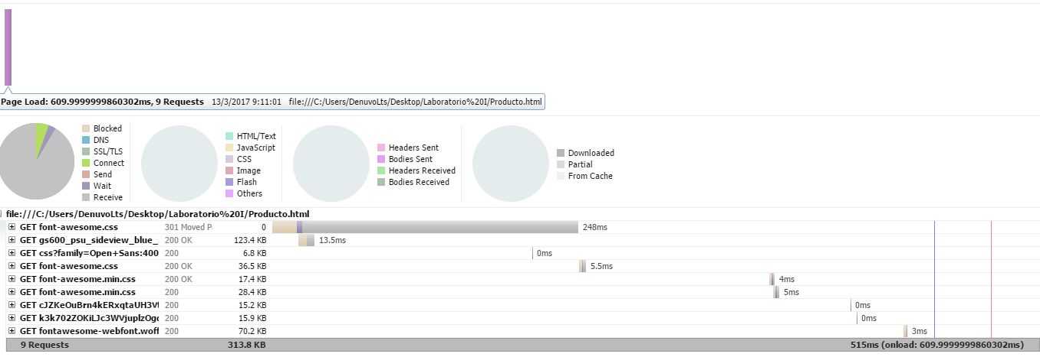

**Estructura de Diseño**

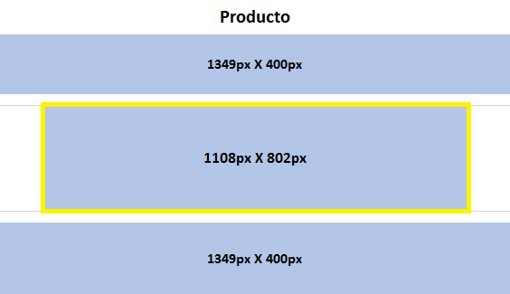

**Panel Mas Información**

**Muestra el Detalle del Producto Seleccionado por el Usuario todo esto lo hace dentro de un Panel Llamado Panel - ProductDetail**

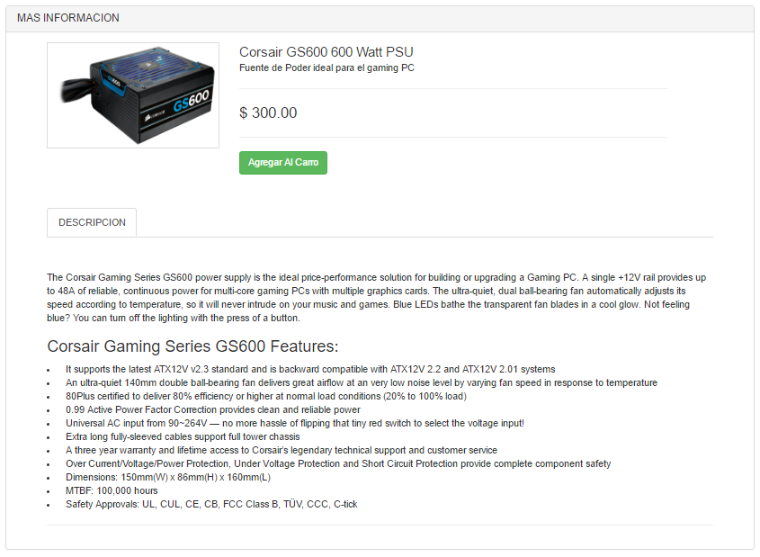

|  |  |
| --- | --- |
| **Panel - ProductDetail** | |
| **Propiedad** | **Tamaño en Pixeles** |
| **Padding-left** | **314.333 px** |
| **Padding-Right** | **314.333 px** |
| **ImageSize** | **237px X 155px** |
| **DescripcionSize** | **1110px X 827px** |

**Botón**

|  |  |
| --- | --- |
| **Botón Agregar al Carro** | |
| **Propiedad** | **Tamaño en Pixeles** |
| **ButtonSize** | **104px X 20px** |

**Color**

|  |  |  |  |
| --- | --- | --- | --- |
| |  | | --- | |  | | **Boton Agregar Al Carro** | |
| **< button>** | |
| **Hexadecimal** | **#5cb85c** |
| **H =120** | **R =92** |
| **S =50** | **G =184** |
| **B =72** | **B =92** |

**Carrito de Compras**

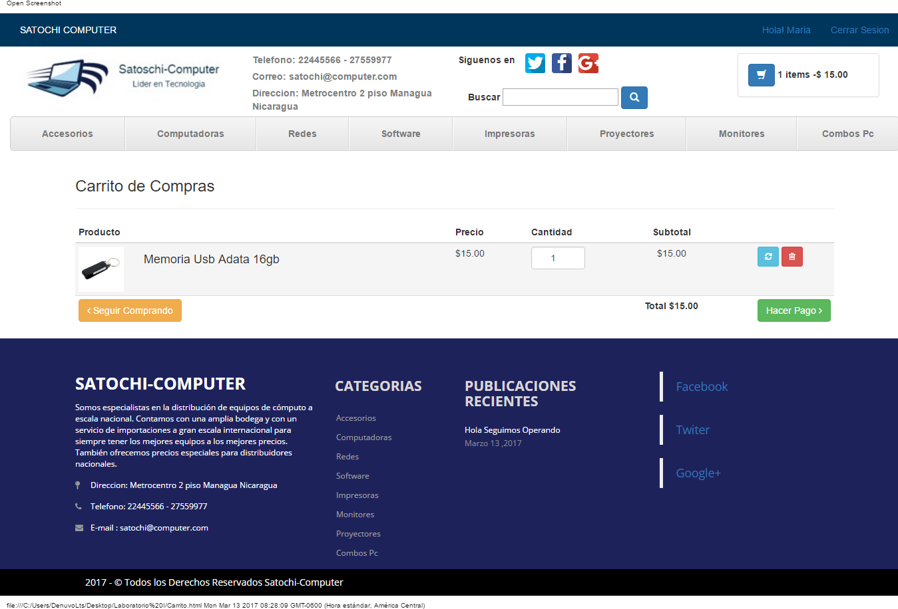

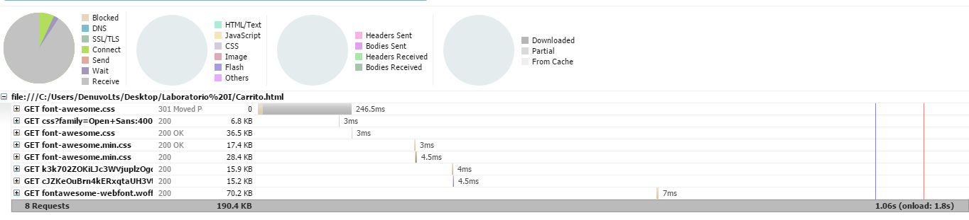**Pruebas de Rendimiento**

**Estructura de Diseño**

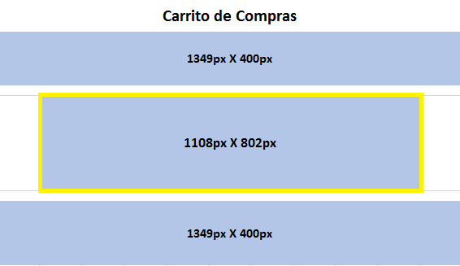

**Contenido de Carrito de Compras**

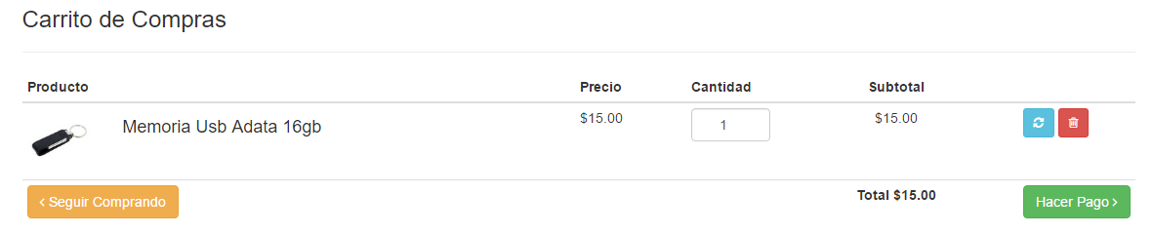

**Botones**

|  |  |
| --- | --- |
| **Botón Hacer Pago** | |
| **Propiedad** | **Tamaño en Pixeles** |
| **ButtonSize** | **84px X 20px** |

**Color**

|  |  |  |  |
| --- | --- | --- | --- |
| |  | | --- | |  | | **Botón Hacer Pago** | |
| **< button>** | |
| **Hexadecimal** | **#5cb85c** |
| **H =120** | **R =92** |
| **S =50** | **G =184** |
| **B =72** | **B =92** |

|  |  |
| --- | --- |
| **Botón Seguir Comprando** | |
| **Propiedad** | **Tamaño en Pixeles** |
| **ButtonSize** | **129px X 15px** |

**Color**

|  |  |  |  |
| --- | --- | --- | --- |
| |  | | --- | |  | | **Boton Seguir Comprando** | |
| **< button>** | |
| **Hexadecimal** | **#f0ad4e** |
| **H =35** | **R =240** |
| **S =68** | **G =173** |
| **B =94** | **B =78** |

|  |  |
| --- | --- |
| **Botón Actualizar** | |
| **Propiedad** | **Tamaño en Pixeles** |
| **ButtonSize** | **10.2px X 12px** |

**Color**

|  |  |  |  |
| --- | --- | --- | --- |
| |  | | --- | |  | | **Boton Actualizar** | |
| **< button>** | |
| **Hexadecimal** | **#5bc0de** |
| **H =91** | **R =194** |
| **S =192** | **G =59** |
| **B =222** | **B =87** |

|  |  |
| --- | --- |
| **Botón Eliminar** | |
| **Propiedad** | **Tamaño en Pixeles** |
| **ButtonSize** | **10.2px X 12px** |

**Color**

|  |  |  |  |
| --- | --- | --- | --- |
| |  | | --- | |  | | **Boton Eliminar** | |
| **< button>** | |
| **Hexadecimal** | **#d9534f** |
| **H =2** | **R =217** |
| **S =64** | **G =83** |
| **B =85** | **B =79** |

Anexos

<https://www.amazon.com>

<http://sevasaonline.com/>

<http://ebay.com/>

<http://www.etech.com.ni/>

<http://www.conico.com.ni/>

<https://comtech.com.ni/>

[www.compuexpress.com.ni/](http://www.compuexpress.com.ni/)