4. Showtime! (20 pts):

Query 1: Total Time Spent on Each Platform

SELECT platform, SUM(time_spent) AS total_time_spent

FROM `average time spent by a user on social media`

GROUP BY platform;

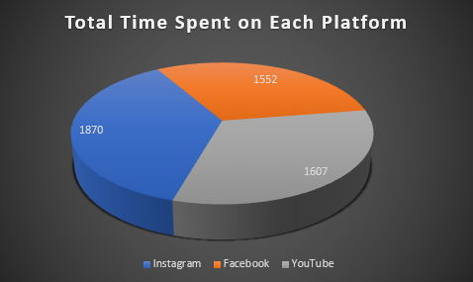

Query 2: Average Time Spent by Users in Different Professions

SELECT profession, AVG(time_spent) AS avg_time_spent

FROM `average time spent by a user on social media`

GROUP BY profession;

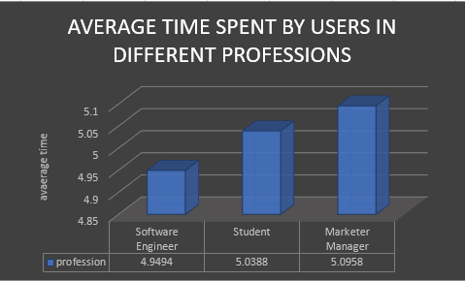

Query 3: Total Time Spent by Each Gender

SELECT gender, SUM(time_spent) AS total_time_spent

FROM `average time spent by a user on social media`

GROUP BY gender;

