Model Training and Validation History
The table below details the epoch-by-epoch progression of the Hybrid ConvLSTM model's learning phase, demonstrating the convergence of training and validation accuracy over time.
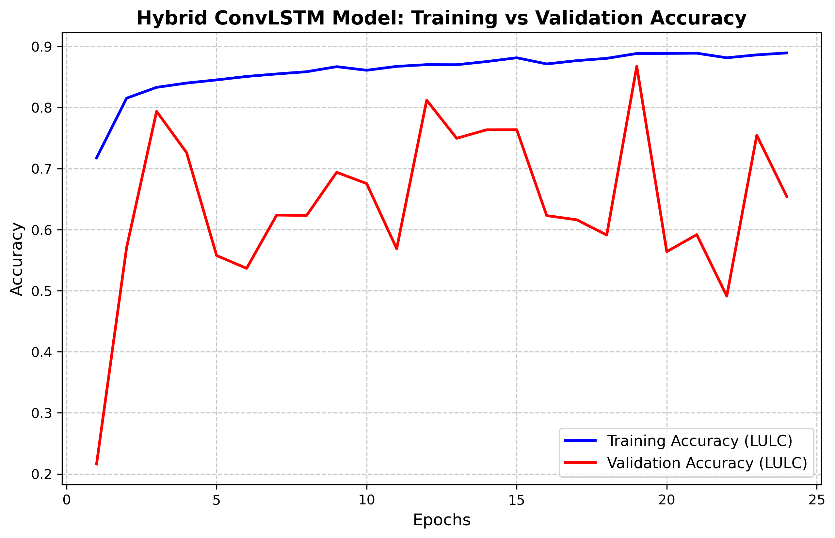

Table X: Epoch-by-Epoch Training and Validation Metrics
Epoch | Training Accuracy | Validation Accuracy | Training Loss (Total) | Validation Loss (Total)
1 | 71.74% | 21.62% | 2.6817 | 390.2658
2 | 81.52% | 57.07% | 1.4951 | 81.8149
3 | 83.29% | 79.36% | 1.3297 | 19.6815
4 | 84.00% | 72.60% | 1.2381 | 2.3815
5 | 84.51% | 55.76% | 1.1395 | 7.3269
6 | 85.08% | 53.66% | 1.1733 | 4.2262
7 | 85.49% | 62.38% | 1.0720 | 3.9121
8 | 85.85% | 62.32% | 1.0618 | 3.3971
9 | 86.68% | 69.38% | 0.9930 | 4.8356
10 | 86.09% | 67.54% | 1.0347 | 2.4904
11 | 86.72% | 56.87% | 1.0093 | 5.7087
12 | 87.01% | 81.19% | 0.9822 | 7.7077
13 | 87.00% | 74.95% | 0.9004 | 5.1045
14 | 87.52% | 76.35% | 0.8747 | 1.4825
15 | 88.14% | 76.36% | 0.8486 | 6.0877
16 | 87.12% | 62.29% | 0.8762 | 2.8324
17 | 87.66% | 61.61% | 0.8993 | 3.6423
18 | 88.04% | 59.11% | 0.8725 | 24.4600
19 | 88.83% | 86.73% | 0.7806 | 2.4406
20 | 88.85% | 56.39% | 0.8055 | 6.8829
21 | 88.88% | 59.18% | 0.8163 | 1.7733
22 | 88.13% | 49.11% | 0.9428 | 37.0320
23 | 88.61% | 75.44% | 0.8164 | 21.1916
24 | 88.93% | 65.40% | 0.8230 | 17.1313

