LLMProjectMemory Operations Guide
  - Start check troubleshoot and close
This is a reference collection for portable Markdown memory graphs. It has no documented application server. In this workspace, canonical operational memory remains in PMDB; the older Markdown pattern is reference material.

Start using the repository
Open README.md and the relevant pattern or skill reference in a Markdown viewer. Follow local relative links from this checkout. No npm server, database, model download, or new operational-memory vault is required to read it.

Check and troubleshoot
Confirm the requested file exists and its links resolve. Check filename case if a link works on another platform but fails on Linux. Treat claims as design/reference material until supported by the actual application. Do not copy credentials, customer records, private conversations, or transient scratch notes into a memory graph.

Close and maintain
Save deliberate documentation changes, review the diff, and close the editor. There is no process or database to stop. Source changes use an independent topic PR against master after appropriate local checks. Do not replace an existing project's canonical PMDB with this pattern without an explicit migration plan.

Before you begin
The non-runtime or blocked status above governs this repository. Work in this checkout, preserve existing files, and do not invent a service merely because a generic tool offers a Start button. Save findings and deliberate source changes; there is no application process to stop unless a verified recipe explicitly names one.

Keep troubleshooting scoped
Record the first error, source revision, working directory, and selected instance. Check the stated prerequisites before changing anything. Preserve useful work before resets. Stop only the process or dedicated dependency you own; do not kill by a guessed port or broad name. Keep credentials and private records out of reports. Migrations, seeds, volume deletion, deployment, and new model downloads are separate operations, not generic restart fixes.

Normal operating sequence
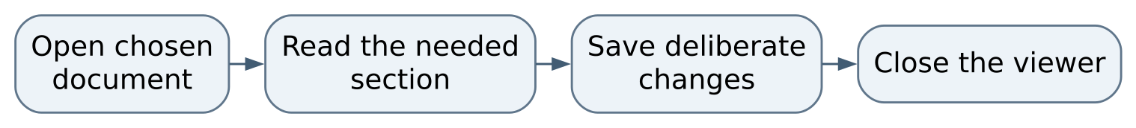
Figure 1 Normal operating sequence

Maintaining this guide
Keep this Markdown, the editable Word edition, PDF, and operating-flow.svg together here. Update them when merged commands, storage, dependencies, or limits change. Edit Word and export PDF independently when convenient, then inspect the affected pages. No running AIOS service is needed to read or maintain these documents.
Source-defined instructions and known gaps are distinguished above. This documentation task did not launch the application or prove a new production workflow. Verify changes locally on NixOS; use a topic PR and human merge for owned source. Deployment is separate, and routine hosted CI remains disabled.

Source and edition
Edition 26 October 2026. Repository OchsSoft/LLMProjectMemory. Inspected source revision 4d86efe5ed721ddefad9d118c0a51cea05b3ef5e.
Source files: README.md.
Editable Word edition | PDF edition

