MiniPMDB Operations Guide
  - Start check troubleshoot and close
MiniPMDB is a separate memory-trust product with its own MongoDB and dashboard, normally port 8797. It is not the primary PMDB service at 8787. Keep demo projects and real private memory separate.
Operating status. Source-defined managed and external modes with NixOS qualification required.

Start the application
The README demo path is:
npm ci --ignore-scripts
npm run judge:demo
It prints the dashboard address and may open a browser itself. Its managed Mongo mode downloads a pinned upstream binary on first use. Generic managed binaries are not proof of NixOS compatibility. The alternative is the repository's Podman Mongo service:
podman compose up -d
MINIPMDB_MONGODB_URI=mongodb://127.0.0.1:27017 npm start
The environment assignment selects external Mongo before startup. Confirm port 27017 is available before launching this dedicated container; otherwise configure another explicit mapping and matching URI. Credentials belong in the private environment, not a saved credentialed URI.

Check that it works
Open http://127.0.0.1:8797 and inspect the storage runtime status. Use the synthetic fail/fix demo only in its demo instance. Real project memory uses project registration and review; a new draft must not be mistaken for approved truth. Local checks include npm run check, npm test, npm run smoke, and npm run judge:dry-run; the last can exercise real Mongo startup.

If something goes wrong
If managed Mongo fails to execute on NixOS, preserve the loader error and use the explicitly configured external Podman route after checking ownership and ports. If the storage runtime changes, restart MiniPMDB as the source instructs. Do not point a synthetic demo at primary PMDB or run demo-reset commands on real data.

Close the session
Save reviewed work and make an appropriate private database backup when needed. Ctrl+C the foreground MiniPMDB process and verify its own managed child exits when using managed mode. For an external dedicated container, stop it separately only when unused, retaining its named volume. Never delete the database directory to stop the service.

Known limitation and next repair
The source reports managed-runtime tests on other platforms; that does not establish native NixOS compatibility. Qualify the external Podman route, storage persistence, and graceful restart before calling this installation supported.

Before you begin
Use this repository root or the precise client/server folder named above. If an installed supervisor already owns this instance, use it instead of starting a second copy. A process is one running program; a port is its numbered network doorway. The address 127.0.0.1 means this machine only.

Keep troubleshooting scoped
Record the first error, source revision, working directory, and selected instance. Check the stated prerequisites before changing anything. Preserve useful work before resets. Stop only the process or dedicated dependency you own; do not kill by a guessed port or broad name. Keep credentials and private records out of reports. Migrations, seeds, volume deletion, deployment, and new model downloads are separate operations, not generic restart fixes.

Normal operating sequence
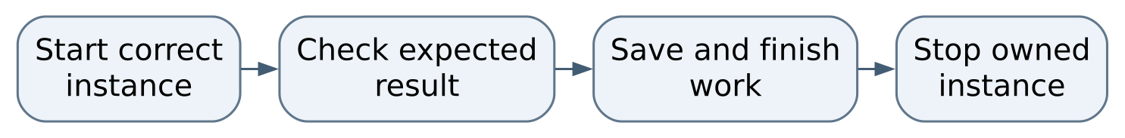
Figure 1 Normal operating sequence

Maintaining this guide
Keep this Markdown, the editable Word edition, PDF, and operating-flow.svg together here. Update them when merged commands, storage, dependencies, or limits change. Edit Word and export PDF independently when convenient, then inspect the affected pages. No running AIOS service is needed to read or maintain these documents.
Source-defined instructions and known gaps are distinguished above. This documentation task did not launch the application or prove a new production workflow. Verify changes locally on NixOS; use a topic PR and human merge for owned source. Deployment is separate, and routine hosted CI remains disabled.

Source and edition
Edition 26 October 2026. Repository OchsSoft/MiniPMDB. Inspected source revision e47f5c1d5b5b0cc82c7e944dcd2ec254244e48de.
Source files: README.md, package.json.
Editable Word edition | PDF edition

