Confidence Interval: What Is It?   
A range where we are positive that the true value exists is called the confidence interval. The likelihood that the confidence interval will contain the correct parameter value depends on the confidence level chosen for the interval.

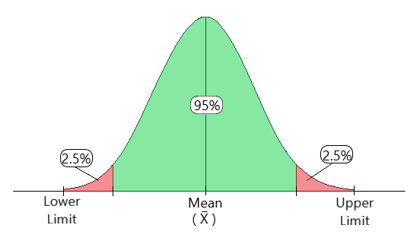

Different Confidence Interval Types   
Typical forms of Confidence Intervals include the following:   
1.Confidence Range for Normally Distributed Data Mean   
Using the t-distribution, one may frequently compute a confidence interval for the mean of normally distributed data. With a given degree of confidence, this interval offers a range that the genuine population mean is likely to lie inside. Sample size, sample mean, and standard deviation are all included in the formula; lesser sample sizes are considered by adjusting using the crucial value from the t-distribution table.

2.Interval of Confidence for Proportions   
A confidence interval for a proportion calculates the likely range of values for the actual population proportion. Depending on the sample size, either the binomial distribution or the normal approximation is typically utilized. The sample proportion, standard error, and crucial z-value related to the selected confidence level are all included in the formula.   
  
3.Confidence Interval for Data That Is Not Regularly Distributed   
Bootstrap approaches provide a versatile way to work with non-normally distributed data or unknown distributions. By resampling the dataset to produce many samples, bootstrap confidence intervals enable the estimation of the parameter distribution. When there is uncertainty or a violation of assumptions regarding the distribution of the data, this strategy is especially helpful.

When are confidence intervals used?

1.When figuring out the range that a population parameter, such as a mean or proportion, is most likely to fall into, confidence intervals are a crucial tool.   
These intervals offer a measure of uncertainty surrounding a point estimate and crucial information on the reliability of study findings.   
2.When working with sample data, confidence intervals aid researchers in communicating the precision of their estimations and enabling them to draw more firm conclusions.

Essentially, confidence intervals acknowledge the inherent variability in data and provide a realistic range for the true population parameter.   
To ascertain if a given value falls within the interval and, consequently, affect judgments about the statistical significance of the data, researchers commonly employ confidence intervals in hypothesis testing.   
A comprehensive understanding of the underlying events is fostered by the prudent use of confidence intervals, which improves the depth and believability of statistical judgments in a variety of fields, including business analytics, social sciences, and medical research.   
To summarize, one of the fundamental ideas in statistics is the Confidence Interval. It provides an analysis of the data. Several sample techniques, including mean, median, and others, can be applied depending on the available data. Additionally, one can choose which distribution to apply at what time to achieve the greatest outcomes.