CS207 Project Report Guidelines & Template

* This report takes 10 marks out of 100 of the course mark + 3 marks as bonus (your total mark of this course is 100 maximum).
* The report should contain the following contents:
  + Development schedule:
    - Division of labor, contribution of each group member and percentage (e.g., member A contributes 20% to the project and takes care of the structure design of xxxx).
    - Weekly schedule.
  + User documentation: given this documentation, the user should be able to use your digital system without knowing the internal design of the circuit. It should contain the necessary information of the input and output of the circuit.
    - Example (text and figure): In the system, mode_sw denotes the main control, it is used to switch between decoder and encoder modes; the mode is indicated by the digital tube (0 for encoding and 1 for decoding), its corresponding pins are xxx; a_rst is the reset button, it is low level activated, its corresponding pin is xxx….

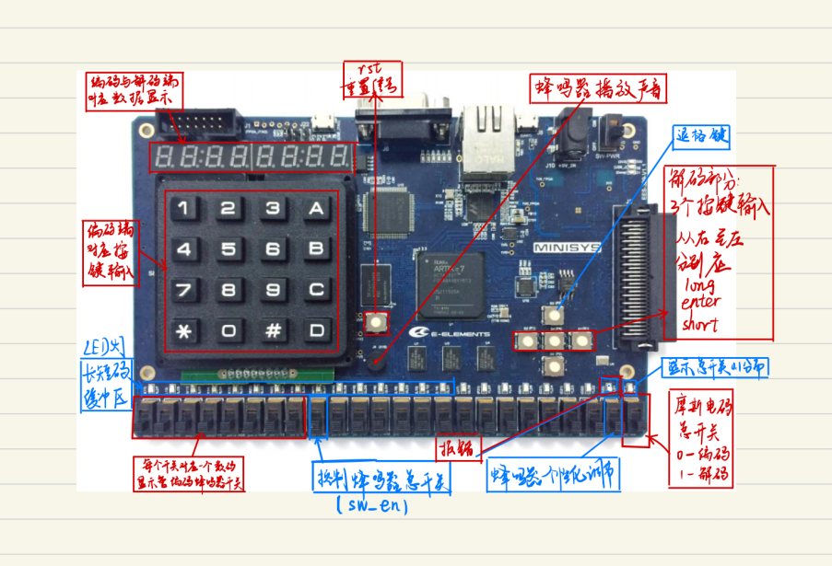

Output of decoder and encoder

Reset button

* + Design of the system: the internal structure of modules.
    - State diagram: it describes how the circuit works (the predefined states and transitions).
    - Architecture diagram of the circuit: it describes the top module, submodules, and their relationship. You are encouraged to use diagram and text to better describe your circuit.
      * Example (figure and text): In our design, the top module has used 3 submodules: aaa, bbb and ccc, where aaa realizes the function of xxx, bbb realizes the function of yyy, and ccc realizes the function of zzz. The module aaa sues the clk of top module, a reset signal and toto, titi signals, its output is sent to the module bbb blablablabla

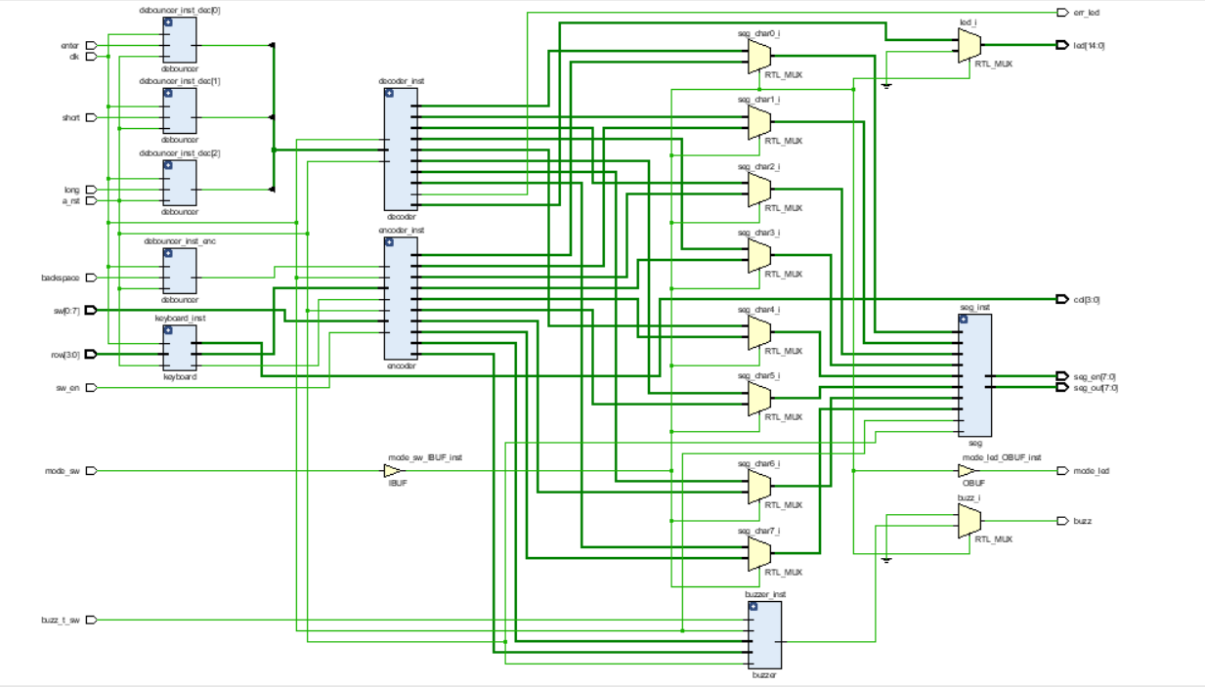

* + - For each module: function of the module, the input and output, their types, design architecture.
      * Suggestion 1: to describe the input and output, you can simply paste a screenshot of your code with comments.
      * Suggestion 2: to describe the architecture, you can paste the diagram (similar to the one above) obtained with the rtl analysis of Vivado.
  + Summary of experience: what were the challenges, what were the knowledge/experience gained when working on the project, what can you improve if being given more time?
    - Team members are suggested to write a summary each. Please indicate the name of the student before each summary.
* Submission of report:
  + Before 11:55pm, Jan. 8th 2023 (Beijing time) via Sakai
  + Each group submits one single report.
  + If no report was submitted on time, all members get 0 for the report part.