# Simulation of a flowering cactus — N = 200,000

- Minecraft Java 1.21.5 added the cactus flower block, which can spawn atop a cactus as a fourth segment, though exceedingly rare  
- Game mechanics documented specify:  
 - 10% chance for a flower when a cactus attempts to grow from 1 to 2 blocks,  
 - another 10% when growing to 3 blocks,  
 - then a final 25% chance when attempting to grow to the next block (the 4th, where the flower appears)  
- Therefore, breaking the 23-block record is feasible: if a cactus is already at 23 cactus-blocks, the next growth can yield the flower and result in 24 total blocks.  
- Yet the probability is extremely low:  
 - Analytical estimate: ≈ 0.000642 (≈ 0.0642%)  
 - Monte Carlo simulation (200 000 trials): ≈ 0.0715%, very close to the theoretical estimate.  
- The flower stops further growth; thus, it's the sole path to 24 — it doesn’t allow endless growth.

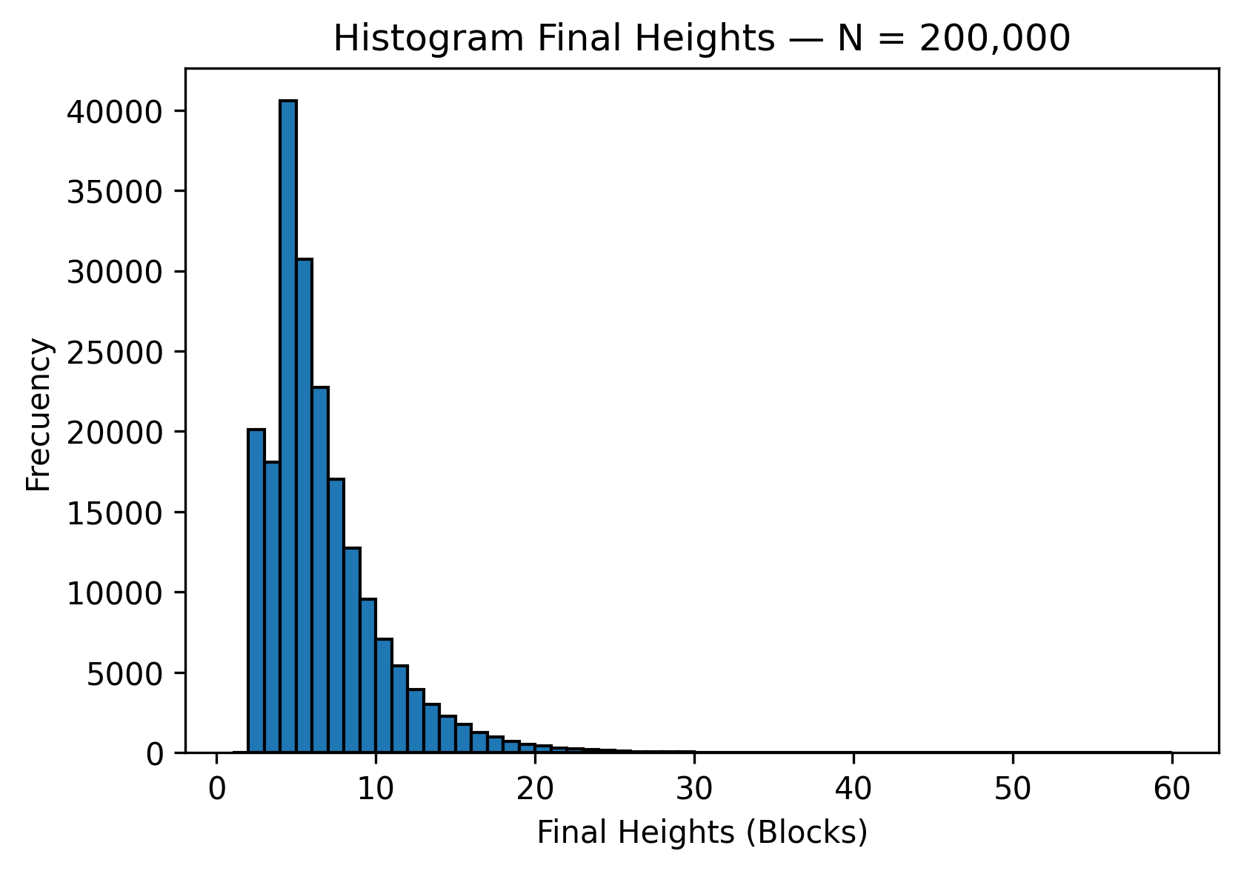

## Executive Summary

- Analytical probability to reach 24 blocks: ≈ 0.2569%  
- Simulation with N = 200,000:  
 ≈ 0.0690% ended at 24 blocks  
- The flower stops further growth; it is the only route to reaching 24 blocks.