McDonnell Douglas DC-10

Autoflight and FCC

Josh Davidson (Octal450)

Updated: 10/28/2024

Note: This guide is not an FCOM and does not describe every single behavior of the system.

Contents

Introduction 3

Flight Mode Annunciator 3

Autoflight Modes 3

Speed Modes 3

Lateral Modes 4

Vertical Modes 4

Armed Modes 5

Controls 5

Flight Guidance Control Panel 5

Other Controls 8

Control Wheel Steering 8

Yaw Damper 8

Procedures 9

Takeoff and Climb 9

Engaging the AP or ATS 9

Disengaging the AP or ATS 9

Climbing to a New Altitude 10

Descending to a New Altitude 10

Performing an ILS Approach or Autoland 10

Tracking a VOR Radial or ILS Localizer 10

# Introduction

The DC-10’s Flight Guidance System (FGS) provides dual Autopilots (APs) and a dual Auto Thrust System (ATS). The system is capable of automatically flying the aircraft from shortly after liftoff, to touchdown and rollout.

The controls for the system are located on the Flight Guidance Control Panel (FGCP) on the glareshield. Outputs from the system are shown on both Flight Mode Annunciators, and the Flight Directors on each Attitude Director Indicator (ADI)­.

The Flight Control Computers (FCCs) provide stability augmentation in yaw via a Yaw Damper. Elevator Feel and Flap Limiter systems are also provided.

# Flight Mode Annunciator

The Flight Mode Annunciator (FMA) shows the engaged and armed modes of the system. There is one FMA for the captain and one for the first officer. Sometimes referred to as the TARP, for Thrust, Arm, Roll, Pitch.

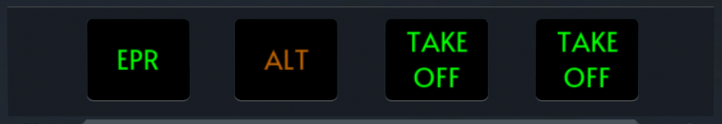

2

1

1. Thrust Window  
   Displays the ATS mode when the ATS is engaged.
2. Arm, Roll, and Pitch Windows  
   Displays the armed, roll, and pitch modes when the respective FD or either AP is engaged.

# Autoflight Modes

## Speed Modes

The Auto Thrust System (ATS) operates independently of the Autopilot. However, the AP and ATS will ensure that no mode conflicts occur.

If the AP is controlling the speed and the ATS is commanded to control the speed, the AP vertical mode will revert to VERT SPD or ALT HLD. If the ATS is controlling the speed, and the AP enters IAS or MACH mode, the ATS will revert to CLAMP. Note that there is no ATS mach mode.

The ATS throttle command is constrained by the active N1 fan speed (GE) or Engine Pressure Ratio (EPR, PW) limit selected on the Thrust Computer Indicator (TCI) and the FGS computed idle limit.

Available modes are:

* SPD: FGCP selected airspeed is being held
* ALPHA SPD: FGCP selected speed too low, safe stall (alpha) margin speed being held
* N1 or EPR: N1/EPR limit being held (TO, MCT, GA, etc.)
* CLAMP: Throttle servos are unpowered and the levers can be moved by the pilot
* RETD: Throttles are being retarded for touchdown

## Lateral Modes

Available modes are:

* HDG HOLD: Levelling out and holding current heading
* HDG SEL: FGCP selected heading is being captured and held
* FMS TRK: FMS lateral path is being captured and tracked
* VOR CAP: VOR localizer is being captured
* VOR TRK: VOR localizer is being tracked
* VOR CRS: VOR station crossing is occurring, holding existing heading
* LOC CAP: ILS localizer is being captured
* LOC TRK: ILS localizer is being tracked
* ALGN: Runway alignment is occurring
* ROLL OUT: Runway centerline is being tracked
* TAKE OFF: After liftoff, levelling out and holding current heading
* G/A: Levelling out and holding current heading

## Vertical Modes

Available modes are:

* ALT HOLD: Altitude is being held
* ALT CAP: FGCP selected altitude is being captured
* VERT SPD: FGCP selected vertical speed is being tracked
* G/S CAP: ILS glideslope is being captured
* G/S TRK: ILS glideslope is being tracked
* FLARE: The flare maneuver is occurring
* IAS HOLD: Current airspeed is being tracked by adjusting pitch angle
* MACH HOLD: Current mach number is being tracked by adjusting pitch angle
* TAKE OFF: Takeoff guidance is being tracked to pitch for V2+10 (V2 for engine-out)
* G/A: Go around guidance is being tracked
* TURB: Turbulence mode engaged

## Armed Modes

Armed modes are:

* VOR: VOR mode is armed
* LOC: LOC mode is armed
* B/CRS: B/CRS mode is armed (FD mode only)
* INS: INS mode is armed
* LAND: LAND mode is armed
* ALT: ALT CAP mode is armed
* ILS: LOC and G/S modes are armed
* DUAL LAND: Both APs are available for Autoland
* SNGL LAND: Only one AP is available for Autoland
* APP ONLY: Autoland is not available, disconnect the AP above 100ft

# Controls

## Flight Guidance Control Panel

The Flight Guidance Control Panel (FGCP) is the location of most of the controls for the Flight Guidance System (FGS). It is located on the glareshield.

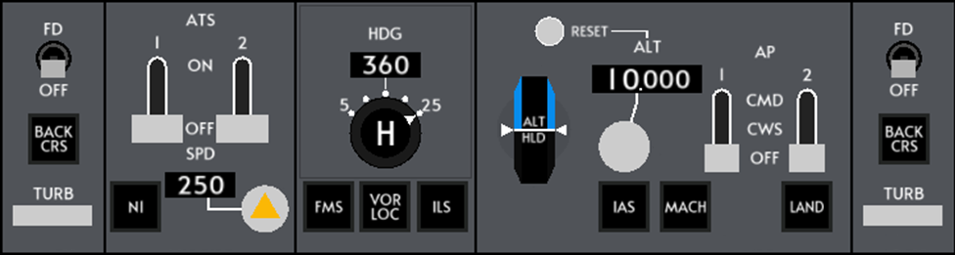

2

3

21

4

4

20

20

5

11

12

13

19

18

17

16

15

14

9

10

8

7

6

3

2

1

1

Knobs 7, 10, and 17 are multi-function knobs. A mouse or trackpad with a scroll wheel is required to use them. This applies to the 2D Panel version as well.

* Turn knobs by using the scroll wheel, hold Shift to accelerate adjustment
* Push knobs by left clicking
* Pull knobs by middle-clicking or holding Shift and left-clicking

1. Flight Director Switch  
   Toggles the Flight Director on the associated ADI.
2. BACK CRS Button (Currently INOP)  
   Arms B/CRS mode for tracking ILS back course. FD mode only.
3. TURB Button  
   Reverts the APs from CMD to CWS, disengages the ATS and disarms ALT CAP, and hides the FD bars from view.
4. ATS Switches  
   Engages or disengages the respective ATS. Switch will trip off automatically if the ATS disengages.
5. N1/EPR Button  
   Sets the ATS to N1/EPR mode. The vertical mode does not change.
6. Speed Window  
   Displays the ATS speed select.
7. Speed Knob   
   Turn: Adjusts the ATS speed select.  
   Pull: Sets the ATS to SPD mode. If the vertical mode is IAS, MACH, TAKE OFF, or G/A, it will revert to VERT SPD or ALT HOLD. SPD mode will not engage if the TCI is set to TO, TO FLX, or ALTN TO.
8. Heading Window  
   Displays the heading select.
9. Bank Limit Selector  
   Selects the maximum bank angle in HDG HOLD, HDG SEL or VOR modes. No effect in other modes.
10. Heading Knob  
    Turn: Adjusts the heading select.  
    Push: Engages HDG HOLD mode. Cancels armed lateral modes.  
    Pull: Engages HDG SEL mode. Cancels armed lateral modes.
11. FMS Button  
    Arms or engages FMS mode (if available). Replaces the INS mode on older DC-10s.
12. VOR LOC Button  
    Arms or engages VOR localizer mode.
13. ILS Button  
    Arms or engages ILS localizer and glideslope modes.
14. Altitude Warning Reset Button  
    Resets altitude alert warning.
15. Vertical Speed Wheel  
    Turning engages VERT SPD if it is not active, which cancels armed vertical modes, then adjusts selected vertical speed. When not in VERT SPD, wheel rotates to display the current vertical speed.
16. Altitude Window  
    Displays the altitude pre-select.
17. Altitude Knob   
    Turn: Adjusts the altitude pre-select by 100ft.  
    Push: Allows adjustment of the altitude pre-select by 1000ft. Disarms ALT CAP.  
    Pull: Arms ALT CAP for the pre-selected altitude.
18. IAS Button  
    Engages IAS vertical mode. Cancels armed vertical modes.
19. MACH Button  
    Engages MACH vertical mode. Cancels armed vertical modes.
20. AP Switches  
    Engages or disengages the respective AP in CWS or CMD. Switch will trip off automatically if the AP disengages.
21. LAND Button  
    Arms or engages ILS localizer, glideslope, and LAND modes.

## Other Controls

Throttles

Yoke

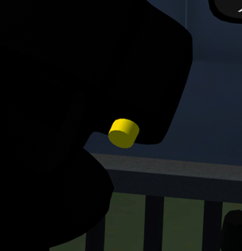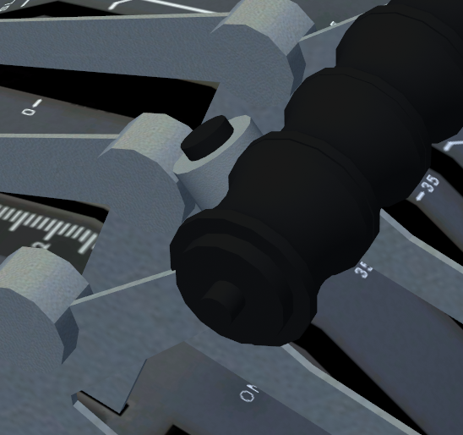

3

2

1

1. AP Disconnect Button (Both Yokes) (Shift + D)  
   Disconnects both APs. Aural warning will sound and the AP light will flash red. Second press silences the warning.
2. Takeoff/Go Around (TOGA) Button (Ctrl + G)  
   If the aircraft is in flight, engages G/A mode. The Thrust Computer Indicator will switch to GA. The ATS will switch to N1/EPR and the throttles will be set to the Go Around thrust limit. If the aircraft is on the ground, engages TAKE OFF mode.
3. ATS Disconnect Button (Both Throttles) (Ctrl + D)  
   Disconnects the ATS. The ATS light will flash red. Second press silences the warning.

# Control Wheel Steering

The FGS provides a Control Wheel Steering (CWS) mode to provide autopilot control of the roll and pitch using the yoke. When the AP is engaged in the CWS mode via the FGCP switches, the FGS holds the current roll and pitch angles. Yoke inputs cause the FGS to adjust the roll/pitch angle in proportion to the force applied. When the force is released, the new roll/pitch angle is held. CWS can be used at any time assuming either AP is available, however due to the slow response rate of the FGS, use of CWS during under 500ft radio altitude is strongly discouraged.

# Yaw Damper

A yaw damper is provided by the FGS to damp Dutch roll and provide turn coordination. The yaw damper is active when above 50ft radio altitude. The rudder pedals do not move with yaw damper commands.

# Procedures

## Takeoff and Climb

1. Extend the flaps and ensure the TCI is set to TO, TO FLX, or ALTN TO mode, then push the TOGA button to engage TAKE OFF mode.
2. Spool the engines up to approximately 60% N1 (GE) or 1.10 EPR (PW) and wait for them to stabilize.  
   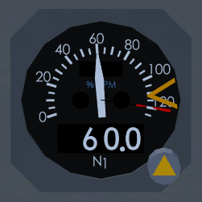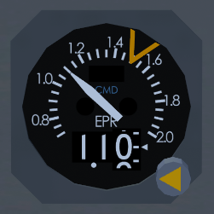
3. Set either ATS switch to ON.
4. Check that N1/EPR mode appears on the FMA and the ATS drives the throttles to the takeoff limit.
5. At 80 knots, observe and crosscheck CLAMP appearing on the FMA and power is set.
6. At rotation speed, smoothly rotate the aircraft up and center the Flight Director bars. Do not chase the bars.
7. At 500ft radio altitude, the AP can be engaged. Center FD bars before engaging the AP.
8. At thrust reduction altitude (typically 1500ft above airport elevation), set the TCI to CL, then push the N1/EPR button. The engines will roll back to the climb limit.
9. At acceleration altitude (typically 3000ft above airport elevation), rotate the vertical speed wheel to engage VERT SPD and set a climb rate of 1000-1500 feet per minute to accelerate.
10. When reaching 250kts, push the IAS button to engage the IAS vertical mode, and push the N1/EPR button to command ATS to maintain the climb limit.

## Engaging the AP or ATS

1. Ensure the desired modes are active, the flight controls and Flight Director bars are centered, and the stabilizer is trimmed.
2. Set the AP switch to CMD or the ATS switch to ON.

## Disengaging the AP or ATS

1. Push the AP disconnect button on the yoke or the ATS disconnect button on the throttles.
2. Silence the disconnect warning and flashing red light by pressing the AP or ATS disconnect button again.

## Climbing to a New Altitude

1. Set desired altitude into the FGCP.
2. Push the IAS or MACH buttons to engage the IAS or MACH vertical modes. Observe CLAMP is displayed on the FMA.
3. If the ATS is engaged, push the N1/EPR button to set power for climb.
4. Pull the altitude knob to arm ALT CAP.
5. If engaged, observe the AP pitching for speed.

## Descending to a New Altitude

1. Set desired altitude into the FGCP.
2. Push the IAS or MACH buttons to engage the IAS or MACH vertical modes. Observe that CLAMP is displayed on the FMA.
3. Manually idle the throttles to roughly 40% N1 or 1.00 EPR to set power for descend.
4. Pull the altitude knob to arm ALT CAP.
5. If engaged, observe the AP pitching for speed.

## Performing an ILS Approach or Autoland

1. Set the frequency and course into either NAV radio on the FGCP.
2. When on an intercept course (30 degrees or less recommended), push the ILS (or LAND) button.
3. Ensure ILS (or LAND) is displayed in the armed mode on the FMA.
4. When LOC CAP engages, ensure ILS (or LAND) remains displayed in the armed mode on the FMA.
5. When G/S CAP engages, ensure the missed approach altitude is set in FCP.
6. Ensure both LOC TRK and G/S TRK is displayed when established.
7. If performing an Autoland, ensure either LAND is displayed in the armed mode on the FMA, or DUAL/SINGLE LAND is annunciated roughly 10 seconds after passing 1500ft radio altitude.
8. Monitor AP performance and be prepared to take over if system disconnects due to loss of ILS signal or malfunction. AP will disengage just after nose wheel touchdown.

## Tracking a VOR Radial or ILS Localizer

1. Set the frequency and course into either NAV radio on the FGCP.
2. When on an intercept course (30 degrees or less recommended), push the VOR LOC button.
3. Ensure VOR or LOC is displayed in the armed mode on the FMA.
4. After VOR CAP or LOC CAP engages, ensure that VOR TRK or LOC TRK is displayed when established.