McDonnell Douglas DC-10

Thrust Limits and TCI

Josh Davidson (Octal450)

Updated: 5/23/2024

Note: This guide is not an FCOM and does not describe every single behavior of the system.

Contents

Introduction 3

Controls and Indicators 3

Thrust Limits 4

N1/EPR Limit Override 5

# Introduction

The DC-10’s three engines are conventionally controlled by cables running from the throttles to each engine. In order to maintain safe operation, thrust limits are controlled and displayed in the cockpit by the Thrust Computer Indicator (TCI) as well as the N1 fan speed or Engine Pressure Ratio (EPR) gauges.

# Controls and Indicators

These controls are used for controlling and displaying the thrust limits.

Thrust Computer Indicator

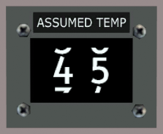

N1 Gauges (3, GE)

Assumed Temp Selector (GE)

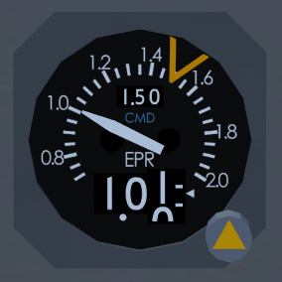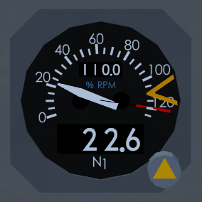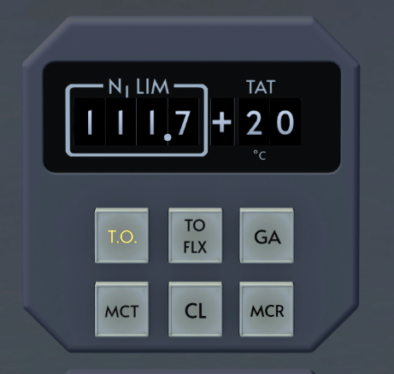

EPR Gauges (3, PW)

4

4

7

6

6

5

5

2

3

1

1. N1/EPR Limit Window  
   Displays the active N1/EPR limit computed by the TCI.
2. Ram Air Temperature Window  
   Displays the Total Air Temperature (TAT) used for N1/EPR limit calculations.
3. N1/EPR Limit Selection Buttons  
   Selects the N1/EPR limit mode on the TRI.
   * TO: Takeoff Limit
   * TO FLX (GE): Takeoff Flex Limit
   * ALTN TO (PW): Derated Takeoff Limit
   * GA: Go Around Limit
   * MCT: Maximum Continuous Thrust Limit
   * CL: Climb Limit
   * MCR (GE): Maximum Cruise Limit
   * ALTN CL (PW): Derated Climb Limit
4. N1/EPR Limit Override Window  
   Displays the N1/EPR limit override. Window is hidden when the override is not enabled.
5. N1/EPR Limit Bug  
   Displays the active N1/EPR limit from the TRI, or the N1/EPR limit override value.
6. N1/EPR Limit Override Knob  
   Pull/Push: Enable/Disable N1/EPR limit override. When pushed in, override is disabled.  
   Turn: Adjust N1/EPR limit override value.
7. Assumed Temp Selector (GE only)  
   Used to select the temperature used for flexible (flex) takeoff operations.

# Thrust Limits

The General Electric CF6 engine is controlled via N1 fan speed.

The Pratt & Whitney JT9D engine is controlled via Engine Pressure Ratio (EPR). EPR is an indicator of the thrust produced by the engine.

N1 (GE) and EPR (PW) can be used to ensure the engine is operating within safe parameters, which is called the thrust limit. There are many different thrust limits that the engines can be controlled to. Some thrust limits are specific to engine type. The Auto Thrust System (ATS) will respect the set thrust limit when engaged.

Normal Takeoff Thrust  
Available with the TCI set to TO. Normal thrust used for takeoff.

Takeoff Flex Thrust (GE)  
Available on GE engines with the TCI set to TO FLEX. Allows flexible takeoff thrust using a derate based on an assumed temperature to reduce engine wear. Assumed temperature for flex computation can be set on the assumed temp selector.

Alternate Takeoff Thrust (PW)  
Available on PW engines with the TCI set to ALTN TO. Allows a fixed takeoff thrust derate to reduce engine wear.

Go Around Thrust  
Available with the TCI set to GA. Maximum thrust available for a go around. This mode should be pre-selected when beginning final approach.

Maximum Continuous Thrust  
Available with the TCI set to MCT. Maximum thrust available for continuous operation without limitations. Only to be used during engine-out operations.

Climb Thrust  
Available with the TCI set to CL. Maximum climb thrust for normal operations. This mode should be entered at the thrust reduction altitude (if unsure, use 1000ft radio altitude).

Cruise Thrust (GE)  
Available on GE engines with the TCI set to CR. Maximum cruise thrust for normal operations. This mode should be entered when reaching cruise altitude.

Alternate Climb Thrust (PW)  
Available on PW engines with the TCI set to ALTN CL. Allows for a derated climb thrust to reduce engine wear. Can be used instead of climb thrust or cruise thrust.

# N1/EPR Limit Override

Normally, the N1/EPR limit is set automatically by the TCI. However, the N1/EPR limits can be overridden by the pilot manually if the TCI malfunctions or an unusual thrust setting is required.

The thrust limit for each engine can be overridden individually. To enable, the N1/EPR limit override knob is pulled on the N1/EPR gauge(s). The N1/EPR limit override window will be uncovered displaying the current override limit. The knob can then be turned to set the desired thrust limit.

The Auto Thrust System may be used with the override set and will respect the overridden limit, but will not exceed the N1/EPR limit commanded by the TCI.