Honeywell Trimble HT9100

FMS and MCDU

Josh Davidson (Octal450)

Updated: 7/8/2025

Note: This guide is not an FCOM and does not describe every single behavior of the system.

Contents

Introduction 3

Multifunction Control and Display Unit 4

Overview 4

Scratchpad 5

Fields and Line Select Keys 5

Pages 7

DATA 7

IDENT 7

MENU 7

PERF INIT 7

POS REF 8

RTE 8

# Introduction

The Honeywell Trimble HT9100 Flight Management System (FMS) is controlled by a Multifunction Control and Display Unit (MCDU). The FMS provides guidance and navigation which can be coupled to the autopilot or simply viewed by the pilot.

The HT9100 is typically used as a retrofit FMS, installed on aircraft which did not originally come with any sort of FMS or GPS guidance.

The HT9100 originally came with “advisory VNAV”, which displayed very basic vertical navigation information on the MCDU. This functionality did not consider aircraft performance, and could not be coupled to an autopilot. As a result it was not very useful. This version of the HT9100 has advisory VNAV removed, and functions only as a lateral FMS, such as the competing CMA900.

# Multifunction Control and Display Unit

The Multifunction Control and Display Unit (MCDU) is the interface between the pilot and the Flight Management System (FMS).

## Overview

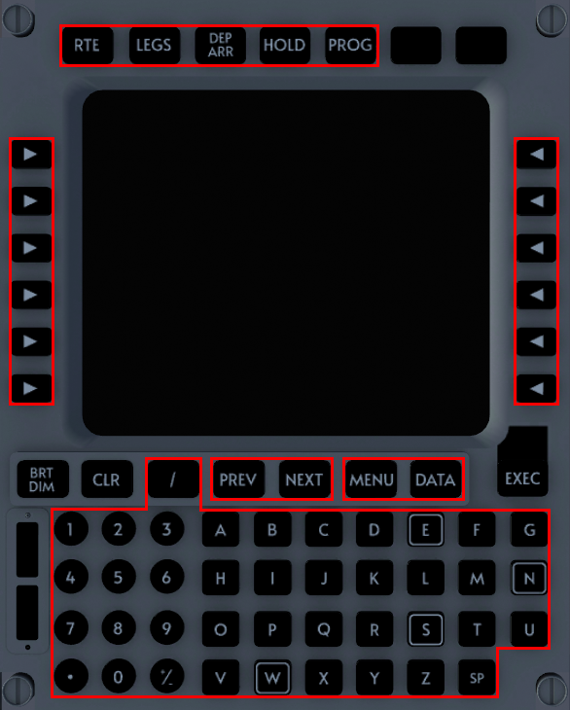

10

8

5

4

9

7

6

2

1

2

3

1. Page Keys  
   Selects the respective page.
2. Line Select Keys (LSK)  
   Selects or enters data into the adjacent field.
3. Display
4. Display Brightness Key
5. Clear Key  
   If the scratchpad contains entered characters, the key performs a backspace. If a message is in the scratchpad, the key clears the message. Otherwise, the “CLR” character on the scratchpad is toggled.
6. Alphanumeric Keys  
   Types the respective character into the scratchpad.
7. Prev/Next Page Keys  
   Goes to the previous or next page. Page numbers are shown in the upper right corner of the display when multiple pages exist.
8. Menu Keys  
   Selects the respective menu page.
9. Execute Key  
   Executes activated modifications. Light appears when execution is required.
10. Annunciator Lights  
    Can display MSG or CALL.

## Scratchpad

The scratchpad consists of the bottom most line of the display. Pressing any of the alphanumeric keys will type the respective character into this line. The CLR key can be used to remove the last character entered.

The scratchpad may also display messages from the FMS which can be removed using the CLR key. When a message is shown, the MSG annunciator light will illuminate on the right of the unit. Once the message is removed, the next message will be shown, unless there are no more messages, at which point the scratchpad contents will revert to their previous state before the message was displayed, and the MSG light will extinguish.

If the scratchpad is empty while the CLR key is pushed, the “CLR” character is shown in the scratchpad. Pushing the CLR key again will empty the scratchpad again.

## Fields and Line Select Keys

Fields refer to locations where text is placed on the display. There are 6 rows and 3 columns. Fields are known as 1L through 6L for the left column, 1C through 6C for the center column, and 1R through 6R for the right column.

Data in fields can be shown in large or small font. An optional label is shown above some fields in small font.

A Line Select Key (LSK) is provided for each of the left or right columns of fields, and allows activation of commands and entering or clearing data. Data in the center column fields are not normally accessible by LSKs.

An asterisk * indicates a command that can be activated by pushing the respective LSK. Pushing a command while the “CLR” character is shown in the scratchpad will perform the clear function of the command. If no clear function is available, “INVALID CLEAR” will be displayed.

Arrows < > indicate a page that can be accessed through pushing the respective LSK. Data in the scratchpad will not be cleared.

Boxes □ indicate a blank field which is requesting data entry. Dashes indicate a blank field, but not requesting data entry.

Data can be entered by typing data into the scratchpad and then pressing the LSK adjacent to the desired field. If the format of the data is incorrect or the data exceeds the allowable entry range, “INVALID ENTRY” will be displayed.

Certain fields perform special checking on entered values. Additional messages may be generated in these situations. For example, the ORIGIN field will validate that the ICAO entered is valid and in the database. If it is not, “NOT IN DATA BASE” will be displayed.

Fields containing forward slashes indicate that it contains multiple properties. For example, SPD/ALT constraint fields contain both the speed and altitude constraint. Entry is performed by following the slash format, in this case, “250/10000”.

Some multi-property fields allow entry of a single value at a time. Single property editing is not supported on all two-property fields or for fields with more than two properties.

Data can be cleared by pushing the CLR key to display the “CLR” character, and then pressing the desired field’s LSK. Some fields cannot be cleared after entry, and will display “INVALID CLEAR” if clearing is attempted.

Certain fields may have additional or special behavior. This behavior will be described in the respective page’s section.

## Pages

This section will cover MCDU pages related to the Flight Management System (FMS). Pages not listed are not currently simulated, but may be added in future versions of the aircraft.

### DATA

This page is a menu that allows selection of other data reference pages. It is accessed by pushing the DATA key.

### IDENT

This page displays information about the FMS and its computers.

This page is displayed at power-up. It can also be accessed from the DATA page.

The aircraft and engine type are displayed in the 1L and 1R fields. It must be verified correct before every flight.

This page has no editable fields.

### MENU

This page provides access to the various systems that the MCDU can interface with. It is accessed by pushing the MENU key. It also displays when the MCDU is powered up.

For this simulation, only the HT9100 is connected, and thus no other systems are displayed.

### PERF INIT

This page is used to initialize the performance data. As this is a lateral only system, there is minimal data entry required.

Transition altitude can be entered into field 1R. Altitude can be entered by entering a flight level number, for example, 300 for FL300, or as a full altitude, 30000.

Cruise altitude is entered into field 1R. Altitude can be entered by entering a flight level number, for example, 300 for FL300, or as a full altitude, 30000.

### POS REF

This page allows for viewing position reference data. It is accessed from the DATA page or the IDENT page.

Field rows are populated with position information from the Global Navigation System (GNS).

This page has no editable fields.

### RTE

This page is used to initialize the flight plan.

The departure airport ICAO is entered into field 1L.

The arrival airport ICAO is entered into field 1R.

A stored Company Route can be entered into field 3R. This feature will be used to allow external flight plan files to be loaded in a future version.

A flight number of any character combination can be entered into field 2R.

When the ACTIVATE> prompt appears in field 6R, it indicates that the system is awaiting activation and execution of the flight plan. Select ACTIVATE> and then push the EXEC key to perform this.