McDonnell Douglas MD-11

Thrust Limits and FADEC

Josh Davidson (Octal450)

Updated: 10/20/2025

Note: This guide is not an FCOM and does not describe every single behavior of the system.

Contents

Introduction 3

Controls and Indicators 3

Thrust Limits 5

N1/EPR Limit Override 6

Alternate Mode 6

# Introduction

The MD-11’s three engines are controlled by Full Authority Digital Engine Control (FADEC). In order to maintain safe operation, thrust limits are computed and enforced by the FADEC and displayed on the Engine and Alert Display (EAD).

# Controls and Indicators

Thrust limits are displayed with engine parameters on the Engine and Alert Display (EAD). General Electrical CF6 engines use N1 as the primary thrust setting parameter, while Pratt & Whitney PW4000 engines use Engine Pressure Ratio (EPR). Tape displays operate similarly to dial displays, but with a vertical tape layout.

General Electrical (Dials):  
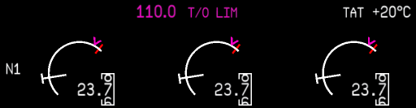

1

6

3

2

5

Pratt & Whitney (Dials):  
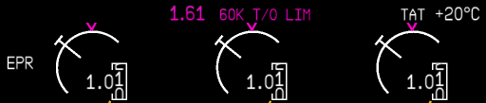

5

4

2

1

3

6

Overhead Panel:  
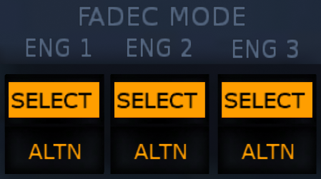

7

1. N1/EPR Command (3)  
   Displays the N1 or EPR commanded by the thrust levers.
2. N1/EPR Limit Bug (3)  
   Displays the active N1 or EPR limit computed by the FADEC.
3. N1/EPR Limit  
   Displays the active N1 or EPR limit computed by the FADEC digitally.
4. Engine Thrust Rating (PW)  
   Displays the active thrust rating, 60K for 60,000lbs and 62K for 62,000lbs. Only displayed on Pratt & Whitney engines when the mode is T/O, T/O FLEX, or G/A.
5. N1/EPR Limit Mode  
   Displays the N1 or EPR limit mode.
   * T/O: Takeoff Limit
   * T/O FLEX: Takeoff Flex Limit
   * G/A: Go Around Limit
   * MCT: Maximum Continuous Thrust Limit
   * CLB: Climb Limit
   * CRZ: Cruise Limit
6. Total Air Temperature  
   Displays the Total Air Temperature (TAT) used for N1 or EPR limit calculations.
7. Alternate Mode Switches (3)  
   Switches the respective engine into alternate mode.

# Thrust Limits

The General Electrical CF6 engine is controlled via N1 fan speed.

The Pratt & Whitney PW4000 engine is controlled via Engine Pressure Ratio (EPR). EPR is an indicator of the thrust produced by the engine.

N1 (GE) and EPR (PW) limits are used to ensure the engine is operating within safe parameters. This is called the thrust limit

There are many different thrust limits displayed on the Engine and Alert Display (EAD) that the engines can be controlled to. The Flight Management System (FMS) automatically selects the best thrust limit mode, but can be set manually using the THRUST LIMITS page of the Multifunction Control and Display Unit (MCDU). The Auto Thrust System (ATS) will respect the set thrust limit when engaged.

Takeoff Thrust  
Available when T/O is displayed on the EAD. Normal thrust used for takeoff. Automatically selected when the FMS is in the takeoff phase. For Pratt & Whitney engines, this can be either 60K or 62K.

Takeoff Flex Thrust  
Available when assumed temperature for flex computation is set on the THRUST LIMITS page of the MCDU. T/O FLEX will be displayed on the EAD. For Pratt & Whitney engines, this is only available in 60K mode. Allows flexible takeoff thrust using a derate based on an assumed temperature to reduce engine wear.

Go Around Thrust  
Available when G/A is displayed on the EAD. Maximum thrust available for a go around. Automatically selected when the Autoflight System enters GO AROUND mode. For Pratt & Whitney engines, this can be either 60K or 62K.

Maximum Continuous Thrust  
Available when MCT is displayed on the EAD. Maximum thrust available for continuous operation without limitations. Automatically replaces the Climb and Cruise thrust limits during engine-out operations.

Climb Thrust  
Available when CLB is displayed on the EAD. Maximum climb thrust for normal operations. This mode is automatically selected at the thrust reduction altitude (typically 1500 feet above the departure airport).

Cruise Thrust  
Available when CRZ is displayed on the EAD. Maximum cruise thrust for normal operations. Automatically selected when reaching the cruise altitude set in the MCDU.

# N1/EPR Limit Override

Normally, the N1 or EPR limit is set automatically. However, thrust limits can be overridden by the pilot manually during a malfunction or an unusual thrust setting is required.

The thrust limit mode can be overridden on the THRUST LIMITS page of the Multifunction Control and Display Unit.

A white box around the limits on the EAD will be displayed when the limit is overridden.

# Alternate Mode

When Alternate is selected on the overhead panel, the ALTN light on the respective switch illuminates, the N1 or EPR Command T bug is removed from the Engine and Alert Display, and the engines revert to the alternate mode of thrust control. In this mode, thrust limits are no longer obeyed, and on Pratt & Whitney engines, the Auto Thrust System will not function.

This mode should only be used if the engines cannot be controlled in Normal Mode due to FADEC failure or loss of data. Should either of these occur, the SELECT light on the respective Alternate switch will illuminate and the engine will automatically revert to Alternate Mode. Alternate Mode should then be confirmed by pushing the respective Alternate Mode switch, followed by switching the other engines into Alternate Mode.

Never allow the engines to operate with only one engine in Alternate Mode. Due to the alternate mode of control, asymmetric thrust settings may occur. Thus, if an engine reverts to Alternate Mode, immediately select Alternate Mode for the other engines.