McDonnell Douglas MD-11

Auto flight and FCC

Josh Davidson (Octal450)

Updated: 7/14/2025

Note: This guide is not an FCOM and does not describe every single behavior of the system.

Contents

Introduction 3

Flight Mode Annunciator 3

Status Boxes 3

Auto Flight Modes 4

Speed Modes 4

Lateral Modes 4

Vertical Modes 5

Land Modes 5

Armed Modes 6

Speed Protection 6

Controls 7

Flight Control Panel 7

Other Controls 9

Roll Control Wheel Steering 9

Longitudinal Stability Augmentation System 10

Yaw Damper 11

Elevator Feel 11

Flap Limit 11

Procedures 12

Takeoff and Climb 12

Engaging the AP or ATS 12

Disengaging the AP or ATS 12

Setting a New Speed or Heading 12

Climbing or Descending to a New Altitude 13

Performing an ILS Approach or Autoland 13

Tracking an ILS Localizer 13

Tracking a VOR Radial 13

# Introduction

The MD-11’s Auto Flight System (AFS) consists of 2 independent Autopilots (APs). Each system has a coupled Auto Thrust System (ATS). The system is capable of automatically flying the aircraft from shortly after liftoff, to touchdown and rollout.

The controls for the system are located on the Flight Control Panel (FCP) on the glareshield. Outputs from the system are shown on both Primary Flight Displays (PFDs) in the form of the Flight Mode Annunciator, Flight Director and target bowtie indicators.

The Flight Control Computers (FCCs) provide stability augmentation in roll, pitch, and yaw during manual flight. These systems are the Roll Control Wheel Steering (RCWS), Longitudinal Stability Augmentation System (LSAS), and Yaw Damper. Elevator Feel and Flap Limiter systems are also provided.

# Flight Mode Annunciator

The Flight Mode Annunciator (FMA) shows the engaged and armed modes of the system. It is located at the top of each PFD.

Status Boxes



Lateral Modes

Vertical Modes

Speed Modes

## Status Boxes

These boxes show the engagement status of the system. When visible and white, the system is off, but available. When the boxes are visible and amber, the system is off and not available.

When turning off a system, the associated box will flash red until silenced (for the AP, aural warning will sound).

When not visible, the systems are engaged. AP1 or AP2 is displayed to indicate the active system. During a DUAL LAND, both APs are engaged, and simply AP is displayed.



When the speed mode is PITCH, the boxes switch places. This is because the AP is now controlling the speed and lateral modes, while the ATS is controlling the vertical mode.



# Auto Flight Modes

## Speed Modes

The speed mode is coupled to the vertical mode. When the AP is controlling the vertical mode, such as altitude hold or vertical speed, the ATS is controlling the speed. When the AP is controlling the speed, the ATS is controlling the vertical mode. During landing, RETARD mode engages at 50 feet radio altitude.

When FMS SPD is engaged, the mode is displayed in magenta. FMS SPD operation is described in the FMS and MCDU document.

Available modes are:

* THRUST: ATS is adjusting the throttles to control airspeed or Mach number
* PITCH: AP is adjusting the pitch angle to control airspeed or Mach number
* RETARD: ATS is retarding the throttles for touchdown

The ATS command is constrained to the active thrust limit and idle limit.

## Lateral Modes

The lateral modes are controlled by the AP.

When the DUAL LAND is active, active mode is displayed in green.

Available modes are:

* HEADING (white): FCP selected heading is being captured and held
* TRACK (white): FCP selected ground track is being captured and held
* NAV (magenta): FMS lateral path is being captured and tracked
* VOR1/VOR2 (white): VOR localizer is being captured and tracked
* LOC/LOC ONLY (white or green): ILS localizer is being captured and tracked
* ALIGN (white or green): Runway alignment is occurring
* ROLLOUT (white or green): Runway centerline is being tracked
* TAKEOFF (white): After liftoff, levelling out and holding current heading

## Vertical Modes

Vertical path modes are controlled by the AP, and level change modes are controlled by the ATS.

The system will automatically engage HOLD mode and capture the altitude selected on the Flight Control Panel, except when the system is in G/S or Autoland modes.

When the DUAL LAND is active, active mode is displayed in green. When the FMS is controlling the vertical mode, the active mode is displayed in magenta.

Available path modes are:

* HOLD (white or magenta): FCP selected altitude is being captured and held
* V/S (white or magenta): FCP selected vertical speed is being tracked
* FPA (white or magenta): FCP selected flight path angle is being tracked
* G/S (white or green): ILS glideslope is being captured and tracked
* FLARE (white or green): The flare maneuver is occurring
* ROLLOUT (white or green): The nose is being lowered to the ground

When in Level Change mode, the AP controls the airspeed by adjusting pitch angle, and the ATS controls the vertical mode by setting power to the active thrust or idle limit. This provides the best climb/descent rates and is automatically engaged based on the aircraft’s position in reference to the FCP selected altitude. When the ATS is in any CLAMP mode, the throttle servos are unpowered and the levers can be moved by the pilot.

Available level change modes are: (white or magenta)

* T/O THRUST (Climb): Takeoff Thrust limit is being set
* T/O CLAMP (Climb): Takeoff Thrust limit was set and the servos are now unpowered
* GO AROUND (Climb): Go Around limit is being set
* MCT THRUST (Climb): Max Continuous Thrust limit is being set
* CLB THRUST (Climb): Climb Thrust limit is being set
* IDLE THRUST (Descent): Throttles are being driven to idle and held
* IDLE CLAMP (Descent): Throttles are being driven to idle and then the servos will be unpowered

## Land Modes

When engaged, the land mode capability is displayed to the right of the vertical mode section in place of the target altitude. The indications will appear roughly 10 seconds after passing 1500 feet radio altitude. When a land mode engages, the only way to exit is to press the Go Around button on the throttles. Other mode selection is inhibited.



* DUAL LAND (green): Both APs are available for Autoland, automatic AP takeover available
* SINGLE LAND (white): Only one AP is available for Autoland
* APPR ONLY (white): Autoland is not available, disconnect the AP above 100 feet

## Armed Modes

Armed modes appear above the active modes on the FMA. They disappear when the mode activates.

Lateral armed modes are:

* NAV ARMED (Magenta): NAV mode is armed
* LAND ARMED (White): LOC mode is armed
* LOC ARMED (White): LOC ONLY mode is armed
* VOR ARMED (White): VOR1 or VOR2 mode is armed

Vertical armed modes are:

* LAND ARMED (WHITE): G/S mode is armed
* PROF ARMED (Magenta): PROF mode is armed

## Speed Protection

The Auto Flight System provides envelope protection to keep the airspeed is between Vmax and Vmin.

At 5 knots above Vmax or 5 knots below Vmin, speed protection will engage. The ATS off box and HI/LO SPEED PROTECTION flash on the FMA.

If the speed mode is THRUST, ATS speed protection will engage and adjust the throttles to correct the airspeed. The current vertical mode remains active.

At 10 knots above Vmax or 10 knots below Vmin, pitch speed protection will engage. The throttles will be driven to the min/max and the pitch angle will be adjusted via AP or FD commands. Pitch speed protection is inhibited when the vertical mode is HOLD to ensure the aircraft does not deviate from its assigned altitude.

If the throttles are already at their limit or the speed mode is PITCH, the AP goes directly into pitch speed protection.

When the airspeed is no longer outside Vmax or Vmin, speed protection disengages and the aircraft recaptures the speed target and continues on its current trajectory.

# Controls

## Flight Control Panel

The Flight Control Panel (FCP) is the location of most of the controls for the Auto Flight System (AFS). It is located on the glareshield.

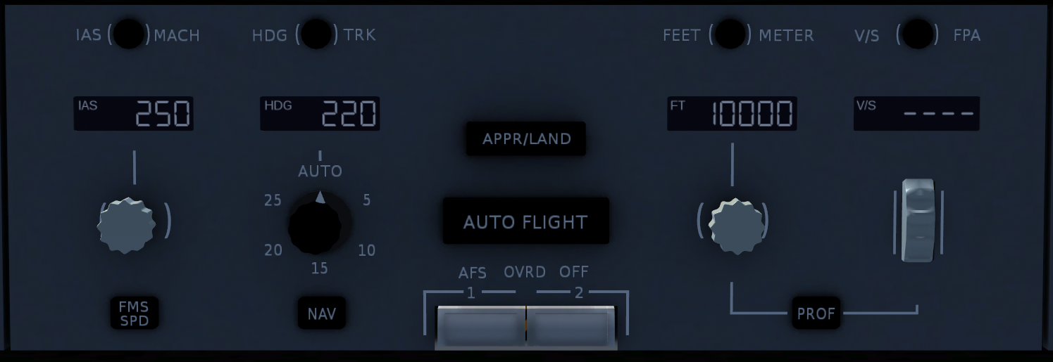

3

16

9

1

17

19

14

6

15

10

13

12

18

5

2

11

7

8

4

Knobs 3, 8, and 15 are multi-function knobs. A mouse or trackpad with a scroll wheel is required to use them. This applies to the 2D Panel version as well.

* Turn knobs by using the scroll wheel, hold Shift to accelerate adjustment
* Push knobs by left clicking
* Pull knobs by middle-clicking or holding Shift and left-clicking

1. IAS Mach Selector  
   Switches the speed pre-select and target between indicated airspeed (knots), and Mach number.
2. Speed Window  
   Displays the speed pre-select. Dashed when FMS SPD is active.
3. Speed Knob  
   Turn: Adjusts the speed pre-select.  
   Push: Sets the speed target to the current speed. Cancels FMS SPD.  
   Pull: Sets the speed target to the pre-selected value. Cancels FMS SPD and RETARD mode.
4. FMS SPD Button  
   Push to engage FMS SPD mode. Requires at least 400 feet radio altitude.
5. Heading Track Selector  
   Switches between heading and ground track modes.
6. Heading Window  
   Displays the heading pre-select. Dashed unless HEADING, TRACK, or TAKEOFF lateral modes are active.
7. Bank Limit Selector  
   Selects the maximum bank angle in HEADING or TRACK modes. No effect in other modes.
8. Heading Knob  
   Turn: Adjusts the heading/track pre-select.  
   Push: Engages HEADING or TRACK and holds the current value. Cancels armed lateral modes.  
   Pull: Engages HEADING or TRACK and sets the target to the pre-selected value.
9. NAV Button  
   Arms or engages NAV mode (if available).
10. APPR/LAND Button  
    Arms or engages LAND modes for ILS approaches if the frequency is in range.
11. AUTOFLIGHT Button  
    When airborne, engages both the ATS and either AP1 and AP2. The engaged AP is alternated every engagement, and pushing the button while engaged will swap to the other AP.
12. AFS Override Off Switches  
    Emergency disconnect switches. Immediately disconnects the ATS and both APs. Also disables AFS Speed Protection and Roll Control Wheel Steering (if equipped). Do not use during normal operation.
13. Feet/Meter Selector (Currently INOP)  
    Switches the altitude pre-select and target between feet and meters.
14. Altitude Window  
    Displays the altitude pre-select.
15. Altitude Knob  
    Turn: Adjusts the altitude pre-select.  
    Push: Engages HOLD mode and holds the current altitude. Cancels armed vertical modes.  
    Pull: Engages Level Change mode and sets the altitude target to the pre-selected value.
16. PROF Button (Currently INOP)  
    Arms or engages PROF mode (if available).
17. Vertical Speed/Flight Path Angle Selector  
    Switches between vertical speed and flight path angle modes.
18. Vertical Speed/Flight Path Angle Window  
    Displays the vertical speed select in feet-per-minute or flight path angle select in degrees.
19. Vertical Speed/Flight Path Angle Knob  
    Engages V/S or FPA modes and adjusts the target value.

## Other Controls

Yoke

Throttles

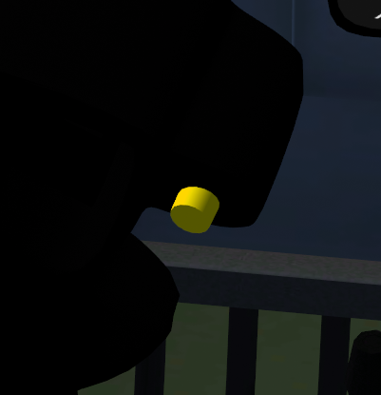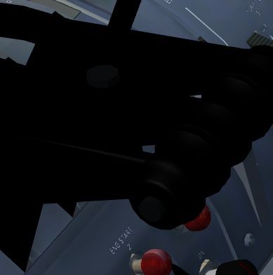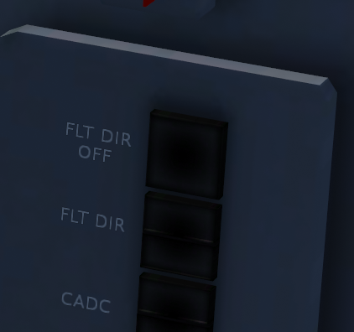

2

1

3

4

5

Sides of Main Panel

1. AP Disconnect Button (Both Yokes) (Shift + D)  
   Disconnects both APs. Aural warning will sound and the AP OFF box on the FMA will flash red. Second press silences the warning. Holding the button temporarily overrides LSAS and RCWS.
2. Go Around Button (Ctrl + G)  
   Engages HEADING and GO AROUND mode. The ATS sets throttles to the Go Around thrust limit. If the gear is on the ground and the AP is on, it will disconnect. Autobrakes are also disarmed. Button has no effect above 2500 feet radio altitude.
3. ATS Disconnect Button (Throttle 1 and 3) (Ctrl + D)  
   Disconnects the ATS. The ATS OFF box on the FMA will flash red. Second press silences the warning.
4. Flight Director Off Button  
   Toggles the Flight Director on the associated PFD.
5. Flight Director Selector (Currently INOP)  
   Switches the associated FD to the other system. For example, the captain’s side switch will set FD1 to be driven by the Flight Control Computer 2.

# Roll Control Wheel Steering

If equipped, the Roll Control Wheel Steering (RCWS) system provides roll axis stability and control when the AP is off and the aircraft is above 500 feet radio altitude. Despite being provided with the AP off, it is still considered an Auto Flight function and at least one AP must be available for RCWS to function.

RCWS 1 outputs to the left inboard aileron and RCWS 2 outputs to the right inboard aileron. The other ailerons and spoilers are backdriven through the active inboard aileron allowing RCWS to drive all roll control surfaces.

When there is no force on the control wheel, RCWS maintains the current roll attitude. When control wheel inputs are made, RCWS commands a roll rate proportional to wheel input.

Attempting to bank the aircraft more than 30 degrees requires increasing force proportional to bank angle. When control wheel force is released, RCWS smoothly returns to 30 degrees of bank.

RCWS is a parallel function, so inputs that it makes are visible by control wheel movement.

If both RCWS and deflected ailerons are equipped, there will be a momentary control wheel deflection when the ailerons deflect or retract with the flaps. This is normal and has negligible effects on controllability. This anomaly is due to the RCWS aileron lagging slightly behind the other ailerons causing the FCC to backdrive the control wheel.

# Longitudinal Stability Augmentation System

The Longitudinal Stability Augmentation System (LSAS) enhances pitch stability and provides envelope protection when the AP is off. There are 4 LSAS channels, 2 per FCC, which each control one of the 4 elevators. If one system is not available, the other channels automatically compensate by increasing their output.

There are multiple functions of the system which can combined can deflect each elevator a maximum of 5 degrees. The pilot can override LSAS at any time with sufficient control column force.

Pitch Attitude Hold (PAH)  
LSAS provides pitch attitude holding when there is no force on the control column. PAH is inhibited when the pitch angle is not within -10 to +30 degrees, bank angle is over 30 degrees, or the aircraft is below 100 feet radio altitude.

The stabilizer trim will be adjusted to fair the elevators. The pilot can override the stabilizer trim at any time. LSAS will resume trimming after a brief delay.

Pitch Attitude Limiting (PAL)  
If the pitch attitude exceeds -10 degrees or +30 degrees, corrective elevator is applied by LSAS to return the pitch attitude to -10 to +30 degrees.

Pitch Rate Damping (PRD)  
LSAS provides pitch rate damping to improve static stability and pitch control especially at high altitude. PRD is active from liftoff to touchdown, including flare. Maximum damping is provided above 20,000 feet, reducing linearly to 30% damping at 16,500 feet.

Pitch Attitude Protection (PAP)  
PAP reduces the chance of tail strike during takeoff and landing. When under 100 feet radio altitude, downwards elevator is applied by LSAS to respect the attitude limit. The limit is linear from 30 degrees at 40 feet radio altitude to 9.5 degrees at 0 feet radio altitude.

Positive Nose Lowering (PNL)  
PNL counteracts the tendency of the aircraft to pitch up when the ground spoilers deploy on touchdown. When the spoilers begin to extend, LSAS will apply 3 degrees of nose down elevator. Once the spoilers extend past 10 degrees, the command will increase to 4 degrees nose down. PNL is disabled if the throttles are advanced for a go around or AFS returns to the Takeoff mode.

Overspeed Protection  
Overspeed protection is provided by LSAS when the aircraft exceeds maximum safe airspeed or Mach. This is accomplished by a nose up command based on the speed rate to achieve the target speed. The target is variable based on the throttle setting. LSAS does not provide flap, slat, or gear overspeed protection.

Stall Protection  
Stall protection is provided by LSAS when the aircraft crosses the warning angle of attack. A nose down command is introduced until the angle of attack reduces sufficiently. If the AP is engaged, it will disengage when LSAS stall protection engages.

# Yaw Damper

A yaw damper is provided by the FCC to damp Dutch roll and provide turn coordination. There are 2 yaw damper channels per FCC, for a total of 4, controlling the upper and lower rudders. The yaw damper is active when above 50 feet radio altitude.

The rudder pedals move with FCC commands only when the Auto Flight System is in Takeoff, Go Around, or Single/Dual Land modes.

# Elevator Feel

The Elevator Feel (ELF) system adjusts the response of the elevators to control column force to provide similar pitch response throughout the airspeed envelope. Controls for the system are on the overhead panel.

The system operates in automatic mode unless set to manual. When in manual mode, the feel must be adjusted by the pilot to slew the reference airspeed for the system. The reference speed can be viewed by selecting the “CONFIG” page on the Systems Display.

# Flap Limit

The Flap Limit system prevents the flaps from extending to certain positions until the airspeed is low enough. When activated, the flap selection will be boxed in amber on the Primary Flight Displays. Protection is provided for flaps 22 through 50 only. An override is available to disable the system on the overhead panel.

# Procedures

## Takeoff and Climb

1. Ensure T/O CLAMP is indicated on the FMA, and that climb speed and initial altitude are set on the FCP. Optionally arm NAV mode and once implemented, PROF mode.
2. Spool the engines up to approximately 60% N1 (GE) or 1.10 EPR (PW) and wait for them to stabilize.  
   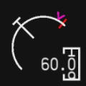 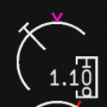
3. Push the AUTOFLIGHT button.
4. Push throttles up and check that T/O THRUST appears on the FMA and the ATS drives the throttles to the takeoff limit.
5. At 80 knots, observe and crosscheck T/O CLAMP re-appearing on the FMA and power is set.
6. At rotation speed, smoothly rotate the aircraft up and center the Flight Director bars. Do not chase the bars.
7. At 100 feet radio altitude, the AP can be engaged unless NAV mode is armed or active, where 400 feet radio altitude is the minimum. Center FD bars before engaging the AP.
8. At 400 feet radio altitude, push the FMS SPD button.
9. At thrust reduction altitude (typically 1500 feet above airport elevation), observe CLB THRUST appearing on the FMA. The engines will roll back to the climb limit.
10. At acceleration altitude (typically 3000 feet above airport elevation), observe the speed target advancing to 250 knots. If FMS SPD wasn’t engaged or was disengaged, pull the Speed Knob to accelerate to the climb speed set in the FCP.

## Engaging the AP or ATS

1. Ensure the desired modes are active, the flight controls and Flight Director bars are centered, and the stabilizer is trimmed.
2. Push the AUTOFLIGHT button.

## Disengaging the AP or ATS

1. Push the AP disconnect button on the yoke or the ATS disconnect button on the throttles.
2. Silence the disconnect warning and flashing red box by pressing the AP or ATS disconnect button again.

## Setting a New Speed or Heading

1. Set desired speed or heading into the FCP.
2. Pull the speed knob or heading knob.

## Climbing or Descending to a New Altitude

1. Set desired altitude into the FCP.
2. Pull the altitude knob to engage level change.
3. If engaged, observe the ATS setting power for climb or descent and the AP pitching for speed.

## Performing an ILS Approach or Autoland

1. Set the frequency and course into the ILS radio using the MCDU NAV RAD page.
2. When on an intercept course (30 degrees or less recommended), push the APPR/LAND button.
3. Ensure LAND ARMED is displayed in the lateral mode on the FMA.
4. When LOC engages, ensure LAND ARMED is displayed in the vertical mode on the FMA.
5. When G/S engages, ensure the missed approach altitude is set in FCP.
6. If performing an Autoland, ensure DUAL LAND is annunciated on the FMA roughly 10 seconds after passing 1500 feet radio altitude.
7. Monitor AP performance and be prepared to take over if system disconnects due to loss of ILS signal or malfunction.

## Tracking an ILS Localizer

1. Set the frequency and course into the ILS radio using the MCDU NAV RAD page.
2. When on an intercept course (30 degrees or less recommended), select *LOC ONLY option in the MCDU NAV RAD page.
3. Ensure LOC ARMED is displayed in the lateral mode on the FMA.

## Tracking a VOR Radial

1. Set the frequency and course into either VOR radio using the MCDU NAV RAD page.
2. When on an intercept course (30 degrees or less recommended), select *VOR ARM option in the MCDU NAV RAD page.
3. Ensure VOR ARMED is displayed in the lateral mode on the FMA.