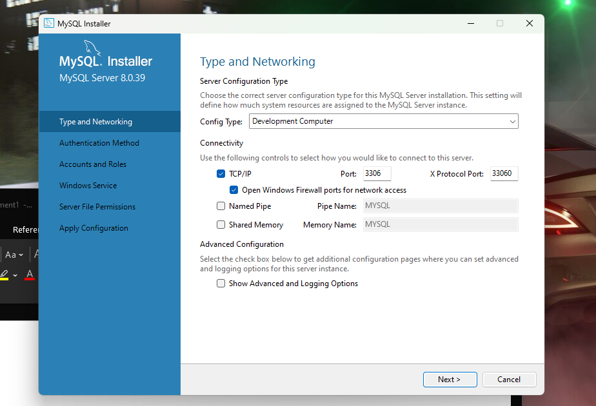

Oct@v1@n19

p_id char(32) primary key //short text
p_id varchar(32) primary key ///short text and can be variable
p_id text(32) primary key ///large text
p_id ENUM(’C++’ , ’Python’ , ’Java’) primary key
mai sunt si float,double, bool, time, date ,timedate, timestamp
varchar vs char
Char daca primeste cuvantul oaie atunci el va ocupa tot 32 de caractere in timp ce varchar se va adapta si va avea doar 5

PRIMARY KEY
Este unica si este obligatoie

show databases;

create database if not exists tutorialdb;

use tutorialdb;
show tables;

create table if not exists people(
p_id int primary key,
p_name varchar(255),
p_age int,
p_height float
);

select * from people;

insert into people (p_id,p_name) values (1,"Bobita");
sau insert into people (values (1,"Bobita", 78 ,180) asa trb sa dau toate detaliile;

show databases;

create database if not exists tutorialdb;

use tutorialdb;
show tables;

create table if not exists people(
p_id int primary key,
p_name varchar(255),
p_age int,
p_height float
);

select * from people;

insert into people values (6,"qwsf",78 ,128),
(3,"asd",34 ,145),
(4,"qwe",123 ,165),
(5,"asdf",45 ,165);

delete from people where p_id=a2;
select * from people;

Cu alter modifici structura la tabel

Contrains(criterii)

show databases;

create database if not exists tutorialdb;

use tutorialdb;

drop table people;

create table if not exists people(
p_id int primary key,
p_name varchar(255) not null, //sa nu fie null
p_age int default 21, //by default its 21
p_height float,
p_ssn char(32) unique, //unic
constraint age_constraint check (p_age >=0 and p_age<100)
);

insert into people (p_id,p_name,p_age,p_ssn) values (2,"Angela",99,"asf"); ///nu poti baga un age mai mare de 100
select * from people;

show databases;

create database if not exists tutorialdb;

use tutorialdb;

drop table people;

create table if not exists people(
p_id int primary key auto_increment,
p_firstname varchar(255),
p_lastname varchar(255),
constraint name_constraint unique(p_firstname,p_lastname) ///nu accepta mai multi cu nume si prenume la fel , dar pot sa fie pers cu acelasi nume sau prenume
);

insert into people (p_firstname,p_lastname) values ("Angela","Angi"),("asdfg","Salut");
select * from people;

Select * from people where p_name like ”M%” ASA O SA TI DEA MIKE ,MIHAI ETC
Select * from people where p_name like ”%a” o sa ti dea care se termina in a
Select * from people where p_name like ”%a%” o sa ti dea care contin n

Select SUM(p_age) from people; //sum all the ages
Select AVG(p_age) from people; //media

